Book of Ether

Chapter 10

Geographical Theory Map: Ether 10:1 - 10:16 People Begin to Spread Over All the Land (Chronology)
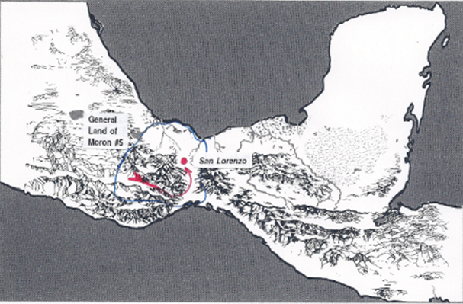

NORTH COUNTRIES (LAND of MORON #5)
Heth perishes in the famine (10:1)
SHEZ reigns, (From where?) builds up “many cities” (10:1)
The people began to spread over all the face of the land (10:4)
Shez begets Riplakish (10:4)
RIPLAKISH reigns (10:4)
“many wives and concubines” (10:5)
“heavy taxes” “many spacious buildings” (10:5)
Fine gold “refined” in his prisons

People rebel (10:8)
Family of Riplakish driven out (10:8) -------------> ? [SAN LORENZO]
<----------------- Morianton (descendant of Riplakish) "went" forth to battle (10:9)
(outlying cities?)

Morianton gains some power (10:9)
Morianton becomes king over all (10:13)
MORIANTON reigns (10:13)
Morianton begets Kim 10:13)
KIM reigns (10:13)
Brother puts Kim in prison (10:14)
BROTHER OF KIM reigns (10:14)
Kim begets Levi (10:14)
Levi battles the king (10:15)
LEVI reigns (10:15)
Levi begets Corom (10:16)
COROM reigns (10:16)
Corom begets Kish (10:17)
KISH reigns (10:17)
Kish begets Lib (10:17)
LIB reigns (10:17)
Poisonous serpents destroyed (10:19)
They build a “great city” [city of Lib] by the narrow neck of land, by the place where the sea divides the land” (10:20)

Ether 10:1 Shez, Who Was a Descendant of Heth . . . Began to Build Up a Broken People:

It seems that wicked King Heth and all his family perished in the famine. Nevertheless, "the Lord did send rain upon the face of the earth; and the people began to revive again, and there began to be fruit in the north countries, and in all the countries round about" (Ether 9:35). Apparently, some years later, a man named Shez began to build up this famine-stricken "broken people." Interestingly, we find in Ether 10:1 that Shez was a "descendant" of Heth." However, in Ether 1:25 it says that Shez was a "son" of Heth.

According to Glenn Scott, this is another example of some translator not knowing if the Hebrew word BN, meant son or descendant. Whatever his relationship, Shez was different from Heth. He remembered how the Lord had brought his ancestors across the great deep. He also remembered the destruction of his people under his wicked ancestor (or father). He ruled righteously and built and rebuilt many cities and the people once again spread over the land. He too lived to "an exceeding old age" (Ether 10:4), and in his old age begat Riplakish, and Riplakish (apparently the youngest) reigned in his stead. [Glenn A. Scott, Voices from the Dust: New Light on an Ancient American Record, p. 52]

Since the famine ended because "there began to be fruit in the north countries," apparently the Jaredite lands were located there. But where specifically did Shez rule from, the local land of Moron or land of Heth? [Alan C. Miner, Personal Notes]

Ether 10:2 And It Came to Pass That Shez Did Remember the Destruction of His Fathers (Covenant Language and Structure):
According to Donald Parry, parallelism is universally recognized as the characteristic feature of biblical Hebrew poetry. (p. i) Apparently, the prophets and writers of the scriptures employed the repetition of alternating parallel lines for the purpose of reinforcing their teachings and doctrines. (p. x) The message of Ether 10:1-3 is covenant related. It speaks to the idea that from the remains of covenant destruction (Shiz’s father Heth had perished by the famine, and all his household save it were Shez”). Either Moroni or Ether stressed the message with a parallelistic extended alternate construction, covenant terms and covenant actions encapsulated by covenant blessings:
A And it came to pass that Shez . . . began to build up again a broken people.
B And it came to pass that Shez did remember
C the destruction of his fathers,
D and he did build up a righteous kingdom;
B for he remembered
C what the Lord had done in bringing Jared and his brother across the deep;
D and he did walk in the ways of the Lord.
A and he [the righteous covenant-faithful Shez] begat sons and daughters.

Here the covenant blessing of “beginning to build up again a broken people” is paired and defined by the parallel blessing of “begetting sons and daughters.” The “remembering” reinforced by the “destruction of Shez’s fathers” is juxtaposed to Shez’s “remembering” the blessings received by the covenant faithful “fathers” Jared and the brother of Jared.
[Alan Miner, Personal Notes and Donald W. Parry, The Book of Mormon Text Reformatted to Parallelistic Patterns , p. 468]
[Note* See another example of the covenant term ”remember” in Ether 6:30 along with extended commentary]

Ether 10:2 Shez . . . Did Build Up a Righteous Kingdom; For He Did Remember What the Lord Had Done:

Neal A. Maxwell comments:

“[There is an] urgency of our coming to know God and His scheme of things, and of also developing within ourselves, our children, and our grandchildren a sense of history, including what God has done for Israel. Such reminders of the past-and millennia of memories from the scriptures-will help us amid present challenges.

“This ‘memory’ or sense of history should reach back not just a few decades but to the very beginning-even way back to the stated purposes of the Lord with regard to this whole mortal experience…scriptures give us a framework for better understanding mortality amid ‘all occasions.’
(We Will Prove Them Herewith, pp. 2-4)
[josephsmith.com . . . Ether ]

Ether 10:2 Shez . . . Remembered What the Lord Had Done in Bringing Jared and His Brother across the Deep; and Did Walk in the Ways of the Lord (Covenant Language):
In Ether 10:2 Moroni records that the Jaredite ruler Shez, who had begun to build up again a broken people, “did remember the destruction of his fathers, and he did build up a righteous kingdom; for he remembered what the Lord had done in bringing Jared and his brother across the deep; and he did walk in the ways of the Lord .”

The term “remember” is associated with faithfulness in keeping covenants. Allen & David Richardson and Anthony Bentley note that the Book of Mormon prophet writers frequently emphasize the importance of remembering. For example, 1 Nephi 10:20: "Therefore remember, O man, for all thy doings thou shalt be brought into judgment." Other classic examples are found in Mosiah 2:41: "O remember, remember that these things are true; for the Lord God hath spoken it," and Mosiah 4:30: "An now, O man, remember, and perish not."

The charge to "remember" is repeated seven times in Helaman 5:5-6. Note that seven is a number that was used in ancient Hebrew culture to signify perfection or completion. (See also, 1 Nephi 15:25; 19:15-16; Jacob 3:9-11; Alma 37:35; 3 Nephi 18:7, 11; and Moroni 4-5.)
All in all, the Book of Mormon prophets stress the importance of remembering the Lord's dealings with their fathers some seventy-nine times! The frequent emphasis on remembering throughout the Book of Mormon is consistent with the Hebrew literature. (See Wallace E Hunt Jr., "Moses' Brazen Serpent as It Relates to Serpent Worship in Mesoamerica," Journal of Book of Mormon Studies, 1993, p. 126.)
The following is quoted from John W. Welch, Reexploring the Book of Mormon, 1992, pp. 127-129:
Brevard S. Childs has shown that various forms of the Hebrew verb zakhor (to remember) occur in the Old Testament well over two hundred times. He shows that what the Old Testament understands by "memory" goes well beyond the mere mental recall of information, though of course that is part of its meaning. To remember often means to be active, to consider, to keep divine commandments, or to act. The word in Hebrew thus carries a wider range of meaning than is common with the verb remember in English. Indeed, to remember involves turning to God, or repenting, or acting in accordance with divine injunctions.
Not only man, but also God "remembers." He remembers covenants he has made with Noah (see Genesis 9:15-16), with Abraham, Isaac and Jacob (see Exodus 2:24; Leviticus 26:42), and with all of Israel (see Ezekiel 16:60; Luke 1:72).
Conversely, the antonym of the verb to remember in Hebrew--to forget does not merely describe the passing of a thought from the mind, but involves a failure to act, or a failure to do or keep something. Hence, failing to remember God and His commandments is the equivalent of apostasy.
Interestingly, words for memory and remembrance also occur well over two hundred times in the Book of Mormon. This high density is not noticed by casual readers, but it vividly reflects a religious sensitivity on the part of Book of Mormon prophets that is similar to that of other Israelite prophets. Though the range of uses of remembering in the Book of Mormon is perhaps not quite as extensive as that identifiable in the Old Testament, the idiom of remembrance in both books includes warning, promises, threats, pleas, and complaints, and the same deep connection between memory and action can be found in both. To remember is to hearken, to awaken, to see, to hear, to believe, to trust. (See Jacob 3:9-11; Mosiah 2:41; 4:30; 13:29-30; Alma 7:16; 9:13-14; 18:10; 36:1-2; 37:35; 46:23; 58:40 and compare with Numbers 15:39-40; Psalms 103:18.)
. . . In such ways the Book of Mormon shows a clear link between the ways of remembrance or forgetfulness and the blessings or cursings associated with the covenant people of God. Since one of the main purposes of the Book of Mormon, as stated on its title page, is to show that God remembers the covenants he has made with his people (see also 1 Nephi 19:15-16; 2 Nephi 29:1-2; 3 Nephi 16:11), it is especially appropriate that eh renewal of covenants includes a commitment to "always remember him, and keep his commandments." as the faithful affirm their willingness to take upon them the name of Jesus Christ (Moroni 4:3).
[Allen H. Richardson, David E. Richardson, and Anthony E. Bentley, Voice from the Dust-500 Evidences Supporting the Book of Mormon, pp. 270-271] [See the commentary on Mosiah 4:30; Helaman 5:6]

Ether 12:17 It Was by Faith That the Three Disciples Obtained a Promise That They Should Not Taste of Death:

It is interesting that Moroni should comment in Ether 12:17 on the “three disciples” or three Nephite apostles that were transfigured. His father Mormon had taken some space in his abridgement to talk about them (see the commentary on 3 Nephi chapter 28) Mormon writes:

“But behold, I have seen them, and they have ministered unto me. And behold they will be among the Gentiles, and the Gentiles shall know them not. They will also be among the Jews, and the Jews shall know them not. And it shall come to pass, when the Lord seeth fit in his wisdom, that they shall minister unto all the scattered tribes of Israel, and unto all nations, kindreds, tongues and people . . . (3 Nephi 28:26-29)

In all probability these three Nephite apostles ministered unto Moroni also. The same could be said about Ether – that he ministered to later Nephite prophets in the land of promise (see Ether 15:34).

Note* For some books on the three translated Nephite apostles see Bruce E. Dana, The Three Nephites and Other Translated Beings, Springville, Cedar Fort, 2003.

Ether 10:4 Riplakish:

Shez lived to "an exceeding old age" (Ether 10:4), and in his old age "begat Riplakish," and Riplakish (apparently the youngest) reigned in his stead. According to Hugh Nibley the name "Riplakish" (Ether 10:4) is a good archaic name, "lord of Lakish." There are at least five ancient cities named that. In fact, the oldest city in Mesopotamia is supposed to have been called Lakish. [Hugh W. Nibley, Teachings of the Book of Mormon, Semester 4, p. 252]

Ether 10:5 [Riplakish] Did Have Many Wives and Concubines, and Did Lay That upon Men's Shoulders Which Was Grievous to be Borne:

In Ether 10:5, Moroni writes that Riplakish "did have many wives and concubines, and did lay that upon men's shoulders which was grievous to be borne." According to Hugh Nibley, this Jaredite practice resembles exactly that which went on in the Old World. The wives and concubines are an important part of the picture, for they provided the main item of expense and the main cause of financial ruin among the rulers of the steppes, where the rule was that every king displayed his wealth and power by the number of his wives and concubines, each one of which had to possess a complete camp and court of her own. [Hugh Nibley, The World of the Jaredites, p. 209]

Ether 10:5 [Riplakish] Did Have Many Wives and Concubines:

Daniel Ludlow raises the question, Did the Jaredites practice polygamy? The early Nephite records indicate quite clearly that the Nephites were not to practice polygamy. The prophet Jacob was commanded by the Lord to say to his people: "there shall not any man among you have save it shall be one wife" (Jacob 2:27). However, Jacob later makes it clear that if the Lord wants His people to "raise up seed" unto Him, then He might command them to practice polygamy (Jacob 2:30).

It is not clear, however, whether or not the Jaredites were commanded by the Lord to practice polygamy. The following evidences have been cited which might indicate that they did practice polygamy:
(1) Many of the men had large numbers of sons and daughters. For example, the brother of Jared had 22 sons and daughters (Ether 6:20) and Orihah had 31 sons and daughters (Ether 7:2).
(2) Riplakish had "many wives and concubines" (Ether 10:5). He was condemned by the Lord for his wickedness, but it is not clear whether or not this condemnation was because of his "many wives."
(3) In Ether 14:2 it states that "every man kept the hilt of his sword in his right hand, in the defence of his property and his own life and of his wives and children." This verse seems to indicate that the people practiced polygamy, but whether or not it was sanctioned by the Lord is not made clear in the record.
[Daniel H. Ludlow, A Companion to Your Study of the Book of Mormon, p. 327] [See the commentary on Jacob 2:24; Jacob 2:27]

Ether 10:4-8 Riplakish [Similarities to Wicked King Noah]:

Ether 10:5-7 describes the reign of Riplakish. Note how his wickedness was duplicated by wicked King Noah (see Mosiah 11). The following are characteristics of both kings:

Characteristics Riplakish Noah
Very immoral Ether 10:5 Mosiah 11:2
Taxed the people heavily Ether 10:5 Mosiah 11:3
Built spacious buildings Ether 10:6 Mosiah 11:8
Glutted himself on the work of others Ether 10:7 Mosiah 11:6
Killed by his own people Ether 10:8 Mosiah 19:20

[Book of Mormon Student Manual, Religion 121 and 122, p. 141]

Ether 10:4-9 Riplakish (and Noah):
Brant Gardner notes that Brent Metcalfe assembled remarkable similarities between king Riplakish in the book of Ether and king Noah in the book of Mosiah:
- Zeniff and Shez were both righteous kings. They were succeeded by their sons Noah and Riplakish (Mosiah 11:1, Ether 10:4)
- Unlike their fathers, Noah “did not eep the commandments of God” and Riplakish “did not do that which was right in the sight of the Lord” (Mosiah 11:2, Ether 10:5).
- Noah and Riplakish each had “many wives and concubines” (Mosiah 11:2, Ether 10:5)
- Noah compelled his subjects to “do that which was abominable . . . and they did commit whoredoms,” while Riplakish “did afflict the people with his whoredoms and abominations” (Mosiah 11:2, Ether 10:7).
- By edict, Noah’s and Riplakish’s people were laden with oppressive taxes ( Mosiah 11:3, Ether 10:5)
- Noah and Riplakish each erected “spacious buildinigs” with the money secured from taxation (Mosiah 11:4-8, Ether 10:5).
- Both kings built opulent thrones (Mosioah 11:9, Ether 10:6).
- Noah’s workers crafted “all manner of fine work,” while Riplakish’s prison workers produced “all manner of fine workmanship” (Mosiah 11:10, Ether 10:7)
- Under both rulers, dissidents were incarcerated or killed (Mosiah 12:17, 17:11-20, 18:35; Ether 10:6).
- Due to internal revolt, Noah and Riplakish were executed (Mosiah 19;20, Ether 10:8).
- Noah’s priests and Riplakish’s descendants were exiled. (Mosiah 19:21, 23; Ether 10:8).
- Following the subsequent political discord, Limhi (a son of Noah) and Morianton (a descendant/son of Riplakish) reigned over the kingdoms (Mosiah 19:26, Ether 10:9)

While the details of Noah’s life cover five chapters in Mosiah, Riplakish’s biography comprises six verses in Ether. Everything we know about the Jaredite ruler bears an analogue to the corrupt Nephite King.(n.5) [Brant A. Gardner, Second Witness, Vol. 6: Fourth Nephi through Moroni, p. 270-271]
[Note* It is interesting in Mormon’s abridgement, how possible Jaredite names appear in his Nephite narrative and belong to unrighteous or rebellious Nephite leaders or individuals. Perhaps in such names Mormon was trying to convey the same incorrect attitudes and beliefs that not only brought down the Jaredites to destruction, but the Nephites also. See the following possibilities: Nehor (Alma 1:15), Korihor (Alma 30:6), Morianton (Alma 50:27), Gadianton (Helaman 2:4). Alan Miner, Personal Notes]

Ether 10:7 He Did Obtain All His Fine Work, Yea, Even His Fine Gold He Did Cause to Be Refined in Prison:

According to Hugh Nibley, the book of Ether relates the permanent confinement of kings with the institution of forced labor in prisons. Riplakish "did obtain all his fine work, yea, even his fine gold he did cause to be refined in prison; and all manner of fine workmanship he did cause to be wrought in prison" (Ether 10:7) Work in prison, we are told, was the alternative to paying ruinous taxes (Ether (10:6).

Much the same system was used by the Assyrians from the beginning: Tiglath Pileser III tells how, "I laid tribute and taxes upon them; . . . [their horses, their mules,] their camels, their cattle and their sheep (and) workmen without number I carried away . . . All the skilled artisans I shrewdly used to best advantage. Feudal dues, forced labor, and overseers I imposed upon the land of Nairi." "The kings, their rulers, I brought in submission to my feet and imposed taskwork." (The reader should note the combination of dues and forced labor -- the same as in Ether. Even kings were made to serve, as was the case among the Jaredites) [Hugh Nibley, The World of the Jaredites, p. 207]

Ether 10:7 His Fine Gold Did He Cause to Be Refined in Prison:

According to John Sorenson, processing ore gets almost no attention in the Book of Mormon. Only a single time are we unmistakably told of smelting. According to the Jaredite account, King Shule "did molten out of the hill, and made swords" (Ether 7:9). The text is puzzling because refining could have consisted of as simple a process as heating a piece of rich ore and pounding it. Certainly the Jaredite king who had his "fine gold . . . refined " within the confines of a "prison" (Ether 10:7) would not have been hauling bulky ore to such a place for smelting, although it might have made sense to have workers treat small amounts of less-than-fine gold in order to improve its quality. In short, we remain largely ignorant about the technical procedures employed by the Book of Mormon craftsmen. It sounds as if they were within the modest range of skill common in later Mesoamerica. [John L. Sorenson, An Ancient American Setting for the Book of Mormon, p. 282]

Ether 10:8 [Riplakish's] Descendants Were Driven out of the Land:

Those who could not pay Riplakish's heavy taxes were imprisoned and forced to labor for his support. So unreasonable were his demands that after forty-two years the people finally rebelled. According to Ether 10:8-9:

there began to be war again in the land, insomuch that Riplakish was killed, and his descendants were driven out of the land. And it came to pass after the space of many years, Morianton, (he being a descendant of Riplakish) gathered together an army of outcasts, and went forth and gave battle unto the people; and he gained power over many cities; and the war became exceeding sore, and did last for the space of many years; and he did gain power over all the land, and did establish himself king over all the land.

This is an intriguing set of verses, both from a geographical perspective and a chronological perspective. First, the fact that there began to be war "again" in the land seems to be a general statement referring to the lands of the Jaredites. However, the statement that "[Riplakish's descendants were driven out of the land" seems to imply that they were banished from the local land where they had ruled from (Moron, Heth, etc.). We are also told that Morianton "did establish himself king over all the land, implying the general lands of the Jaredites, but we are not told where Morianton chose to rule from. The Book of Mormon geographer is left to his own to decide whether Morianton ruled from the local land of Moron, or from the local land of Heth, or from some other location. [See Geographical Theory Maps]

The fact that Riplakish's "descendants" (rather than "sons) were driven out of the land and that a "descendant" (Morianton) regained power "after the space of many years" seems to imply an extended length of time. The Book of Mormon student should note that in the genealogy of Ether 1:6-32, Morianton is also listed as a "descendant" of Riplakish. [Alan C. Miner, Personal Notes] [See Appendix --Chronology]

Ether 10:11 He Did Do Justice unto the People, But Not unto Himself:

Neal A. Maxwell comments:

“Strange as it seems, some are more fair to others than they are to themselves! Morianton, for instance, was able to prosper a whole nation he had conquered with an army of outcasts. Furthermore, as a ruler he dealt justly with his people. However, he was not fair with himself. In what way? Because of his immoral life-style. He was his own victim! (See Ether 10:11.)

“When we sin, we not only sin against God and others but also we actually sin against ourselves. We act against our own self-interest, leaving self-inflicted wounds. Morianton would have done well to follow this sage advice: ‘You cannot play with the animal in you without becoming wholly animal, play with falsehood without forfeiting your right to truth, play with cruelty without losing your sensitivity of mind. He who wants to keep his garden tidy doesn't reserve a plot for weeds.’ (That Ye May Believe, pp. 154-55)
[josephsmith.com . . . Ether ]

Ether 10:12 Morianton Built Up Many Cities:

Ether 10:12 says that "Morianton built up many cities." According to Warren and Palmer, it appears that during this time period of Morianton, "city" life became commonplace. The people evidently grew in both numbers and prosperity. That suggests significant gains in agricultural productivity, such as was demonstrated in the work by Flanner and Marcus (1983) on the Olmecs. If we can compare the Jaredites somewhat to the Olmecs, then the Jaredites apparently tied together advances in maize production with innovation in irrigation. That greatly reduced their dependence on weather conditions for food and set a pattern that would be followed elsewhere in Mesoamerica.

A very good illustration of a site from that period is San Jose Mogote. The residents developed an efficient irrigation system to improve agricultural productivity and were then able to concentrate also on crafts. [Bruce W. Warren and David A. Palmer, The Jaredite Saga, 7-5, 7-14, unpublished]

Ether 10:12 Morianton built up many cities (Illustration): Figure 7-4 Photo showing Warren and Palmer at San Jose Mogote by the temple [Bruce W. Warren and David A. Palmer, The Jaredite Saga, 7-14, unpublished]

Ether 10:13 Morianton Did Live to an Exceeding Great Age and . . . Begat Kim:

One again we find the tradition of the youngest son being chosen to succeed a Jaredite king, for it says in Ether 10:13 that "Morianton did live to an exceeding great age, and then he begat Kim." It is interesting that Kim "did reign eight years, and his father died," meaning that Kim had apparently taken over the duties of king a full eight years before Morianton died. [Alan C. Miner, Personal Notes]

Ether 10:14 [Kim's] Brother Did Rise Up in Rebellion:

King Kim, following his father's example, did not reign righteously, and "was not favored of the Lord." Therefore Kim's brother (unnamed) "did rise up in rebellion" (Ether 10:14) and overthrew Kim. The Book of Mormon student should continue to note that all power struggles seem to involve the royal family, and that much of the time the conquered family member is preserved "in captivity." [Alan C. Miner, Personal Notes]

Ether 10:14 [Kim] Did Remain in Captivity All His Days:

The text says that the brother of Kim "did bring [Kim] into captivity; and he did remain in captivity all his days. Thus Kim probably stayed in the same local area from which he had ruled.

According to Glenn Scott, Kim became another of a long line of royal captives in the typical Asiatic pattern of his ancestors. Continuing in that pattern, while in captivity Kim begat a son whom he named Levi, who also remained a royal captive for forty-two years after his father's death. Whether Levi was released or escaped, Moroni does not say, but Levi organized a rebellion, overthrew his uncle, and reclaimed the throne. King Levi was one of several good rulers, and during his reign his people prospered. Moroni wrote that Levi "did live to a good old age and begat sons and daughters, and he also begat Corom, whom he anointed king in his stead" (Ether 10:16) (again the youngest son). King Corom ruled righteously and when he died his son, Kish, ruled as king. [Glenn A. Scott, Voices from the Dust: New Light on an Ancient American Record, p. 52]

Ether 10:14 He Did Remain in Captivity All His Days:

Hugh Nibley writes:

“The Jaredites, like their Asiatic relatives and unlike the Nephites, were thoroughgoing monarchists, and their monarchy is the well-known Asiatic despotism lacking none of the trimmings. Where could one find a more perfect thumbnail portrait of the typical Asiatic overlord than in the four verses that describe the reign of Riplakish? (Ether 10:5-8). The lechery and cruelty, the magnificence and the oppression are all there…Such is the practice, mentioned many times in the book [Hajji Baba], of keeping a king prisoner throughout his entire lifetime, allowing him to beget and raise a family in captivity, even though the sons thus brought up would be almost sure to seek vengeance for their parent and power for themselves upon coming of age. Thus Kib (Ether 7:7) was taken captive by his own son, begot yet other children in captivity, and died of old age, still a prisoner…It seems to us a perfectly ridiculous system, yet it is in accordance with the immemorial Asiatic usage.” (Lehi In The Desert / The World Of The Jaredites, p. 205)
[josephsmith.com . . . Ether ]

Geographical Theory Map: Ether 10:16 - 10:32 City of Lib Built Where the Sea Divides the Land (Chronology)
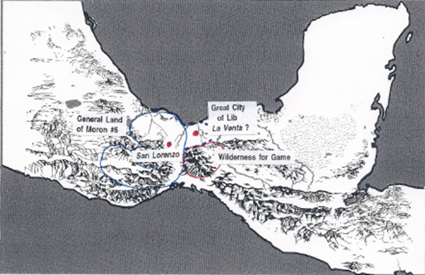

LAND OF MORON #5
[Capital = San Lorenzo?]

COROM reigns (10:16)
Corom begets Kish (10:17)
KISH reigns (10:17)
Kish begets Lib (10:17)
LIB reigns (10:17)
Poisonous serpents destroyed (10:19)
They build a “great city” [city of Lib ] by the narrow neck of land, by the place where the sea divides the land” (10:20)

[City of Lib = San Lorenzo or La Venta?]

“They did preserve the land southward for a wilderness, to get game. (10:21)
“The whole face of the land northward was covered with inhabitants” (10:21)
They were exceeding industrious” (10:22)
“They did. . . traffic with one another” for gain (10:22]
“They did work all manner of ore” . . . they did make gold, silver, iron, brass, copper all manner of metals” (10:23)
“They did have silks, and fine-twined linen; and they did work all manner of cloth” (10:24)
“all manner of weapons of war.” “all manner of work of exceedingly curious workmanship” (10:27)

Lib begets Hearthom (10:29)
HEARTHOM reigns (10:30)

Kingdom overthrown----------- (10:30) Hearthom lives in Captivity
Hearthom begets Heth (10:31)
Heth begets Aaron (10:31)
Aaron begets Amnigaddah (10:31)
Amnigaddah begets Coriantum (10:31)
Coriantum begets Com (10:31)

AMGID is king (10:32) [Question: Where does he have his throne?]

COM obtains 1\2 kingdom(?)
<----------------- Com defeats Amgid (10:32)

COM reigns over all (10:32) [Question: From where?]

_______________

Ether 10:17 And Kish Reigned in [Corom's] Stead:

Ether 10:17 says that "Kish reigned in [Corom's] stead." Although Kish is not specifically mentioned as Corom's son, there are some clues in the record that seem to imply as much Corom. First we find that Corom "begat many sons and daughters"; secondly, Corom did "pass away after he had seen many days"; and then thirdly, "Kish reigned in his stead." These actions follow the Jaredite kingship tradition of bestowing the royal powers upon the youngest son. In addition to these clues, the genealogy of Ether back to Jared, which is found in Ether 1:6-33, says that "Kish was the son of Corom" (Ether 1:19). [Alan C. Miner, Personal Notes]
Ether 10:17 Kish:

According to Hugh Nibley, to write a history of what could have happened at the very beginning of recorded history would have been as far beyond the scope of any scholar living in 1830 as the construction of an atom bomb would have been . . . Yet as we look at Jaredite names, it is not surprising that three of the oldest cities in the world, (one of them traditionally described as the first city in the world after the flood) all bear the good Jaredite name of "Kish" (see Ether 10:17). [Hugh Nibley, The World of the Jaredites, pp. 256, 258]

According to Verneil Simmons, "Kish" was the name of an ancient Sumerian city somewhat north of the city of Ur in southern Mesopotamia. [Verneil W. Simmons, Peoples, Places and Prophecies, p. 235]

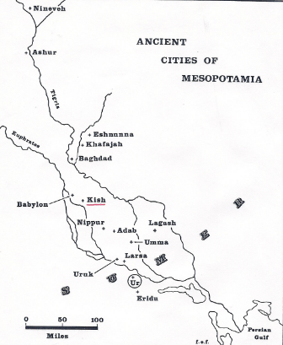
Ether 10:17 Kish (Illustration): Map #1, Ancient Cities of Mesopotamia. [Verneil W. Simmons, Peoples, Places and Prophecies, p. 22]

Ether 10:17 Kish:

The book of Ether account gives little information about King Kish other than his name. However, it is noteworthy that he was the son of a righteous king named Corom and the father of a righteous king named Lib (Ether 1:18-19; 10:17-19). Thus, King Kish was apparently one of the truly righteous Jaredite monarchs.

According to Bruce Warren, there might be evidence of this King Kish on ancient Mesoamerican glyphs. The word "qix" (pronounced "kish") means "feather," and is found in hieroglyphs at the Olmec archaeological site of Palenque in southern Mexico. There is a glyph at Palenque on the Tablet of the Cross which is associated with the calendar name Nine Wind of Quetzalcoatl. The name Quetzalcoatl means "feathered serpent" and is associated with the Mesoamerican white god. On the Tablet of the Cross are found engravings that trace the genealogy of a person named Kan Balam, the son of King Pacal who is buried in the great tomb there. Among the names of Kan Balam's royal ancestors is found what may be the full name of King Kish--U-Kish Kan. U-Kish Kan was apparently an ancient king of the Olmec culture. With this in mind, it is interesting that the name "Kan" means "serpent," and one of the meanings of "kish" is "feathered." Thus, the name of U-Kish Kan has been translated as "he of the feathered serpent." The name "he of the feathered serpent" also suggests a relationship to Quetzalcoatl, the feathered serpent god of Mesoamerica. The fact that the Jaredite king Kish was a righteous king also suggests that he had such a relationship.

According to the glyphs at Palenque, the Olmec king U-Kish Kan was born on Wednesday, 8 March 993 B.C., and took the throne on Wednesday, 25 March 967 B.C. U-Kish Kan was considered the ancient divine founder of the Palenque dynasty of kings even though he was not from Palenque originally. These dates thus represent a possible chronological correlation between the Olmec kings and the Jaredite kings.

As a further evidence of this U-Kish-Kan, there has been found in the archaeological site of San Lorenzo Tenochtitlan, located about 30 miles west of La Venta, in southern Mexico, an engraved stone known as Monument 47. It depicts a king who has a serpent around his waist and who is holding the head of the serpent in his hands. The serpent has feathers on its head. This monument is Olmec in style and dates to the beginning of the first millennium B.C. The monument's head is missing, but because of the dating and imagery of the monument, it could be a representation of U-Kish-Kan or "he of the feathered serpent." It is located in San Lorenzo Tenochtitlan in southern Mexico. This monument is also Olmec in style and dates to the beginning of the first millennium B.C. [Bruce W. Warren, Blaine M. Yorgason, Harold Brown, New Evidences of Christ in Mesoamerica, Unpublished Manuscript] [SEE a more thorough write-up by Bruce Warren on this subject in Joseph Lovell Allen & Blake Joseph Allen, Exploring the Lands of the Book of Mormon, Second Edition, 2008, pp. 132-133]

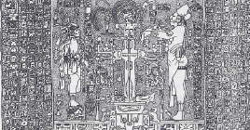
Ether 10:17 Kish [U-Kish-Kan] (Illustration): Tablet of the Cross from the Temple of the cross at Palenque, Chiapas about A.D. 692. This tablet gives much mythological and legendary ancestry for the Maya rulers Pacal and Chan-Bahlum who lived in the seventh century A.D. However, the earliest mythological ancestry dates back into the third millennium B.C. (Courtesy of Linda Schele.) [Bruce W. Warren and Thomas Stuart Ferguson, The Messiah in Ancient America, p. 88]

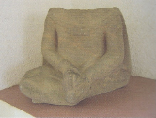
Ether 10:17 Kish (Illustration): This small monument, located at the archaeological site of San Lorenzo Tenochtitlan, Veracruz, shows the person’s hands placed on the head of a serpent with feathers protruding from its head, thus identifying his name as U-Kish Kan, who was born on March 8, 993 BC [and began his reign on March 25, 967 BC]. The monument’s head has been severed from the body. [Joseph Lovell Allen & Blake Joseph Allen, Exploring the Lands of the Book of Mormon, Second Edition, 2008, p. 132]

Ether 10:17 Kish (Jaredite Kingship Chronology):

Joseph Allen writes:

The Classic Period of the Olmecs, as determined by the number and quality of monuments, encompasses the time from 1200 BC to 600 BC. This dating is consistent with the Classic Period of the Jaredites as described in Ether 10. This six-hundred-year period appears to embrace the kingships of Shiz to Com and occupies only one and a half pages in the book oif Ether. By utilizing the date of the ascension to the throne of [the Olmec/Jaredite?] King Kish at the age of twenty-six on Wednesday, March 25, 967 BC, as determined by the dates on the Temple of the Cross at Palenque, we can approximate the dates of the thirteen other [Jaredite] kings mentioned in Ether 10. The reconstruction of the kingships in intervals of fifty years each is as shown below. By adding the last six Jaredite kings, plus Ether, a congtemporary of Corioantumr, with intervals of fifty years, we arrive at an ending date for the Jaredites of 250 BC, which is almost identical to the date given by Ixtlilxochitl for the destruction of the “giants.”

Shez 1250 BC
Riplakish 1200 BC
Morianton 1150 BC
Kim 1100 BC
Levi 1050 BC
Corom 1000 BC
KISH 967 BC
Lib 900 BC
Hearthom 850 BC
Heth 800 BC
Aaron 750 BC
Amnigaddah 700 BC
Coriantum 650 BC
Com 600 BC
Shiblom 550 BC
Seth 500 BC
Ahah 450 BC
Ethem 400 BC
Moron 350 BC
Coriantor 300 BC
Ether (Coriantumr) 250 BC

We may be inclined to say that if we have seen one [stone]Olmec head, we have seen them all. This, however, is not the case. Each sculpture is uniquely different. In [Olmec] times the amount of work required to carve out of basalt a detailed face and then to transport it down river from the Tuxtla Mountains to its resting place was probably an almost overwhelming task. The archaeologists’ examinations of the various monuments show that the monuments date to separate time periods, suggesting that the monuments represent a dynasty or a king lineage. [Joseph Lovell Allen & Blake Joseph Allen, Exploring the Lands of the Book of Mormon, Second Edition,2008, pp. 119-120]

Ether 10:18 Lib Reigned in [Kish's] Stead:

Ether 10:18 states that "Lib reigned in [Kish's] stead," but no specific genealogical linkage is mentioned. However, in the genealogy of Ether back to Jared, found in Ether 1:6-33, we are told that "Lib was the son of Kish" (Ether 1:18).

Ether 10:18 Lib Reigned in [Kish's] Stead (Location):

When King Kish passed away, his son Lib "reigned in his stead" (Ether 10:18). In the account of the days of Lib we find that his people,

were exceedingly industrious, and they did buy and sell and traffic one with another, that they might get gain. And they did work in all manner of ore, and they did make gold, and silver, and iron, and brass, and all manner of metals; and they did dig it out of the earth; wherefore they did cast up mighty heaps of earth to get ore . . . And they did work all manner of fine work. And they did have silks, and fine-twined linen; and they did work all manner of cloth . . . And they did make all manner of tools to till the earth, both to plow and to sow, to reap and to hoe, and also to thrash. And they did make all manner of tools with which they did work their beasts. And they did make all manner of weapons of war. And they did work all manner of work of exceedingly curious workmanship. And never could be a people more blessed than they . . . (Ether 10:22-28)

According to Warren and Palmer, the enormous leap in culture described for the time of Lib can be seen in the ruined city of San Lorenzo. Furthermore, both the timing and location are an excellent match. San Lorenzo was an impressive centre built up above the floodplain overlooking the Coatzocoalcos River.

San Lorenzo represents the first great center of the Olmec civilization of Mesoamerica. The prophet Ether gave a careful description of the culture that developed with Lib (San Lorenzo). According to Ether 10:23-28, the elements of culture were trade, metallurgy, mining, textiles and weaving, agriculture, domesticated animals, warfare, and a very unique art style.

The Olmec culture developed on the Gulf Coast of Mexico in about 1450 B.C. Their culture developed in San Lorenzo, and spread to other important sites such as La Venta, Laguna de los Cerros, and Tres Zapotes (see illustration). Other minor sites became involved. The Olmec culture eventually spread from the "heartland" to other sites throughout Mesoamerica and Mexico, where the traits are often called "Olmecoid."

Some seventy different languages are spoken today in the area known as Mesoamerica. Scholars have classified these languages, and determined relationships between them. Ultimately, they created language trees to show how the different branches developed from a few languages (Campbell, Lyle, and Marianne Mithun eds., 1979). The linguists then attempted to reconstruct the time at which the various branches separated. This has considerable impact on Book of Mormon studies since it augments and relates to the data developed by archaeologists (Joesink-Mandeville, 31). Applying these techniques, Campbell and Kaufman (41, 80, 1976) have concluded that the Mixe-Zoque language spoken today in the Isthmus of Tehuantepec region was once the language of the archaeological Olmecs. As we have just examined the strong resemblances of the Olmecs to the later Jaredites, this information is of no small importance. It allows a possible flashback to the vocabulary used when Lib first established his city. The time-depth of Mixe-Zoque has been calculated as 3500 years, or very roughly 1500 B.C. That is approximately the time when the Olmecs began their massive building program at San Lorenzo. [Bruce W. Warren and David A. Palmer, The Jaredite Saga, 8-1,2,3,4,5, unpublished]

Ether 10:18 Lib Reigned in [Kish's] Stead (Location - San Lorenzo) [Illustration-not shown]: Remains of an ancient reservoir at San Lorenzo Tenochtitlan, Veracruz] [F.A.R.M.S. Staff, "The Lands Of The Book Of Mormon, Slide #84]
Ether 10:19 In the Days of Lib the Poisonous Serpents Were Destroyed:

According to John Sorenson, serpent symbolism appeared in Olmec art very prominently. [John L. Sorenson, An Ancient American Setting for the Book of Mormon, p. 329]

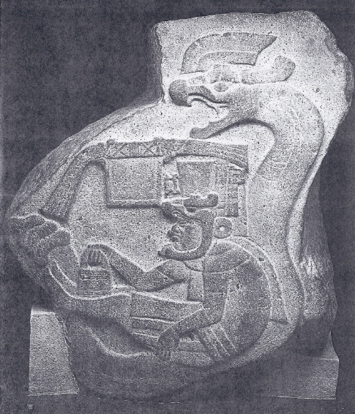
Ether 10:19 In the days of Lib the poisonous serpents were destroyed (Illustration): The Jaredites were deeply concerned about the power of snakes in connection with drought (see Ether 9:30-4; 10:19). Some priests or rulers may have considered themselves to be under the protection of serpents. This awesome Olmec rattlesnake is on Monument 19 at La Venta. [John L. Sorenson, Images of Ancient America, p. 215]

Ether 10:19 In the Days of Lib the Poisonous Serpents Were Destroyed:

According to Bruce Warren, one of the fascinating episodes in Jaredite history is the account of poisonous serpents being a threat to their survival. The account is as follows:

And it came to pass [in the days of King Heth] that there began to be a great dearth upon the land . . . for there was no rain upon the face of the earth. And there came forth poisonous serpents also upon the face of the land, and did poison many people. And it came to pass that their flocks began to flee before the poisonous serpents, towards the land southward, which was called by the Nephites Zarahemla . . . And it came to pass that the Lord did cause the serpents that they should pursue them no more, but that they should hedge up the way that the people could not pass, that whoso should attempt to pass might fall by the poisonous serpents. (Ether 9:30-33)

Seven kings later in Jaredite history, we are told that finally the plague of poisonous serpents was resolved:

And it came to pass that Lib also did that which was good in the sight of the Lord. And in the days of Lib the poisonous serpents were destroyed. . . . And they built a great city by the narrow neck of land, by the place where the sea divides the land. (Ether 10:18-20)

Do we have any archaeological evidence from Jaredite times of a focus on serpents? Warren considers such evidence from three archaeological sites in ancient Mesoamerica. These three sites are: 1. Palenque, Chiapas, Mexico; 2. San Lorenzo Tenochtitlan, Veracruz, Mexico; and 3. La Venta, Tabasco, Mexico.

First, hieroglyphic writing on the Tablet of the Cross at Palenque speaks of an ancestral king by the name of U-Kish Chan ("he of the feathered serpent") U-Kish Chan is considered the ancient founder of the Palenque dynasty of kings, even though he was [not] from Palenque.

Second, Monument 47 from San Lorenzo Tenochtitlan shows a king who has a serpent around his waist and is holding the head of the serpent in his hands. The serpent has feathers on its head. This monument is Olmec in style and dates to the beginning of the first millennium B.C. The monument has the head missing, but the imagery of the monument equals that of U-Kish Chan from the much-later Tablet of the Cross at Palenque. Could the San Lorenzo monument represent U-Kish-Chan?

Third, the layout of the central part of the archaeological site of La Venta represents a serpent focus: the large, volcanic-shaped mound representing the upturned head of a serpent, the ridges at the site of the serpent body, and the diamond-shaped tassels on two of the buried serpentine panels representing the body design on a variety of rattlesnakes, etc. The implication is that the serpent for the Olmecs and/or the Jaredites became a symbol for the fertile earth and that corn or maize grows from its back or from the earth.

A tentative hypothesis to explain the above information could be stated as follows: At least by the days of the Jaredite King Kish, a cult focused on the serpent was developing. His son, King Lib, built a city in the narrow neck of land at La Venta, Tabasco, that emphasized the serpent cult. Much later in time, the kings at Palenque, Chiapas, were claiming divine kingship from this ancestral king U-Kish Chan, who probably originally resided at San Lorenzo Tenochtitlan, Veracruz. The imagery, dating names, and locations all make sense. However, all hypotheses are designed to be tested, and so this hypothesis should be subjected to rigorous testing. [Bruce W. Warren, "Jaredites and Serpents," in Ancient America Foundation Newsletter, No. 13, May 1998, pp. 3-4]

Ether 10:19 And in the Days of Lib the Poisonous Serpents Were Destroyed:

Joseph Allen notes that on a recent Book of Mormon lands tour, it came to his attention that a green tile representation of a serpent's head which was discovered over thirty years ago at the Olmec site of La Venta may have a tie-in with a passage in the Book of Mormon: " . . . and in the days of Lib the poisonous serpents were destroyed" (Ether 10:19).

For years he has taken groups to Villahermosa, Tabasco, Mexico to witness the outstanding artifacts and monuments that are on display at the marvelous outdoor museum there. These large stone remnants of the Olmec/Jaredite culture feature two large (20 x 30 feet) mosaic serpent displays which have been transplanted from the archaeological site of La Venta 75 miles to the west by the Gulf of Mexico. These mosaics were buried 20 feet below the surface.
The traditional archaeological interpretation of these mosaics has been that they are representations of jaguar heads and that they had something to do with a religious ceremony. Recent evidence, however, indicates that instead of representing jaguar heads, they really represent serpent heads. Add to this the discovery by Dr. Bruce Warren of the name of the Jaredite king Kish as "U-Kish-Chan" (which is associated with a feathered serpent concept), and we might begin to understand why the ancient Olmecs may have buried a serpent's head.

Much like the people of Anti-Nephi-Lehi who buried their weapons of war and at the same time buried their sins deep in the earth (see Alma 24:10-18), the people at the time of King Lib may have symbolically buried a serpent to represent the burial of some sin. As we read the preceding chapter of Ether 9, we consider the possibility of a dual meaning in the account of the poisonous serpents. Secret combinations had gained control of the hearts of the people (Ether 9:26). Thus, King Lib may not only have destroyed the poisonous serpents, but the "old serpent" and his secret combinations as well, for Lib "did that which was good in the sight of the Lord" (Ether 10:19) .

How better could this object lesson have been taught than by having the people literally cover the head of a mosaic serpent with dirt as a sign not just that they were grateful for the destruction of the temporal serpents, but also as a covenant sign that they had destroyed the secret combinations or spiritual serpents, and that they would bury these sins and be faithful to their covenants with the Lord. [Joseph L. Allen, "Poisonous Serpents Uncovered," in The Book of Mormon Archaeological Digest, Vol. I, Issue IV, 1998, p. 6]

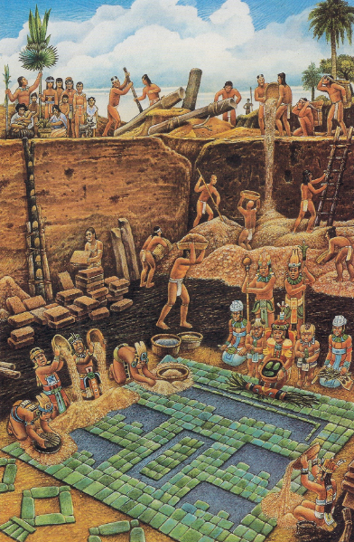
Ether 10:19 And in the days of Lib the poisonous serpents were destroyed (Illustration): Buried Creations. In mysterious rituals the Olmec at La Venta created stone masterworks and immediately concealed them. About 2,600 years ago workers dug a pit 23 feet deep in a courtyard, spread a base of sticky tar from petroleum seeps, and laid out blue-green serpentine blocks. They bordered the image with yellow clay, tamped blue clay in central openings, then covered it all with layers of colored clay. In 1943 archaeologist Matthew Stirling and his crew dug for two months to remove tons of rubble. What was the impressive mosaic they uncovered, now preserved with other La Venta artifacts in a Villahermosa park? Was it so sacred that it had to be concealed? If a notch on one side is the forehead cleft typical of Olmec deities, the image may represent a jaguar mask. But if the notch belongs at the bottom, as Kent Reilly of Southwest Texas State University believes, the central column could symbolize the sacred tree of life. (George E. Stuart, "New Light on the Olmec," in National Geographic , Vol. 184, No. 5 (November 1993), pp. 106-107. Painting by Felipe Davalos. Photograph by Kenneth Garrett.) [See also John L. Sorenson, Images of Ancient America: Visualizing Book of Mormon Life, p. 143]

Ether 10:19 They Did Go into the Land Southward to Hunt Food for the People of the Land:

According to Hugh Nibley, in the tenth chapter of Ether we read how great hunting expeditions were undertaken in the days of King Lib into the rich game country of the south "to hunt food for the people of the land" (Ether 10:19). Westerners are prone to think of hunting as a very individualistic activity . . . but that is not the way the ancient Asiatics hunted. According to Odoric and William, the Mongols always hunted in great battues, thousands of soldiers driving the game towards the center of a great ring where the king and his court would take their pick of the animals . . . In these great hunts the king was always the leader, as among the Jaredites: "And Lib also himself became a great hunter" (Ether 10:19). "Kings must be hunters," and every royal court must have its hunting preserve in imitation of the early rulers of Asia who invariably set aside vast tracts of land as animal refuges where habitation was forbidden. Here the Book of Mormon confronts us with a truly astounding scoop: "And they did preserve the land southward for a wilderness, to get game. And the whole face of the land northward was covered with inhabitants (Ether 10:21). The picture of the old Asiatic hunting economy is complete in all its essentials, and correct on all points. [Hugh Nibley, The World of the Jaredites, p. 222]

Ether 10:19 They Did Go into the Land Southward to Hunt Food for the People of the Land:

We find in Ether 10:19 that the Jaredites "did go into the land southward to hunt food for the people of the land." Thus the Jaredites seem to have been living in the land "northward." However, the verses here could yield some clues to the Book of Mormon geographical picture. The reader should note that Ether 10:19 tells of the final destruction of poisonous serpents. In the very next verse, we have a "narrow neck of land" mentioned. We can thus assume that the text is not only speaking of the same serpents mentioned in the ninth chapter of the book of Ether, which serpents were able to "hedge up the way" (Ether 9:33), but that the reason they were able to do so was because of this "narrow neck of land." The Jaredite record states that before the serpents were able to "hedge up the way," there was a great drought, and:

there came forth poisonous serpents also upon the face of the land, and did poison many people. And it came to pass that their flocks began to flee before the poisonous serpents, towards the land southward, which was called by the Nephites Zarahemla. And it came to pass that there were many of them which did perish by the way; nevertheless, there were some which fled into the land southward." (Ether 9:31-32)

Now, in Ether 10:21 we find that the people of Lib "did preserve the land southward for a wilderness." All this information leads us to make some comparisons with the geographical information cited by Mormon in Alma 22:31:

And they came from there [the land of Desolation] up into the south wilderness. Thus the land on the northward was called Desolation, and the land on the southward was called Bountiful, it being the wilderness which is filled with all manner of wild animals of every kind, a part of which had come from the land northward for food.

Mormon also goes on to say that there was "a small neck of land between the land northward and the land southward" (Alma 22:32). Thus there seems to be a geographical correlation here. [Alan C. Miner, Personal Notes] [See Geographical Theory Maps] [See the commentary on Alma 22:31-32; Ether 9:33; 10:21]

Ether 10:19 They Did Go into the Land Southward:
According to Brant Gardner, Zoquean speakers (“Olmec” ?) moved into the Grijalva Valley (proposed land of Zarahemla). Zoque was spoken in the Grijalva Valley and particularly at Chiapa de Corzo.(n.14) The Escalera phase, an identified development period at Chiapa de Corzo begins approximately 500 B.C. and “apparently witnessed the introduction of large platform structures,” according to archaeologist Gareth W. Lowe.(n.15) An earlier population had lived at this site; however, the introduction of large platforms suggests new influences.

Linguist Lyle Campbell indicates that, by 500 B.C., common Zoquean was a separate language from the Mixe-Zoque language that is attributed to the Olmec.(n.16) . . . This development is significant for understanding the cultural connections of the Jaredites and the Mulekites, who appear in Jaredite lands (somewhere on the Gulf Coast) at approximately this period. As I interpret the record, the Mulekites absorbed jaredite/Olmec culture and language, then moved up the Grijalva Valley to found Zarahemla . . . The Mulekite move to Zarahemla was simply part of a larger [Jaredite] population expansion southward. [Brant A. Gardner, Second Witness, Vol. 6: Fourth Nephi through Moroni, pp. 276-277]

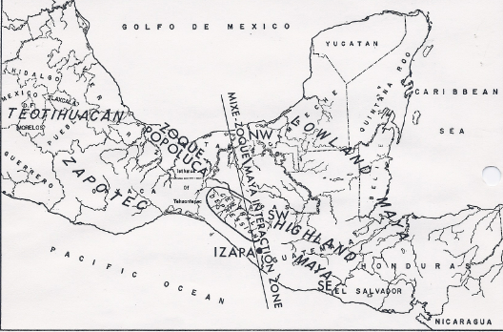
Ether 10:19 They did go into the land southward (Illustration ): The Mixe-Zoque / Masya InteractionZone – Map showing distribution of major culture areas in Mesoamerica as related to Izapa and a highly idealized zone of Mixe-Zoque/Maya interaction; in Preclassic times the zone of interaction may have curved closer to the Usumacinta River (to the right) and its tributaries. [Gareth W. Lowe, Thomas Lee, Jr., and Eduardo Martinez, Izapa: An Introduction t o the Ruins and Monuments, p. 306]

Ether 10:20 They Built a Great City By the Narrow Neck of Land:

The Jaredite settlements were just north of the narrow neck of land. The Jaredites lived in a land later called Desolation, not because the land was completely barren but because the people suffered a desolating annihilation there (Hel 3:6). And the land of Desolation was defined as the land just north of the narrow neck, Thus the land on the northward was called Desolation…and now, it was only the distance of a day and a half’s journey for a Nephite, on the line Bountiful and the land Desolation (Alma 22:31-32, see also Alma 63:5).
[josephsmith.com . . . Ether ]

Ether 10:20 They Built a Great City by the Narrow Neck of Land, by the Place Where the Sea Divides the Land:

In the days of Lib the people "built a great city by the narrow neck of land, by the place where the sea divides the land" (Ether 10:20). If the term "narrow neck of land" can be equated with "the small neck of land" found in Alma 22:32, where "the small neck of land" was "between the land northward and the land southward" such that "the land of Nephi and the land of Zarahemla [which were part of the land southward] were nearly surrounded by water" (Alma 22:32); then this gives possible meaning to the words "by the place where the sea divides the land" (Ether 10:20).

The Book of Mormon geography student might take caution in the fact that this "great city" was described as being built BY the narrow neck of land and not IN it, and BY the place where the sea divides the land and not AT it. One should also take caution in the fact that the terms "the narrow neck of land" and the "small neck of land" are never specifically termed an "isthmus." Additionally, we can't be certain that the terms were ever capitalized. If they were only uncapitalized descriptive phrases, it is hard to know whether the two terms positively describe the same area.

In our geographical studies of the Book of Mormon, we encounter the terms "small neck of land" (Alma 22:32), "narrow pass" (Alma 50:34, 52:9), "narrow neck" (Alma 63:5, Ether 10:20), and "narrow passage" (Mormon 2:29). Are the terms synonymous or different? Do these terms refer to the same geographical landmark? Let us examine them:

(A) Small neck of land: "And now, it was only the distance of a day and a half's journey for a Nephite, on the line Bountiful and the land Desolation, from the east to the west sea; and thus the land of Nephi and the land of Zarahemla were nearly surrounded by water, there being a small neck of land between the land northward and the land southward." (Alma 22:32)
(B) Narrow pass: "The narrow pass which led by the sea into the land northward, yea, by the sea, on the west and on the east" (Alma 30:34). "The narrow pass which led into the land northward" (Alma 52:9).
(C) Narrow neck: "The narrow neck which led into the land northward" (Alma 63:5).
(D) Narrow passage: "the narrow passage which led into the land southward" (Mormon 2:29).

Three of the terms (B,C,D) imply a geographical entity which leads between a land southward and a land northward, while the fourth (A) is described as being located "between" a land northward and a land southward. Thus we might say: B = C = D or at least they are similar. We can also say that A is similar to B, and A is similar to C, and A is similar to D, or perhaps they might all be equal.

The small neck of land (A) was bordered on at least on one side and maybe two sides by a sea. The narrow pass (B) also "led by the sea . . . on the west and on the east" which implies that a sea (the west sea) bordered it on the west, and a sea (east sea) bordered it on the east. Thus we might say: A is similar to B, or perhaps A = B.

We have three equations: A is similar to B (maybe equal), B = C = D (maybe similar); and A is similar to B (maybe equal). Therefore, do we conclude A = B = C = D (one small-narrow-pass-passage), or do we separate these four descriptive terms into two entities (1. a small-narrow neck of land; and 2. a narrow pass-passage), or do we keep them as four separate entities? I would think that the answer to this question has a lot to do with our theoretical model.
The logic of the scriptures quoted above could lead to a number of things: (1) Logic could consolidate all of the terms into one isthmus; (2) Logic could make two entities, a small/narrow neck of land and a narrow pass/passage; (3) Logic could make a narrow corridor (1-1.5 day's journey in width) running westward along the west coast of Zarahemla, then have it move northward between the land northward and the land southward through a much broader and longer isthmus, and then have it run northward and parallel to a northeastern coast. If this corridor was referred to both as a "narrow passage" and a "narrow neck," then my narrow neck (passage) would not be an isthmus, it would be a travel corridor through an isthmus. It would also be a consolidation of terms; or (4) Logic could make 4 or more separate geographical entities. Thus we see that the interpretation of the terms "small neck," narrow neck," "narrow passage," and "narrow pass," is not a simple task.

Assuming a Mesoamerican setting, much has been in the way of interpretation concerning this “narrow neck of land.” By referring to the Mesoamerican map, we see that for those travelers trying to go along the Pacific coastal plain of Guatemala northward towards Mexico City, there is a rugged set of mountains that block travel along the Pacific coast of Mexico. Indeed, from ancient Jaredite (Olmec) times until the present, it seems that most all traffic going northward from the Pacific coast of Guatemala, when confronted with these rugged mountains, move s north instead through the Isthmus of Tehuantepec on relatively flat ground and thus moves toward the Atlantic coast and the Veracruz area before turning to climb up to Mexico City in its ultimate course northward. Now this "small neck" or “narrow passage” which separated (or connected) the total "land northward" from the total "land southward" and “a day and a half's journey” across be a description of the width of the travel corridor from the Pacific Coast through the Isthmus of Tehuantepec to the Atlantic coast ? This concept of a travel corridor will be emphasized even further when we see charts of Olmec trade routes –see the commentary on Ether 10:22. [Alan C. Miner, Personal Notes]

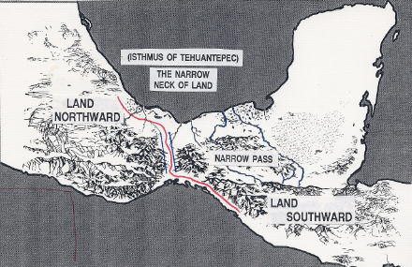
Ether 10:20 A narrow neck of land (Illustration) Route of the “Kings Highway” [Alan Miner]
Ether 10:20 They Built a Great City . . . by the Place Where the Sea Divides the Land:

A "great city" was built by Lib midway through the historical account of the Jaredites, and it was located "by the place where the sea divides the land" (Ether 10:20). According to Warren, this city was La Venta, in the state of Tabasco, Mexico. The Tonala River forms the boundary between the states of Veracruz and Tabasco very near the Isthmus of Tehuantepec through which the ancient travel corridor called "the Kings Highway" conveyed most of the traffic from the lands southward to the lands northward. As the Tonala river approaches the Gulf of Mexico, there is a region of swamps interspersed with dry land. About ten miles from the coast, the ancient city now called La Venta was built. It occupied a total surface area of about two square miles, but it had a great amount of water surrounding it (Drucker and Heizer, 1960:36).

Sisson has shown that during Olmec times the river courses were different than today. In fact, much larger volumes of water were carried to the coast from the Grijalva river which at that time had a much different course. This led to substantial economic advantages. La Venta was located at the hub of the principal communication routes. hese were east-west and north-south, within the labyrinth of rivers and navigable coastal lagoons of Tabasco. La Venta must have begun as a store for San Lorenzo. With the decline of San Lorenzo, La Venta converted itself into an important center of its own right. From its strategic position, its inhabitants could exercise control over the travels of both merchants and ideas. This control must have accentuated the social differences already existing, and led to the accumulation of unequal amounts of riches and power (Sisson, 1983)

The most dominant feature on the site is the large central pyramid. It has a series of ten ridges which proceed up to the top. The diameter is 420 feet, and its height is 103 feet. From the top it is possible to see almost over to the seacoast. Now cleared off, the pyramid looks like a volcano. Nothing like it has ever been discovered anywhere in the world. In fact, it looks similar to dozens of volcanic cinder cones in the Tuxtla mountains. Even more interesting is the fact that most of the basalt for the enormous stone heads, burial chambers, thrones, and other monuments at La Venta was quarried from the slopes of the pliocene volcano, Cerro Cintepec (Corn Hill) in the Tuxtlas. The excavators of La Venta, Heizer and Drucker speculated as follows:

We suggest, purely as a hypothesis, that the La Venta Pyramid was an artifact made in imitation of a Tuxtla cinder cone, and that it was erected at this major ritual centre in order to serve as a surrogate for a familiar and ritually important form (Heizer and Drucker, 1968:52-56).

[Bruce W. Warren and David A. Palmer, The Jaredite Saga, pp. 8-27--8-29, unpublished]

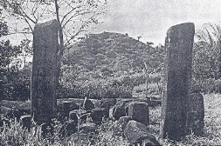
Ether 10:20 They built a great city . . . by the place where the sea divides the land (Illustration): The ruins of La Venta, thought to be the city of Mulek. [Central Pyramid at La Venta, constructed one millennium before Christ by the Olmecs. It is over thirty meters high and gives a commanding view of the countryside. It is shaped like one of the volcanoes in the Tuxtla Mountains. Basalt columns in the foreground were hewn anciently and transported perhaps a hundred kilometers to La Venta] (Photo by Daniel Bates. Courtesy David A. Palmer and the Society for Early Historic Archaeology] [JohnL. Sorenson, An Ancient American Setting for the Book of Mormon, p. 215]

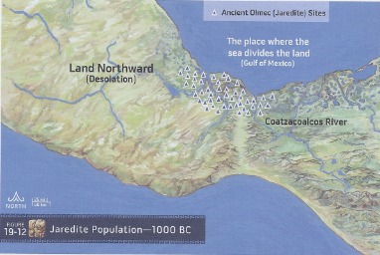
Ether 10:20 The place where the sea divides the land (Illustration): This map illustrates the Allen’s perspective that the Gulf of Mexico is representative of where “the sea divides the land.” Note* The label “Coatzacoalcos River” on this map is shown on top of the Grijalva River, while the Coatzacoalcos River that runs through the Isthmus of Tehuantepec into the Gulf of Mexico doesn’t show up very well. [ Joseph Lovell Allen & Blake Joseph Allen, Exploring the Lands of the Book of Mormon, Second Edition, p. 463

Ether 10:20 The Place Where the Sea Divides the Land:
Ted Stoddard and Lawrence Poulsen write the following:
Most Book of Mormon scholars maintain that the Isthmus of Tehuantepec is the geographic feature that divided the land northward from the land southward. In that respect, we make no distinction between the “narrow neck which led into the land northward” (Alma 63:5) and the “
isthmus, such as that in Merriam-Webster’s Collegiate Dictionary, 11th edition, “a narrow strip of land connecting two larger land areas,”3aptly describe the role of the Isthmus of Tehuantepec in connection with the Book of Mormon’s land northward and land southward. Further, as explained below, we propose that the words in Ether 10:20, "the small neck of land between the land northward and the land southward” (Alma 22:32). From our perspective, “narrow neck” and “small neck” are synonymous terms.
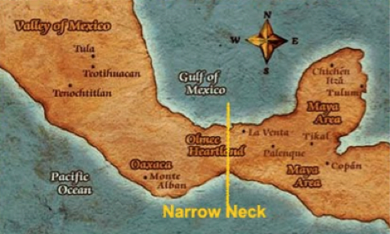
Location of the narrow neck of land nephicode.blogspot.com

Ether 10:20 contains three geographic pointers to which Moroni seems to expect us to relate: (1) “a great city,” (2) “the narrow neck of land,” and (3) “the place where the sea divides the land.” Verses 19 and 21 also bring into the picture the geographic pointers of the land southward and the land northward, but Book of Mormon readers often do not seem to understand the relevance of those verses in connection with the content of verse 20
We propose that “the land” Moroni is talking about here is the land northward and the land southward. “The place where the sea divides the land,” therefore, is the boundary line between the land northward and the land southward. Whatever “the place” is from a geographic perspective, it must be capable of functioning as the boundary line between the land northward and the land southward.
During the wicked reign of Heth ten generations before Lib, the people experienced “a great dearth . . . for there was no rain upon the face of the earth.” As a consequence of the famine, poisonous serpents “came forth . . . upon the face of the land,” and the people’s flocks fled before the serpents “towards the land southward,” . . . (see Ether 9:26–35).
Subsequently, as explained in Ether 10:19, eight generations after Heth, during the reign of Lib, the poisonous serpents that previously had kept the Jaredites out of the land southward, at “the place where the sea divides the land,” were destroyed. At this point in time, that outcome permitted the Jaredites to go into the land southward to hunt the “animals of the forest” for food.
We propose that a distinctive geographic feature located in close proximity to the land southward functioned as a unique habitat for the poisonous serpents with the result that the Jaredites could not use this route into the land southward for the generations between Heth and Lib.
During and following the reign of King Lib, the Jaredites preserved the land southward for a wilderness in which they could hunt wild game for food (see Ether 10:21). Book of Mormon scholars often tend to associate that wilderness with the wilderness “which was west and north, away beyond the borders of the land [of Zarahemla]” (Alma 2:36). That wilderness was known to the Nephites as Hermounts (Alma 2:37). Part of that wilderness during the first century BC, according to Mormon, “was infested by wild and ravenous beasts” (Alma 2:37).
We propose that today that wilderness area is known as the wilderness of Tehuantepec. More specifically, Tehuantepec consists of the wilderness of Uxpanapa on the north and the wilderness of Chimalapa on the south. Until the construction of the dams along the Grijalva River when the government moved a few people into very small sections of this territory, it had never been inhabited by humans throughout the history of the New World. Today, we can still say that this wilderness territory is, essentially, uninhabited except by animals of the forest.
We propose that at least some of the territory of the wilderness area “preserved” by the Jaredites under King Lib can today be referred to as “the wilderness of Hermounts.”

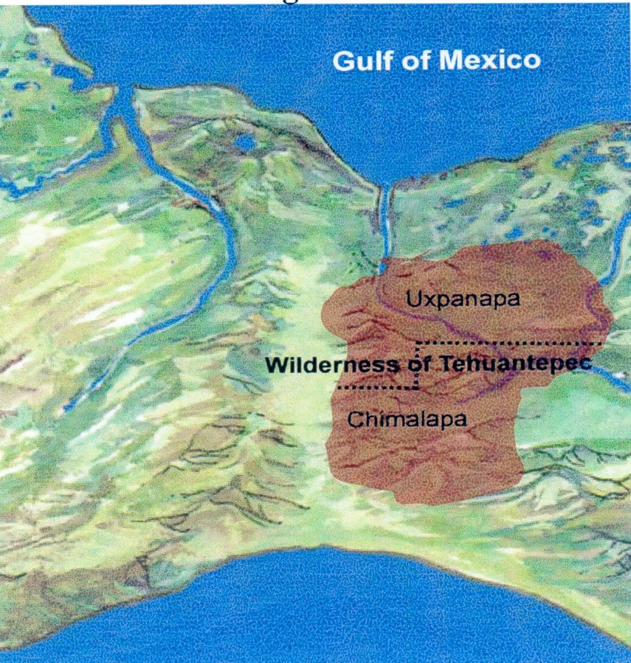
Small neck of land running from the Pacific coast on the south up through the Isthmus of Tehuantepec northward to the Gulf of Mexico. The Wilderness of Tehuantepec is highlighted.

To understand the task that Olmec/Jaredite travelers faced in moving between the land northward and the land southward, or vice versa, we must understand the Mesoamerican territory associated with the Isthmus of Tehuantepec.
In going from the land southward to the land northward, ancient travelers typically found themselves at the southern base of the Isthmus of Tehuantepec. At that point, they proceeded due north, traveling initially along a trail that ran between the mountains of Oaxaca on the west and the mountains of Chiapas on the east. At one point, travelers felt like they could almost reach out and touch the mountains on the west and on the east, as the distance between the two mountain ranges is only about five miles—reflecting the concept of a “mountain pass.” The mountainous country of the trail continues until nearly the halfway point through the isthmus. Near that point, travelers crossed a tributary of the Coatzacoalcos River, and soon the country opens up into relatively flat country on the west and riverine country associated with the Coatzacoalcos River on the east. Travelers could then readily continue north or eventually go west or northwest as trails opened up in those directions. Going east was much more difficult than going west, as the eastern terrain associated with the Coatzacoalcos River basin [the mouth of the Grijalva River and the mouth of the Usumacinta River] made travel difficult from that point to the coast of the Gulf of Mexico, especially during the windy season and the rainy season
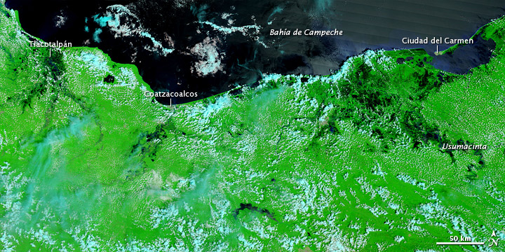
Map showing the darkened areas of the Coatzcoalcos river basin and the eastward river basins of the Grijalva River and the Usumacinta River. As one travels south from the plains between the Coatzacoalcos and the Usuamacinta River basins, mountains are encountered.

Ancient travelers could move between the land northward and the land southward at points along the northern half of the Isthmus of Tehuantepec. However, as noted previously, such eastward travel was extremely difficult because of the riverine system of the Coatzacoalcos River basin. In fact, as we read in the Book of Mormon, this route was probably seldom used by the Jaredites until the reign of King Lib when the poisonous serpents were eradicated. Crossing the Coatzacoalcos typically required the use of canoes that faced extreme obstacles when the Coatzacoalcos was impacted with conditions associated with the windy season and the rainy season—about nine months out of the year.
We propose that if the Olmecs are indeed the Book of Mormon Jaredites and if the Isthmus of Tehuantepec is the Book of Mormon’s narrow neck of land, we have a good chance of identifying the geographic feature alluded to in the Ether 10:20 reference as “the place where the sea divides the land.”
Let’s assume we are either looking at a map of the Olmec/Jaredite heartland associated with the Isthmus of Tehuantepec/narrow neck of land or standing on the ground at a geographic point in the Olmec/Jaredite heartland by or in the isthmus/narrow neck of land. What geographic feature stands out in that position of the heartland on the northern half of the isthmus?

The only geographic feature that stands out is the Coatzacoalcos River and its riverine basin. And when we understand the nature of the Coatzacoalcos River basin, we will understand how the Coatzacoalcos, both physically and geographically, truly divides the land southward from the land northward in the northern half of the isthmus/narrow neck of land and thereby functions as the border line between the land northward and the land southward.

In that respect, at one point in the nineteenth century, the United States seriously explored the possibility of constructing a canal, with locks, to join the Gulf of Mexico with the Pacific Ocean. One appealing feature of the proposal was the availability of the Coatzacoalcos River as a navigable waterway for many miles inward from the Gulf of Mexico.

According to the engineering study for this proposed canal, the “Atlantic plains” of the Coatzacoalcos River extend from the Gulf of Mexico to the base of the Cordilleras and comprise a “breadth of country of about fifty miles” and a distance of about seventy miles. Thus, the Coatzacoalcos is not merely a river but also involves an extensive riverine basin. The engineering study about the potential canal contains the following information:

This portion of the Isthmus consists of several rich and extensive alluvial basins, which are traversed by . . . many rivers, of which the Coatzacoalcos, which drains the northern slope of the Cordilleras, is the principal, and occupies the central portion of the Isthmus.
This water flows through a non-mountainous district of alluvial soil, and drains miles of flat, low, marshy country for a distance of nearly 70 miles before it reaches the Gulf.
The country along the Coatzacoalcos . . . is an extensive plain, covered with thick forests and dense wild grasses, intersected by numerous tributaries of the river, and for the greater part of the year is nothing more than a vast marsh.
The Coatzacoalcos . . . is subject to annual overflow, by which these extensive alluvial fields and woodlands are completely inundated, and remain, after the subsidence of the waters, a month or more. . . .
The northerly winds prevail from December to the end of March, and frequently last for several days, bellowing with great violence, and changing the temperature . . . from 80 degrees to 68 or 70 degrees within a few hours. . . .
The rainy season begins in July and ends in November, although there is more or less rain throughout the greater portion of the year. It is during this season that the annual inundation takes place, and for a month or more the country is flooded so that it is possible to pass in boats from one river to another. . . .
The country is thickly wooded, and covered with tall, dense grasses and shrubs, which prevent the sun’s rays from reaching the ground.16

At this point, we invite you to look at any map, ancient or modern, that shows the northern half of the Isthmus of Tehuantepec (in the heartland of Olmec/Jaredite territory) to observe how the Coatzacoalcos River and its associated basin territory as described above—fifty miles wide and seventy miles long—indeed “divides” the land on the east and west of the northern half of the Isthmus of Tehuantepec—especially during the windy season and the rainy season, which together involve about nine months of the year. In the process, we invite you to place yourself “on the ground” between 1800 and 1200 BC to anticipate the difficulties you would have of moving from the west to the east—or from the land northward to the land southward or vice versa—especially at certain times of the year. Truly, the land is divided by the Coatzacoalcos River basin. When applied to the land northward and the land southward, “divided” here is synonymous with “forms a boundary line” that separates the land northward from the land southward.

A natural issue to raise here is to point out that Ether 10:19–21 refers to “the place where the sea divides the land” as the dividing line between the land northward and the land southward—not “the place where the river divides the land.” Understanding the riverine water conditions of the Coatzacoalcos River basin during most of the year helps us understand what Moroni is telling us.

That is, as Richard Diehl points out in speaking of the Coatzacoalcos territory, “The river’s width varies tremendously over the course of the annual rainy season/dry season cycle.” Further, “Most precipitation falls between May and November, the traditional wet months of Mesoamerica’s lowlands, but nortes, storms that blow in from the Gulf during the ‘dry season,’ are so common that March and April are the only truly dry months of the year.”17

Thus, the potential “dividing-the-land” role of the Coatzacoalcos territory as “the place where the sea divides the land” is reflected in Diehl’s further description of the Coatzacoalcos basin territory:

The Coatzacoalcos and Tonala basins are complex mosaics of large streams, tributaries, natural levees, swamps, upland ridges, and plateaus. Today, as in the past, seasonal changes in river levels dominate life in the region. Summer rains swell their currents until they spill over their banks and inundate the surrounding countryside. By September the cattle pastures of May are vast lakes better suited to fishing than ranching. By November, the rivers return to their established courses as the floodwaters recede. Water levels continue to drop until the next rainy season, when the cycle begins once again.

Rivers, streams, and lagoons influence every aspect of life in the region. Until highways and bridges were constructed in the 1980s, riverboats and dugout canoes were the main means of transport in much of the region. . . .

[The Olmecs’] tropical lowlands are a very dynamic environment, constantly changing in response to natural and human induced causes. Deeply buried salt domes thrust the earth’s surface upward, rising sea levels flood coastal margins, rivers change their courses, and humans clear the jungle for farmland. These processes affect modern inhabitants as much as they affected their Olmec predecessors.18

Today, via modern roads and bridges, travelers can readily cross some of the Coatzacoalcos territory, mostly on the northerly side of the isthmus. Try to imagine, however, the problems faced by Olmec/Jaredite travelers as they encountered the mighty Coatzacoalcos and its attendant water-dominated riverine basin environment and then faced the task of crossing either from east to west or from west to east, especially during some months of the year. And when the winds and hurricanes and tides at the mouth of the Coatzacoalcos are considered in conjunction with the massive amounts of water from the rainy season, ancient Olmecs/Jaredites could easily have thought of the Coatzacoalcos basin as a “sea.” But ancient Book of Mormon Nephites would have had no issue with the outcome that the geographic feature reflected in the Coatzacoalcos River basin divided the land northward from the land southward and thus functioned as the boundary line between the land northward and the land southward on the northern half of the Isthmus of Tehuantepec/narrow neck of land.

When we understand the geologic and geographic circumstances associated with the Coatzacoalcos River basin, we will appreciate the fact that the Coatzacoalcos is more than a mere river. That is, the entire Coatzacoalcos riverine basin very aptly can be looked at as a geographic feature that “divided the land” on the west and the east of the northern section of the Isthmus of Tehuantepec and thus formed the boundary line between the land northward and the land southward in the northern half of the isthmus/narrow neck of land. And if we were to draw a map of the territory to reflect the Coatzacoalcos basin during much of the rainy season, the basin on that map would look like an inland sea. Christopher Pool’s description of the lower Coatzacoalcos River basin drives home that point:

The earliest major center of Olmec culture, San Lorenzo, lies at the upper end of the lower Coatzacoalcos River basin, about 60 km south of the river’s mouth. A short distance upstream from San Lorenzo, a geological fault at Pena Blanca separates dissected upland hills and mesas from the deltaic lowlands to the north. The change in river gradient here causes the river to slow, dropping its load of mud and sand and splitting into distributary channels that reunite farther downriver. Sandy sediments build up into natural levees along the river banks, whereas fine-grained muds deposited away from the channel compact and subside, producing low, seasonally flooded marshes and permanent swamps. The meandering river channels migrate laterally as they cut away at the outer side of the bends and deposit sand bars on the inner side. The traces of this action can be seen in the meander scars of the lowlands, sloughs separated by slightly higher ribbons of ancient levees. As the river cuts away the banks, the bends slowly approach one another, and eventually the river breaks through, forming oxbow lakes. On occasion the river will cut a new channel, abandoning the old course. The abandoned course slowly fills with sediments, creating long, sinuous sloughs, or esteros, which wander across the flood plain. Over the course of time, the lateral erosion of the river has isolated low islands and flat-topped mesas composed of ancient Tertiary and Pleistocene sediments. These plateaus and the salt domes emerging from the swamps provided important areas of high land for settlements, including San Lorenzo itself.

The rhythm of the river dominates life along the Coatzacoalcos. During the rainy season, from June to October, the river overflows its banks and floods the low plains, or potreros. As the waters rise, the levees become a string of low islands before they disappear below the flood. In normal years, the floods rise to the level of the 24 m contour, about 6.4 m above the river’s dry season level, and the potreros remain flooded until November. At these times, humans and land animals retreat to higher land, and boats provide the main means of transportation. Exceptional floods, occurring about once in 50 years, create a vast sheet of water broken only by the mesas and salt domes. These greater floods define the edge of the high flood plain, a narrow band of flat land between the low floodplains and the uplands.19

Ann Cyphers and Fernando Botas explain that the Coatzacoalcos River flows to the north except when it floods and the tidal flood impacts the river: “Today a web of seasonal streams and lagoons, or estuaries, crisscross the southern floodplain. . . . During the rainy season this drainage . . . exhibits a northward current . . . except when the mighty Coatzacoalcos River floods and the tidal flood enters the system forcing the current to flow with a southward direction.”20

Thus, when we understand the flooding and the tremendous volume of water that occur in the Coatzacoalcos River basin during much of the year, we can see why Moroni spoke of this geographic feature as “the place where the sea divides the land.”

At this point, we should perhaps pause and ask ourselves why Moroni inserted the content of Ether 10:20 into his abridgment of the Book of Ether. Why did he feel the need to add his clarification comments about the Jaredites’ decision to build a great city by the narrow neck? In fact, “the narrow neck of land” and “the place where the sea divides the land” are Nephite rather than Jaredite geographic pointers—but there they are in the middle of the Jaredite record. In addition, from the Nephite perspective, Moroni clearly understood the nature of “the place where the sea divides the land” because that specific geographic feature was the dividing line between the two territories that the Nephites referred to as the “land southward” and the “land northward.” In essence, Moroni seems to be merging historical facts of the Nephites with those of the Jaredites.

[Ted Dee Stoddard and Lawrence L. Pousen, “Analyzing ‘The Place Where the Sea Divides the Land’ and the ‘Great City’ of the Jaredites,” Book of Mormon Archaeological Forum]

Ether 10:20 A Great City:
Ted Stoddard and Lawrence Poulsen write the following:
Ether 10:20 contains three geographic pointers to which Moroni seems to expect us to relate: (1) “a great city,” (2) “the narrow neck of land,” and (3) “the place where the sea divides the land.” If our proposal for “the place where the sea divides the land” on the northern half of the Isthmus of Tehuantepec/narrow neck of land is indeed valid, we see options for the “great city” that is “by the narrow neck of land.”
That is, if the Coatzacoalcos River basin is the boundary line between the land northward and the land southward, we should then expect to find the remains of the “great city” mentioned in Ether 10:20—“by the narrow neck of land, by the place where the sea divides the land”—somewhere nearby. We hypothesize, therefore, that the “great city” mentioned by Moroni is San Lorenzo Tenochtitlan.21

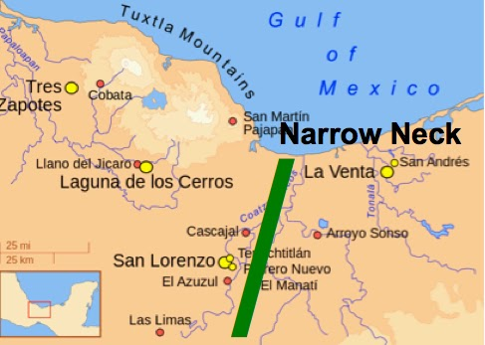

San Lorenzo Tenochtitlan, so named by Matthew Stirling, involves a cluster of three settlements on an island in the swamps and marshes west of and near the Coatzacoalcos River and south of the Chiquito River, which is a branch of the Coatzacoalcos. In fact, San Lorenzo was probably located where it is because of the Coatzacoalcos. As Pool says, “San Lorenzo proper occupies the slopes and summit of a plateau that rises 50 meters above the floodplain of the Coatzacoalcos River. . . . At the top of the plateau, massive thrones, colossal heads, and smaller sculptures of humans, felines, birds, and supernatural monsters, most carved from imported basalt, proclaimed the power of its rulers and its sacred source. Long lines of U-shaped drain stones directed water to the edges of the plateau, reflecting the rulers’ control over this precious resource. The elites of San Lorenzo lived in large structures raised on low clay platforms amid the monuments that legitimized their authority.”22 Ten of the colossal Olmec heads were discovered at San Lorenzo.

The status, role, and importance of San Lorenzo in the Olmec civilization support Moroni’s wording of “a great city”—evidently the first one built in the “heartland” of the Olmec civilization. According to Richard Diehl, San Lorenzo was the “primary hearth” of the new civilization known to today’s archaeologists as the Olmecs. In fact, “San Lorenzo emerged as Mesoamerica’s first city, and perhaps the oldest urban center anywhere in the Americas.”23 By 1200 BC, San Lorenzo was “the primary hearth” of the Olmec civilization.24 By 900 BC, it covered over twelve hundred acres, had several thousand permanent residents, and exhibited the full range of urban characteristics: “political and religious power, social ranking, planned public architecture, highly skilled craftspeople, control of interregional trade networks, and complex intellectual achievemenys.25

Those comments about San Lorenzo help point out the distinctions between San Lorenzo and La Venta, another “heartland” Olmec/Jaredite city that was built on the east side of the Coatzacoalcos River a few hundred years after San Lorenzo was built. According to Michael Coe, “A long series of radiocarbon dates from the important Olmec site of La Venta spans the centuries from 1200 to 400 BC, placing the major development of this center entirely within the Middle Preclassic.”26 Thus, although La Venta was an important Olmec/Jaredite city in the “heartland,” it was not the first heartland city. It was evidently built during the process of Olmec/Jaredite expansion into the eastern territory of the “heartland” and hence into the land southward.

Richard Diehl makes the following additional comments about San Lorenzo:

San Lorenzo occupies a long ridge that rises above the surrounding riverine lowlands 37.5 miles from the Gulf of Mexico. Today the Chiquito branch of the Coatzacoalcos river flows east of the ridge, but 3,000 years ago a riverine network surrounded the ridge on all sides, creating a giant island at the head of the lower Coatzacoalcos basin. San Lorenzo occupied the ridge at the center of the island while subordinate secondary centers at El Remolino and Loma del Zapotes controlled the river junctures at its northern and southern edges. Location was as critical to success in Early Formative times as it is today and the San Lorenzo ridge was one of the best pieces of real estate in the Olmec world. High enough to remain dry during even the worst floods, yet close to fertile river levee farmlands and aquatic resources, it was also easily defended. Freshwater springs at the summit yielded the best drinking water in the region while asphalt, hematite, sandstone, limestone, and other prized natural resources occurred nearby. Finally, control of the river junctures at the base of the island gave San Lorenzo’s rulers control over every important fluvial and terrestrial transportation route in the Coatzacoalcos drainage. Little wonder then that the site emerged as the first Olmec political and economic power.27

Again, such descriptive language from the perspective of the Olmec civilization goes a long way in defending Moroni’s use of “great city” in describing what we propose is the Jaredites’ “great city by the narrow neck of land, by the place where the sea divides the land.”

In speaking of the San Lorenzo colossal basalt heads and other monuments that were carved by the Olmecs, Diehl says:

Archaeologists agree that these sculptures served as “rulership monuments,” the heads as portraits of living or recently deceased rulers, and the thrones as their royal seats. Thus the identification of individual sets of heads and thrones along the north-south axis of the plateau is highly significant. The most likely explanation is that they formed a ritual processional way created to honor the living ruler and his real or fictitious ancestors. This gigantic display of dynastic history would have served to justify the power of the rulers and probably functioned until the San Lorenzo polity collapsed. If this interpretation is correct, the entire plateau surface was given over to royal ritual and state affairs. It is important to note that San Lorenzo did not employ the later Mesoamerican architectural arrangement of mounds and courtyards forming plaza groups. Early Formative public architecture here and elsewhere in Mesoamerica emphasized large flat platforms rather than high mounds. In fact, the entire San Lorenzo plateau was the largest platform of all.28

That language parallels the kingship dynasties of the Jaredites throughout the book of Ether.

The Ether 10:20 wording that the Jaredites “built a great city” is epitomized in the construction of the platforms. As Diehl points out, 2.36 million cubic feet of construction fill was deposited one basket load at a time for just one of the platforms—an enormous undertaking that is compounded dramatically when we view the causeways and other platforms of San Lorenzo.29

In summary, San Lorenzo definitely reflects the epitome of a “great city” of the Olmecs/Jaredites in Mesoamerica—the first such city built by the Olmecs/Jaredites in the heartland of the Olmec civilization. We naturally want to give it a Jaredite name, but the Book of Mormon is silent on this issue.

[Ted Dee Stoddard and Lawrence L. Pousen, “Analyzing ‘The Place Where the Sea Divides the Land’ and the ‘Great City’ of the Jaredites,” Book of Mormon Archaeological Forum]

Ether 10:20 Where the Sea Divides the Land:

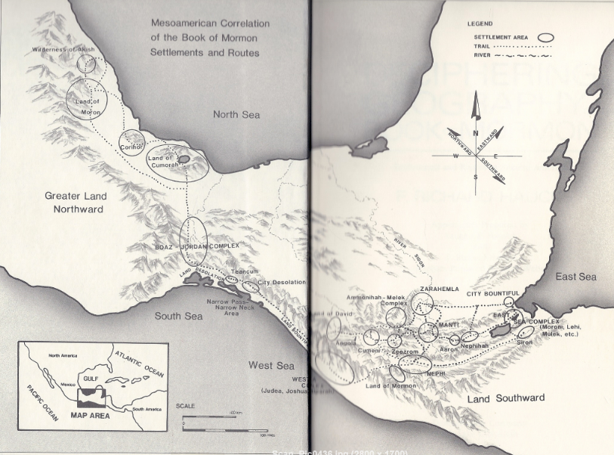
The above is the theoretical Book of Mormon map set in Mesoamerica by Richard Hauck in his 1988 book, Deciphering the Geography of the Book of Mormon. The Land Desolation is placed on the Pacific coast. The Narrow Pass & Narrow Neck area are located on the Pacific coast just southeast of the City Desolation and just southeast of where one sees the natural harbors (Mar Muerto) or “the place where the sea divides the land.” (Ether 10:20) In the 1990s Clate Mask would propose a theoretical model that if set in Mesoamerica would be similar to Hauck’s model.

On September 15, 2014 Kirk Magleby would post an article on his website Book of Mormon Resources in which he gives a more detailed reasoning behind Hauck’s original proposal. (I should note that although Magleby and Hauck differ in model proposals for the land of Nephi, they tend to have similar ideas concerning the narrow neck, narrow pass, the City Desoaltion and the location “where the sea divides the land.
Magleby writes:

Land Neck
"Land-neck" is an obsolete word meaning isthmus

Neckland
"Neckland" is an obsolete word meaning a neck or narrow strip of land.

Led into
The sense of "lead in" or "lead into" is to conduct or guide along a path.
"Led into" is used four times in a geographic context in the Book of Mormon.
• Alma 52:9 the narrow pass led into the land northward.
• Mormon 3:5 the narrow pass led into the land southward.
• Alma 63:5 the narrow neck led into the land northward.
• Mormon 2:29 the narrow passage led into the land southward.

All three features (narrow pass, neck & passage) were very near the actual border, the line between the lands southward and northward Alma 22:32, 3 Nephi 3:23. The narrow passage was right on the border Mormon 2:29. All three were distinctive enough to function in the role of independent gate or path leading into the much larger and more substantial lands northward and southward. This map shows our correlations,

Necks
A neck is a constriction, a pinch point. Vertebrates have necks. Bottles, flasks and jars have necks. To some degree, the words "neck" and "narrow" are redundant because most necks are longer than they are wide. Necks are usually associated with peninsulas that protrude like a head from a body. Isthmuses that connect two larger bodies are also called necks. . . . The narrowest part of a mountain pass can be called a neck . . .

We propose that:
• the narrow (small) neck of land is Barra San Marcos. The black lines show the modern road traversing the length of the sandbar, intersecting at right angles with Cabeza de Toro road.
• the narrow pass is the Mexican railroad grade shown as the purple line skirting around Cerro Bernal and Laguna de la Joya.
• the narrow passage is the mountain pass at the Agua Dulce River where Mexican Federal Highway 200, shown in light blue, runs today.
• the Bountiful.Desolation line is the red line that runs from a point high in the Sierra Madre westward to Mar Muerto.

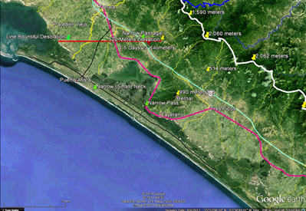

Proposed Narrow (Small) Neck, Narrow Pass, Narrow Passage and Bountiful/Desolation Border Line

On the map above, the yellow lines are rivers emptying into the Pacific. The white line is the continental divide and the blue lines are rivers in the Mezcalapa - Grijalva drainage basin. Green pushpins represent geographic features mentioned in the text. Yellow pushpins are elevation markers.
These correlations fit the sense of "led into" brilliantly.
• The narrow (small) neck route led only into the land northward.
• The narrow pass, flanking a mountainous ridge that crosses over the Bountiful/Desolation line, can lead either northward or southward depending on one's location at the time. When the Nephites were in land Bountiful, the narrow pass led northward Alma 52:9. When the Nephites were in land Desolation, the narrow pass led southwardMormon 3:5.
• The narrow passage was right on the Bountiful/Desolation border line, so movement could go either way. When the Nephites were in land Desolation, the narrow passage led southward Mormon 2:29.

The fact that three transportation corridors exist today (coast road, railroad, highway) through this area lends credibility to the Book of Mormon account of three geographic features providing access between the lands southward and northward.

We could constructively consult the OED for the terms "narrow pass" and "narrow passage" but our scope in this article is the narrow (small) neck of land.

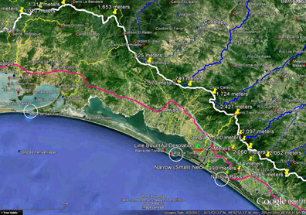
Boca de San Francisco, Boca del Mar Muerto & Boca del Cielo

Divides
The verb "divide" means to partition, cleave or cut into pieces. The narrow (small) neck of land was geographically proximate to a place where the sea divides the land Ether 10:20. This place could not have been an isthmus. An isthmus by definition is a place where the land divides the sea. This place must have been an inlet of the ocean or an outlet (mouth) where an inland saltwater lagoon breaches a sandbar. Along the Pacific coast of Oaxaca and Chiapas, the mouth of a lagoon is called a "boca" which is Spanish for "mouth." The map below shows three of these bocas, highlighted by white circles.

The Boca del Mar Muerto is large enough (.56 kilometers wide) that ocean-going vessels transit it regularly. It divides the Barra San Marcos to the east from Barra de Tonala to the west in the land/sea/land pattern the text describes. Mar Muerto is home to the largest fishing fleet in southern Mexico.

We propose that Boca del Mar Muerto at the northwestern end of Barra San Marcos and the southeastern end of Barra de Tonala is the place where the sea divides the land . . . “
[Posted by Captain Kirk at 1:27 PM, September 15, 2014, Book of Mormon Resources bookofmormonresources.blogspot.com]

Ether 10:21 They Did Preserve the Land Southward for a Wilderness to Get Game:

We find in Ether 10:21 that the Jaredites "did preserve the land southward for a wilderness to get game." The land southward was a "wilderness" and according to Ether 10:19 apparently "covered with animals of the forest. The "wilderness" was apparently the "south wilderness" that is described in Alma 22:31 [Alan C. Miner, Personal Notes] [See the commentary on Alma 22:31-32; Ether 9:33; 10:19]

Ether 10:21 The Whole Face of the Land Northward Was Covered with Inhabitants:

In Ether 10:21 we find that "the whole face of the land northward was covered with inhabitants." However, the Book of Mormon geography student is left to wonder as to just how far the "land northward" extended. If the Jaredite people were part of a civilization which built up "many mighty cities" (Ether 9:23), then we might have some clues as to just how far reaching that civilization was. Here the Book of Mormon geography student would be wise to compare, even in a general way, the known ancient civilizations on the American continent for the proposed time period. [Alan C. Miner, Personal Notes]

Joseph Allen writes that the Jaredites and the Olmecs both reached their high, or Classic Period, at the same time: He proposes the following dating for the Olmec Culture:

2600 BC—1200 BC Olmec Preclassic
1200 BC—600 BC Olmec Classic
600 BC—250 BC Late Olmec

Allen notes that the events that occurred in Ether 10 correspond with the 1200 BC—600 BC time period when the Olmecs built many cities and reached a high cultural period. . . . The Olmecs built many cities in what we refer to as the “land northward” during this time period, as mentioned in the Book of Mormon. Figure 5-9 shows a map of archaeological sites in the area along the Gulf Coast of Mexico, illustrating the massive civilization that flourished in the area from 1500 BC to 300 BC. [Joseph Lovell Allen & Blake Joseph Allen, Exploring the Lands of the Book of Mormon, Second Edition, 2008, pp. 123, 119]

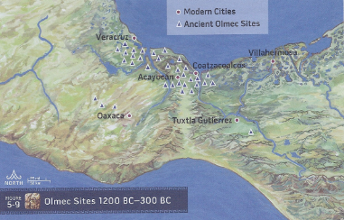
Ether 10:21 The Whole Face of the Land Northward Was Covered with Inhabitants (Illustration): Figure 5-9 Olmec Sites 1200 BC—300 BC [Joseph Lovell Allen & Blake Joseph Allen, Exploring the Lands of the Book of Mormon, Second Edition, 2008, p. 121]

Ether 10:22 They Were Exceeding Industrious:

According to Daniel Ludlow, it is possible that approximately one-third of the time period of the Jaredite civilization is covered in the brief account in chapter 10 of the book of Ether. Although the record is very scanty, the few details presented indicate these people had a high state of civilization. For example, the historian mentions that the people:

(1) "were exceedingly industrious, and they did buy and sell and traffic one with another, that they might get gain" (Ether 10:22);
(2) did work in "all manner of ore, and they did make gold, and silver, and iron, and brass, and all manner of metals;. . .and they did work all manner of fine work" (Ether 10:23);
(3) had "silks, and fine-twined linen; and they did work all manner of cloth" (Ether 10:24);
(4) did "make all manner of tools to till the earth, both to plow and to sow, to reap and to hoe, and also to thrash. And they did make all manner of tools with which they did work their beasts" (Ether 10:25-26);
(5) did "make all manner of weapons of war. And they did work all manner of work of exceedingly curious workmanship" (Ether 10:27).

[Daniel H. Ludlow, A Companion to Your Study of the Book of Mormon, pp. 323-324]

Ether 10:22 They Did Buy and Sell and Traffic One with Another:
Richard A. Diehl discusses the way in which the Olmec horizons became so influential:
By 1200 B.C. Olmec merchants penetrated highland and Pacific coastal Guatemala, Oaxaca, and central Mexico in their quest for exotic bird feathers. Obsidian and basalt already circulated outside their immediate source areas; in these instances, the Olmecs apparently managed to insert themselves into the established networks and export the goods back to their home bases. In the case of iron ores, and perhaps other materials as well, they created demand for things that no one had used before and even colonized unoccupied source zones. . . . Regular visits by Olmec merchants strengthened these ties to the point that some rulers adopted the outward trappings of Olmec elite culture and may even have accepted Olmec women as marriage partners. The intensity and duration of these highly personal relationships depended upon the fortunes of individual Olmec rulers and merchants and their foreign trading partners.(n.22) [Brant A. Gardner, Second Witness, Vol. 6: Fourth Nephi through Moroni, p. 279]

Ether 10:22 They Did Buy and Sell and Traffic One with Another:
John Lund writes that Mesoamerican scholar Michael Coe has identified numerous monuments scattered over hundreds of miles by the Olmecs between 1400 B.C. and 900 B.C. (n. 170) The impact of the Olmec society is easily underestimated. The Olmecs had a profound effect on all the New World cultures with which they associated. Their impact reached into the northern parts of South America and to north of the Rio Grande. Olmec influence was pervasive and transformed the social, economic, and religious landscape for generations to come in America. “Wherever Olmec influence or the Olmecs themselves went, so did civilized life.”(n.171) [John L. Lund, Mesoamerica and the Book of Mormon: Is This the Place?, p. 120]
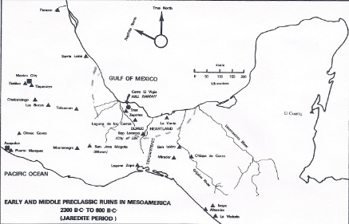
Ether 10:22 They did buy and sell and traffic one with another (Illustration): Map 7. Early and Middle Preclassic Ruins in Mesoamerica. 2300 B.C. to 600 B.C. (Jaredite Period). [David A. Palmer, In Search of Cumorah, p. 260]

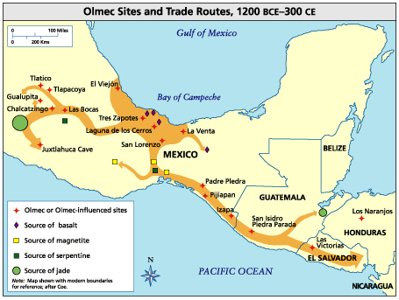
Ether 10:22 They did buy and sell and traffic one with another (Illustration): Olmec Sites and Trade Routes, 1200 BCE-300 CE [Latinamericanstudies.org]

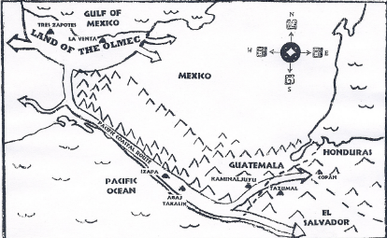
Ether 10:22 They did buy and sell and traffic one with another (Illustration): This is a crude sketch of a well-illustrated chart at the archaeological museum at the site of La Venta in the state of Tabasco, Mexico. La Venta was an important Olmec center. This chart illustrates how Olmec influence spread from their Gulf Coast heartland to other areas via trade routes and migrations. [Clate Mask, “And They Called the Place Bountiful,” p. 28]

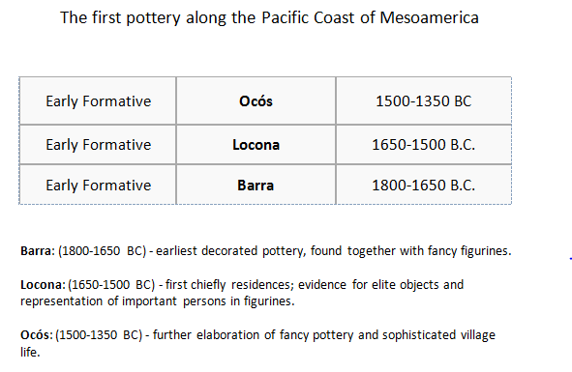
Ether 10:22 They did buy and sell and traffic one with another (Illustration): The first pottery along the Pacific Coast of Mesoamerica.
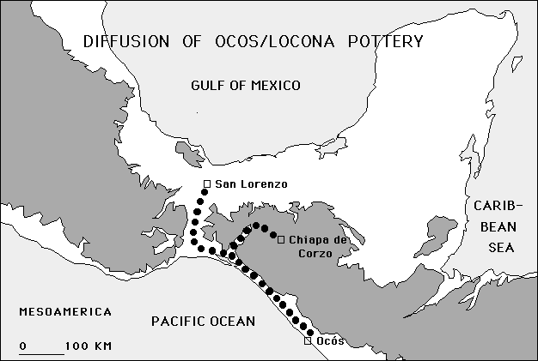
Ether 10:22 They did buy and sell and traffic one with another (Illustration): Diffusionof Ocos/Locona Pottery

Ether 10:23 They Did Make . . . Iron:

In Ether 10:22 we find that the Jaredites "did make . . . iron." According to Warren and Palmer, when the Olmec culture first started, this was also the time when the first concave iron ore mirrors appeared. Such iron mirrors have been discovered in a number of locations, including the archaeological site of San Lorenzo in Southern Mexico. Several are on display in the National Museum of Anthropology in Mexico City (see illustration).

Iron beads have also been found at a number of Olmec sites. It has been reported that altogether 2131 iron pieces have been discovered. (Agrinier, Pierre, 1984:77)

At the site of San Jose Mogote (located just north of the city of Oaxaca, Mexico) a form of iron called Magnetite was worked between 1000 and 850 B.C. Scores of mines were in use extracting iron, and four located in the valley of Oaxaca have been identified by Ferreira as the source of iron used at that time (1976:317) [Bruce W. Warren and David A. Palmer, The Jaredite Saga, pp. 8-10,11,12, unpublished]

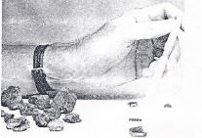
Ether 10:23 They did make . . . iron (Illustration): Chunks of magnetite ore and remnants of very smooth iron mirrors which were found by the University of Michigan in excavations of workshops at San Jose Mogote. They are three thousand years old. [David A. Palmer, In Search of Cumorah, p. 133] Also

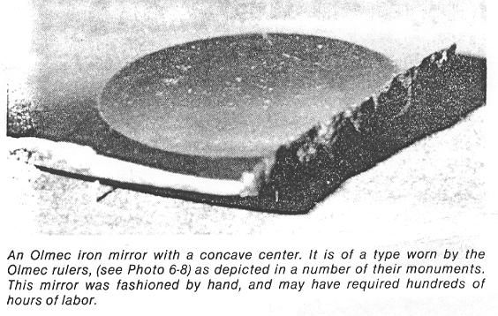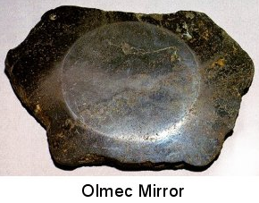
Ether 10:23 They did make . . . iron (Illustration-not shown): An Olmec iron mirror with a concave center. It is of a type worn by the Olmec rulers. This mirror was fashioned by hand, and may have required hundreds of hours of labor. [David A. Palmer, In Search of Cumorah, p. 113] Also “Olmec Mirror [lamplight.ca]

Ether 10:23 They did make . . . iron (Illustration-not shown): Magnetite iron ore mined anciently in the hills around San Jose Mogote. [F.A.R.M.S. Staff, "The Lands Of The Book Of Mormon, Slide #88]

Ether 10:23 They Did Work in All Manner of Ore . . . Iron:

According to Glenn Scott, in Ether 10:23 we have recorded one of the most controversial claims in the Book of Mormon, "they did work all manner of ore . . . they did cast up mighty heaps of earth to get ore, of gold, and of silver, and of iron, and of copper." Archaeologists agree that Mesoamericans were using gold, silver , and copper when the Spanish came, but do not support this early date, and of iron they admit no evidence at all.

However, in the early 1970s, the University of Michigan undertook a major archaeological project in the Oaxaca Valley of Mexico. There they found "an iron ore workshop," dated about 1200 B.C. They later found thirty four mining areas in that valley.

Ilmenite and magnetite were used to make mirrors in Oaxaca about 1474 B.C., and Michael Coe found at San Lorenzo an Olmec magnetite pointer which he says may have been part of a floater compass.
In the Old World, iron was known almost as early as other metals. The Bible credits it to pre-Flood Tubal Cain (Genesis 4:22). Verneil Simmons writes that "the start of true metal-working was in Asia Minor, in the vicinity of Lake Van, in the shadow of Mount Ararat." [Glenn A. Scott, Voices from the Dust, pp. 53, 55]

Ether 10:23 All Manner of Metals:

Ether 10:23 states that the Jaredites made "all manner of metals." According to Warren and Palmer, perhaps we might find a link to Jaredite "metals" in the linguistic data of Mesoamerica. It has been shown that the ancient Proto-Mixe-Zoque language was that of at least some of the people who inhabited San Lorenzo and the surrounding Olmec area. The linguistic data confirm some of the cultural traits mentioned in connection with that city which are difficult to confirm archaeologically. It is particularly interesting to note that they had a word for "metal." [Bruce W. Warren and David A. Palmer, The Jaredite Saga, p. 8-7, unpublished]

Ether 10:23 Iron:

According to Walter Kaiser, although there have been critics of early iron production, one may still demonstrate that knowledge of working in terrestrial iron existed long before the so-called Iron Age that typically is dated as beginning somewhere around 1200 B.C.

Lloyd Bailey argued that the reference to iron in the story of Cain's relatives necessitated the conclusion that it was not reliable. The fact that Genesis 4:22 depicted Tubal-Cain as one who "forged all kinds of tools out of bronze and iron" clearly violated our modern conventions that had assigned the onset of the iron age at 1200 B.C. How could smelting of metals have been achieved in a mere seven generation period from the first appearance of humans on the earth? asked Bailey. The earliest evidence for working in crude iron that he would grant was that done by the Hittites in 1500 B.C.

Actually, evidence now exists to demonstrate that many of the skills for working in various arts and crafts were known, lost, rediscovered and lost once again only to be found by a later generation. The fact that the Hebrew word for "iron," barzel , is probably a loan word from the early Sumerians who lived in the Mesopotamian valley in the latter part of the fourth and early third millennium should have given us reason for pause. The Sumerian word for "iron" was parzillum , which easily could explain the Hebrew barzel by the labial "b" and "p" interchange minus the case ending of -um (which Hebrew has dropped) and the doubling of the final "l" that is only needed in Sumerian. The Hebrew word for iron, then, was known and used already more than two and a half millennia before the official start of what we later called our Iron Age in 1200 B.C. Several other finds have added to the importance of this fact. Therefore, it would be premature to conclude that working in terrestrial iron was impossible prior to our dating of the Iron Age. [Water C. Kaiser Jr., The Old Testament Documents: Are They Reliable & Relevant?, pp. 68-69]

Ether 10:23 All Manner of Metals (Gold, Silver, Copper)
According to Ether 10:23, the Jaredite people living north of the narrow neck of land dug up “mighty heaps of earth” from which they extracted gold, silver, and copper. (Ether 10:23) Previously in Ether 9:17, not only gold and silver were mentioned, but “precious things.”
The Hill Vigia has been proposed as a candidate for the Hill Ramah of the Jaredites (and also the Hill Cumorah of the Nephites). It is located in Veracruz, Mexico in the heartland of the Olmec.
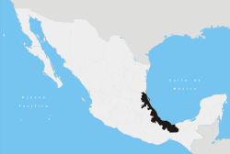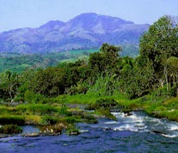
State of Veracruz within Mexico Hill Vigia / Proposed Hill Ramah

According to John L. Lund, if such was the case then one does not have to travel far from the Jaredite Hill Ramah (Hill Vigia) to find gold. Directly north of the Hill Vigia in the same State of Veracruz is the Cerro de Oro. A direct translation will suffice: “Hill of Gold.” After the Olmec occupation and before the conquistadores, the area was settled by the Totonacs. A few decades before the Spanish arrived the Totonacs were subjected to the Mexicas. Each conquered nation paid tribute in goods and services for which they were known. The Totonacs were required to pay tribute in gold. Additionally, they were known for their goldsmiths and their fine gold jewelry.(n.172) The first gold Cortes received after landing on the shores of Veracruz was from the Totonac mines near the Hill Vigia.(n.173)
West of this proposed Mesoamerican Hill Ramah/Cumorah (Hill Vigia) there are truly a plethora of mines producing an abundance of gold, silver and copper. The Hill Bernal in the state of Tamaulipas near the city of Tampico is another candidate.
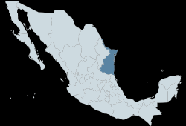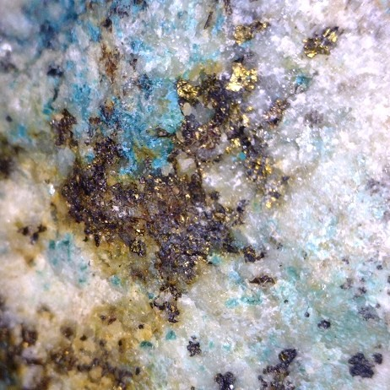
State of Tamaulipas within Mexico Gold & copper ore
[Note* Tampico is a city and port at the southern end of the state of Tamaulipas, Mexico; it is located on the north bank of the Pánuco River, about 6 miles from the Gulf of Mexico. According to the sixteenth-century native historian Ixtlilxochitl, Panuco is where the “ancient ones” landed.]
Many of the mines in the heart of Mesoamerica produce both silver and gold from the same mine. In the mountainous area south of Mexico City and west of the candidates for the Hill Ramah/Cumora are many mining towns of which Taxco, Mexico (in the state of Guerrero) is the most famous. This particular town in known for its silver. Mexico is still the number one producer of silver in the world today. Nearby are mines of gold and copper.
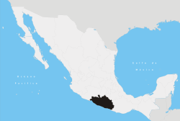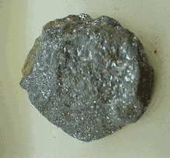
State of Guerrero, Mexico Silver ore

This means that west of the Hill Ramah/Cumorah within a three hundred miles east to west zone, one should find evidence of gold, silver, and copper. Four separate mining areas possessing gold, silver and copper are required in order to qualify as the lands of the primary events in the Book of Mormon. Where are those criteria met? The answer is in Mesoamerica, Southwestern United States, the Northern Rockies, and Western Canada. However, there is no single place east of the Mississippi River, including all twenty-six states, where one can find gold, silver, and copper together in one locale in abundance, much less four separate locations.
Tomb #7 at Monte Alban, Oaxaca, Mexico is a Zapotec burial chamber. Because it lay undiscovered by the Spanish and by grave robbers, it is a prime example of the artifacts and beliefs of these people. Germane to the search of the tomb was the existence of gold, silver, and copper. More than three hundred objects have been discovered in this tomb. Among the treasures buried with the dead were rock crystals and numerous intricate carvings of figurines in gold, silver, and copper, turquoise, jade, obsidian, alabaster, and dozens of pearls.
[Note* The Zapotec civilization was an indigenous pre-Columbian civilization that flourished in the Valley of Oaxaca in Mesoamerica. Archaeological evidence shows that their culture goes back at least 2,500 years. Zapotec civilization had its beginnings in the Central Valleys of Oaxaca in the late 6th Century BC. The Zapotec left archaeological evidence at the ancient city of Monte Albán in the form of buildings, ball courts, magnificent tombs and grave goods including finely worked gold jewelry. Monte Albán was one of the first major cities in Mesoamerica and the center of a Zapotec state that dominated much of the territory that today belongs to the Mexican state of Oaxaca.]
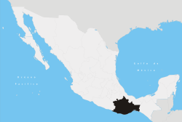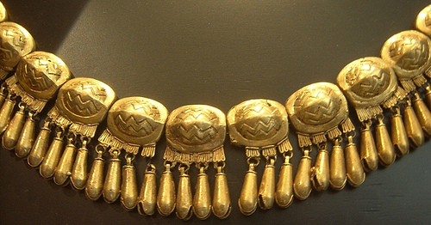
State of Oaxaca, Mexico Gold jewelry from Tomb #7

Jade is a precious stone recognized around the globe. Guatemala is the source of the highest quality jade in the world.
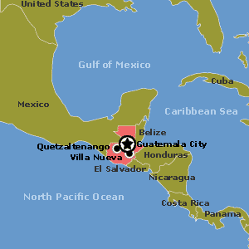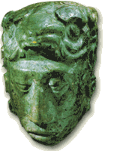
Country of Guatemala (in red) Jade carving

Precious stones are rated according to their hardness. In China the hardness of the jade rates at 6.5 to 7; the same is true of the jade from New Zealand. The highlands of Guatemala produce a jade of an 8.5 level of hardness. The colors of Guatemalan jade vary from an almost white to the deepest of green. For the Olmecs, Chinese, Egyptian, and Maya, dark green was associated with life and death. Jade death masks of dark green were the most prized as were figurines made from dark green jade. Most Maya tombs thus far excavated have numerous jade artifacts.

Mesoamerica qualifies as the only candidate on the North American continent where there are several areas that have gold, silver, copper and other precious gems within a five hundred to six hundred and fifty mile zone. [John L. Lund, Mesoamerica and the Book of Mormon: Is This the Place?, pp. 127-132]
Ether 10:23 They Did Work All Manner of Ore, and They Did Make . . . Brass:

According to John Sorenson, brass is an "alloyed metal," usually intentionally made by mixing copper and zinc, yet sometimes the alloy results from smelting ore which naturally contains both copper and zinc, hence mention of "brass" objects does not necessarily imply a sophisticated development of metallurgy among the Jaredites" but perhaps only a modest knowledge. The Book of Mormon text says almost nothing about metallurgical techniques, and what is said need not be interpreted as involving particularly complex operations. Consider the case of Peru, whose museums display abundant metal artifacts, yet Bray emphasizes the "rudimentary nature" of the equipment and methods involved.

Earle R. Caley and Dudley T. Easby, Jr. state that "Direct archaeological evidence of smelting operations is rare in pre-Conquest Peru and unknown in Mexico for all practical purposes." But that does not mean there were no smelting operations--quite surely there were. While it is true that complex technological processes generally leave traces in the archaeological record, in reality little useful information has been recovered so far by Mesoamerican archaeologists about most "complex processes," not just metals. How stone monument carving, textile manufacturing and dyeing, wood carving, jewelry crafting and many other processes were conceived and performed is known only imperfectly, and virtually never by the discovery or excavation of workshop sites. [John L. Sorenson, "Viva Zapato! Hurray for the Shoe! in Review of Books on the Book of Mormon, Vol. 6, Num. 1, pp. 322-323] [See the commentary on Helaman 6:11]

Ether 10:23 Brass . . . Copper:

According to John Sorenson, it is interesting that Ether 10:23 accurately distinguishes brass from copper in one subtle bit of context. The record says that the Jaredites "did make" brass; however they dug up heaps of earth "to get ore . . . of copper." Naturally they would not have got "ore of brass" or bronze, for those metals must be manufactured by alloying. The terminological distinction comes out exactly as it would from a person who wrote with a real knowledge of metallurgy. [John L. Sorenson, An Ancient American Setting for the Book of Mormon, p. 284]

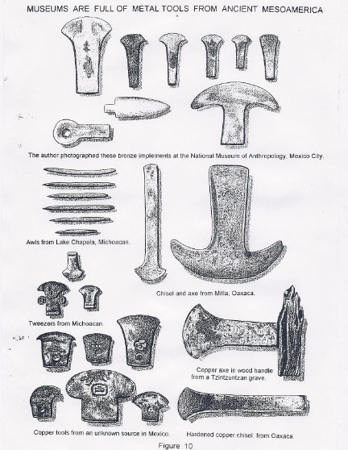
Ether 10:23 They did work in all manner of ore (Illustration): Museums Are Full of Metal Tools from Ancient Mesoamerica: (a) The author photographed these bronze implements at the National Museum of Anthropology; (b) Awls from Lake Chapala, Michoacan; (c) Chisel and axe from Mitla, Oaxaca; (d) Tweezers from Michoacan; (e) Copper axe in wood handle from a Tzintzuntzan grave; (f) Copper tools from an unknown source in Mexico; (g) Hardened copper chisel from Oaxaca. [Glenn A. Scott, Voices from the Dust, p. 54]

Ether 10:24 They Did Have Silks:

Ether 10:24 mentions that the Jaredites "did have silks." According to Hugh Nibley, since few substances suffer more complete oxidation than silk, it is not surprising that the only evidence we have of its early existence is written records. But these are sufficient to allow the Jaredites the knowledge of how to produce silken garments. According to the Encyclopedia Britannica silk was worn in China in the first half of the third millennium B.C. [Hugh Nibley, The World of the Jaredites, p. 218] [See the commentary on Ether 9:17]

[Note* SEE the commentary on “silks” in Ether 9:7]

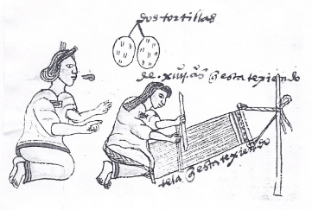
Ether 10:24 They did work all manner of cloth (Illustration): A picture of weaving from the Codex Mendoza [John L. Sorenson, Images of Ancient America, p. 74]

Ether 10:28 Prospered by the Hand of the Lord (Covenant Imagery):

In Ether 10:28 we find the phrase "prospered by the hand of the Lord." According to David Seely, the image of the hand of God in both the Old Testament and the Book of Mormon stands for the Lord's power to intervene in the affairs of men and the events of history. Comparison between the ways this image is used in the two scriptures supports what the Book of Mormon claims about its own origin.

The hand of God was what afflicted Job (see Job 19:21) and at the same time had the power to heal him (see Job 5:18). The hand of the Lord was what once made the Jaredites prosperous (see Ether 10:28) but later destroyed them (see Ether 1:1). [David Rolph Seely, "The Image of the Hand of God in the Book of Mormon And the Old Testament," in Rediscovering the Book of Mormon, pp. 140-141]

Ether 10:30 Hearthom . . . Served . . . in Captivity:

When Hearthom, the son of Lib, had reigned for 24 years,

behold, the kingdom was taken away from him. And he served many years in captivity, yea, even all the remainder of his days. And he begat Heth_{[2]} in captivity, and Heth_{[2]} lived in captivity all his days. And Heth_{[2]} begat Aaron, and Aaron dwelt in captivity all his days; and he begat Amnigaddah, and Amnigaddah also dwelt in captivity all his days; and he begat Coriantum_{[2]}, and Coriantum_{[2]} dwelt in captivity all his days; and he begat Com_{[2]}. (Ether 10:30-31)

According to Warren and Palmer, beginning in the time of Hearthom, many subsequent rulers and their people actually "served" "in captivity" (Ether 10:30). This can perhaps explain why such enormous monuments were brought from the Tuxtla mountains to the site of San Lorenzo. If the time and location correlate with the account in the tenth chapter of the book of Ether, then it was perhaps the movement of these enormous monuments was work performed by slaves who happened to be direct descendants of Jared. [Bruce W. Warren and David A. Palmer, The Jaredite Saga, p. 8-20]

Ether 10:30 Hearthom . . . served . . . in captivity (Illustration- not shown): Jaredite History: From the Great Tower to Ramah. [Bruce W. Warren, "Jaredite History: From the Great Tower to Ramah," unpublished]

Ether 10:30-31 Hearthom . . . Heth . . . Aaron . . . Amnigaddah . . . Coriantum . . . Com . . . Dwelt in Captivity:
Brant Gardner notes that the Jaredite royal lineage from Heth forward spent six generations in captivity before regaining the kingdom, but Moroni includes absolutely nothing about the actual rulers during these same generations. The genealogy lists only those who should have been kings. [Brant A. Gardner, Second Witness, Vol. 6: Fourth Nephi through Moroni, p. 281]

Ether 10:31 He Begat Heth . . . and Heth Begat Aaron:

John Sorenson writes that chapter 10 in the Book of Ether can lull the reader to sleep with a long list of kings which are only distinguishable by whether or not they were righteous. However, Moroni’s abridgment comes not from a secular, royal history but from the personal record of Ether. In verses 30-31, we realize that the record does not follow the line of kings but Ether’s own genealogical line. Heth, Aaron, Amnigaddah, Coriantum, and Com all dwelt in captivity. But none of these reigned as king until Com took half the kingdom. Thus, Ether’s record is the story of his forefathers, not just the kings of the Jaredites.

“Neither did Ether give much attention to those usurping rulers, likely from a competing lineage, who imprisoned his ancestors and so kept them from their place on the throne; in fact, their names aren’t even mentioned in the Book of Ether. (See Ether 10:30-31; Ether 11:17-19.) To the people of Jared’s lineage, those names were not important.

“In significant ways, the burden of these ancient American records was about the fate of the central families who kept them. Others were sometimes mentioned, but only because they provided necessary scenery and furniture for the primary drama. Even centuries-long periods could be ignored, no doubt because little happened then which was considered crucial in determining the destiny of the descendants of Nephi or of Jared.” (John L. Sorenson, Ensign, Sept. 1984, “Digging into the Book of Mormon”)
[josephsmith.com . . . Ether ]

Ether 10:31 Com[2]:

According to Warren and Palmer, the name "Com" (Ether 10:32) has a parallel in Maya. It means log stool or armadillo (Laughlin: 1975 Tzotzil dictionary p. 104). [Bruce W. Warren and David A. Palmer, The Jaredite Saga, p. 8-20]

It is interesting that Com2 was the son of Coriantum2 (Ether 10:31), just as Com1 was the son of Coriantum1 (Ether 9:24-25). Could this be a case of name adoption by kings? [Alan C. Miner, Personal Notes]

Ether 10:32 Com Drew Away Half the Kingdom and . . . Obtained Power over the Remainder of the Kingdom:

In Ether 10:32 it says that "Com[2] drew away half the kingdom and . . . obtained power over the remainder of the kingdom." According to Warren and Palmer, it was apparently in the time of Com2 that San Lorenzo suffered an enormous devastation. It appears to have been the result of an uprising by the slaves in a civil war. Those slaves were perhaps descendants of Jared.

The lead excavator of San Lorenzo was Michael D. Coe. He has stated that the Olmec phase of San Lorenzo ended in 900 B.C. (Coe, M.D. and Diehl, R.A., 1980:31). The actual date could possibly have been as much as two hundred years earlier, with recalibration of the radiocarbon dates; therefore, a spread from 1100 to 900 B.C. must be considered. The site of San Lorenzo was purposely destroyed, and Coe speculated as follows:

Why was this done? Because the Olmec monuments must have stood for a class of leaders that held the tributary populace in such a firm grip, forcing from them incredible expenditures of labor. These stones must have been the symbols of all that had held them in thrall, and they destroyed these symbols with as much fervor as the Hungarian revolutionaries toppled the giant statue of Stalin in Budapest in 1956 (Coe, 1968:86).

It seems evident that the descendants of Jared had ample reason to destroy those monuments which they and their ancestors were forced to quarry, transport, and sculpt (see illustration). [Bruce W. Warren and David A. Palmer, The Jaredite Saga, pp. 8-20, 21]

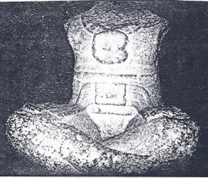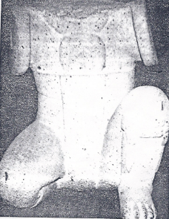
Ether 10:32 Com drew away half the kingdom and . . . obtained power over the remainder of the kingdom (Illustration): Left: Monument of a seated Olmec ruler on display in the National Museum of Anthropology, Mexico City. Note the pendant hung from the neck, believed to be a representation of the concave iron mirrors worn by the rulers. The head and arms were knocked off deliberately, probably in a civil war. Right: Statue of a crouching man found at San Lorenzo. The head was deliberately knocked off, probably during the destruction which accompanied a civil war at San Lorenzo. [David A. Palmer, In Search of Cumorah, pp. 138, 140]

Ether 10:32 Com_{[2]} Drew Away Half of the Kingdom and He Reigned over the Half of the Kingdom:

When "Com_{[2]} drew away half of the kingdom" and "reigned over half of the kingdom" (Ether 10:32), did Com₂ set his throne up in the local land of Moron or somewhere else?

Chapter 11

Geographical Theory Map: Ether 11:4 - 11:15 Civil War - Moron Regains All of Kingdom (Chronology)
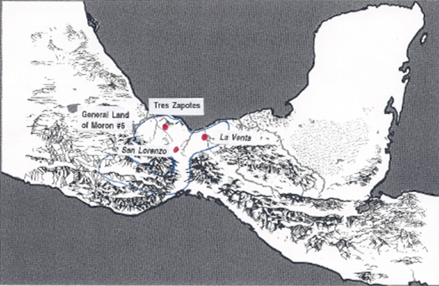

LAND of MORON #5
Capital = La Venta?

COM reigns over all (10:32) [Question: From where?]
Com begets Shiblom (11:4)
SHIBLOM reigns (11:4)
Brother of Shiblom rebels & starts war (11:4)
Shiblom slain (11:4)
Seth (Shiblom's son) brought into captivity (11:9)
Ahah (Shiblom's son) obtains kingdom (11:10)
AHAH reigns (11:10)
ETHEM (Ahah's descendant) reigns (11:11)
Ethem begets Moron (11:14)
MORON reigns (11:14)
[TRES ZAPOTES?]

<------------------ Mighty man overthrows Moron & gains 1\2 of kingdom (11:15)
Moron regains all of kingdom (11:15)

Ether 11:4 Shiblom (Shiblon):

In Ether 11:4 we find the name "Shiblom." The reader should note that in the genealogical listing in Ether 1:11-12, Shiblom's name is given with a slightly different ending of "Shiblon." Here in chapter 11, Shiblon had to fight a great war against those who followed his brother.

According to Warren and Palmer, it is interesting to note that the name "Shiblon" can mean "lion cub" in Semitic languages (Urrutia:1982). In the Popol Vuh, an ancient Mesoamerican history of their native origins, one of the hero twins carries the name of Ixbalanque. It means "small jaguar deer." The consonants of the name correspond to the name of Shiblon! The meaning of those two names both mean a small animal (lion in the Semitic language and jaguar in Maya). The other twin is called Huapu, possibly referring to Shiblon's brother. It can mean hunter and flower (Warren, 1983). [Bruce W. Warren and David A. Palmer, The Jaredite Saga, p. 8-22, unpublished]

Ether 11:4 Shiblom:

According to research by the Zarahemla Research Foundation, the first occurrence of the name for the son of Com is spelled "Shiblon" (Ether 1:12) in the Printers Manuscript. However, the six references to the son of Com found in Ether 11:4-9 are all spelled "Shiblom." [Zarahemla Research Foundation, A Comparison of the Manuscripts and Editions of the Book of Mormon, p. 269]

Note* Because the name Shiblom ends with the letter "m," it might be more characteristic of Jaredite names. This practice of ending names with "m" is called "mimmation," and has been commented on by Hugh Nibley. [Alan C. Miner, Personal Notes]

Ether 11:4 There Began to Be an Exceeding Great War in All the Land:

According to John Sorenson, Ether 11 makes clear that from the time Com ruled, the system was in trouble. The internal dating of the account puts the sensational destruction at San Lorenzo close to the time of the troubles mentioned in Ether 11:4 and 6, although of course we have no way to confirm a direct correlation. [John L. Sorenson, An Ancient American Setting for the Book of Mormon, p. 119]

Ether 11:5 The Brother of Shiblom Caused That All the Prophets . . . Should Be Put to Death(Covenant Language):

“As with the Nephites, the Jaredite society moved through various stages of decline. As we have seen thus far in their history, the Jaredites went through the cycle of prosperity, and so on. But as with the Nephites, eventually the depths of the apostasy became more and more serious. Here in this chapter we see the Jaredites moving toward the final stages of their cycle of apostasy. Earlier we are told the people rejected the prophets, mocking and reviling them, but the king passed a law protecting the prophets and punishing those who persecuted them. (See Ether 7:23-26.) Note the contrast with a later king who made it state policy to execute the prophets (v. 5). And finally the wickedness became so rampant that the prophets were withdrawn (v. 13).” (Book of Mormon Student Manual, 1981, p. 45-6)
Ether 11:6 A Great Destruction Such an One As Never Had Been Known (Covenant Language):

We read an almost unnoticed account in the book of Ether about a great destruction that took place prior to the final great civil war that brought the Jaredite history to a close. This great destruction is recorded in Ether 11 as follows:

11:1 And there came also in the days of Com many prophets, and prophesied of the destruction of that great people except they should repent, and turn unto the Lord . . .
11:2 And it came to pass that the prophets were rejected by the people, and they fled unto Com for protection, the people sought to destroy them.
11:3 And they prophesied unto Com many things; and he was blessed in all the remainder of his days.
11:4 . . . and he begat Shiblom; and Shiblom reigned in his stead. And the brother of Shiblom rebelled against him, and there began to be a great war in all the land.
11:5 And it came to pass that the brother of Shiblom caused that all the prophets who prophesied of the destruction of the people should be put to death;
11:6 And there was great calamity in all the land, for they had testified that a great curse should come upon the land, and also upon the people, and that there should be a great destruction among them, such an one as never had been upon the face of the earth, and their bones should become as heaps of earth upon the face of the land except they should repent of their wickedness.
11:7 And they hearkened not unto the voice of the Lord, because of their wicked combinations; wherefore, there began to be wars and contentions in all the land, and also many famines and pestilences, insomuch that there was a great destruction, such an one as never had been known upon the face of the earth.

Notice that there was a curse prophesied on the land and people in addition to their wars and contentions. Joseph Allen writes:

A great destruction was reported in both the Olmec and the Jaredite cultures many years prior to their final war. The dates of the Ixtlilxochitl account are somewhat inconsistent, making it difficult to rely on them. However, he speaks of the event of a great hurricane that uprooted trees and buildings and that caused many of the animals to suffocate. In this regard it is interesting that the Aztec calendar (buried at the time the Aztecs were conquered by Cortez in 1519 A.D and later rediscovered) depicts four major destructive periods of Mesoamerican history--periods that are also mentioned by Ixtlilxochitl. They are:

Period I: Sun of Water (the earth was destroyed by a flood)
Period II: Sun of Air (the earth was destroyed by a hurricane)
Period III: Sun of Earth (the earth was destroyed by an earthquake)
Period IV: Sun of Fire (the earth will be destroyed by fire)

The destruction we are talking about took place in Period II—between the flood and the earthquake (3100 BC AD 30). Using the Maya calendar base date (3114 BC) as the base date of the flood and using the first calculation of Ixtlilxochitl of the destruction by the hurricane (1,715 years from the flood), we arrive at the year of 1398 BC as the date for the great hurricane. Regarding this destruction, Ixtlilxochitl writes: “And 1,714 years after the flood, the people were destroyed by a very great hurricane that carried away trees, rocks, houses, and large buildings.”(n.21)

This [approximate dating of a great destruction] is consistent with Mesoamerican history and the history here in Ether Chapter 11. [Joseph Lovell Allen & Blake Joseph Allen, Exploring the Lands of the Book of Mormon, Second Edition, 2008, pp. 124-125]

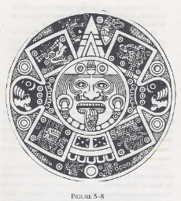
Ether 11:6 A great destruction such an one as never had been known (Illustration) (Chronology): Four destructive periods as illustrated on the Aztec Calendar Stone [Joseph L. Allen, Exploriong the Landsof the Book of Mormon, p. 64]

Ether 11:11 Ethem, Being a Descendant of Ahah, Did Obtain the Kingdom:

Moroni writes few details concerning the period following Ahah's short and bloody reign, except that "Ethem, being a descendant of Ahah, did obtain the kingdom." (Ether 11:11). This might suggest that considerable time may have passed in the interim; however, Ether 1:9 says that "Ethem was the son of Ahah." King Ethem was also wicked to the point that "there came many prophets and prophesied again unto the people . . . that the Lord would utterly destroy them from off the face of the earth except they repented of their iniquities." Yet, Ethem and the people continued in their wickedness and the prophets withdrew. King Ethem was succeeded by his son, Moron, who was no better than his wicked father.

Ether 11:9-14 Seth . . . Ahah . . . Ethem . . . Moron:

According to Warren and Ferguson, four generations followed Shiblom in which there were iniquitous kings; they were Seth, Ahah, Ethem, and Moron (see Ether 11:9-14). At the site of La Venta, there are in fact four colossal Olmec heads. It is interesting to compare the number of rulers at both San Lorenzo and La Venta with the numbers of Olmec colossal heads discovered. Eight colossal heads have been found at San Lorenzo. Although the book of Ether does not tell us how many kings there were in the ruling class, the subjected class of Jaredites had eight generations from Lib to Shiblom. In a SEHA newsletter (#103.60, August 12, 1967) Dr. Fred W Nelson Jr. concludes that "these heads could have been sculpted to represent the kings or famous generals of the period."

These giant Olmec stone heads were quarried and carved in the Tuxtla mountains, and then transported by land and water to the site of San Lorenzo. The actual distance travelled would have been over eighty kilometers. Some of those monuments weighed twenty tons!

Though the heads superficially appear negroid, most experts now dismiss that possibility. As far as the stubby noses and facial features, Michael Coe makes the comment that to sculpt a protruding nose would have meant removing several additional tons of basalt by the most tedious process and would have increased the chances of breakage in transport. In actuality, very little rock was removed from the boulders. [Bruce W. Warren and David A. Palmer, The Jaredite Saga, pp. 8-12--16]

Geographical Theory Map: Ether 11:15 - 11:32 Ether Prophesies Doom to Coriantumr (Chronology)
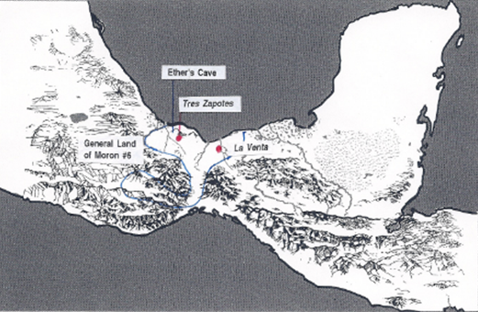
LAND OF MORON #6
[Capital = La Venta?]

MORON reigns (11:14)
[TRES ZAPOTES?]

<------------------ Mighty man overthrows Moron & gains 1\2 of kingdom (11:15)
Moron regains all of kingdom (11:15)

MORON reigns (11:15)
<----------------- Mighty man (Desc. of Bro. of Jared) overthrows Moron (11:17-18)
MIGHTY MAN reigns (from where?)
(Captivity)

Moron begets Coriantor (11:18)
Coriantor begets Ether (11:23)

CORIANTUMR reigns (from where? during the days of Ether) (12:1)
Ether tells ALL things from the beginning of man
After the waters receded from off “this land” it became “a chosen land” (13:2)
“It was the place of the New Jerusalem” (13:3)
1st Year:
Coriantumr battles those who he feels seek to destroy him (13:18)
Ether dwelt in the cavity of a rock-------- Cave
Many people slain (13:18)

2nd Year:
Ether prophesies to Coriantumr (13:20)
(All to be slain except him if no repentance)
(“Another people to receive the land for their inheritance””)

People seek Ether's life (13:22)
Ether flees to cave (13:22) ---------------> Cave
Shared gives battle to Coriantumr (13:23)

3rd Year:
Shared brings Coriantumr into captivity (13:23)

_______________

Ether 11:15 There Arose a Mighty Man among Them . . . He Did Overthrow Half of the Kingdom:

Ether 11:15 says that,

there arose a rebellion among the people [of King Moron], because of the secret combination which was built up . . . and there arose a mighty man among them in iniquity, and gave battle unto Moron, in which he did overthrow the half of the kingdom; and he did maintain the half of the kingdom for many years. And it came to pass that Moron did overthrow him, and did obtain the kingdom again.

The word "overthrow" seems to imply an internal conflict, but one might ask, From where did King Moron still reign over half of the kingdom? And from where did the "mighty man" reign over the other half of the kingdom? [Alan C. Miner, Personal Notes]

Ether 11:17 There Arose Another Mighty Man; and He Was a Descendant of the Brother of Jared:

After King Moron had regained the kingdom from the first "mighty man," there arose "another mighty man, and he was a descendant of the brother of Jared" (Ether 11:17). This second "mighty man" overthrew King Moron and obtained the kingdom; "wherefore, Moron dwelt in captivity all the remainder of his days; and he begat Coriantor. . . . and Coriantor dwelt in captivity all his days. . . and Coriantor begat Ether" (Ether 11:18,19,23). [Alan C. Miner, Personal Notes]

Ether 11:22 And They Did Reject All the Words of the Prophets:

The last prophet called of God to warn the Jaredite nation and to witness against them was Ether, the son of Coriantor. Donl Peterson notes that Moroni could have empathized with Ether, since both were prophets of God sent to preach to a people who were "past feeling" and who "did reject all the words of the prophets" (Ether 11:23). Both men were the last of their once great civilizations, and both were called upon to record their final struggles and then were charged to be responsible for preserving the precious records of their fallen people. [H. Donl Peterson, Moroni: Ancient Prophet Modern Messenger, p. 47]

Ether 11:23 Coriantor Begat Ether, and He Died, Having Dwelt in Captivity All His Days:

Monte J. Brough comments:

“For those of us who try to understand the great loss of our loved ones, we may compare our lot with that of Ether. We don’t know exactly what happened to Ether’s family. The record is silent as to his brothers and sisters and his wife and children, if any. We know little about his own household except that he was a son of Coriantor, who traced his genealogy back to Jared. Ether recorded that Coriantor died after begetting him, having spent his entire life in some form of captivity. Ether records that his great-grandfather Ethem ‘was wicked in his days’ (Ether 11:11). Ether’s grandfather Moron also ‘did that which was wicked before the Lord’ (Ether 11:14).

“Ether obviously came from difficult circumstances in his home, with somewhat of a ‘wicked’ environment imposed on the household of his extended family. It is likely that he had little contact with his imprisoned or deceased father during the years of his youth. Somehow I envision a faithful and loving mother who accepted responsibility for her son because of her husband’s captivity and untimely death. I know of several faithful men and women who have also lost their fathers early in life. It is a great loss to lose a parent at a young age. Yet many who have done so were taught important principles by their other parent, which resulted in a deep and abiding testimony of the gospel. The abridged record of Ether does not disclose the influence of a wonderful mother or even much detailed information regarding Ether’s own immediate family. We are left to wonder about the family’s conditions during Ether’s youth.

“Of Ether’s personal life, we know that he was possessed of an unwavering faith and testimony of the Lord. The record does teach that the loss and destruction of his people, and possibly members of his own family, was so enormous that Ether was left alone. None of his own immediate or extended family survived the tragic civil war that resulted in the death and destruction of an entire people. No person among all of the people would repent and listen to the voice of this great spiritual giant.
‘For behold, they rejected all the words of Ether’ (Ether 13:2).” (Heroes From the Book of Mormon, pp. 191-2)

Neal A. Maxwell comments:

“Ether was born of a kingly line, but at one point his family was in captivity. Ether’s father ‘dwelt in captivity all his days.’ (Ether 11:23; see also Ether 1:6-33, Ether 6:22-27.) Someday when we have the fulness of such episodes, we may see clearly how Ether’s excellence arose out of adversity.

“So far as we can tell, Ether, like Joseph in Egypt, was not consumed by resentment or bitterness as a result of his captivity. It is so easy for us to overlook how Ether might have been disabled by this early experience, but he refused to let himself become emotionally crippled. Yet here was someone born of a royal line who spent much of his time living and writing in a cave.” (Ensign, Aug. 1978, “Three Jaredites”)

[josephsmith.com . . . Ether ]

NOTES

. See Kelley 1965, 112, 114, Figures 23,34,49-53.
. King Kish was born, Wed 8 March 993 B.C., 5.7.11.8.4 1 Kan 2 Kumku. He acceded to the throne, Wed 25 March 967 B.C., 5.8.17.15.17 11 Kaban 0 Pop (0 Pop is New Year's Day in the Tikal calendar)
. Karl W. Luckert, 1976. Olmec Religion: A Key to Middle America and Beyond. University of Oklahoma Press: Norman.
. By the way, we do have a good archaeological example of the combination of fertilizing rain, corn plants, serpent mouth cave opening, and a human figure holding an Olmec serpent year bearer calendar unit on Monument 1 at Chalcatzingo, Morelos. There is also a much-later Aztec monument that has rattles from a snake intertwined with corn cobs.
. See Olmec Religion--A Key to Middle America and Beyond: Carl W. Luckers, 1976, Univ. Press.
. Warren, 1991, "Ask Bruce," Book of Mormon Archaeology Digest, 1:13.
. Flannery 1970, "Climate & Man: Formative Oaxaca," Archaeology 2:149.
. M. Coe & R. Diehl 1980, In the Land of the Olmec, vol. 1.
. Simmons 1986, 44.
. Gerhard F. Hasel, "The Polemical Nature of the Genesis Cosmology," Evangelical Quarterly 46 (1974): 80.
. See Deimal's Sumerisches Lexikon, Heft 2, where he quotes an inscription from E. Ebeling's Keilschriften aus Assur religiosen Inhalts I, 185, 3, 1.
. Several other finds have added to the importance of this fact. At Tell Asmar (Oriental Institute Communications, 17, pp. 59-61), at Dorah in northwest Turkey (Illustrated London News, November 28, 1959, p. 754), and at Catal Huyuk (Kenneth A. Kitchen, Ancient Orient and the Old Testament. Downers Grove, Ill.: Inter-Varsity Press; London: Tyndale Press, 1966, p. 37, no. 10, where he refers to Anatolian Studies 14 (1962-1964): 111-14).
. Earle R. Caley and Dudley T. Easby, Jr., "New Evidences of Tin Smelting and the Use of Metallic Tin in Pre-Conquest Mexico," Actas y Memorias, 35a. Congreso Internacional de Americanistas, Mexico 1962, vol. 1 (Mexico, 1964), 508.

