Book of Ether

Chapter 2

Ether 2:1 [They] Went down into the Valley Which Was Northward . . . Nimrod:

In Ether 2:1 we find that Jared and the brother of Jared led their followers "into the valley which was northward, and the name of the valley was Nimrod." According to Hugh Nibley, it's very interesting that in the north end of Mesopotamia all the places bear the name Nimrod. There's Bir Nimrod and dozens of Nimrod names up north in Mesopotamia where you go through. [Hugh W. Nibley, Teachings of the Book of Mormon, Semester 4, p. 253]

Ether 2:1 The Name of the Valley was Nimrod:

Jared’s company left Babylon in a northerly direction (Ether 1:42) and entered a valley named after Nimrod. He was a leader in the building of the tower of Babel, and excited his people to rebel against God.

“He [Nimrod] persuaded them not to ascribe [their prosperity] to God, as if it was through his means they were happy . . . He also said he would be revenged on God, if he should have a mind to drown the world again; for that he would build a tower too high for the waters to be able to reach! And that he would avenge himself on God for destroying their forefathers! Now the multitude were very ready to follow the determination of Nimrod, and to esteem it a piece of cowardice to submit to God; and they built a tower.” (Josephus, Antiquities of the Jews, chap. IV, v. 2-3)
[josephsmith.com . . . Ether ]

Ether 2:1 Nimrod:

Glenn Scott writes:

Hugh Nibley notes that Clement of Rome, in his Homilia (9:3) wrote, "Noah's descendants waged bitter war among themselves, after his death, to see who would possess his kingship; finally one of the blood of Ham [Nimrod] prevailed." (Nibley 1988 World of the Jaredites, 165) Genesis 10:8-10 tells us, "He [Nimrod] began to be a mighty one in the earth. . . . And he began a kingdom, and the beginning was Babel . . ."

Josephus (4:2) indicated that the original purpose of the tower of Babel was to unite the people in a vast project of constructing a refuge in case of another flood. That was to them a real and terrifying prospect in view of their recent past. The construction of such an artificial mountain on the flat alluvial plain, was an understandable response by those former hill people. However, through the years, the emphasis shifted to a "Mountain of God" or "Hill of Heaven" concept, perhaps from placing a temple on its summit, which permitted them to worship their God (or gods) on high places . . . The translator of the Book of Jasher, in a footnote, suggested that Nimrod's desire to teach idolatry and to raise the tower was a means of uniting all peoples under his standard. . . .
[Glenn A. Scott, Voices from the Dust: New Light on an Ancient American Record, pp. 17-19]

Ether 2:1 Nimrod:

In Ether 2:1 we find the name "Nimrod." According to Warren and Palmer, after the Flood, in 2811 B.C., a king by the name of Etana ruled in the city of Kish, in Mesopotamia. The same individual is in the list of kings at the city of Uruk under the name of Lugal-Banda in 2805 B.C. (Warren, B.S., and Tvedtnes, J.A., 1983). Warren and Tvedtnes have concluded that not only are Etana and Lugal-Banda the same individual, but also that their description contains many elements which are similar to the famous Nimrod of the Old Testament account. Specifically, Lugal-Banda was known earlier as the Lord of Marad (Semitic word) or Martu (Sumerian word), meaning the Lord of the West. [The name Nimrod comes from the Hebrew verb marad, meaning “rebel.” Adding an “n” before the “m” converts the word to an infinitive construct, in this case meaning “The Rebel.”] The consonants of that title (NMRD) are consonants in the name, NiMRoD. In the Semitic scripts from the ancient Near East, only the consonants were included, not the vowels. Thus, it was concluded that Lugal-Banda was the best candidate for the Nimrod of the Genesis account. He ruled until about 2797 B.C. [Bruce W. Warren and David A. Palmer, The Jaredite Saga, ch. 2, unpublished]

Del DowDell writes that,

“the word Nimrod may not be a name at all, but likely . . . a type, a representative, of a system that is epitomized in rebellion against God. This rebel was a figure, common in Sumerian literature, of one who fits the description of the man who rebelled against God. He is also known in the literature of the Babylonians, the Assyrians, and the Hittites. Even in Palestine, tablets have been found with his name on them.
[Del DowDell, Who Really Settled MesoAmerica?, pp. 40-41]

Ether 2:1 Nimrod:

The name "Nimrod" is mentioned in Ether 2:1. According to Hugh Nibley, in Genesis 10:4 we read that Nimrod, the "mighty hunter against the Lord," founded the kingdom of Babel, and in the next chapter that Babel was the name of the tower built to reach to heaven. (Note that the vague "before the Lord" of the Kings James version (Genesis 10:9) conceals the true meaning, rendered "against the Lord" by the Rabbinical and early Christian writers) This Nimrod seems to be the original arch-type of the "Mad Hunter." (Note that under the direction of Nimrod men said, "We will ascend to heaven and smite him (God) with bows and spears; and God knew all their works, . . . and he saw the city and the tower which they were building," (Jasher 9:20).

A very early Christian writing tells how Noah's descendants waged bitter war among themselves after his death, to see who should possess his kingship; finally one of the blood of Ham prevailed, and from this the Egyptians, Babylonians, and Persians derive their priesthood and kingship. "From the race of Ham," says the text," came one through the magical (as opposed to the holy) succession named Nimrod, who was a giant against the Lord . . . (p. 165) Even Isaiah (Isaiah 14:12-14) recalls that in the beginning the adversary himself set up his throne "upon the Mountain of the assembly in the regions of the North," and there pretended to be "like the Most High."

Nimrod claimed his kingship on the ground of victory over his enemies. His priesthood, however, he claimed by virtue of possessing "the garment of Adam." The legends of the Jews assure us that it was by virtue of owning this garment that Nimrod was able to claim power to rule over the whole earth, and that he sat in his tower while men came and worshiped him. The Apocryphal writers, Jewish and Christian, have a good deal to say about this garment. To quote one of them: "the garments of skin which God made for Adam and his wife, when they went out of the garden, were given . . . after the death of Adam . . . to Enoch"; hence they passed to Methuselah, and then to Noah, from whom Ham stole them as the people were leaving the ark. Ham's grandson Nimrod obtained them from his father Cush. As for the legitimate inheritance of this clothing, a very old fragment recently discovered says that Michael "disrobed Enoch of his earthly garments, and put on him his angelic clothing," taking him into the presence of God. This garment of Enoch was supposed to be the very garment of skins that John the Baptist wore, called by the early Christians "the garment of Elias." An Arabic "Life of John the Baptist" says that Gabriel brought it to John from heaven as "the garment of Elijah"' "it went back," says John Chrysostom, "to the beginning of the world, to the times before which Adam required covering. Thus it was the symbol of repentance. . . ." (pp. 168-169)

Incidentally, the story of the stolen garment as told by the old rabbis, including the great Eleazer, calls for an entirely different rendering of the strange story in Genesis 9 from the version in our King James Bible. They seemed to think that the erwath of Genesis 9:22 did not mean "nakedness" at all, but should be given its primary root meaning of "skin covering." Read thus, we are to understand that Ham took the garment of his father while he was sleeping and showed it to his brethren, Shem and Japheth, who took a pattern or copy of it (salmah) or else a woven garment like it (simlah) which they put upon their own shoulders, returning the skin garment to their father. Upon awaking, Noah recognized the priesthood of two sons but cursed the son who tried to rob him of his garment. By an extremely common type of substitution, the simlah of Genesis 9:23 could very easily stand for an original tsimlah, a copy, imitation, pattern, or by an equally common type of transposition for Salmah, a garment or mantle, as in Micah 2:8. Even as it stands simlah means only a woven garment and can hardly refer to the original skin article. This is, apparently, the source of the widespread legend that Ham stole the garment of Noah and claimed to possess the priesthood by virtue of his illegal insignia. Ham's descendants, Cush and Nimrod--both Africans, though Nimrod in his wandering moved to Asia--made the same claim. It is interesting that according to certain ancient scriptures which the Latter-day Saints claim have been restored by revelation in our own age, Pharaoh (who represents the Afro-Asian line of Cush-Nimrod) was blessed as to the kingship but cursed as to the priesthood, and he offered Abraham the privilege of wearing his own royal insignia in hope that Abraham would return the compliment by allowing Pharaoh to wear his priestly ones (Abraham 1:26-27). According to a very old tradition, Pharaoh coveted the priesthood of Moses exactly as his ancestor Nimrod did that of Abraham, and it was said that the Pharaohs of Egypt dressed in a skin garment "to show that their origin was older than time itself." (Note, Abraham's refusal to make the exchange was the real reason for his being expelled from Egypt, according to apocryphal writers.)

Whatever the details, the priests and kings of antiquity certainly wore such garments, and the skin garment was often imitated in woven materials, in fact, the skin garment was itself held to be a substitute for a still older garment made of the leaves of the ficus religiosus. (pp. 169-171) [Hugh Nibley, The World of the Jaredites, pp. 165, 168-169]
Geographical Theory Map: Ether 2:1 Jared Goes down into the Valley of Nimrod (Year )


Choose: Eastern Migration Theory Choose: Chronology-- Year
Western Migration Theory
Southern Migration Theory

Ether 2:1 Jared . . . Went down into the Valley Which Was Northward [Valley of Nimrod] [EASTERN MIGRATION THEORY]:

Nibley has suggested that the valley of Nimrod known to the Jaredites is "the great valley system due north of upper Mesopotamia," in the region of Lake Van in eastern Turkey. In this area, the explorer and scholar Emin found the name of Nimrod attached to many legends and place names during the late 1800's. According to Randall Spackman, the huge valley system of the Euphrates-Murat Rivers, referred to by Nibley, is north of Mesopotamia . . . (see illustration). Near both ends of the valley system, approximately 225 miles apart, there are mountains known today as Nemrut Dagi or "Mount Nimrod." The Jaredite travellers could have gone "down" into this great valley system if their route from Babylonia took them along the favored nomadic route, the pastoral corridor. . . Following the pastoral corridor away from lower Mesopotamia, their route would have run roughly parallel to the Tigris River for nearly 500 miles before crossing over the Eastern Taurus Mountains and down into the Murat River valley. [Randall P. Spackman, The Jaredite Journey to America, pp. 34-36]

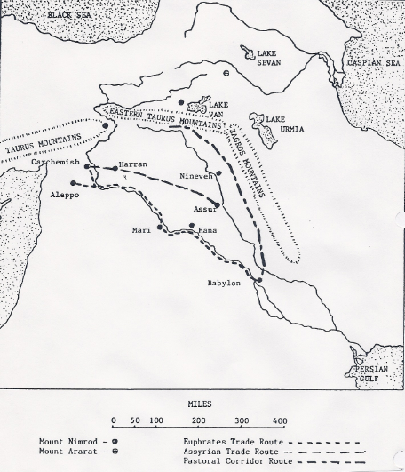
Ether 2:1 Jared . . . went down into the valley which was northward (Illustration) [EASTERN MIGRATION THEORY]: Map II The uprooting of the Jaredites should not be viewed as a unique phenomenon, but as part of a much larger scattering of vast numbers of people in ancient Mesopotamia. Map II shows three established trade routes along the Euphrates River or from Asshur on the Tigris River across northern Mesopotamia to Harran and Carchemish (the land northward). [Randall P. Spackman, The Jaredite Journey to America, pp. 27-29, unpublished]

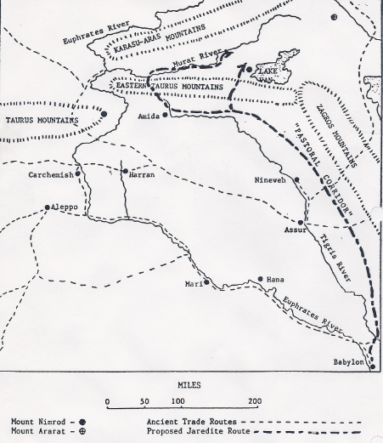
Ether 2:1 Jared . . . went down into the valley which was northward (Valley of Nimrod) [Illustration] [EASTERN MIGRATION THEORY]: Map III, A proposed Jaredite route from Babylonia] [Randall P. Spackman, The Jaredite Journey to America,, p. 37, unpublished]

Ether 2:1 Jared . . . Went down into the Valley Which Was Northward [Valley of Nimrod] [SOUTHERN MIGRATION THEORY]:
Although Del DowDell favors the Southern Migration Theory, he places his Valley of Nimrod in a different location than George Potter. He writes that by assuming that the tower of Babel was in the area of present day Babylon, which is along the Euphrates River, and that the group went northward from there (Ether 2:1), their travels would take them from the east bank in the basic direction of present day Baghdad. . . .
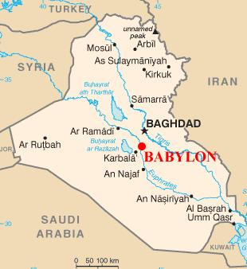
Location of Buhayrat ath Tharthar [Lake Tharthar]

Since the Brother of Jared was directed to lead the colony “down into the valley which is northward” (Ether1:42) and that valley was known by the name of Nimrod (Ether 2:1) . . . it might be assumed this valley was relatively close to the area in which Jared and his friends lived, and closed enough to the tower of Babel for them to know of it and the confusion of tongues taking place there (Ether 1:33) . . .

We do not know from scripture the exact location of the Valley of Nimrod, . . . however, an interesting geographical area exists just north and west of Baghdad between the Tigris and Euphrates rivers, on what would have been near the edge of the Land of Shinar . . .

Since Mesopotamia is mostly flat, level land, occasionally broken up by wadis, there seems to be only one area where this valley could possibly have been—and that is a [modern-day] lake area northwest of Baghdad known as Buhayrat ath Tharthar [Lake Tharthar]. This is a man-made lake or reservoir of deep, fresh water, covering 230,000 hectares. The three-mile long Samara Dam was built in 1954 for irrigation and controlling the floods of the Tigris and Euphrates rivers, which created [Lake Tharthar] which is today one of the most beautiful artificial lakes in Iraq. . . .

In ancient times this lake area was a deep depression with several wells . . . In antiquity, this low lying depression could well have been described as a valley northward from Babylon, with wells, animal and plant life to support a gathering of Jaredites and their livestock for a short period of time. [Del DowDell, Who Really Settled MesoAmerica?, pp. 61-63]
Ether 2:1 Flocks Which They Had Gathered Together:

Edward Butterworth writes that if the Jaredites were told to carry flocks of “every kind” with no reference to “herds”, it suggests that they were to have a good supply of small animals and fowl. Sheep, goats, and some fowl may have been the extent of the “flocks” mentioned here. [Edward Butterworth, Pilgrims of the Pacific, p. 36]

Ether 2:1 [They] Went . . . with Their Flocks . . . Fish . . . Bees . . . All Manner of That Which Was upon the Face of the Land [EASTERN MIGRATION THEORY]:

In relating the account of the Jaredites, Moroni writes:

[They] went . . . with their flocks which they had gathered together, male and female, of every kind. and they did also lay snares and catch fowls of the air; and they did also prepare a vessel, in which they did carry with them the fish of the waters. And they did also carry with them deseret, which, by interpretation, is a honey bee; and thus they did carry with them swarms of bees, and all manner of that which was upon the face of the land . . . (Ether 2:1-3)

According to Hugh Nibley, it is a remarkable thing that the mention of flocks of any kind is conspicuously absent from the story of Lehi's exodus to the Promised Land. What an astonishing contrast from the story of the Jaredites! The one group hastening away from Jerusalem in secrecy to live a life of hunting and hiding in the desert and almost dying of starvation, and the other accepting volunteers, as it were, from all sides, moving out in a sort of massive front, driving innumerable beasts before them and carrying everything from libraries to hives of bees and tanks of fish! It would be hard to conceive of two more diametrically opposite types of migration, yet each fits perfectly with the customs and usages recorded throughout history for the part of the world to which the Book of Mormon assigns it.

But how could the Jaredites have carried all that stuff with them? The same way other Asiatics have always done--in wagons. And such wagons! "Measuring once the breadth between the wheel ruts of one of their carts," William of Rubruck reports, "I found it to be twenty feet over . . . I counted twenty-two oxen in one team, drawing a house upon a cart . . . the axletree of the cart was of huge size, like the mast of a ship. " It is generally agreed that ox-drawn vehicles were older than horse-drawn, but both go back to the fourth millennium B.C. [Hugh Nibley, The World of the Jaredites, pp. 187-189]

Ether 2:2 They Did Also Lay Snares and Catch Fowls of the Air:

According to Warren and Palmer, in the Sumerian culture there were fowlers who caught birds with an arsenal of nets.
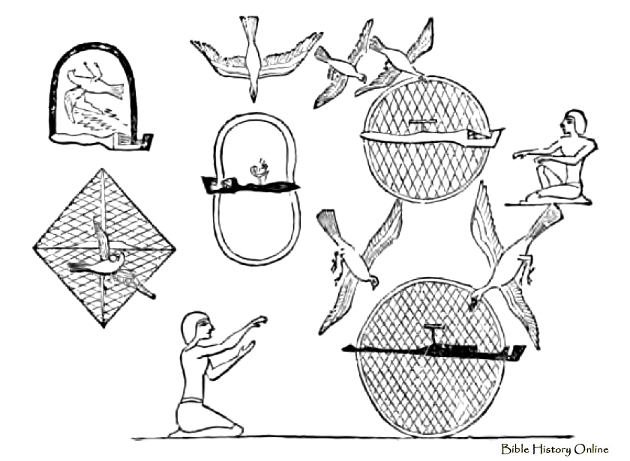
Deliveries of fifty-four roasted birds are recorded in Sumerian documents. This would explain the phrase in Ether, "and they did also lay snares and catch fowls of the air" (Ether 2:2). Many of those fowl were taken on the final boats used by the Jaredites to cross the ocean (Ether 6:4). According to Mesoamerican scholars, birds were also an important part of the diet in the Olmec site of San Lorenzo (Coe and Diehl, 1980). [Bruce W. Warren and David A. Palmer, The Jaredite Saga, ch. 4, unpublished]

Ether 2:2 They Did Also Prepare a Vessel, in Which They Did Carry With Them the Fish of the Waters:

According to John Heinerman, fishing activity and a thriving fishing industry were already in place and served as a major source of Sumer's food supply, especially during construction of the Great Tower on the plains of Shinar. However, it is interesting that the world's first glass fish aquarium was built in Sumer by some unidentified individual, who, according to historian Samuel Noah Kramer, "for one reason or another was an ardent lover of fish." A single cuneiform clay tablet, appropriately called by archaeologists the "Home of the Fish" document, "begins with a reassuring announcement that the speaker has built a house for the fish, large, spacious, and unapproachable, and provided it with fine food and drink, especially beer and sweet cookies." The speaker then urges his friends and acquaintances to join him in his "house of fish" and watch various live specimens swim around, while enjoying the food, snacks, and free beer and wine provided for that occasion.

The Book of Mormon tells of a similar portable aquarium being constructed by the Jaredites at the time they were told to abandon their residences near "the great tower at the time the Lord confounded the language did also prepare a vessel, in which they did carry with them the fish of the waters" (Ether 2:2). The ancient "Home of the Fish" tablet mentions sixteen different fish, only a few of which can be described with some reasonable degree of certainty--the carp, the sturgeon, the catfish, and the trout. [John Heinerman, Hidden Treasures of Ancient American Cultures, Springville: Cedar Fort, Incorporated, 2001, pp. 106-107]

Ether 2:2 They Did Also Prepare a Vessel, in Which They Did Carry With Them the Fish of the Waters:

It is interesting that the people who followed Jared and his brother "did also prepare a vessel in which they did carry with them the fish of the waters" (Ether 2:2).
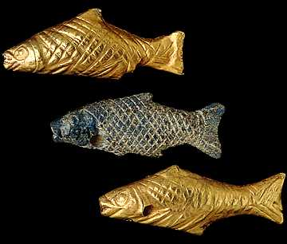
Mesopotamian Fish Amulets

According to Randall Spackman, more than fifty different types of fish were known to Mesopotamian fishermen, but it is not known how many freshwater varieties the Jaredites were able to carry in their specially constructed, watertight containers. [Randall P. Spackman, The Jaredite Journey to America, p. 30, unpublished]

[Note* Considering the fact that water weighs approximately eight pounds per gallon, some form of heavy transport would have been required to carry the tank, not to mention the manpower needed to position the tank. Nibley speaks of the cultural heritage of large wagons for land transport. However, a “vessel” can also be associated with a boat. And rather than huge water-tight containers, it is much easier to imagine porous containers connected to a boat for water transportation-- where there is no need to support huge amounts of weight, and where there is a more reasonable ability to keep the fish alive. [Alan C. Miner, Personal Notes]

Ether 2:2 They Did Carry With Them the Fish of the Waters:

The Jaredites carried vessels of fish. Edward Butterworth writes, do you suppose that fish was an important part of their diet? Some people, like the Polynesians make vessels of split bamboo and tow their fish behind them so they could have fresh ones when they wanted them. [Does that mean that the Jaredites traveled when they could by water?]
Butterworth continues: I have an idea they also used fish for other reasons. Probably to keep down algae and larvae in the water supplies near their camps along the way. By forming fish traps at the inlets and outlets of their water supply they could keep their fish from leaving and always have a good supply. [Edward Butterworth, Pilgrims of the Pacific, pp. 33-34]

Ether 2:3 They Did Also Carry with Them Deseret, Which, by Interpretation, Is a Honey Bee:

The word "deseret" is evidently transliterated from the original record, but fortunately the interpretation is included in Moroni's abridgment: "a honey bee" (Ether 2:3). This is one of the few Jaredite words transliterated in our present Book of Mormon; therefore it is of special significance to the scholars. Dr. Hugh Nibley has written extensively on the background of this word, including the following ideas:

By all odds the most interesting and attractive passenger in Jared's company is deseret, the honeybee. We cannot pass the creature by without a glance at its name and possible significance, for our text betrays an interest in deseret that goes far beyond respect for the feat of transporting insects, remarkable though it is. The word deseret we are told (Ether 2:3), "by interpretation is a honeybee," the word plainly coming from the Jaredite language, since Ether (or Moroni) must interpret it. Now it is a remarkable coincidence that the word deseret, or something very close to it, enjoyed a position of ritual prominence among the founders of the classical Egyptian civilization, who associated it very closely with the symbol of the bee. The people, the authors of the so-called Second Civilization, seem to have entered Egypt from the northeast as part of the same great outward expansion of peoples that sent the makers of the classical Babylonian civilization into Mesopotamia. Thus we have the founders of the two main parent civilizations of antiquity entering their new homelands at approximately the same time from some common center--apparently the same center from which the Jaredites also took their departure. The Egyptian pioneers carried with them a fully developed cult and symbolism from their Asiatic home. Chief among their cult objects would seem to be the bee, for the land they first settled in Egypt was forever known as "the land of the bee," and was designated in hieroglyphic by a picture of the bee, while the king of Egypt "in his capacity of 'King of Upper and Lower Egypt'" bore the title, "he who belongs to the sedge and the bee."

From the first, students of hieroglyphic were puzzled as to what sound value should be given to the bee-picture. . . . We know that the bee sign was not always written down, but in its place the picture of the Red Crown, the majesty of Lower Egypt was sometimes "substituted for the superstitious reasons." If we do not know the original name of the bee, we do know the name of this Red Crown -- the name it bore when it was substituted for the bee. The name was dsrt (the vowels are not known, but we can be sure they were all short). The "s" is dsrt had a heavy sound, perhaps best represented by "sh," but designated by a special character -- an "s" with a tiny wedge above it by which the Egyptians designated both their land and crown they served. . . . The bee symbol spread in other directions from its original home, wherever that was. . . . In all of these the bee is the agent through which the dead king or hero is resurrected from the dead, and it is in this connection that the bee also figures in the Egyptian rites. Now the original "deseret" people, the founders of the Second Civilization, "the intellectuals of On," claimed that their king, and he alone, possessed the secret of resurrection. That, in fact, was the cornerstone of their religion; it was nothing less than "the king's secret," the power over death by which he held his authority both among men and in the hereafter. . . . I am personally persuaded that the archaic and ritual designation of the bee was deseret, a "word of power" too sacred to be entrusted to the vulgar, being one of the keys to "the king's secret." [Hugh Nibley, The World of the Jaredites, pp. 191-192]

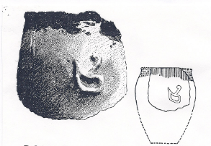
Ether 2:3 Deseret (Illustration): The Red Crown (Dsrt Crown) is clearly depicted on a prehistoric potsherd from Nakada, thus placing it among the oldest known symbols of royalty. It is the crown of the Lady Neith and is often substituted for the sign of the bee. Journal of Egyptian Archaeology 9, Plate XX (after Wainwright). [Hugh Nibley, There Were Jaredites, p. 321]

Ether 2:3 They Did Carry With Them Swarms of Bees:

The Mesopotamian civilization of Sumer is believed to have flourished between 4000 -1000 B.C. According to Vivian Morgan, in Sumer, honey was used in medicine as well as an offering to the gods before 2000 BC. Honey was a rare and expensive commodity in Ancient Mesopotamia.

To date, the first written record of its use as medicine was from a Sumerian clay tablet dated from 1900-1250 BC.

The Babylonians used it for the same reasons as well and ritual uses were referred to in the time of Hammurabi (around 1500 BC).

The earliest writing known of beekeeping comes from Governor/King Shamash-res-usur (781-745 BC) of Suhu, which was a small independent kingdom on the middle Euphrates river.

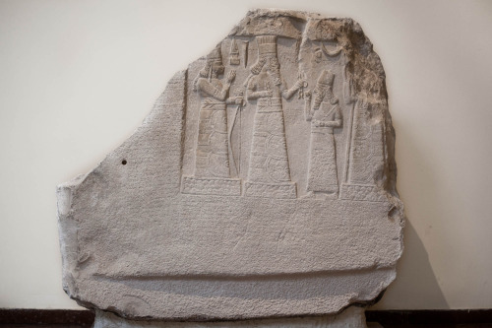
Shamsh-res-usur, governor of Mari and Suhi, attitude of prayer in front of the gods (Adad and Ishtar).
This Stele with inscription and relief is from the 8th century BCE and housed in the Palace Museum of Babylon (Ennigaldi-Nanna’s museum?). The inscription says that the governor reigned for 13 years and during his reign erected the city of Gabarri-ibni, while also re-establishing the canals and encouraging the planting of date palms in different cities, and working on the development of agriculture in the city of Suhi.

[He wrote concerning beekeeping and this little kingdom].

“I am Shamash-res-usur, Governor of Suhu and Mari. Bees which gather honey, which no one among my forefathers had seen [in Suhu?] nor brought down to the land of Suhu, I brought down from the mountains of Habha and established in the town Gabbari-ibni. They collect honey and wax. I understand how to do the melting out of honey and wax, and the gardeners also understand it. Any later person who appears let him ask the old men of the country [of Suhu] whether it is true that Shamash-res-usur the Governor of Suhu introduced bees."

The Egyptians, [who descended from Ham the son of Noah according to Bible chronology], knew the art of beekeeping and employed it extensively. Many raised their own bees for honey and wax. Like the Sumerians, honey was known to the ancient Egyptians (at least according to written records) for its healing benefits.

On the walls of the sun temple of Nyuserre Ini from the Fifth Dynasty, before 2422 BCE, workers are depicted blowing smoke into hives as they are removing honeycombs.[3][4] (see below)

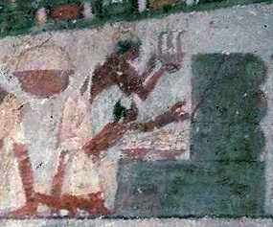
Egyptian workers blowing smoke into beehives

The Papyrus Ebers (medicinal Egyptian manuscript dating to 1550 BC) shows that honey was used extensively, both externally and internally

Sealed pots of honey were found in the grave goods of pharaohs such as Tutankhamun, an Egyptian pharaoh of the 18th dynasty who ruled from about 1332 BC – 1323 B.C. His famous tomb is pictured below.

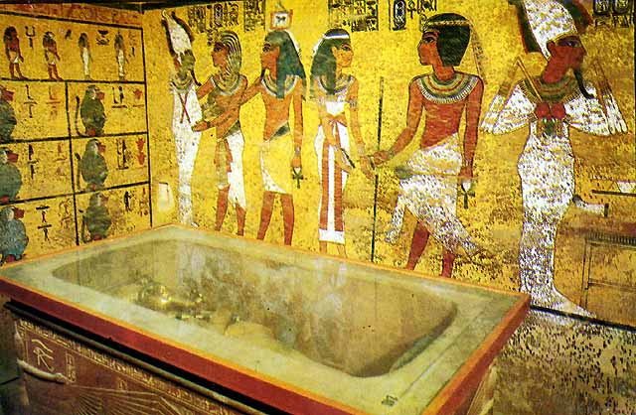
Tomb of Tutahkhamun

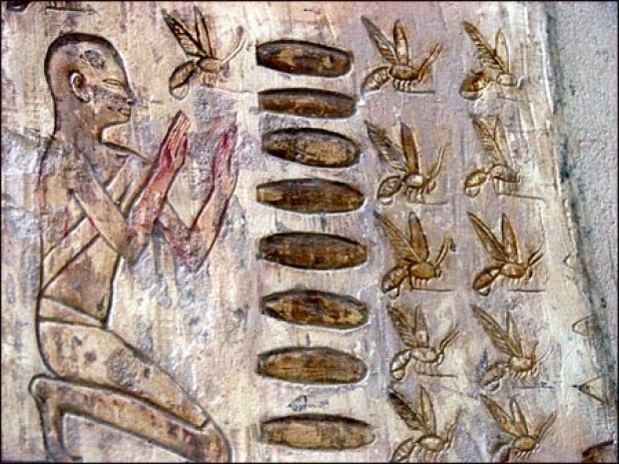
A hieroglyphic scene of an Egyptian worker gathering honey. This comes from the tomb of Pabasa. Pabasa, who was also called Pabes, has a large tomb at Asasif, just outside the entrance to Hatshepsut’s temple at Deir el-Bahri. Pabasa dates to the 25th dynasty or roughly about 700 B.C.

Vivian Morgan writes:

Some suggest [the use of honey] may be the oldest medicine known to man. Honey contains antibacterial agents as well as osmotic (draws out moisture) properties. . .
Honey is twice as sweet as cane sugar and considered to be a complete food. It contains half of all amino acids that are essential for human life and thirty-five percent of it is protein. The Greek Pythagoras was said to have existed on honey alone. It’s also long-lasting (no sell-by date needed). Jars placed in Ancient Egyptian tombs, several thousand years old, are still edible today. Perhaps this is why it’s also a symbol of immortality.

The God(s) are said to value this by-product of bees. The Promised Land was said to “flow with milk and honey” and honey was the best that God(s) could offer. It was also considered the food of these deities and represented immortality, rebirth and fertility. In Ancient Greece, honey was a sign of wisdom and Christians thought it to symbolize Christ’s compassion and gentleness.

Honey is symbolic of many other things. Its sweetness is thought to have bestowed gifts of learning and poetry. It was used as a symbol of the sun, partly because of the flowers from which it was made as well as the golden colour itself. Some saw it as a sign of wealth and abundance, probably because in ancient times it was a rare commodity that was mostly used by the wealthy.

Like the Sumerians, the Egyptians used honey and beeswax for other purposes as well. Ancient Egyptians would apply this material in mummification, boat building and metal casting.
[Vivian Morgan, “Honey – Ancient Egypt, Sumer and Modern Uses,” www.ancientworlds.net]

[Note* The following comes from an article posted on the Internet from members of the Artisans Gallery Team. They write:
Beekeeping was widely practiced in the ancient world. Bees and beekeeping are often depicted in ancient artwork. But let’s begin with the discovery in 2007 of remnants of ancient honey combs, beeswax and intact hives, attesting to a 3,000 year old beekeeping industry in Northern Israel. The Bible refers to Israel as a “land of milk and honey” but no mention of honey bee cultivation. These findings show that there was a highly developed beekeeping industry in the Holy Land. ("The Honey Bee in the Ancient World," blueterracotta.com)

[Note* Just because something like “swarms of bees” aren’t part of modern history or part of archaeology doesn’t mean that they didn’t exist. As with many archaeological finds, once they are uncovered, history is re-written. Take for example the following recent statement made about the presence of beekeeping in ancient Israel:

There are no textual references to beekeeping in ancient Syria-Palestine prior to the late Hellenistic period.[12] The Hebrew word for honey, debaš, like Akkadian dišpu, can refer to both bee honey and any number of sweet substances. Thus Canaan may have been the "land of milk and fruit syrup."[13] Explicit biblical mentions of bee honey refer to wild honey (e.g., Deuteronomy 32:13). It must be noted, however, that our understanding of ancient Levantine apiculture is changing: until recently it was believed that no conclusive archaeological evidence for beekeeping in the Levant had been found, but this has changed in light of the excavations at Tel Rehov in Israel, where an apiary dating to the tenth or ninth century BC was recently discovered.[14] ["A Brief Survey of Ancient Near Eastern Beekeeping" by Ronan James Head from FARMS Review: Volume - 20, Issue - 1, Pages: 57-66. Provo, Utah: Maxwell Institute, 2008]
[Alan Miner Personal Notes]
Ether 2:3 They Did Carry With Them Swarms of Bees (Southern Migration Theory):

George Potter writes:

Honey bees were not native to much of the ancient world. The earliest Biblical record of honey is when Jacob (Israel) instructed his sons to take a gift of honey to the Egyptian (Joseph) to try to win the release of his two sons (Genesis 43:11) Yet hundreds of years earlier, the Book of Mormon records that the Jaredites took honey bees with them from Mesopotamia to the seashore where they built their ships. Here the Book of Mormon is in harmony with what is known of the history of Mesopotamia (Sumeria). From the 21st Century B.C. the cuneiform writings of Sumeria and Babylonia mention honey bees.[xxxv]

What did the Jaredites do with their honey bees when they left for the promised land? When the Spanish conquered Mexico and Central America, they found that native populations of Mexico and Central America were beekeepers.[xxxvi] Yet, the New World bees were probably not the bees of the Jaredites, rather bees unique to the Americas.[xxxvii] The European honey bee which Native Americans called “white man’s flies” were not introduced in the Americas until 1638.[xxxviii] It is likely that the Jaredite honey bee was the warm climate dwarf bee Apis florea. These small wild bees range in the warm climates of southeast Asia. The bees of Mesopotamia could have been native, or brought there from India which had bees at that time and traded with Sumeria.[xxxix]


Apis Florea

The wild Apis Florea bees provide a fascinating aspect of the Jaredite trail. Apparently the Jaredites left their swarms of honey bees at the seashore. We can assume this for three reasons, 1.) there is no specific reference to taking bees aboard their ships (Ether 6:4), 2.) they were traveling in the hulls of air tight barges where swarms of bees would have been poor shipmates, and 3.) Old World bees were not found in the New World. The Dakakah trail would have led the Jaredites to the most suitable place to build their barges, at the inlet of Khor Rori (where much later Nephi probably constructed his ship). Nephi wrote that “we did come to the land which we called Bountiful, because of its much fruit and also wild honey, and all there things were prepared of the Lord that we might not perish” (1 Nephi 17:5, Italics add). Nephi seemed to realize that the Lord had prepared Bountiful with wild, not domesticated, honey. Honey bees are not native to Arabia, an area the size of Europe, except in Oman[xl]. The honey in Oman is still gathered mostly as wild honey, and the bees are still considered wild, being only “somewhat managed”.[xli] So how did these wild honey bees originally come to Oman? Did they fly across the Persian Gulf or were they left by the Jaredites?
Notes:
[xxxv] http://billybee.com/infocenter.html
[xxxvi] Ibid.
[xxxvii] Ibid.
[xxxviii] Ibid
[xxxix] http://billybee.com/infocenter.html. and Mininstry (Oman), p. 14,15)
[xl] http://www.fao.org/docrep/x0083e/x0083E02.htm.
[xli] hhtp://book.nap.edu/books/03094295X.html/364

[George D. Potter, “An alternative Model for the Jaredite Trail,” The Nephi Project (Nephiproject.com)]

Ether 2:3 They Did Carry With Them Swarms of Bees:

In Ether 2:3, mention is made that the people of Jared and his brother took with them the "honey bee." According to Randall Spackman, honey was rare and expensive in Babylonia; so, the transportation of honey bees by the Jaredites indicates that they carried the luxury items with them as well. [Randall P. Spackman, The Jaredite Journey to America, p. 30, unpublished]

J. Eric Thompson wrote that not only was the domestic bee in ancient America but that there were gods of bees and beekeepers. Honey was considered a real treat for the Indians. Equally important was the black wax taken from the hives which was often traded for other commodities. The existence of the bee, anciently, is supported by Ignacio Bernal whose specialty was the Olmec civilization.(n.18) [Diane E. Wirth, A Challenge to the Critics, p. 56] [Note* The Olmec civilization coincides with the times of the Jaredites]

According to Verneil Simmons, the stingless bees (Meliponidae) of the tropical areas of the Old World were also found in the tropical areas of the New World, although they were unknown in Peru. Columbus found honey from these bees in his first landing in Cuba. The Mayas of today still raise them and Maya lore concerning beekeeping was ancient long before the arrival of the Spaniards. Sahagun, the great Spanish priest historian of the early days of the Conquest in Mexico, wrote that the Aztecs kept three kinds of honeybees. In a newly discovered wall painting at the ancient city of Cholula, in Mexico, a bee is depicted hovering over a drinking scene. . . . The stingless bees of the Maya are hived in hollow logs. Left to themselves they will build nests in hollow trees or even in the ground. Their nests are well insulated and the bees are capable of surviving for long periods sealed up in the nests. This type could have survived the long journey of the Jaredites. (See The Social Behavior of the Bees, Michener, pp. 23, 329). [Verneil W. Simmons, Peoples, Places and Prophecies, pp. 32, 120, 272]

According to Warren and Palmer, linguistic data on the proto-Mixe-Zoque speakers (the Mesoamerican equivalent of Jaredite times) gives evidence for things spoken of in the Book of Ether, such as the honey bee, not explicitly proven archaeologically for that time period. There was a word for honey (spelled one way) and also a word for bee (spelled another way). [Bruce W. Warren and David A. Palmer, The Jaredite Saga, pp. 8-6,7, unpublished]

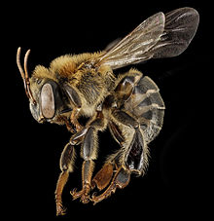
Ether 2:3 They Did Also Carry with Them Deseret, Which, by Interpretation, Is a Honey Bee (Illustration):
Melipona bee [Internet images, en.wikipedia.org]

Ether 2:3 They Did Carry With Them Swarms of Bees:

Douglas Christensen writes that because Old World bees were not found in the New World, some have postulated that the Jaredites didn’t take bees with them on their voyage across the great sea to the promised land. And this is probably a good assumption. Christensen notes that this reasoning assumes that the bees carried by the Jaredites were the apis melifera (Old World) species. However, Christensen reasons that the Jaredites may have carried with them the Asian bee melipona, which was the most likely bee of ancient Mesoamerica. The Jaredites might also have brought the apis melifera which later became extinct. Whatever the case, we just don’t know. [Douglas K. Christensen, “The Sacred Honey Bee,” Book of Mormon Archaeological Forum]

Ether 2:3 Seeds of Every Kind:

According to John S. Thompson, by applying some techniques of literary analysis to the Jaredite exodus narrative in Ether 1–3 and 6, the text reveals that it is more than just a historical account. The author or editor of the narrative uses imagery and dialogue to help the reader look beyond the historical facts and see elements of the creation, Christ, and temples, among other things.

Ether 2:1–3 also reflects Creation imagery in the "seeds of every kind," "fowls of the air," "fish of the waters," "flocks," and even the creeping things of the earth—the "swarms of bees"—which the Jaredites take with them on their journey. The request in verse two that the Jaredites prepare a vessel for carrying fish seems odd to the modern reader, especially since the Jaredites would be traveling on water more than once (see Ether 2:6), but the imagery of Creation would not be complete without it, for every type of created being mentioned in Genesis 1–2 is represented here. These three simple verses could have been left out of the record if the writer's purpose was to report major events in the lives of the Jaredites, and, due to the difficulty of engraving on metal plates (see Jacob 4:1), superficial data would most likely be excluded. Therefore, the inclusion of this Creation-related data is a perfect example of how the selection of material gives the reader insight into the theme or themes which the author/editor tries to develop. [John S. Thompson, “The Jaredite Exodus: A Literary Perspective of a Historical Narrative,” Journal of Book of Mormon Studies 3/1 (1994)]

Ether 2:3 Seeds of Every Kind:

Edward Butterworth writes that it is obvious that since the Jaredites had “seeds of every kind” that the Jaredites were accomplished farmers. Farming and irrigation were developed to a high degree in ancient Babylon and Assyria. You can find many references to this. We find that the Jaredites carried with them “swarms of bees” (Ether 2:3) The most important reason for carrying the bee was to pollinate their crops. Over one hundred thousand kinds of plants require bees in order to produce seeds. [Edward Butterworth, Pilgrims of the Pacific, pp. 28, 32]

Ether 2:3 Seeds:

The people who followed Jared and his brother took with them "all manner of that which was upon the face of the land, seeds of every kind" (Ether 2:3). According to Randall Spackman, the Jaredite inventory of seeds certainly would have included barley and onions, the staples of the Babylonian diet. Other plants represented could have been wheat, millet, rye, lentils, beans, garlic, turnips, peas, cucumbers, cabbage, lettuce, apples, pomegranates, figs, apricots, grapes, pears, plums, cress, cumin, coriander, and mustard. Nuts such as pistachios and almonds could have been gathered from the foothills. [Randall P. Spackman, The Jaredite Journey to America, p. 30, unpublished] [Note* SEE John Sorenson’s publications on ancient transoceanic transmission of plant and animal life.]

Ether 2:3 Seeds:

In Ether 2:3 it mentions that the Jaredites carried with them “seeds of every kind.” Presumably some of those seeds would have been carried across the ocean and ended up being planted in America many hundred years before Christ. Concerning the idea of ancient transoceanic travel and the transport of seeds or plants John Sorenson writes:

Latter-day Saints may have wondered why virtually all secular scholars and scientists have rejected the idea that ancient sailors succeeded in voyaging from the Old World to the New. Their rejection is not just in reference to the Book of Mormon story but against all claims that seaborne migrants capable of having any significant effect breached the ocean barrier prior to Columbus, except for a few Vikings considered of no historical importance. Prevailing views by reputed experts have assumed that "primitive sailors" would have found it impossible to cross the "forbidding" oceans.1 In the 1930s one scholar even spoke of the American continents as being "hermetically sealed by two oceans."2 Such views were not so much scientific conclusions as echoes of the prevailing isolationist political doctrine of the times that refused to grant value to "foreign" people or ideas. Thus famous Maya archaeologist Sylvanus Morley opined in 1927 that there was "no vestige, no infinitesimal trace, of Old World influence . . . to detract from the [inventive] genius of our [sic] native American mind." "There is no room for foreign origins here," he went on to claim in his article entitled "Maya Civilization 100% American."3 By the end of the 20th century this absolute view had eased only insignificantly. . . .
By the year 2000 I had concluded that the only way to break this particular intellectual logjam was to put forward hard scientific evidence that doubters could not explain away by offhanded reference to the inventiveness of the human mind. The approach I desired could best be pursued by demonstrating that the flora and fauna of the New World had been shared with the Old World. Some useful research had already established a limited body of such evidence. These concrete biological features would be important because no one can claim that the human mind had invented the same plant on opposite sides of the ocean.10
Floral Evidence for Diffusion
Over the last four years 98 species of plants have been identified that originated in either the Old World or the New yet were also grown in pre-Columbian times in the opposite hemisphere. That distribution cannot be explained the way cultural parallels have been by inventionist-minded scholars. A plant is an objective fact that demands a physical explanation for the presence of the same species on two sides of an ocean . . . For example, some have supposed that seeds were carried thousands of miles by birds, or evolutionary processes have been claimed as yielding identical species in multiple locations, but these notions are never more than nonempirical speculation.11 The only rational explanation for multiple plant distributions is that people sailed across the oceans before Columbus, nurturing and transporting plants en route . . .
As I dug into neglected books and journals, the number of plants reported to be shared across the oceans mounted . . .
Sorenson then provides an extensive list of "Plants for Which There is Decisive Evidence of Transoceanic Carriage." What follows below are just of few of the plants whose culture would date them to Jaredite times:
Plants for Which There is Decisive Evidence of Transoceanic Carriage
Species Common Name From To By
Agave sp. agave America India 300 BC
Amaranthus amaranth America Asia BC
Ananas comosus pineapple America Middle East, India 600 BC
Annona squamosa sweetsop America India 2500 BC
Arachis hypogaea peanut America China, Indonesia 2800 BC
Argemone mexicana prickle poppy America India 1100 BC
Canavalia ensiformis jack bean America India 1600 BC
Datura metel datura America Asia, Europe BC
Luffa acutangula ribbed gourd India America BC
Luffa cylindrica vegetable sponge Asia America 1200 BC
Macroptilium lath. phasey bean America India 1600 BC
Mimosa pudica sensitive plant America India BC
Mollugo verticillata carpet weed Eurasia America BC
Musa x paradisiaca banana, plantain South Asia Middle America BC
Phaseolus lunatus lima bean America India, China 1600 BC
Phaseolus vulgaris kidney bean America India, Middle East 1600 BC
Zea mays maize, corn America Eurasia, Africa? 2500 BC

[John L. Sorenson, “Ancient Voyages Across the Ocean to America: From ‘Impossible’ to ‘Certain’, in Journal of Book of Mormon Studies 14/1 (2005)]

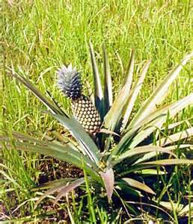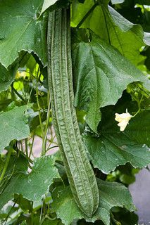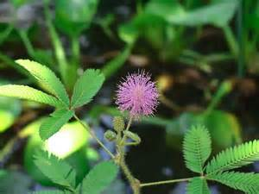
Pineapple ribbed gourd sensitive plant


Plantains compared with normal bananas Lima beans

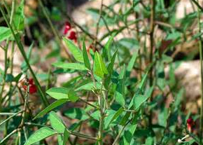
Phasey bean Zea Mays (Indian Corn)

Ether 2:4 The Lord Came down and Talked with the Brother of Jared; and He Was in a Cloud:

According to Lee Donaldson, anciently covenants that man made with God were entered into with a specific formula which bound both parties. The biblical scholar George Mendenhall identified six common steps in ancient covenants and treaties (Interpreter's Dictionary 1:714). These elements are as follows: (1) the preamble, (2) historical prologue, (3) stipulations, (4) blessings and curses, (5) witnesses, and (6) deposit and public reading of the covenant.

The first element, the preamble, like all ancient preambles, contains the names of both parties to the covenant. This preamble also mentions the physical location where the covenant is established. . . . This is accomplished in Ether 2:4 which says, "And it came to pass that when they had come down into the valley of Nimrod the Lord came down and talked with the brother of Jared; and he was in a cloud, and the brother of Jared saw him not."

Anciently, the preamble also contained a token of the superior authority of the one setting the terms of the covenant. The same is true with the Book of Mormon covenant to serve the God of the land, as found in the book of Ether. Moroni noted that the Lord came down in a cloud. The cloud was a divine token of the power and glory of the king of heaven. For instance, this was the same token of authority that the Lord used in creating the preamble to the Sinai covenant with Moses (Exodus 199). The cloud also led the covenant people through the wilderness (Exodus 13:21) and was a heavenly sign of the Lord's authority in the Savior's transfiguration (Matthew 17:5). Additionally, the Doctrine and Covenants equates the clouds of heaven with "the glory of the Lord" (D&C 84:5). [Lee L. Donaldson, "The Plates of Ether and the Covenant of the Book of Mormon," in The Book of Mormon: Fourth Nephi through Moroni, From Zion to Destruction, pp. 70-71]

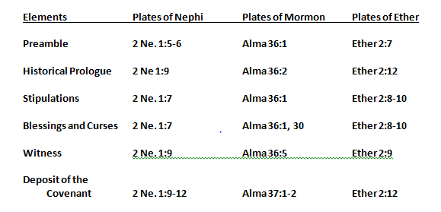
Ether 2:4 The Lord came down and talked with the brother of Jared (Illustration): The biblical scholar George Mendenhall identified six common steps in ancient covenants and treaties (Interpreter's Dictionary 1:714). [Lee L. Donaldson, "The Plates of Ether and the Covenant of the Book of Mormon," in The Book of Mormon: Fourth Nephi through Moroni, From Zion to Destruction, p. 73]

Ether 2:5-13 They Should Go Forth into the Wilderness . . . They Should Come Forth Even unto the Land of Promise (Covenant Language and Structure):

At the end of the first chapter of the Book of Ether (chapter 1:33-43), the brother of Jared had “cried” to the Lord that he, his “brother,” and his “friends” might escape the wrath of God resulting from the conduct of the people at the great tower, and that the Lord would ”confound not our language.” (1:36) The Lord responded and told the brother of Jared to “go at the head of them down into the valley which is northward. And there will I meet thee and I will go before thee into a land which is choice above all the lands of the earth.” (1:42)

In Ether chapter 2 we find that after the brother of Jared complied with what the Lord commanded, “the Lord came down and talked with the brother of Jared” (2:4)

Here in Ether 2:5-13 Moroni inserts the Lord’s compliance with the covenant that was made and recorded in Ether chapter 1. According to Donald Parry, parallelism is universally recognized as the characteristic feature of biblical poetry. (p. i) Apparently, the prophets and writers of the scriptures employed the repetition of alternating parallel lines for the purpose of reinforcing their teachings and doctrines. (p. x)

Ether 2:5-13
5. And it came to pass that the Lord commanded them that they should go forth into the
wilderness.
Yea into that quarter where never had man been.
And it came to pass that the Lord did go before them, and did talk with them as he stood in a
cloud, and gave directions whither they should travel. . . .
6. And it came to pass that they did travel in the wilderness, and did build barges, in which they
did cross many waters, being directed continually by the hand of the Lord.

7. And the Lord would that they should come forth even unto the land of promise, which
was choice above all other lands, which the Lord God had preserved for a righteous
people.

According to Parry, the verses that follow (8-10) are an "extended alternate" type of parallelism, which takes the form A-B-C-D/A-B-C-D. (p. xiii). This parallelism emphasizes the decrees of God concerning the land of promise.
8. a. And he had sworn in his wrath unto the brother of Jared, that whoso should possess this
land of promise,
b. from that time henceforth and forever, should serve him, the true and only God,
c. or they should be swept off
d. when the fulness of his wrath would come upon them.
9. a. And now, we can behold the decrees of God concerning this land, that it is a land of
promise;
b. and whatsoever nation shall possess it shall serve God,
c. or they shall be swept off
d. when the fulness of his wrath shall come upon them.
And the fulness of his wrath cometh upon them when they are ripened in
iniquity.

10. a. For behold, this is a land which is choice above all other lands;
b. wherefore he that doth possess it shall serve God
c. or shall be swept off; for it is the everlasting decree of God.
d. And it is not until the fulness of iniquity among the children of the land, that
they are swept off.
[Donald W. Parry, The Book of Mormon Text Reformatted according to Parallelistic Patterns, F.A.R.M.S., p. 455]

[Note* In verse 11 Moroni inserts his own additional covenant witness and warning:

11. “And this cometh unto you, O ye Gentiles

that ye may KNOW the [covenant] decrees of God—
that ye may repent, and not continue in your iniquities until the fulness come,
that ye may not bring down the fullness of the wrath of God upon you
as the inhabitants of the land have hitherto done.

12. Behold, this is a choice land, and whatsoever nation shall possess it shall be free from
bondage, and from captivity, and from all other nations under heaven,
if they will but serve the God of the land, who is Jesus Christ, who hath been manifested
by the things which we have written.

13. And now I [Moroni] proceed with my record. . . .

Moroni lets us know that we should not be amiss if we look at the language of the story being told in the Book of Ether as being shaped by the covenants that the Lord made with the Jaredites. At times that language might be very symbolic.

The history recorded in the Book of Mormon is shaped by covenants. For example, the same type of covenant language as recorded above by Moroni can be found in the Nephite record. In 1 Nephi 2:19-20 and in 2 Nephi 1:5-20 we find a similar covenant witness concerning this land of promise as recorded by Nephi. Mormon also included this covenant language in his abridgment of the Nephite record.

[Alan Miner, Personal Notes]

Geographical Theory Map: Ether 2:5 Into That Quarter Where Never Had Been Man (Year )

Choose: Eastern Migration Theory Choose: Chronology-- Year
Western Migration Theory
Southern Migration Theory

Ether 2:5 They Should Go Forth into the Wilderness, Yea, into That Quarter Where There Never Had Man Been [EASTERN MIGRATION THEORY]:

The Lord commanded Jared and his brother that "they should go forth into the wilderness, yea, into that quarter where there never had man been" (Ether 2:5).

According to Randall Spackman, the "wilderness" or "quarter where there never had man been," into which the Jaredites moved from the valley of Nimrod, may be the vast mountainous region around Lake Van and Mount Ararat. This region had been populated prior to 2000 B.C., but the area was basically deserted for about 500 years. Perhaps this depopulation was connected with the tremendous climatic changes that resulted in the diminished flows of the Tigris and Euphrates Rivers and the warm sub-Boreal period across all of Asia . . . The phrase "quarter where there never had man been," as a description of this area, may be reflected by the Assyrian king Tiglath-Pileser I (1115-1077 B.C.) who campaigned in these Armenian highlands. His annals record: "By toilsome paths and arduous passes, through which no king before me had gone, by hidden tracks and unmade roads I led my armies . . ." [Randall P. Spackman, The Jaredite Journey to America, p. 35, unpublished]

[Note* The Book of Mormon student might wonder if the definition of the term "wilderness" here in Ether 2:5 gives the reader any help with understanding that term as it is used in other parts of the Book of Mormon story. If we were to go strictly by the text, then the term "wilderness" would apparently refer to a region where "there never had man been." However, by placing the story in a real-world setting, the term "wilderness" might also imply a mountainous region. [Alan C. Miner, Personal Notes]

Ether 2:5 They Should Go Forth into the Wilderness, Yea, into That Quarter Where There Never Had Man Been [EASTERN MIGRATION THEORY]:

According to Hugh Nibley, from the plain of Shinar (the location of the tower), the Jaredites moved northward into a valley named after Nimrod, the mighty hunter, and thence "into that quarter where there never had man been." This would take them into the land of great broad valleys where the Tigris, Euphrates, Kura, and Araks rivers have their headwaters, a "hub of radiating valleys and routes to which the Euphrates owes its importance as a highway of commercial and military penetration. The frequent occurrence of the name of Nimrod in this area may not be without genuine significance, for no historical phenomenon has been more thoroughly demonstrated than the extreme tenacity of place names. [Hugh Nibley, The World of the Jaredites, p. 181] [See the commentary on Ether 2:1]

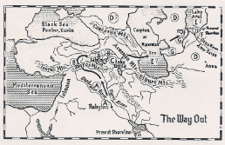
Ether 2:5 Into that quarter where there never had man been (Illustration) [EASTERN MIGRATION THEORY]:
A. The Land of Shinear, where the Great Tower was (P. Dhorme, in Rev. Biblique (1928): 509-511). Ether 1:33.
B. "The valley which was northward" (2:1). (The northern headwaters of the Euphrates "command a hub of radiating valleys and travel routes, to which the Euphrates owes its importance as a highway of commercial and military penetration." A. Moret, Hist. de l'Orient 1:306).
C. "And the name of the valley was Nimrod" (2:1). Nimrod country: home of Nimrod place-names and legends. (N. Emin).

D. "That quarter where there never had man been" (2:5). Anau, once thought to be the oldest city in the world, was originally built in a wilderness.
E. "The sea in the wilderness" (2:7). Both the Aral and Caspian Seas were much larger in ancient times than they are today.
F. "Many waters" (2:6). The Turanian plain was anciently full of lakes, marshes, and streams. The Oxus Delta was a vast lake.
G. Ancient course of the Oxus (as recently as the time of Alexander), now dried up.
[Hugh Nibley, The World of the Jaredites, p. 202]

Ether 2:5 Into That Quarter Where There Never Had Man Been (EASTERN MIGRATION THEORY):

According to Glenn Scott, as Jared's colony traveled northward, they probably followed the course of the River Tigris because had they followed the other great river, the Euphrates, they would have been diverted far to the west of the mountain valley named for Nimrod (Ether 2:4). It would also have added some 270 miles to their journey, only to bring them to the same area near Mount Ararat.

Following the Tigris River, at about 260 miles north of Babel, they would reach one of the major cities of that distant time. Originally named Calah, it is said to have been built by Asshur, one of the sons of Shem (Genesis 10:11). Later it was renamed Nimrud, no doubt by (or in honor of ) the mighty hunter who unified the cities of Mesopotamia under his rule. Another 180 miles north they would pass a mountain called Nimrut Dagi and a small lake called Nimrut Golu, just west of a much larger lake named Van Golu or Lake Van. Lake Van may have been the first of the "many waters" they crossed on their long journey (Ether 2:6). [Glenn A. Scott, Voices from the Dust, p. 25]

Ether 2:5 They Did Travel in the Wilderness [EASTERN MIGRATION THEORY]:

According to Glenn Scott, there are many reasons for concluding that as Jared's colony "traveled in the wilderness" (Ether 2:6) from the Valley Nimrod, they probably traveled east rather than west.
First, had they gone west, they would likely have encountered other peoples (from the great tower) known to have appeared in Europe in the latter part of the fourth millennium B.C.
Second, was the extreme length of their migration as indicated by the Brother of Jared's cry to the Lord, "thou . . . hath driven us forth, and for this many years we have been in the wilderness" (Ether 3:3).
Third, the customs of the Jaredites, as described by Ether, were remarkably like those of the Mongol tribes of east Asia.
Fourth, "the wind did never cease to blow towards the promised land" (Ether 3:3). From the rotation of the earth, the prevailing westerlies blow around the earth from west to east.
Fifth, the extreme length of their sea voyage (344 days) could only have been across the Pacific which covers one-third of our world, and is many times wider than the Atlantic.

We have no way of knowing exactly how many years Jared's colony may have wandered on their long migration across the uncharted steppes and mountains of Asia. Ether 3:3 records the brother of Jared as saying, "O Lord, thou . . . has driven us forth, and for these many years we have been in the wilderness . . ." For an idea of the length of their journey, let us make a comparison. The famous Lewis and Clark expedition went a straight line distance of approximately 1,800 miles, but by following the winding rivers and mountain valleys from St. Louis to the Pacific coast, they actually travelled about 4,000 miles. By the same ratio, the roughly 7,000-mile airline distance from Babel, north to Valley Nimrod then east to the Pacific coast of China, would represent over 15,000 rugged land miles. [Glenn A. Scott, Voices from the Dust, p. 27]

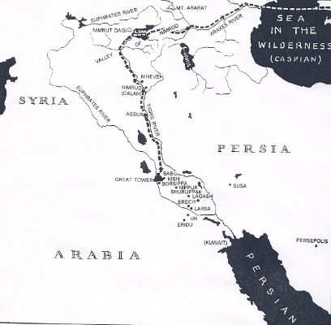
Ether 2:5 Into that quarter where there never had man been (Illustration) [EASTERN MIGRATION THEORY: The Initial Migration Route of the Jaredites. The Jaredites left the site of the Great Tower and traveled north to the valley called Nimrod. Sometime thereafter they crossed the Sea in the Wilderness beginning their long, long migration across central Asia. [Glenn A. Scott, Voices from the Dust, p. 26]

Ether 2:5 They Should Go Forth into the Wilderness, Yea, into That Quarter Where There Never Had Man Been [WESTERN MIGRATION THEORY]:
According to Brant Gardner, if the Jaredites traveled to “the valley which was northward,” they logically went through the river valley of either the Tigris or the Euphrates.(n.2) . . . The headwaters of both are in the mountains east of the Mediterranean. Although the Jaredites do not know their final destination, they will cross water, meaning, geographically, that they will be heading for the Mediterranean. Although there is no evidence for either [river] valley I see the Euphrates route as more plausible, since it brought them more directly to the Mediterranean shore.
Logically, the Jaredites followed a river valley (I suggest the Euphrates as more direct), until they reached the seashore. Either they embarked on the Black Sea and traveled through it to the Mediterranean, or they embarked directly on the Mediterranean.(n.4) I hypothesize that a likely scenario was sailing west across the Mediterranean, perhaps stopping in northern Africa or southern Spain
I interpret the statement ‘quarter were there never had man been’ as figurative, suggesting that God was sending the Jaredites away from urbanized civilization, not away from all human beings. Joseph Allen (who interprets the statement more literally and who favors an eastern migration and a voyage across the Pacific) makes the assumption that the “quarter where there never had man been” was [“parts of ]Asia.” While there might have been regions that were uninhabited, certainly all of Asia was not uninhabited.(n.8) . . . Allen writes that “Ixtlilxochitl and modern histories of the Chinese proclaim an Asian settlement from the great tower.” His assertion about modern Chinese histories is completely unsupported.” [Brant A. Gardner, Second Witness, Vol. 6: Fourth Nephi through Moroni, p.177-179, 183-184

Ether 2:5 They Should Go Forth into the Wilderness, Yea, into That Quarter Where There Never Had Man Been (SOUTHERN MIGRATION THEORY)
According to Potter, Linehan and Dickson, the Jaredites were instructed to go north to the Valley of Nimrod, where they would be met by the Lord. From the Valley of Nimrod, the Lord led them south into the Arabian wilderness desert) where they eventually took the Dakakah Trail through the Empty Quarter. . . .

The Book of Ether indicates that from the Valley of Nimrod the Jaredites were led directly into a wilderness or desert (Ether 2:5). The Tower of Babel is believed to have been within the city walls of ancient Babylonia(n. 4) (near today’s Baghdad). The Valley of Nimrod was north of Babel, probably near the ruins of Nineveh that was settled by Nimrod the hunter (Ether 2:1)(n5.) The ruins of Nineveh are approximately 250-300 miles north of the ruins of Baghdad. From the valley of Nimrod “the Lord commanded them that they should go forth into the wilderness.” The Book of Mormon does not state which direction whether north, south, east, or west, that the Jaredites took from Nimrod to reach the wilderness. . . .

The Book of Mormon specifically says, “The Lord commanded them [the Jaredites] that they should go forth into the wilderness, yea, into that quarter where there never had man been” (Ether 2:5). This clue is meaningless to most Westerners, but for anyone living in the Near East, where the Jaredites started their saga, it is a clear reference to southern Arabia . . . Arab mythology holds that God created the world, and that two quarters are where people lived, and that one quarter was the sea, and one quarter was the desert, were no man ever lived. To this day, the great sand desert of southern Arabia is called the Ar Rub Khali or Empty Quarter. Being larger than the state of Utah, the Empty Quarter of Arabia is the largest sand desert in the world, and there is still no archaeological evidence that man has ever dwelt therein.(n.8) [George Potter, Frank Linehan, and Conrad Dickson, Voyages of the Book of Mormon, Chap. 7: “Ophir the Jaredite’s Harbor,” pp. 201-202]

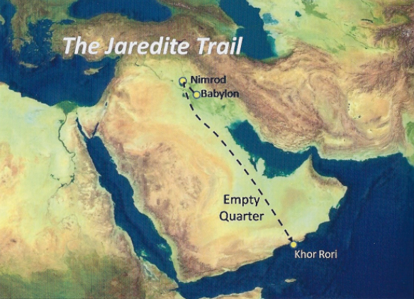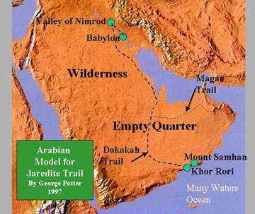
Ether 2:5 They should go forth into the wilderness, yea, into that quarter where there never had man been”(SOUTHERN MIGRATION THEORY) Route from the Valley of Nimrod to the Empty Quarter [George Potter, Frank Linehan, and Conrad Dickson, Voyages of the Book of Mormon, Chap. 7: “Ophir the Jaredite’s Harbor,” p. 202]

Ether 2:5 They Should Go Forth into the Wilderness, Yea, into That Quarter Where There Never Had Man Been (SOUTHERN MIGRATION THEORY)
Although Del DowDell favors a Southern Migration Route, he differs from Potter, Linehan and Dickson on the initial route from the Valley of Nimrod. DowDell writes that Ether’s account does not state the direction they traveled from the Valley of Nimrod, nor does it describe geographical features unique to Asia. All we know is that when Jared’s colony left the valley, they traveled in the wilderness and crossed many waters requiring them to build barges (Ether 2;6). They were also led to a sea in the wilderness (Ether 2:7). We do not know if that sea is the same as that great sea which “divideth the lands”(Ether 2:13), where the colony camped for four years, as some scholars claim, or a sea in the wilderness not connected to the great sea, or ocean; however, the scriptures seem clear enough that it was a separate sea. . . .
It should be noted that the mention of “sea in the wilderness” (Ether 2:7) skips in the narration too “did bring Jared and his brethren forth even to that great sea which divideth the lands” (Ether 2:13), with the writing in between a parenthetical note added by Moroni. So both comments about “sea” made in Ether’s narration should be read together. Whether this means the two seas are the same or different seas, is totally clear—that is, the term “that they should NOT stop beyond the sea in the wilderness” means that the colony went beyond a sea in the wilderness to a great sea where they camped. Obviously, the colony had to build barges to cross many waters before reaching this great sea (Ether 2:6) and their final camping site before embarking to the land of promise (Ether 6:4) . . .
While George D. Potter claims the Jaredites did not build barges to cross “many waters” until they reached the great sea, presenting the concept that it would have been faster to walk around waterways or small lakes encountered on their trek to the sea . . . However, Southern Mesopotamia is an area described as an alluvial salt marsh. [Walking around this area to get to the Empty Quarter –“where there never had man been”] would not be possible in this marshland region, since even today Arabs of the area use small craft and reed boats to travel through this swampy delta which stretches for miles in every direction in the upper flood plain that empties into the Persian Gulf. For the Jared colony to have crossed from the north of this area to the south, a distance of nearly two hundred miles in this swampy marshland filled with connecting rivers and lakes, would obviously have required some type of vessel. [Del DowDell, Who Really Settled MesoAmerica?, pp. 63-65]

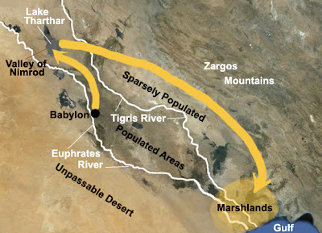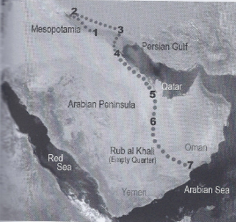
Ether 2:5 They should go forth into the wilderness, yea, into that quarter where there never had man been” (Illustration) (SOUTHERN MIGRATION THEORY) Left: Del DowDell’s proposed route from the Valley of Nimrod to the marshland of Southern Mesopotamia. Right: Del Dowdell’s proposed Southern Migration route. [NephiCode.blogspot]

Ether 2:5 Into That Quarter Where There Never Had Man Been(SOUTHERN MIGRATION THEORY)
According to Del DowDell , The scripture states that the “Lord would not suffer that they should stop beyond the sea in the wilderness: (Ether 2:7). If this “sea in the wilderness” was indeed the Persian Gulf, which is at the southern drainage of the marshland just crossed, and large enough to have been called a sea by the Jaredites, there is nothing but desert wilderness beyond. Through this wilderness, or uninhabited region, the colony traveled along the seashore in a southeasterly direction until they reached the area of the Qatar peninsula. From this point, they headed into the Ar Rab’al Khali, or Empty Quarter where truly “never had man been.” (Ether 2:5)
Once into this area, referred to simply as the Sands by the Bedouins, they would have picked up the Dakakah Trail . . . Actually it was not really a trail in the traditional sense—there were no worn tracks in the sand from long and steady use of camel caravans. The “trail” did not show up along this inland route until a couple of thousand years after the Jaredites crossed it. Yet it was a route because it moved from water hole to water hole, and would have been the only way to travel form north to south across the Arabian Peninsula through the Empty Quarter. [Del DowDell, Who Really Settled MesoAmerica?, pp. 80-81]
Ether 2:5 Into that quarter where there never had man been”(Illustration) (SOUTHERN MIGRATION THEORY) Map of Del DowDell’s proposed Southern Migration route . [Del DowDell, Who Really Settled MesoAmerica?, p. 81]

Ether 2:5-6 The Lord “Did Go Before Them in a Cloud: [SOUTHERN MIGRATION THEORY]
According to Potter, Linehan and Dickson, the Lord “did go before” the Jaredites “in a cloud, and gave directions whither they should travel” (Ether 2:5-6). The Lord led Moses and the children of Israel into Arabia (Midian)(n.9) in a cloud and a pillar of fire (Exodus 13:21). The Lord guided Lehi and his family through Arabia by giving them the Liahona (1 Nephi 16:10). . . . The reason the Lord had to guide them is simple for those who know and travel about Arabia: it is easy, and extremely dangerous to become disoriented in the wasteland deserts of Arabia. At the same time, it is nearly always fatal if one gets lost and misses the watering holes, a fact that is never truer than in the Empty Quarter where summer temperatures can climb to 145 degrees F. It must be remembered that the Jaredites traveled in an uninhabited place. There was no one to stop and ask directions to the next well . . .

The first successful Westerner to cross the Empty Quarter was Bertram Thomas, who made the crossing in 1930-1931.
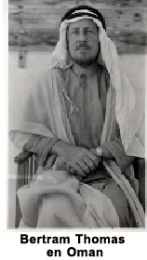
But he needed guides from the Murri tribe, who were the only people who knew how to find the watering holes of the ancient Dakakah Trail. The Dakakah trail is not a trail in the traditional sense—that is, there are no worn tracks in the sand. It is a series of distant watering holes, that if found, can support a passage through the Empty Quarter. [George Potter, Frank Linehan, and Conrad Dickson, Voyages of the Book of Mormon, Chap. 7: “Ophir the Jaredite’s Harbor,” p. 202]

Ether 2:7 The Jaredites Crossed a “Sea in the Wilderness” or “Many Waters” [SOUTHERN MIGRATION THEORY]
According to Potter, Linehan and Dickson, there is only one known route through the Empty Quarter, the Dakakah Trail . . . The trail ends at the Salalah Coastal Plain on the Indian Ocean in [modern-day] Oman, the place where most LDS scholars believe Nephi built his ship. In other words, the only trail across the Empty Quarter leads straight to the body of water that Nephi called Irreantum, meaning “many waters.” . . . [the same words—“many waters” applied to the Jaredites in Ether 6:7] . . .
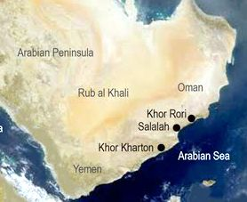
[That is,] If the Jaredites embarked from Khor Rori into the Arabian Sea, they would have had to cross many bodies of water (seas and oceans) to reach the New World [Thus the meaning of the term “many waters” is one of continuous connected water bodies [oceans & seas] that make up the “great sea which divideth the lands.” ]. [George Potter, Frank Linehan, and Conrad Dickson, Voyages of the Book of Mormon, Chap. 7: “Ophir the Jaredite’s Harbor,” p. 203-204]
[Note* According to Potter’s thinking, the “sea in the wilderness” spoken of in Ether 2:7 is a synonym for “many waters” and “great sea which divideth the lands.” Alan Miner, Personal Notes]

Ether 2:6 Many Waters:

According to Lee Donaldson, the ocean was described by the same term, "many waters," in different texts (1 Nephi 17:5; Ether 2:6, 6:7). Many waters is "an Old Testament expression which often designates the waters of chaos" (Interpreters's Dictionary 4:816). The Lord was the only one who could help both families pass through the chaos to the promised land. [Lee L. Donaldson, "The Plates of Ether and the Covenant of the Book of Mormon," in The Book of Mormon: Fourth Nephi through Moroni, From Zion to Destruction, p. 77]

Similar to the Israelites, the Jaredites also had to "cross many waters, being directed continually by the hand of the Lord" (Ether 2:6; compare 2 Samuel 22:16-18; Psalms 18:15-17). Moreover, the Lord "did go before them, and did talk with them as he stood in a cloud, and gave directions whither they should travel" (Ether 2:5; compare Exodus 13:21-22). Inasmuch as the Apostle Paul compared the Israelites' crossing the waters and being led by the cloud to baptism and the Holy Ghost, such a comparison might also be made with the Jaredites (see 1 Corinthians 10:1-4). From the scriptural motifs it seems evident that the Lord often leads his children into the wilderness, but he does not leave them alone. He gives them ordinances, the Gift of the Holy Ghost, and even his own presence. [Thomas R. Valletta, "Jared and His Brother," in The Book of Mormon: Fourth Nephi through Moroni, From Zion to Destruction, pp. 311-312]

Ether 2:6 They Did Build Barges, in Which They Did Cross Many Waters (WESTERN MIGRATION THEORY):

According to Warren and Palmer, in the Sumerian culture from which the Jaredites came, model boats have been found in excavations of houses in various places. A model boat (see illustration) gives some idea concerning typical Mesopotamian water-borne commerce. Such a boat could have been a major mode of transportation by the Jaredites on the first part of their journey up the Euphrates River. The Jaredites also built large "barges" (Ether 2:6) to cross the inland seas ("many waters"--"the sea in the wilderness"--Ether 2:6,7) and "barges after the manner which they had built" (Ether 2:16) to cross the ocean ("that great sea which divideth the lands"--Ether 2:16) In the Sumerian culture, commerce extended throughout the Persian Gulf and even outside of it into Oman and Pakistan. Ocean-going vessels were constructed from wood in large shipyards.

It is also clear that large barges were constructed in Mesoamerica subsequent to 1500 B.C. They would have been used among other things to move enormous Olmec heads over long distances in the state of Veracruz. [Bruce W. Warren and David A. Palmer, The Jaredite Saga, ch. 4, unpublished]

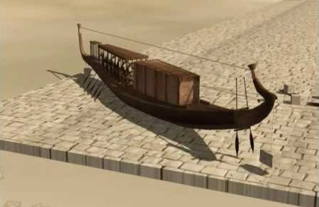
Ether 2:6 They did build barges, in which they did cross many waters (Illustration): A model boat that gives some idea concerning typical Mesopotamian water-borne commerce. [Internet images, maritime-connector.com]

Ether 2:6 They Did Cross Many Waters (EASTERN MIGRATION THEORY):

While traveling in "the wilderness," the group who followed Jared and his brother "did cross many waters" (Ether 2:6). According to Hugh Nibley, it is a fact that in ancient times the plains of Asia were covered with "many waters," which have now disappeared but are recorded as existing well down into historic times; they were of course far more abundant in Jared's time. . . . "The face of the country may have differed considerably from what it is now," says Vernadsky, "the rivers were much deeper and many lakes were still left from the glacial age which later turned into swamps." . . . The steady and continual drying up of the Asiatic "heartland" since the end of the last ice age . . . is a relatively recent discovery. Whoever wrote the book of Ether showed remarkable foresight in mentioning waters rather than deserts along the migrants' way, for most of the deserts are of very recent origin, while nearly all the ancient waters have completely vanished. [Hugh Nibley, The World of the Jaredites, pp. 183-184]

Glenn Scott writes that one of those records which documents these vast areas of water in central Asia was written in the fifth century B.C. by Herodotus, who explored the land of the Sythians between the Caspian Sea and Lake Balkhash. Even as late as his time, the land presented formidable water barriers to travel. [Glenn A. Scott, Voices from the Dust, p. 29]

Geographical Theory Map: Ether 2:5-6 Travel in the Wilderness--across Many Waters (Year )

Choose: Eastern Migration Theory Choose: Chronology-- Year
Western Migration Theory
Southern Migration Theory

Ether 2:7 The Lord Would Not Suffer That They Should Stop beyond the Sea in the Wilderness (EASTERN MIGRATION THEORY):

The Lord would not allow Jared's group to stop "beyond the sea in the wilderness" (Ether 2:7). According to Hugh Nibley, they had to cross the Caspian Sea, which was a vast sea at that time, twice as large, at least 2,000 miles long. It was huge, and after they crossed it, the Lord said that they had to keep going. [Hugh W. Nibley, Teachings of the Book of Mormon, Semester 4, p. 254]

According to Randall Spackman, the Jaredites, having entered "that quarter where there never had man been," first traveled through "wilderness," and then built "barges" and crossed "many waters," including a body of water large enough to be referred to as "the sea in the wilderness" (Ether 2:7). A northeasterly journey up the Murat River valley would have led the Jaredites into the depopulated region near Lake Van, past Mount Nimrod, and onto the vast empty plain at the foot of Mount Ararat. Not far from this plain, there was a passable route leading southeast toward the Caspian Sea and another route leading northward toward the Black Sea. Because of the ease of the water route using barges, the journey to "the sea in the wilderness" probably would have led toward the Caspian Sea, although a route to the Black Sea cannot be ruled out . . . Hugh Nibley stated that his own "guess" was that the Caspian Sea was the Jaredite "sea in the wilderness." Upon reaching the Caspian Sea, the Jaredites would have encountered the largest landlocked body of water in the world, a great salt lake lying below sea level. Virtually surrounded by desert areas, the Caspian Sea's major sources of water were the Volga and Ural rivers (see illustration). The sea may have been shrinking because of the diminished flow from the rivers, creating salt flats near the shoreline. [Randall P. Spackman, The Jaredite Journey to America, pp. 41,45, unpublished]

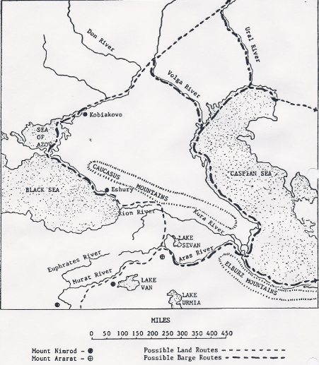
Ether 2:7 The sea in the wilderness (Illustration) (EASTERN MIGRATION THEORY): Map IV, Possible Jaredite routes near the sea in the wilderness. [Randall P. Spackman, The Jaredite Journey to America, p. 47, unpublished]

Ether 2:7 The Lord Would Not Suffer That They Should Stop beyond the Sea in the Wilderness, but He Would That They Should Come Forth (EASTERN MIGRATION THEORY):

According to Randall Spackman, there were a number of alternative routes that the Jaredites may have taken "that they should come forth" (Ether 2:7) and reach the borders of East Asia. The northern routes assume that the nomadic community traveled via the broad highway of the steppes of inner Asia. Based on the available information, this steppe highway would have been the most traveled and, therefore, most likely route. Whether they reached this highway through the Black Sea or the Caspian Sea, they would have moved eastward along a well-traveled trade route, through hospitable grasslands and across the "many waters" of southern Siberia. Eventually, the Jaredites would have been required to choose whether they would follow the trade route that led into the mining areas of the Altai Mountains or the less traveled route that led to Lake Baikal. These northern routes eventually would have led the wanderers through the mountains north of the Mongolian plateau and into the river valleys and grasslands of the plateau (see illustration).

It is interesting to note that several modern communities in northern Mongolia are named Moron, the same name given by the Jaredites to the first land they settled when they reached America. In Mongolian the word moron means river, and it would not seem unlikely that the steppe valleys of the Mongolian plateau were known as the land of rivers. It is certainly too bold to assert that the name given by the Jaredites to their American land of Moron (Ether 7:5) may have been taken originally from the beautiful river valleys of Mongolia where they attempted to stop; however, the exact correspondence of the names is intriguing. [Randall P. Spackman, The Jaredite Journey to America, pp. 50-52, 62, unpublished]

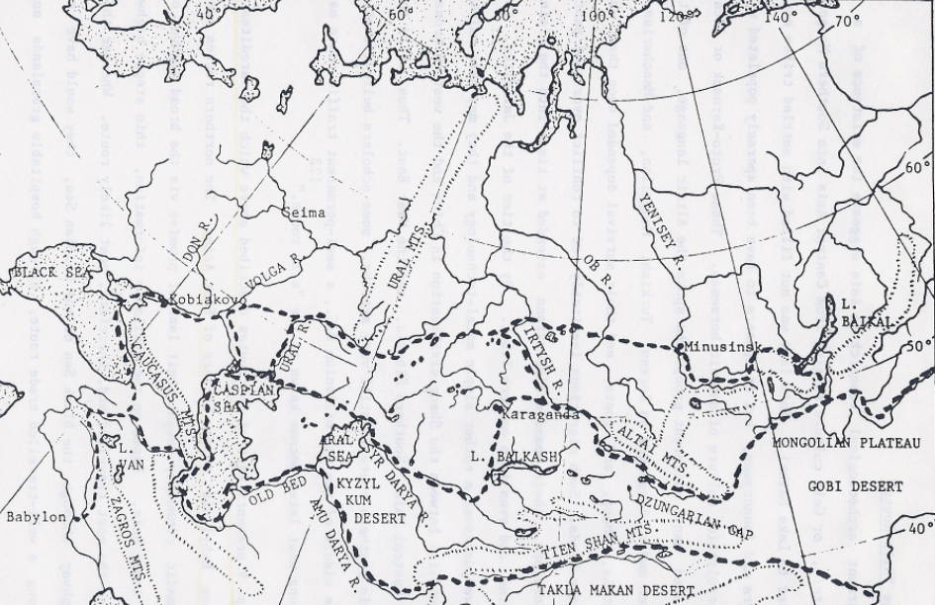
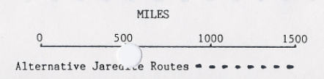
Ether 2:7 The Lord would not suffer that they should stop beyond the sea in the wilderness, but He would that they should come forth (Illustration) (EASTERN MIGRATION THEORY): Map V, Possible Jaredite routes from the "sea in the wilderness" toward the "great sea which divideth the lands." [Randall P. Spackman, The Jaredite Journey to America,, p. 51, unpublished]

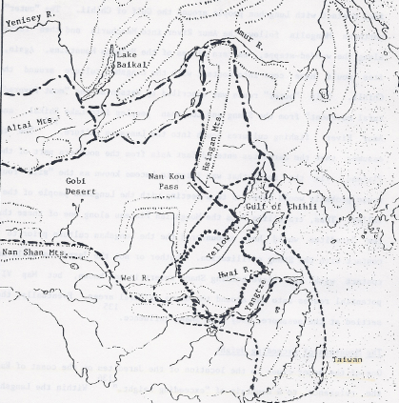
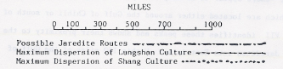
Ether 2:7 The Lord did bring Jared and his brethren forth even to that great sea which divideth the lands (Illustration) (EASTERN MIGRATION THEORY): Map VI Three probable routes of the Jaredites into East Asia from the Mongolian Plateau] [Randall P. Spackman, The Jaredite Journey to America, p. 56, unpublished]

Ether 2:7 The Lord Would Not Suffer That They Should Stop beyond the Sea in the Wilderness, but He Would That They Should Come Forth (EASTERN MIGRATION THEORY):

According to Scott Glenn, from a study of the physical characteristics of the terrain which the Jaredites traveled and from records brought back by later travelers through Asia, the only practical route for them must have been very close to one which, centuries later, was named the "Silk Road" (see illustration).

Of course, that famous route over which were carried spices and silk from China (mentioned as early as 302 B.C. by the Greek historian Megasthenes) did not yet exist in Jared's time. So the Jaredites had to break the trail (led by the Lord) from oasis to oasis.

History records that from 206 B.C. to A.D. 220, there were more than forty intermediate caravan stops along that famous road. It is worth noting that many of those still bear the same or similar names which have come down to our time after more than 2,200 years.

Where the steppe (grassland) and the mountains meet is the ancient Silk Road caravan stop named Alma Ata, one of the most beautiful sites in Kazakhstan, with meadows in the foothills and snowcapped mountains beyond. From there, the Jaredites would have entered the region named by the Chinese, Xinjiang (New Marches), a vast empty land of steppes, desert, and mountains, which seem to have been designed by nature as a barrier between east and west.

According to Scott, recent archaeological evidences confirm that East Asia was indeed a land through which the Jaredites might have migrated. This evidence appears in reports by Dr. Nobuhiro Yoshida, vice president of the Japanese Petrograph Society, in which he describes petroglyphs found in north central China and southwest Japan which indicate that early Chinese ideograms evolved out of proto-Sumerian glyphs. About 200 of these petroglyphs have been found in China on Mount Garan (Sacred Horse) in the Quwu mountain range (less than ninety miles from the Huang Ho River and the ancient Silk Road site of Lanzhou). The most remarkable thing about these inscriptions is that they can be deciphered by using proto-Sumerian glyph codes very similar to those in use at the ancient Mesopotamian cities of Ur and Uruk about 50,000 years ago and to others found along routes where Sumerian peoples are known to have traveled. Dr. Yoshida's reports were printed in the Japanese science magazine, The Moo, for March 1990. [Glenn A. Scott, Voices from the Dust, pp. 29,32]

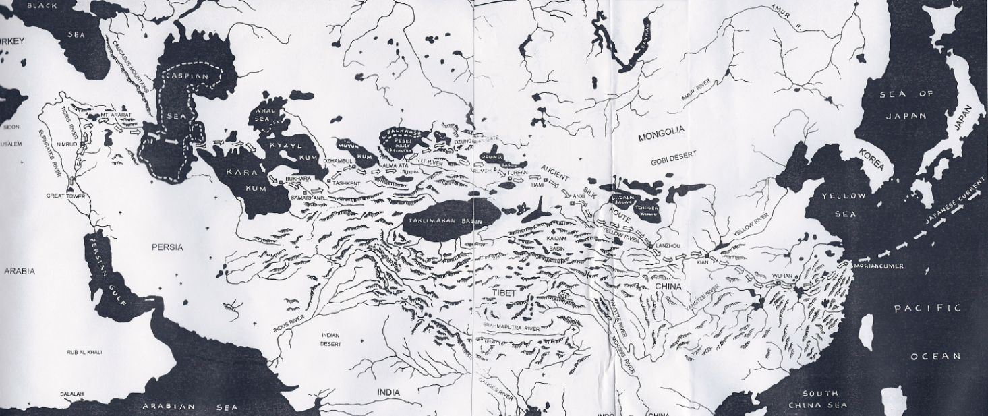
Ether 2:7 The Lord would not suffer that they should stop beyond the Sea in the wilderness, but he would that they should come forth (Illustration) (EASTERN MIGRATION THEORY): The Most Probable Route Taken By the Jaredites Across Central Asia. The proposed route of the Jaredites shown on this map, stretching from the Great Tower to camp Moriancumer, is the most likely of the very few practical routes across central Asia. That route is basically the same as the one which, centuries later, became known as the "Silk Road," over which silks and spices were brought from the Far East to Europe. [Scott A. Glenn, Voices from the Dust, pp. 30-31]

Ether2:8 He [The Lord] Had Sworn in His WRATH (Covenant Language):
In Ether chapter 2, Moroni writes about the Lord talking to the brother of Jared about their travels through the wilderness and ultimately coming forth to a "land of promise, which was choice above all other lands, which the Lord God had preserved for a righteous people." (Ether 2:7) This seems to reflect a glorious atmosphere of goodness. But then in verse 8 Moroni writes:
And he [the Lord God] had sworn in his wrath unto the brother of Jared, that whoso should possess this land of promise, from that time henceforth and forever, should serve him, the true and only God, or they should be swept off when the fulness of his wrath should come upon them.
The meaning of the word “wrath” is “violent anger; vehement exasperation” so it is hard to envision the Lord talking kindly to the brother of Jared at one moment and swearing at him with the wrath that only the Almighty might muster in the next moment. A possible explanation can be found in the use and understanding of covenant language.
In the Semitic language, or in the Hebrew in which the Bible was written, when something was absolutely going to happen in the future, it is often spoken of as if it had already occurred in the past. Hebrew scholars are familiar with this idiom and refer to it as “the prophetic perfect,” “the historic sense of prophecy,” and the “perfective of confidence.”
In his magnificent work Figures of Speech Used in the Bible, E. W. Bullinger . . . wrote that the past is used instead of the future to emphasize the certainty of an event.
The past tense is used instead of the future tense] when the speaker views the action as being as good as done. This is very common in the Divine prophetic utterances where, though the sense is literally future, it is regarded and spoken of as though it were already accomplished in the Divine purpose and determination. The figure is to show the absolute certainty of the things spoken of. [4]
The distinguished scholar and author of the very well-known Young’s Concordance, Robert Young, agrees with Bullinger. He wrote: “The past is frequently used to express the certainty of a future action.” [8]
There are many examples of the prophetic perfect in the Bible, far too many to list here, however the following might serve as a biblical example:
Genesis 15:18. The Hebrew text reads, “To your descendants I have given this land.” This promise was made to Abraham before he even had any descendants to give the land to. Nevertheless, God states His promise in the past tense to emphasize the certainty of the event. The KJV, ARV (American Revised Version of 1901), YLT, and NASB all have the past tense in their versions.
("The Prophetic Perfect," http://www.truthortradition.com/ taken from The Christian’s Hope: The Anchor of the Soul)
Thus when Moroni writes in Ether 2:8: “And he [the Lord God] had sworn in his wrath unto the brother of Jared,” Moroni is emphasizing the certainty of the covenant penalty that would follow if the descendants of the brother of Jared and Jared (and their covenant “friends”) did not serve the Lord. Sadly, Moroni would record the certainty of the covenant “destruction” of the Jaredites in Ether 14:25: “And thus we see that the Lord did visit them in the fulness of his wrath, and their wickedness and abominations had prepared a way for their everlasting destruction.” [Alan Miner, Personal Notes]

Ether 2:8 Whoso Should Possess This Land of Promise . . . Should Serve Him . . . or They Should Be Swept Off (Covenant Language and Structure):

According to Lee Donaldson, the second element of ancient covenants was the historical prologue. The historical prologue of a covenant focuses the people's minds and hearts as they remember their history. Ancient Israel, for instance, always remembered the Exodus and the Sinai covenant as they recited their history. The brother of Jared's covenant to "serve the God of the land" (Ether 2:12) became the focal point of Jaredite historiography. In addition the Lord clearly states the stipulations of this covenant (covenant element #3):

"And he [the Lord] had sworn in his wrath unto the brother of Jared that whoso should possess this land of promise, from that time henceforth and forever, should serve him, the true and only God, or they should be swept off when the fulness of his wrath should come upon them." (Ether 2:8)

The reader should take note that Moroni repeats the stipulations of this covenant three additional times in the verses which immediately follow (Ether 2:9, 10, 12).

Moroni also concludes his tragic record of the Jaredites with Coriantumr remembering "the words [concerning the covenant] which had been spoken by the mouth of all the prophets, and he saw them that they were fulfilled thus far, every whit" (Ether 15:3). [Lee L. Donaldson, "The Plates of Ether and the Covenant of the Book of Mormon," in The Book of Mormon: Fourth Nephi through Moroni, From Zion to Destruction, p. 71] [See the commentary on 1 Nephi 5:5; 1 Nephi 17:36-38; 2 Nephi 1:5-12]

Ether 2:9 We Can Behold the Decrees of God concerning This Land (Covenant Language and Structure):

In Ether 2:8-9, Moroni is careful to record the covenant between the Lord and the brother of Jared. That covenant concerned a "land of promise which was choice above all other lands which the Lord God had preserved for a righteous people." The Lord "swore in his wrath unto the brother of Jared that whoso should possess this land of promise, from that time henceforth and forever, should serve him, the true and only God, or they should be swept off when the fulness of his wrath should come upon them." Then in the very next verses which follow, Moroni declares, not only in sad retrospective, but also as a warning to the future Gentile inhabitants: "And now, we can behold the decrees of God concerning this land . . ." (Ether 2:9).
According to Lee Donaldson, the covenant to obey Jesus Christ as the God of the land fits a very old pattern. . . . Anciently, the covenants that man made with God were entered into with a specific formula which bound both parties. The biblical scholar George Mendenhall identified six common steps in ancient covenants and treaties (Interpreter's Dictionary 1:714). These elements are as follows: (1) preamble, (2) historical prologue, (3) stipulations, (4) blessings and curses, (5) witnesses, and (6) deposit and public reading of the covenant . . . A close look at the second chapter of Ether illustrates each of these six elements (see the illustration). It is interesting that the same covenant is given in all three sets of plates that make up our Book of Mormon. In view of the requirement of "three witnesses" (Ether 5:4), it is significant that the Lord selected three different sets of plates (the plates of Nephi, the plates of Mormon, and those of Ether) to stand as vital components in establishing the Book of Mormon covenant.
[Lee L. Donaldson, "The Plates of Ether and the Covenant of the Book of Mormon," in The Book of Mormon: Fourth Nephi through Moroni, From Zion to Destruction, pp. 70-74] [See the commentary on Ether 5:4]

Ether 2:9 We can behold the decrees of God concerning this land (Illustration): The overarching Book of Mormon covenant to obey Jesus Christ as the God of the land fits a very old pattern] [Lee L. Donaldson, "The Plates of Ether and the Covenant of the Book of Mormon," in The Book of Mormon: Fourth Nephi through Moroni, From Zion to Destruction, p. 73]

Ether 2:9 And Now, We Can Behold the Decrees of God concerning This Land (Covenant Language and Structure):

According to Lee Donaldson, the fifth element of ancient covenants deals with witnesses. In Ether 2:9, Moroni makes the statement, "and now, WE can behold the decrees of God concerning this land."

The prophet Ether personally stood as an eyewitness to the terrible fulfillment of the curses of the covenant and "beheld that the words of the Lord had all been fulfilled; and he finished his record" (Ether 15:33). However, a broader look at the Book of Mormon reveals that this same covenant to serve Jesus Christ as the God of this land is also part of the plates of Nephi and the plates of Mormon (see illustration). Why is this same covenant given in all three sets of plates? Is it significant that the Lord selected three different sets of plates to establish his covenant? And is this the reason why Mormon wanted the message of the plates of Ether to be included with his record? (Mosiah 28:19).

Having a set of three in making covenants is an ancient pattern. For instance, the baptismal covenant is made "in the name of the Father, and of the Son, and of the Holy Ghost" (3 Nephi 11:25). Moroni, in the middle of his abridgment of the Jaredite record, prophesies that "in the mouth of three witnesses shall these things be established; and the testimony of three . . . shall stand against the world at the last day" (Ether 5:4). [Lee L. Donaldson, "The Plates of Ether and the Covenant of the Book of Mormon," in The Book of Mormon: Fourth Nephi through Moroni, From Zion to Destruction, pp. 72-74] [See the commentary on Ether 5:4]

Ether 2:12 This Is a Choice Land . . . If They Will But Serve the God of the Land, Who Is Jesus Christ:

In Ether 2:12 Moroni writes:

“Behold, this is a choice land, and whatsoever nation shall possess it shall be free from bondage and captivity, and from all other nations under heaven, if they will but serve the God of the land, who is Jesus Christ, who hath been manifested by the things which we have written.”

Thomas S. Monson writes that “The revered Abraham Lincoln accurately described our plight:

‘We have been the recipients of the choicest bounties of Heaven. We have been preserved, these many years, in peace and prosperity. We have grown in numbers, wealth, and power as no other nation has ever grown; but we have forgotten God. We have forgotten the gracious hand which preserved us in peace, and multiplied and enriched and strengthened us; and we have vainly imagined, in the deceitfulness of our hearts, that all these blessings were produced by some superior wisdom and virtue of our own. Intoxicated with unbroken success, we have become too self-sufficient to feel the necessity of redeeming and preserving grace, too proud to pray to the God that made us.’ (Proclamation for a National Fast Day, March 30, 1863. (Be Your Best Self, p. 96-97)
[josephsmith.com . . . Ether ]

[Note* In 1863 Abraham Lincoln also proclaimed a Thanksgiving Holiday

THANKSGIVING BECOMES A HOLIDAY IN THE UNITED STATES OF AMERICA
Since the days of the Pilgrims, festivals of Thanksgiving for autumn harvest were observed sporadically in local communities across the American colonies. Significantly, the month of October, 1777 saw the union of all 13 colonies in a thanksgiving celebration for the very first time. George Washington proclaimed a National Day of Thanksgiving in 1789. John Adams and James Madison both urged Americans to observe a period of thanksgiving. But as new generations came into being, the thanksgiving tradition dwindled.
Considered the "Mother of Thanksgiving," Sara Hale (1788-1879) was an influential editor and writer who wrote editorials and letters to elected officials for forty years before eventually urging President Lincoln to proclaim a national day of thanksgiving. She selected the last Thursday in November because, as she said, harvests were done, elections were over, and summer travelers were home. She also believed a national thanksgiving holiday would unite Americans in the midst of dramatic social and industrial change and “awaken in Americans’ hearts the love of home and country, of thankfulness to God, and peace between brethren.”
Note* It is worthy of note that it took the Revolutionary War and the Civil War to bring the country to its knees in thankfulness to God for the blessings we enjoy.

In 1863 Abraham Lincoln proclaimed a national Thanksgiving holiday. Since that Proclamation Thanksgiving has been observed annually. Since Lincoln’s original proclamation, only one president has failed to mark Thanksgiving Day on the fourth Thursday in November. As president, Franklin D. Roosevelt used his authority to reschedule Thanksgiving. In 1939, FDR caused a stir by declaring that Thanksgiving would occur on the third Thursday in November instead of the fourth. Why? Roosevelt thought moving the holiday up by one week would help Depression-era merchants by giving them more selling days before Christmas. In 1841, Congress fought back with a joint resolution officially establishing the fourth Thursday of November as the national holiday.
In a manuscript written by Puritan leader William Bradford, he called his fellow Separatists “Saints” and “Pilgrimes.”
Most fortunately, according to Cotton Mather, the Pilgrims’ ship the Mayflower was a converted cargo ship that had been used to carry wine. This wine had accidentally leaked or been spilled and had seeped into the wood of the ship over time. The alcoholic wine acted as a disinfectant and not one of the Separatist Pilgrims on the Mayflower died from sickness during the voyage (something almost unheard of).
These Saints” or “Pilgrims” named their settlement "Salem," a shortened word for Jerusalem. This was done as evidence that the Pilgrims believed that America was a promised land--the land of the New Jerusalem. The word "Salem" also means peace. It is not surprising that the New England area provided the early spiritual leadership and direction for this new land that would become the United States of America.
In the fall, when the harvest was great and bountiful, the Pilgrims decided to give thanks to God and their Native American friends for helping them through their first year in the New World. The first Thanksgiving feast was patterned after the Jewish holiday of Sukkot. Historically, Sukkot commemorates the period during which the children of Israel were wandering in the desert prior to entering the Promised Land. Agriculturally, Sukkot is also a harvest festival. The Jewish holiday of Sukkot celebrates the fall harvest, giving thanks unto God for the food that sustained their lives as they journeyed to the Promised Land. The Pilgrims celebrated their harvest Thanksgiving feast in their Promised Land of America after they had wandered as “pilgrims” for many years.
Cotton Mather notes that the year after the first landing at Plymouth, more Pilgrims arrived, but they had failed to furnish enough food and supplies. Then there came a drought that lasted from May to July. It had ruined part of the crop and threatened to destroy it all. Faced with famine and starvation the Pilgrims set aside a day of fasting and prayer. At the beginning of the day there was not a cloud in the sky, but by evening the clouds started to roll in. Rain came. The Indians were amazed. This convinced them of the power of the white man's god. The Indians were also amazed because while the rains had come heavy where they lived and beaten down the cornstalks in their village, the rain was much more controlled where the Pilgrims were and their cornstalks stood tall after the storm. The Pilgrims were so thankful for the rains that had preserved their crops and their lives that they set aside a day for a day of Thanksgiving.
The Pilgrims acknowledged that the hand of God was upon then. As their leader Gov. William Bradford put it,
“Thus out of small beginnings greater things have been produced by His hand that made all things . . . and gives being to all things that are; and, as one small candle may light a thousand, so the light here kindled hath shone unto many, yea in some sort to our whole nation; let the glorious name of Jehovah have all the praise.”
So in addition to the “Horn of Plenty” decorating our tables in symbolism of the harvest, it might be wise to also include candles as symbols unto the family, the nation and the world that we owe all our praise to Christ Jehovah.
Our Thanksgiving celebration serves as a constant reminder that our nation is a Biblical covenant nation— NOT an Atheist nation—NOT a Muslim nation—NOT a totally Secular nation with no special or particular spiritual direction—it IS a nation that is part of a whole “promised land” that should look to God the Father and his son Jesus Christ and the Holy Ghost for guidance. As a nation that is part of a “promised land” we should NEVER shrink from giving honor and thanks to the God that helped found this nation and preserve this nation. We should NEVER shrink from teaching the principles of this God to the children of this nation. Yet our history and tradition are being threatened.
Alan Miner, Personal Notes]

Ether 2:12 Free from Bondage, and from Captivity, and from All Other Nations under Heaven (Covenant Language and Structure):

According to Lee Donaldson, the biblical scholar George Mendenhall identified six common steps in ancient covenants and treaties (Interpreter's Dictionary 1:714): (1) the preamble, (2) historical prologue, (3) stipulations, (4) blessings and curses, (5) witnesses, and (6) deposit and public reading of the covenant.
Moroni cites the blessing part of the Lord's covenant with the brother of Jared in Ether 2:12: "Whatsoever nation shall possess it [the promised land] shall be free from bondage, and from captivity, and from all other nations under heaven . . ." The curses are enumerated by Moroni in Ether 2:8-9, "they should be swept off when the fulness of his wrath should come upon them," and "the fulness of his wrath cometh upon them when they are ripened in iniquity." [Lee L. Donaldson, "The Plates of Ether and the Covenant of the Book of Mormon," in The Book of Mormon: Fourth Nephi through Moroni, From Zion to Destruction, p. 72]

Ether 2:12 Free from bondage, and from captivity, and from all other nations under heaven (Illustration): The overarching Book of Mormon covenant to obey Jesus Christ as the God of the land fits a very old pattern] [Lee L. Donaldson, "The Plates of Ether and the Covenant of the Book of Mormon," in The Book of Mormon: Fourth Nephi through Moroni, From Zion to Destruction, p. 73]

Ether 2:12 That Ye May Know the Decrees of God . . . by the Things Which We Have Written: (Covenant Language and Structure)

Moroni brings forth the last element of ancient covenant-making demonstrated in the Lord's covenant with the brother of Jared with these words, "And this cometh unto you, O ye Gentiles, that ye may know the decrees of God . . . by the things which we have written" (Ether 2:11-12)

According to Lee Donaldson, this covenant was deposited and read publicly for every nation that came, or will come, to the promised land. Prophets sent to the Jaredites either read or quoted the covenant to them frequently (Ether 7:23; 9:28; 11:1,12,20). They reminded the Jaredites to serve the Lord or "the Lord God would send or bring forth another people to possess the land, by his power, after the manner by which he brought their fathers" (Ether 11:21). The final recorded act of Ether's life was to deposit the record in a manner that the people of Limhi did find them" (Ether 15:33). The Jaredite covenant was read during the reign of king Mosiah (Mosiah 28:17-19). Finally, Moroni promises that "the Gentiles" possessing the promised land will not only have access to the words of the covenant, but that the covenant will apply to them (Ether 2:12). [Lee L. Donaldson, "The Plates of Ether and the Covenant of the Book of Mormon," in The Book of Mormon: Fourth Nephi through Moroni, From Zion to Destruction, p. 72] [See the commentary on Ether 5:4]

Ether 2:13 That Great Sea Which Divideth the Lands: [WESTERN MIGRATION THEORY]
Brant Gardner writes:
The “great sea which divideth the lands” is either the Pacific or the Atlantic, but this description contains no identifying details . . . I interpret this narrative text as saying that they traversed the Mediterranean (the “sea”) and stopped at the Atlantic coast. They lingered past a reasonable period for provisioning, despite Yahweh’s command that they not “stop beyond the sea in the wilderness,” prompting his chastisement of the brother of Jared (v. 14) . . . [Brant A. Gardner, Second Witness, Vol. 6: Fourth Nephi through Moroni, pp. 181-182]

Ether 2:13 That Great Sea Which Divideth the Lands [WESTERN MIGRATION THEORY]:
Duane Aston remarks:
From ancient Babylon a western wilderness journey would bring the Jaredites rather directly to the shores of a large sea, that after crossing, they could reach America. Consulting biblical maps that illustrate the kingdoms of Old Testament times, please notice that these maps identify The Great Sea, lying to the west of bible lands. This Great Sea, in later centuries, is recognized as being the Mediterranean Sea. So what has this got to do with the Jaredites? Only that a simple statement made in the Book of Ether most likely identifies just what sea it was that the Jaredites had come to. Isn’t it interesting that a great sea,” mentioned in Ether 2:13 was probably none other than the Mediterranean Sea.

From the map, please note that indeed the Mediterranean Sea is geographically a “great sea, which divideth the lands.” It is known that the Mediterranean Sea is the world’s largest inland body of water, and it divides the land. There is no other such large body of water in the world quite like it. It might also be noted that the name “Mediterranean” is derived from the Latin Medius, or middle, and terra meaning earth or land. [Duane Aston, The Other Side of Cumorah, pp. 155-156]

[Note* In the Bible Encyclopedia, I found the following:

The Great Sea (ha-yam ha-gadhol) is the name given to the Mediterranean, which formed the western boundary of Palestine (Numbers 34:6 Joshua 15:12, 47 Ezekiel 47:19; Ezekiel 48:28). It is also called "the hinder sea" (Hebrew ha-yam ha-'aharon), i.e. the western sea (Deuteronomy 11:24; Deuteronomy 34:2 Joel 2:20 Zechariah 14:8), and "the sea of the Philis" (Exodus 23:31), which, of course, applies especially to the part washing the shore of Philistia, from Jaffa southward. Generally, when the word "sea" is used, and no other is definitely indicated, the Mediterranean is intended (Genesis 49:13 Numbers 13:29, etc.). It was the largest sheet of water with which the Hebrews had any acquaintance. Its gleaming mirror, stretching away to the sunset, could be seen from many an inland height. [Bible Atlas /Encyclopedia biblehub.com] [Alan Miner, Personal Notes]

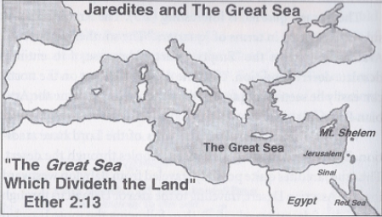
Ether 2:13 That great sea which divideth the lands (Illustration) [WESTERN MIGRATION THEORY]: Jaredites and The Great Sea [Duane Aston, The Other Side of Cumorah, p. 156]

Geographical Theory Map: Ether 2:13 Jared Comes Forth to the Great Sea and Moriancumr (Year )
Choose: Eastern Migration Theory Choose: Chronology-- Year
Western Migration Theory
Southern Migration Theory

Ether 2:13 They Called the Name of the Place Moriancumr :

According to Warren and Palmer, after many years of travel in the wilderness the Jaredites arrived at the "great sea which divideth the lands." They called their settlement "Moriancumr" (Ether 2:13, apparently after the name of the brother of Jared. Although the actual name of the brother of Jared is not mentioned in the scriptures, many Latter-day Saints quote the following story related by George Reynolds to indicate that his name was revealed to the prophet Joseph Smith after the translation of the Book of Mormon:

"While residing in Kirtland, Elder Reynolds Cahoon had a son born to him. One day when President Joseph Smith was passing his door he called the prophet in and asked him to bless and name the baby. Joseph did so and gave the boy the name of Mohonri Moriancumer. When he had finished the blessing he laid the child on the bed, and turning to Elder Cahoon he said, 'The name I have given your son is the name of the brother of Jared; the Lord has just shown (or revealed) it to me.' Elder William F. Cahoon, who was standing near, heard the Prophet make this statement to his father; and this was the first time the name of the brother of Jared was known in the Church in this dispensation."
[George Reynolds, "The Jaredites," in The Juvenile Instructor, Volume, 27, p. 282. Also Improvement Era VIII:705; Also Sperry, 1968]
Ether 2:13 Moriancumr (Moriancumer)?:

In 1999, the Zarahemla Research Foundation (RLDS) finished an exhaustive review of all known manuscripts and editions of the Book of Mormon in order to restore the text "to its purity." The result was the Restored Covenant Edition of the Book of Mormon. One of their "restorations" involves the geographical place name "Moriancumr" (Ether 2:13), which they have changed to read "Moriancumer." [Zarahemla Research Foundation, "Geography Concordance" in The Book of Mormon: Restored Covenant Edition, p. 1005]

[Note* This must be considered tentative subject to the verification of Royal Skousen, director of the Book of Mormon manuscript project, who will not comment at this time relative to such changes. [Personal communication, 11/22/1999]

Ether 2:13 The Came to the Sea . . . and Dwelt in Tents upon the Seashore for the Space of Four Years (Jaredite Harbor Qualifications) [SOUTHERN MIGRATION THEORY]
While other Jaredite migration theorists tend not to elaborate on the qualifications of their Jaredite harbor, Potter, Linehan and Dickson take the opportunity to give a number of detailed qualifications as to why their candidate of Khor Rori, Oman fits the story in Ether.
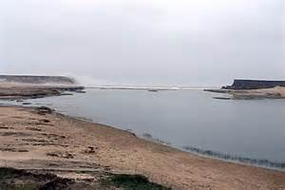
Natural port of Khor Rori extending into the Arabian Sea (nephiproject.com)

- It had the maritime resources needed to build a ship. The Jaredites needed tangible resources to fabricate their vessels: strong straight hardwoods, cotton or other fabric for sails, cordage for rope, and so on. These materials might have been available in several locations in the Old World, but in Arabia probably only in Oman at the inlet known as Khor Rori. Khor Rori had excellent moorage in its natural harbor in the Jaredite period and was later used as the exporting harbor for the important frankincense trade.
Ships require large timbers for structural support. The leading marine archaeologists believe that the shipbuilders of this region used imported timbers from India. We have no specific documentation that Khor Rori was trading for shipbuilding timbers as far back as 25090 BC. However, there are written records that timbers were exported from White India to Mesopotamia as early as 2520 BC, which suggest that other seafaring ports in the region were doing likewise. Khor Rori is believed to have been an active harbor since 3000 BC. The Jaredites built eight barrages for two extended families, their friends and their families. In or on these barges they also carried water and food provisions for what became a 344-day voyage (Ether 3:1, 6:11). The Jaredite barges had to be large, yet we know they were only the length of a tree (Ether 2:17). Fortunately, the best wood for building a ship comes from the tall straight teak tree. In India, a teak tree can grow straight up to a height of 150 feet.
- It was adjacent to a “quarter where never had man been.” Khor Rori is at the southern end of the Empty Quarter, which qualifies in a most excellent fashion as the “quarter where never had man been.”
- It was near a “mountain of exceeding height.” While camped in this location, the brother of Jared met the Lord on a mountain he described as being of “exceeding height” (Ether 3:1). Rising above Khor Rori stands Mount Samban, which reaches a height of nearly six thousand feet. It is the tallest mountain in all of southern Oman. Mount Samban is a mountain of religious importance—it is one of the few mountains that is mentioned in the Bible (Genesis 10:30).
- “White and clear stones, even as transparent glass” are found there. The brother of Jared melted out of a rock sixteen stones that were “white and clear, even as transparent glass” (Ether 3:1). Arabia is famous for its clear quartz, so transparent that it is cut into semi-precious stones called the “Diamonds of the Sultans” (also known as Desert Diamonds and Qaysumah Diamonds). These clear stones are found throughout Arabia and mined in the Empty Quarter . . . Today, Oman exports silicon quartz sand for the production of semi-conductors .
- It has Honeybees The Book of Mormon records that the Jaredites took honeybees with them from Nimrod to the seashore where they built their ships. Here the Book of Mormon is much in harmony with what is known about the history of Babel (Sumeria). As early as the twenty-first century BC, the cuneiform writings of Sumeria and Babylonia mention honeybees . . . Local residents have shown us where wild honey is still harvested at Khor Rori. Further, with the exception of Oman where Khor Rori is found, honeybees are not native to Arabia, an area the size of Europe. How did these wild honey bees originally come to Oman?
- It has a tradition of “large people.” The Jaredites were said to have been “large.” (Mosiah 8:8-10, Ether 15:25-26). Khor Rori had a very large people living there for at least a short period of time around 2500 BC. The ruling tribe that lived in that Salalah plain area during that time was the Adite tribe. According to local tradition, the Adites were giants.
- The brother of Jared can be biblically linked to this area. The brother of Jared’s name was “Moriancumer.” This name was revealed to the Prophet Joseph Smith in Kirtland, Ohio, while the Saints were headquartered there. George Reynolds wrote:

While residing in Kirtland, Elder Reynolds Cahoon had a son born to him. One day when President Joseph Smith was passing Brother Cahoon’s door he called the Prophet and asked him to name the baby. Joseph did so and gave the boy the name Mahonri Moriancumer. When he had finished the blessing, Joseph laid the child on the bed and turning to Elder Cahoon he said, “the name I have given your son is the name of the Brother of Jared: the Lord has just shown (or revealed) it to me.” (n46)
The Jaredites called the land where they built their ships next to the sea “Moriancumer” (Ether 2:13). Tribes in the Near East have the tradition of naming mountains, wadis, and other geographical features after people who are important to them . . . Note these facts: the two mountain ranges just to the west of Khor Rori , [or immediately west of the Salalah coastal plain]are called the “Marrah” mountains and the “Qamar” mountains, the latter sometimes spelled “Camar” or “Comar.” These mountains run parallel to the Indian Ocean and follow each other. It is common to see on maps of southern Arabia the two names written side by side, the “Marrah Camar” mountains.(n52) Of course, Latin spellings of Arab words change over time, and it is also true that Arabic is a vocalized language where vowels are not written. But by removing the vowels from MarrahCamar we have “Mrrhcmr.” Is this name a remnant of the name “Moriancumer” (Mrncmr)?
Before the reader gives a final answer to the above question, let us consider another perspective. In the book of Genesis (10:26-30) we are told that the family of “Jerah” initially migrated to southern Arabia with some or all his brothers.(n40) Reverend Charles Forster, provides variant spellings for Jerah – Jarah (Arabia Felicis), Jarach, Jare (St. Jerome), and Jerha by modern Arabs.(n42) . . . According to Smith and Sjodahl’s commentary on the Book of Ether, some early Bible translations spelled Jerah as “Jared.” (n43) [SEE APPENDIX]
If such was the case, then from Genesis 10:25-30 we learn that one of the brothers of this “Jared” named in Genesis was “Ophir.” Interestingly, “Ophir” happened to be the destination to which King Solomon and King Hiram’s ships sailed and from which they returned laden with gold, peacocks, precious stones and other riches (1 Kings 10:11) . . . The LDS Bible Dictionary states that Ophir was probably a PORT in southern Arabia. Indeed, many scholars believe that the port of Khor Rori, was the ancient port of Ophir. The Reverend Charles Forster, for example, sustains the traditional argument that the land of Dhofar, with its port at Khor Rori, was the Biblical land of Sephar (see Genesis 10: 30) where the man Ophir and his brother Jerah ” settled.(n47)
So it appears that the brother of Jared in the Bible (Ophir) had a port named after him and that this port was possibly Khor Rori. And the mountains nearby the port of Khor Rori were possibly named after Moriancumr, the brother of Jared in the Book of Mormon. And in the book of Ether it is said that they named the place where they camped “Moriancumr,” and this was a place where they built ships and sailed them to the New World. This place Moriancumr has also been linked to Khor Rori. So this leads us to the next question: Could the biblical brother of “Jared” (Ophir) and the Jaredite brother of Jared (Moriancumr) have been the same person? If so, both had a harbor named after them. But why different names? Perhaps the brother of Jared may have been given a new or sacred name when he saw the Lord through the veil (Ether 3:13). Under similar circumstances, new names were given to Abram (Abraham), Jacob (Israel), Saul (Paul) and other prophets.

[George Potter, Frank Linehan, and Conrad Dickson, Voyages of the Book of Mormon, Chap. 7: “Ophir the Jaredite’s Harbor,” pp. 210-213]

Ether 2:14 And [the Lord] Stood in a Cloud and Talked with [the Brother of Jared]:

According to Millet, McConkie, and Top, just as Jehovah appeared to and conversed with Moses and led the children of Israel in the wilderness in a cloud by day and in a pillar of fire at night (see Exodus 13:21; Numbers 11:25; 12:5), so did he lead the Jaredites as they were in the wilderness. Ether 2:14 states that the Lord "stood in a cloud and talked with [the brother of Jared]." From this cloud of glory the Lord directed both of these prophets and gave them directions for their journey. The image of a cloud associated with the Lord's appearance is not unique to his dealings with ancient peoples. In this dispensation the Lord also spoke of a cloud of glory, one that will surround him when he again returns to earth and appears to man (see D&C 34:7). [Joseph F. McConkie, Robert L. Millet, and Brent L. Top, Doctrinal Commentary on the Book of Mormon, Vol. IV, pp. 266-267]

Ether 2:14 For the Space of Three Hours Did the Lord Talk with the Brother of Jared:

In the book of Ether, we read this account:

And it came to pass at the end of four years that the Lord came again unto the brother of Jared and stood in a cloud and talked with him. And for the space of three hours did the Lord talk with the brother of Jared, and chastened him because he remembered not to call upon the name of the Lord. (Ether 2:14)

According to Bruce Dana, one could infer from this verse that the Lord chastened him for three hours for not praying. However, it seems that the brother of Jared never stopped praying to the Lord; he committed a sin of omission by not praying "for [or performing something for or with] his brethren who were with him." This is borne out in the subsequent verse: "And the brother of Jared repented of the evil which he had done, and did call upon the name of the Lord for his brethren who were with him. (Ether 2:15) Moreover, the Lord said unto him: "I will forgive thee and thy brethren of their sins."

Dana believes that, for three hours, the Lord was giving instructions on how to build the barges for the long journey upon the water. In support of this belief, verse 16 reads: "And the Lord said: Go to work and build, after the manner of barges which ye have hitherto built. And it came to pass that the brother of Jared did go to work, and also his brethren." [Bruce E. Dana, Mysteries of the Kingdom, pp. 49-51]

[Question: Is there any symbolism in the number 3? Alan Miner, Personal Notes]

Ether 2:14 [The Lord] Chastened [the Brother of Jared]:

After four years at the place called Moriancumer, the Lord chastened the brother of Jared "because he remembered not to call upon the name of the Lord" (Ether 2:13).

According to Thomas Valletta, many modern readers are puzzled by this apparently ungrateful behavior. One recent commentary notes that "it seems highly unlikely that a man of the spiritual stature of the brother of Jared--one who had received marvelous manifestations and had previously exercised great faith in the Lord--would suddenly cease praying to his Maker." The commentary continues: "It may be that what this verse is saying to us is that [the brother of Jared] was chastened by the Lord because he had not fully followed and implemented the counsels of the Lord previously received. It may be that in the relative comfort of the seashore he had allowed his prayers to become less fervent, more casual and routine. He may have been calling upon the Lord in word, but not in faith and deed" (J. McConkie, Millet, and Top 4:269). Whatever the reasons for the Lord's chastening Jared's brother, it is important to remember that other great prophets were also rebuked by the Lord. Moses was reproved for not explicitly following God's instructions in the wilderness of Zin (Numbers 20:7-11; 27:12-14; Deuteronomy 32:51-52). The Apostle Peter received a sharp rebuke for letting his love of the Lord get in his way of comprehending the need for the Atonement (Matthew 16:21-23). Even the Prophet Joseph Smith was reprimanded for having "feared man more than God" (D&C 3:7). There is nothing demeaning in being corrected by the Lord, that comes from not humbly receiving the correction. The book of Job reads "Behold, happy is the man whom God correcteth: therefore despise not thou the chastening of the Almighty" (Job 5:17). The Lord has declared, "as many as I love, I rebuke and chasten: be zealous therefore, and repent" (Revelations 3:19). Jared's brother, like the rest of God's prophets, took immediate action to turn away the Lord's wrath (Ether 2:15). [Thomas R. Valletta, "Jared and His Brother," in The Book of Mormon: Fourth Nephi through Moroni, From Zion to Destruction, pp. 312-313]

[Note* Could the textual setting of this recorded "chastening" of the brother of Jared carry any meaning? In other words, this "chastening" directly follows a recorded covenant. Could it be that the brother of Jared was not approaching the Lord in a covenant manner? (or teaching his people to approach the Lord in a covenant manner?) The oddly distinct wording of the text says that the Lord chastened the brother of Jared because "he remembered not [a covenant term] to call upon the name of the Lord" (Ether 2:14). [Thomas Cherrington, Personal communication]

Ether 2:14 For the Space of Three Hours Did the Lord Talk With the Brother of Jared, and Chastened Him:

Neal A. Maxwell writes that we often make the mistake of expecting perfection from the prophets. One of the main reasons why some early saints apostatized was because of perceived imperfections in the Prophet Joseph Smith. Joseph openly admitted that he was not perfect, and in the D&C, he was sorely chastised because he feared man more than God (DC 3:7). Similarly, Nephi struggled with his weakness, which was an uncharitable anger towards his enemies (2 Ne 4:17,27-29). Moses’ faithless disobedience brought upon him a sore chastisement (Num 20:11-12). And the brother of Jared became, for a time, negligent with his prayers, only to suffer an unimaginable three-hour rebuke from the Lord. Yet, the brother of Jared later became legendary for his great faith. What are we to learn from this?

Rather than be critical of the prophets, or make the equally fatal mistake of covering their sins, we should rejoice that the Lord’s most valuable servants were, after all, only human. In this, we can take consolation. If Joseph feared man more than God, maybe there is hope for us. If Nephi felt anger, Moses was disobedient, and the brother of Jared forgot to pray, maybe there is hope for the rest of us. We can only hope! (Neal A. Maxwell, “A Wonderful Flood of Light,” p. 113) [josephsmith.com . . . Ether ]

Ether 2:14 The Lord Chastened the Brother of Jared:
According to Brant Gardner, Yahweh’s chastisement of the brother of Jared (Ether 2:14) was probably not about prayer in general, but rather because the brother of Jared had not offered a very specific prayer—one regarding the continuing of their journey. They had paused for four years. When Yahweh moves past chastisement to instruction, those instructions deal with continuing to the promised land.
The mention of “three hours” is more likely mentioned because of the number “3” rather than the hours of time. Alonzo L. Gaskill, a Ph.D. in biblical studies and LDS Institute instructor, notes that “when the number [three] is used in scripture, it frequently serves to emphasize divine involvement, backing, or influence.”(n.3) [Brant A. Gardner, Second Witness, Vol. 6: Fourth Nephi through Moroni, p. 182]
[Note* The number 3 is also an indicator of a covenant witness either of obedience or disobedience.. Alan Miner, Personal Notes]

Ether 2:16 Jared . . . Built Barges after the Manner Which They Had Built:

According to Randall Spackman, the Jaredite watercraft are described in the book of Ether as "barges" (Ether 2:16). Barges are normally defined as flat-bottomed cargo vessels used chiefly for canal and river navigation. In addition, the Jaredite record implies a box-like form by its references to the top, bottom, sides, and ends of the barge (Ether 2:17). Both the definition of "barges" and the implied box-like form are in harmony with the eminent nautical scholar Casson's representation of the earliest Egyptian and Mesopotamian planked boats as square-ended and flat-bottomed, "more barge than boat, a form that might have been chosen because it involved simpler carpentry." These vessels were common on the rivers and canals of lower Mesopotamia and would have been familiar to the Jaredites. [Randall P. Spackman, The Jaredite Journey to America, p. 64, unpublished]
Ether 2:16 & 2:22 “Barges” and “Vessels”
The Book of Ether used the words “barges” (2:16) and ”vessels” (2:22) to describe the Jaredite ships. Potter, Linehan and Dickson writes: “What did this mean to the Prophet Joseph Smith as he translated the plates? According to Webster’s American Dictionary of the English Language, First Edition 1828, we learn:
VESSEL 4. Any building used in navigation, which carries a mast and sails, from the largest ship of war down to a fishing sloop.(n2)
BARGE. D/ bargie It.[alian] and Spanish; barca; Ir barc. Barge, and bark or barque, a ship are radically one word.(n3)
We learn from Webster that in 1828 the word barge meant a ship. Webster traced the word to barca or barcoin, which means “small boat” or “ship.” [George Potter, Frank Linehan, and Conrad Dickson, Voyages of the Book of Mormon, Chap. 8, p. 217]

Ether 2:16 “Barges” . . . They Were Small:
In Ether 2:1-3 there is a description of the Jaredites AFTER they fled from the great tower but BEFORE they were commanded by the Lord to go forth into the wilderness. It reads as follows:
2:1 And [they] went down into the valley which was northward . . . with their flocks which they had gathered together, male and female, of every kind.
2:2 And they did also lay snares and catch fowls of the air; and they did also prepare a vessel, in which they did carry with them the fish of the waters.
2:3 And they did also carry with them deseret, which, by interpretation, is a honey bee . . . and all manner of that which was upon the face of the land, seeds of every kind.

These animals and supplies were supposedly carried with the Jaredites into the wilderness where they “did build barges, in which they did cross many waters.” (Ether 2:6) These animals and supplies were also supposedly carried with them when they “set forth into the sea” on their “vessels or barges” to the promised land. In Ether 6:4 it says that, “when they had prepared all manner of food, that thereby they might subsist upon the water and also food for their flocks and herds, and whatsoever beast or animal or fowl that they should carry with them . . . they got aboard of their vessels or barges, and set forth into the sea.”
Some authors have interpreted these verses to mean that in the exact same manner as Noah and the ark, the Jaredites gathered up ALL MANNER of animals. This theory has direct implications not just for the Jaredite journey into the wilderness (that is, the people and fodder necessary to maintain and collect such a variety of animals, and the size and strength of the barges that they built in the wilderness), but for the four years they spent by the sea, and for the size and strength of the vessels that they built to carry them to the promised land. More importantly, this theory implies that these animals were apparently used to REPOPULATE the Promised Land (America). Thus when we find in Ether (;17-19 that they had “all manner of fruit, and of grain . . . and also all manner of cattle, of oxen, and cows, and of sheep, and of swine, and of goats, and also many other kinds of animals which were useful for the food of man. And . . . horses, and asses, . . . elephants and cureloms and cumoms,” according to this same theory of repopulation these animals must have been brought over by the Jaredites. An example of this theory is given by Del Dowdell. He writes:
It is also unknown how light the vessels were in comparison to their length and displacement weight, yet they obviously had to be large enough and strong enough to carry elephants (n4) horses, donkeys and two other species of large animal called the cureloms and cumoms.(n5) in addition to the people and about a year’s supply of provisions plus necessities to start a new life in an unknown land.
n4. Whatever animal found in the land of promise the Jaredites had to have brought with them since in the flood “all flesh died that moved upon the earth, both of fowl, and of cattle, and of beast, and of every creeping thing” (Genesis 7:19) [Who Really Settled MesoAmerica?, pp. 105, 112 note #4]
Dowdell seems to be taking his theory from Mormon Doctrine regarding the Flood. According to Bruce R. McConkie and Joseph Fielding Smith:
In the days of Noah the Lord sent a universal flood which completely immersed the whole earth and destroyed all flesh except that preserved on the ark. (Gen. 6; 7; 8; 9; Moses 7:38-45; 8; Ether 13:2 “Noah was born to save seed of everything, when the earth was washed of its wickedness by the flood.” (Teachings, p. 12) This flood was the baptism of the earth; before it occurred the land was all in one place, a condition that will again prevail during the millennial era. (D&C 133:23-24).
There is no question but what many of the so-called geological changes in the earth’s surface which according to geological theories took place over ages of time, in reality occurred in a matter of a few short weeks incident to the universal deluge. (Man: His Origin and Destiny, pp. 414-436). [Bruce R. McConkie, Mormon Doctrine, 1968, p. 289.]
According to Ussher’s chronology of the Old Testament in the Bible, the Flood took place in about 2350 B.C. and the Tower of Babel was built in about 2200 B.C., about 150 years later. This brings up the question of how the animals mentioned in Ether 2:1-3 and Ether 9:17-19 [plus possibly hundreds of additional varieties] got to the American continent in a little more than about one hundred and fifty years?
Were the Jaredite barges big enough to contain ALL the various animal species on the American continent [not to mention a year’s supply of their food and water]? And if the Jaredites didn’t bring ALL the animals with them on their barges, then how does Mormon Doctrine (at least Mormon Doctrine according to McConkie and Smith) account for all the various animal diversity on the American continent in the space of about 150 years?
It is one thing for DowDell to use the words of past authority figures in the Church for his support. It is quite another for him to condemn other perspectives because of those same statements. There is NO official LDS doctrine on a universal Flood. Nor is it my task to declare such a doctrine. However, as to the Jaredites, I DO NOT feel that the text reflects the need to have the Jaredites gathering and carrying ALL possible animal species, including elephants and carnivorous wild beasts with them. Nor do I think that the text requires a full year’s supply of provisions for the animals and the Jaredites on HUGE barges. Ether 2:16 says “they were small.” I also do NOT think that there was a need to repopulate the Americas (the Promised Land) with the animals on the Jaredite vessels. The website FAIRMormon addresses the problems with the so-called “LDS Doctrine of the Flood.” [Alan Miner, Personal Notes]

Ether 2:16 Go to Work and Build [SOUTHERN MIGRATION THEORY):
According to Potter, Linehan and Dickson, the Jaredites likely were master shipbuilders. We think the Jaredites had built other Mesopotamian barges before they built the ships they sailed into the Promised Land. They were commanded by the Lord to construct ships somewhat similar to those they had previously built. In so doing, it is important to remember that the Lord gave them specific instructions on how to modify their ships rather than a complete design for a vessel.

An analysis of the ancient Omani ships that sailed the seas of the Near East circa 2500 BC gives a model of what the Jaredite ships may have looked like . . . The Mesopotamian ships had hulls that were formed by using a light-weight composite of multiple layers of material. These unique vessels seem to match well the description of the Jaredite ships . . . The ancient seagoing Omani ships used tight bundles of reeds to form only the outer shell of the ship. The reed shell was then water proofed by quilting a smooth layer of reed matting on both sides of the reed bundles. Then, both the inner and outer matting received a coating of bitumen (pitch). In this way the hollow hulls of the Omani ships could hold within them the Jaredites and their provisions and still float lightly upon the water like a bird. They were also “tight like a dish”

It is also likely that the Jaredites had built other Omani-type ships during the four years they lived there before the Lord pointedly said “go to work and build” (Ether 2:16). It is likely they would have used these ships to learn the art of sailing in open waters. However, such ships would not have been capable of surviving a crossing of the Indian and Pacific Oceans. . . .

Ocean winds and waves subject a vessel to pressures that would be too severe for a reed hull to withstand during long months at sea. For these reasons, we think the Jaredites constructed ships similar to those they had previously built and that they replaced the reed-bundle shell, or at least line it, with wooden planks and used a wooden keel and wooden beams to add significant strength for the hull. It is even possible that the Jaredites previously had built large wooden ships. Graham Faiella, author of The technology of Mesopotamia, writes that the “larges boats and ferries [of Mesopotamia] were made of wood that were 20 to 30 feet (6 to 9 m) long.”(n8) [George Potter, Frank Linehan, and Conrad Dickson, Voyages of the Book of Mormon, Chap. 8, p. 219-221]

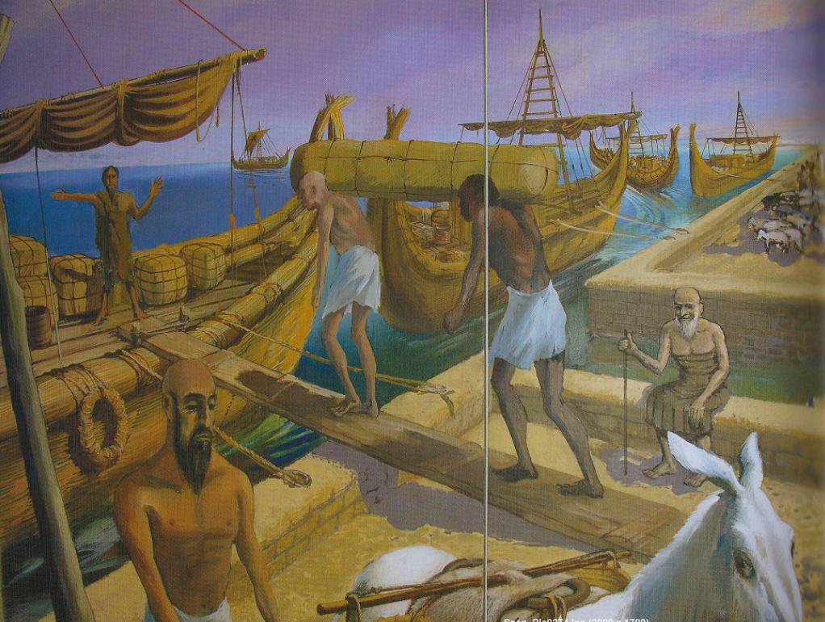
Ether 2:16 Go to work and build [SOUTHERN MIGRATION THEORY): Ether vessels (Illustration): Mural depicting ancient Persian Gulf port, Bahrain National Museum [George Potter, Frank Linehan, and Conrad Dickson, Voyages of the Book of Mormon, Chap. 8, p. 216]

Ether 2:16 They Were Small [EASTERN MIGRATION THEORY]:

According to Randall Spackman, as to the size of the barges, the Book of Ether states simply that they were "small" (Ether 2:16) and "the length of a tree" (Ether 2:17). The barges may have been small in comparison with typical sea-going craft from lower Mesopotamia. Casson reported that the capacity of Mesopotamian vessels ranged from an extremely large ship of 300 gur or approximately 31 tons, to a normal vessel of 60 gur, about 6 tons, to the smallest craft which only carried a single ton of cargo. Casson estimated that a small barge carried about 30 gur or 3 tons of cargo. Several sea-going junks were described by Donnelly, ranging from 30 to 70 feet in length. Thus, the declaration that the Jaredite barges were small could reasonably mean that they were approximately 30 to 40 feet long and capable of carrying about 3 to 5 tons of cargo.

It is interesting that the Jaredite record speaks of the barges as "small" in direct proximity with references to the vessels being "light upon the water" (Ether 2:16). A small barge may have been more seaworthy than a larger vessel. Heyerdahl's experience with small craft is instructive: "Speaking of aboriginal watercraft, safety at sea does not increase with the size of the vessel; indeed, numerous experiments in the Pacific and Atlantic oceans have convinced the writer and others of the fact that primitive vessels less than thirty feet in length have a greater chance of survival in stormy seas than similar vessels of larger dimensions. It is a great advantage to a vessel to be small enough to move freely between and over the swells, since a boat much over thirty feet long will either be forced to bury bow or stern into surrounding waves, or will bridge two waves simultaneously with the risk of breaking amidships."

An alternative meaning of the word "small" may mean that the barges were overcrowded when they were loaded. [Randall P. Spackman, The Jaredite Journey to America, pp. 74-76, unpublished]

Ether 2:16 They Were Light upon the Water, Even Like unto the Lightness of a Fowl:

Richard Gudmundsen has designed a barge according to the specifications given by the Lord to the brother of Jared (see illustration). Readers should note the peculiar shape of the boat's hull. It is designed so that when the wind blows, aerodynamic forces will cause the boat to point in a direction which will have the least hydraulic (water) drag. Thus it will skitter across the water like a duck, yet will not spin in a manner which would cause sea sickness to the occupants. (Note the reference to ducks in the abridger's description--Ether 2:16). [Richard A. Gudmundsen, Scientific Inquiry Applied to the Gospel of Jesus Christ, pp. 99-103]

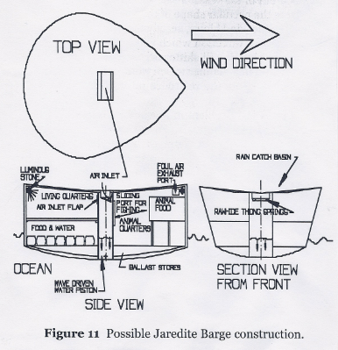
Ether 2:16 They were light upon the water, even like unto the lightness of a fowl upon the water (Illustration): Possible Jaredite Barge Construction. [Richard A. Gudmundsen, Scientific Inquiry Applied to the Gospel of Jesus Christ, p. 99]

Ether 2:16 They Were Light upon the Water:

The barges are described as being "light upon the water" (Ether 2:16). According to Paul Hedengren, this is probably referring to draft, the nautical term for how far into the water a floating object extends. Any object settles in water until the weight of the water it displaces is equal to the weight of the object. If it cannot displace water equal to its weight, it sinks. Since the object will settle until it displaces water equal in weight to the vessel's weight, the wider and flatter the bottom of a vessel, the lighter upon the water it will float.

Sitting light upon the water has two effects on a vessel. First it makes it less sensitive to currents in the water, since there is less surface for the water to push on. Second it makes it more sensitive to wind, since there is more surface for the wind to push on.

In heavy seas, besides being watertight, a vessel should be able to avoid rolling, either end over end or sideways. The design of the Jaredite barges may have made them less susceptible to some common causes of rolling in small sailing vessels. The end over end roll may be caused by racing down the face of a high wave and burying the bow of the craft in the water at the bottom. Before the buoyancy can lift the bow, the stern may be lifted up and over the bow by the following wave. If a boat is light upon the water, with peaked ends, it is less likely to plant the bow deep enough to allow the stern to be pivoted over it.

In regard to lateral rolling, although there is no statement in the text about whether the barges were self-righting, the weight of secured supplies plus any secured ballast may have made the barge self righting. Had it not been, it certainly would not have been a voyage conducive to singing of God's praises during severe tempests as the text says occurred (see Ether 6:9). [Paul Hedengren, The Land of Lehi: Further Evidence for the Book of Mormon, pp. 78-79]

Ether 2:16 They Were Light upon the Water, Even Like unto the Lightness of a Fowl upon the Water [EASTERN MIGRATION THEORY]:

According to Randall Spackman, the Jaredite record describes the barges as "light upon the water, even like unto the lightness of a fowl upon the water" (Ether 2:16). For a hull to be "light upon the water" indicates that the boat had a shallow draft. The barges sat on the water rather than in it. This type of displacement pattern is typical of vessels with wide flat bottoms. . . . It might be well and good to have a shallow draft, but how do you get a wide barge to slip through the water as efficiently as possible, or with the "lightness of a fowl upon the water"? In the western world, the mould of the hull was patterned after a fish, with the greatest fullness towards the bow or the front. However, in East Asia, the hull was molded after the outline of a swimming bird, with the widest part of the boat towards the stern or towards the rear. The first European to observe and write about this difference was Admiral Paris in 1840: "For our best hulls we have taken the fishes as models, always larger at the cephalic end, but the Chinese, who also copied Nature, imitated the palmipeds, which float with the greatest breadth behind . . . In this they were acute, for aquatic birds, like boats, float between the two media of air and water, while fish swim only in the latter." [Randall P. Spackman, The Jaredite Journey to America, pp. 69-71, unpublished]

Ether 2:17 The Ends Thereof Were Peaked:

The ends of the Jaredite barges were described as "peaked" (Ether 2:16). According to Paul Hedengren, one way of producing peaks is to taper and bend up the ends of hull planks. This technique can produce a very strong hull.

There are some marked similarities between the Jaredite barges and the earliest known examples of merchant ships. The National Geographic of December, 1987, presents an artist's reconstructive drawing of a 14th century B.C. trading vessel based upon what the article calls the oldest known shipwreck. Excavation of the vessel provided information for drawing the bottom of the vessel. As the upper portions had decayed, the upper portions of the drawing were modeled after a 14th century B.C. Egyptian tomb painting showing the arrival of a Syrian fleet. The ship is fifty feet long. [Paul Hedengren, The Land of Lehi: Further Evidence for the Book of Mormon, pp. 78-79]

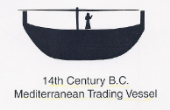
Ether 2:17 The ends thereof were peaked (Illustration-not shown): 14th Century B.C. Mediterranean Trading Vessel. [Paul Hedengren, The Land of Lehi: Further Evidence for the Book of Mormon, p. 79]

Ether 2:17 The Ends Thereof Were Peaked:

According to Randall Spackman, in what is a striking modern parallel to the Jaredite description of the "lightness" of the barges and their "peaked" ends (Ether 2:16-17), Laechler and Wirt wrote of the Chinese junk, "It does not cut through the water but skims across its surface . . . It is modeled after water birds, and its stern resembles their upswept tails in form." Commenting on this quality in sea-going junks, Donelly wrote: "The stern is always higher than the bow . . . The vessel will more easily lie head to wind in a gale, and . . . stands a better chance against being 'pooped' by an overtaking wave in a heavy sea. Also from this point of vantage on the high poop where he works the unwieldy tiller, the steersman commands a good view over the bow of the boat." [Randall P. Spackman, The Jaredite Journey to America, pp. 71-73, unpublished]

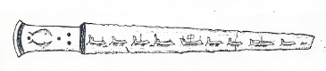
Ether 2:17 The ends thereof were peaked (Illustration): Included in the famous Dorak treasure from Turkey is a silver sword. Down the length of the silver blade is engraved nine seagoing ships. All have peaked prows. . . . The sword is dated c. 2500 B.C. (It can be seen in color in The Art of Warfare in Biblical Lands, Vol. 1, Yigael Yadin, p. 144.) [Verneil W. Simmons, Peoples, Places and Prophecies, pp. 30, 272]

Ether 2:17 The Length Thereof Was the Length of a Tree:

According to Dr. Sami Hanna, an expert in Semitic languages, in Ether 2:17 we learn that the Jaredites built their barges under the direction of the Lord, and that "the length thereof was the length of a tree." In the Semitic culture, common objects are used to relate distances, etc. Therefore, this phrase is completely within Semitic context. [Brenton G. Yorgason, Little Known Evidences of the Book of Mormon, p. 38]

Ether 2:17 The Length Thereof Was the Length of a Tree:

The Jaredite barges were built to "the length of a tree" (Ether 2:17). According to Paul Hedengren this might have been to avoid having joints at the ends of planks. The movement of a vessel through waves produces longitudinal flexing that would tend to separate joints at the ends of planks. Thus the Jaredite ships were not longer than the length of the available trees. [Paul Hedengren, The Land of Lehi: Further Evidence for the Book of Mormon, p. 79]

Ether 2:17 The Length Thereof Was the Length of a Tree (EASTERN MIGRATION THEORY):

According to Randall Spackman, Worcester has written that "most of the timber" used in East Asia for boatbuilding was pine. This "light, soft and tough" wood was obtained from trees that were cut for sale when they were "over 20 years old and about 50 feet high." If the same sort of materials were used by the Jaredites, then the phrase "the length of a tree" (Ether 2:17) might simply mean that the barges were about 50 feet long or less.

On the other hand, the phrase "the length of a tree" could also be interpreted as a reference to the Jaredites' use of a particular method for constructing their barges. Unlike modern boatbuilding techniques, which involve the creation of a keel and frame before the planking is applied, Mesopotamian boatbuilders first created a box-like hull of edge-joined planks into which they inserted frames, a central shelf or spine, and deckbeams. For the greatest rigidity and strength, a single beam made from one large tree was required for the central shelf of the vessel. . . . Thus it would seem logical to assume that "the length of a tree" had some direct connection with the extreme tightness of the Jaredite hulls. [Randall P. Spackman, The Jaredite Journey to America, pp. 76-77, unpublished]

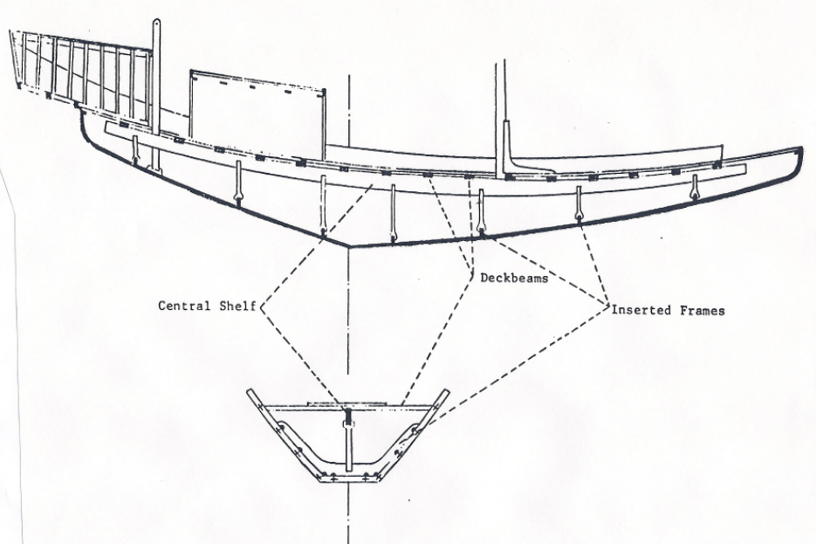
Ether 2:17 The length thereof was the length of a tree (Illustration): Figure 11, Mesopotamian And Egyptian Boatbuilding System, The Jaredite Journey to America, p. 78, unpublished]

Ether 2:17 The Door Thereof, When It Was Shut, Was Tight Like unto a Dish:

According to Randall Spackman, each vessel had a "door" (Ether 2:17) which, "when it was shut, was tight like unto a dish." The Jaredites would have required some means of putting their provisions into the barges; so, at least one opening of some kind may be assumed. That this opening was merely a hatch is unlikely. Pictures and models of ancient barges nearly always show a deck house of some type. Furthermore, a flush-decked vessel with one or more hatches would provide no protected area from which the helmsman could steer the vessel during storm conditions. There was such an area because the brother of Jared complained about it: "O Lord, in them there is no light; whither shall we steer?" (Ether 2:19) That is, with the door closed and without a window or opening in this protected area, the helmsman either could not tell where to steer or could not steer at all. Thus it seems that there must have been some form of deck house with a door, but no windows, covering at least part of the stern of the vessel. Of course, there may have been several additional hatches through which the Jaredites loaded their provisions and animals. [Randall P. Spackman, The Jaredite Journey to America, p. 86, unpublished]

Ether 2:17 Tight Like unto a Dish (EASTERN MIGRATION THEORY]:

Noah, the first shipbuilder of Biblical record, was commanded to make an ark of "gopher wood" and to coat it inside and out with pitch (Genesis 6:14-16). According to Randall Spackman, pitch is also mentioned as material for coating boat hulls in documents from the 3rd Dynasty of Ur, about 2000 B.C., and it is clear from Mesopotamian records during the 2nd millennium B.C., that it was standard practice in Jared's Babylonia to coat the outside of the vessel with pitch and the inside of the planks with fish oil. In northern China, however, the ancient waterproofing technique was to coat the hulls with tung oil, sometimes mixed with fish oil or lime, a practice which one early European traveller noted "suffereth no wormes, which is the occasion that one of their shippes doth twice last out one of ours."

Thus, the use of pitch, fish oil or tung oil for waterproofing and protection from worms may have been comprehended in the words "tight like unto a dish" (Ether 2:17). [Randall P. Spackman, The Jaredite Journey to America, pp. 79-80, unpublished]

Ether 2:17 Tight like a dish [SOUTHERN MIGRATION THEORY]:
Potter, Linehan and Dickson write that dishes in the Middle East in the third millennium BC were simple earthen-ware pottery made from a mixture of clay and sand that was dried until it was hardened by sunlight. When fully dried, the sand inside the clay sealed the pot to make it waterproof. We read that Omani ships had a final layer of pottery clay applied to the outer side of the hull. In other words, the ships were sealed tight and had the exact outer appearance of an ancient dish and pottery. [George Potter, Frank Linehan, and Conrad Dickson, Voyages of the Book of Mormon, Chap. 8, p. 219-220]

Ether 2:19 In Them There Is No Light, Whither Shall We Steer? . . . in Them We Cannot Breath:

According to Warren and Palmer, it is unlikely that the first set of Jaredite barges was completely enclosed, because enclosure posed added construction challenges. Thus, we can assume that the first set of barges was a rehearsal for the construction of the second set. The first set of barges probably had a rudder. When the second set was built, totally enclosed, they asked not only "whither shall we steer? (Ether 2:19) but exclaimed "in them we cannot breathe!" (Ether 2:19) and "behold, O Lord, in them there is no light!" (Ether 2:19). [Bruce W. Warren and David A. Palmer, The Jaredite Saga, ch. 5, unpublished]

Ether 2:19 In Them Is No Light . . . In Them We Cannot Breathe:

Paul Hedengren notes that the Jaredites constructed two sets of barges. After leaving the valley of Nimrod, the Jaredites traveled in the wilderness for a while, built barges, crossed "many waters" (Ether 2:6) and then traveled in the wilderness to "that great sea which divideth the lands" (Ether 2:13) before finally being directed to build barges again. Of the second set of barges we read, "And the Lord said: Go to work and build, after the manner of barges which ye have hitherto built" (Ether 2:16).

There are some indications, however, that the design of the second set of barges was not exactly like the first. The phrasing "after the manner" permits possible accommodations for a much longer and more arduous ocean voyage.

For the first set of barges, apparently the deck only needed to keep rain and occasional boarding waves from flowing down into the vessel. As a consequence, this lighter deck contained sufficient openings to provide adequate ventilation and needed light below.

For the Jaredite ocean voyage, however, the waves were so high that "they were many times buried in the depths of the sea, because of the mountain waves which broke upon them" (Ether 6:6) To do this, the force exerted on the deck would have been much greater than was normally exerted on the hull. Thus the deck must have been very strong. To achieve this strength, traditional openings for ventilation and light were apparently not possible.

Thus the reader should notice that only with the second construction of barges are concerns about the absence of light and ventilation expressed. As the brother of Jared says, "Oh Lord, in them there is no light . . . And also we shall perish, for in them we cannot breathe" (Ether 2:19). [Paul Hedengren, The Land of Lehi: Further Evidence for the Book of Mormon, pp. 77-78]

Ether 2:19 In Them There Is No Light (Revelation & Individual Responsibility):

Many readers skip over the process of shipbuilding by the brother of Jared (and also by Nephi) as if the Lord gave them a revelation and the next day they went out in their backyard and put a ship together with a little help from a few brothers. The Book of Mormon student would do well to ponder the words of Elder Harold B. Lee:

The Lord gave to the brother of Jared, that great prophet, a blueprint of the ships that he was to construct, by which he was to take his people across large bodies of water to a promised land. [But] as he surveyed these and began to build, he faced two problems: (1) no provision was made for ventilation and (2) there was no light. The ventilation problem was solved rather simply [by the Lord?] by having holes at proper places that could be opened and closed [see Ether 2:20-21]; but the matter of light was [quite different or was it?] . . . The Lord said to the brother of Jared, "What will ye that I should do that ye may have light in your vessels?" (Ether 2:23)--as much as to say, "Well, have you any good ideas? . . . [The Lord then details the problem but instead of providing an answer He just leaves the brother of Jared on his own.] It was as though the Lord were saying to him, "Look, I gave you a mind to think with, and I gave you agency to use it. Now you do all you can to help yourself with this problem; and then after you've done all you can [both temporal and spiritual], I'll step in to help you." . . .

[The next thing we find is the brother of Jared gathering sixteen stones molten out of rock to the top of the mountain and petitioning the Lord to (1) forgive his sins (see Ether 3:2); (2) forgive the sins of his people (see Ether 3:3); and (3) touch the stones that they might give off light (see Ether 3:4-6)]

This is the principle in action. If you want the blessing, don't just kneel down and pray about it. Prepare yourselves in every conceivable way you can in order to make yourselves worthy to receive the blessing you seek. (Harold B. Lee, "How to Receive a Blessing from God," Improvement Era, Oct. 1966, pp. 862-63, 896)

While in no way trying to lessen anyone's appreciation for the faith that it took to ask the Lord to touch sixteen stones and make them give off light, or the additional spiritual lessons conveyed by the scriptural story or by Elder Lee's remarks, I have to wonder at this point just how much time and how many failed attempts on his own it took the brother of Jared before he felt like he had done all that he could mentally, physically and spiritually do in order to feel worthy to return to the Lord for help? For example, what prompted him to "molten" stones out of rock in the first place? Why didn't he just ask the Lord to light up any old stones? Or for that matter, why didn't he just ask the Lord to control the seas so that they could have windows which were not dashed out by the "mountain waves"? To me it is obvious that in stressing the spiritual, most of the cultural details concerning the brother of Jared's required study and experimentation with existing materials and maritime lore has been left out of the story. The same can also be said for Nephi and his struggle to build his ship. [Alan C. Miner, Personal Notes] [See the commentary on 1 Nephi 17:8; 18:2]

Ether 2:19 Whither Shall We Steer?:

According to Randall Spackman, the book of Ether contains only four brief references to the technology used by the Jaredites for the propulsion and control of their barges. First, the complaint of the brother of Jared, "O Lord, . . . whither shall we steer?" (Ether 2:19) indicates that the vessels had some method of steering which was interfered with by the enclosed deck house. Second, after the vessels were loaded, the Jaredites are said to have "set forth into the sea" (Ether 6:4). Presumably, they did not attempt to drift away from the seashore, but used some means of propulsion. Third, the record states that "they were driven forth before the wind" (Ether 6:8) implying that some form of sail may have been used when weather conditions permitted it. Finally, the Book of Ether says that "they did land upon the shore of the promised land" (Ether 6:12). This is not very helpful, but it does not say their barges were "wrecked" upon the shore. It would seem, therefore, that they used some method to control their landing, probably similar to what they used to "steer" and to "set forth" in the beginning. Hence, it would not be contrary to the record to assume that the barges had one or more forms of propulsion and control.
Mesopotamian carved seal stones from the 4th millennium B.C. show reed craft with a man "at the stern, either paddling or steering, while another man stands in the bow holding a forked stick for punting or sounding the river bed." In Mesopotamia several hundred years before the time of Jared, the single steering oar attached to the stern of the vessel (see illustration) was common . . . Because of the size of the barges and their use at sea, long oars manned by a standing oarsman must have been considered a key element in the propulsion and control system for each barge. There may have been some type of steering oar which could be manned during good weather, but which was impossible to use from within an enclosed deck house. [Randall P. Spackman, The Jaredite Journey to America, pp. 86-89, unpublished]

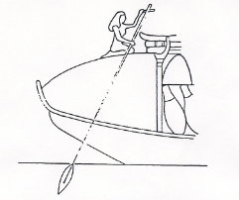
Ether 2:19 Wither shall we steer? (Illustration): Egyptian steering oar with tiller bar attached to the vessel's stern] [Randall P. Spackman, The Jaredite Journey to America, p. 90, unpublished]

Ether 2:20 A Hole in the Top [Thereof] . . . [Thereof] . . . [Thereof] . . . [Thereof]:

In providing a solution for the difficulty of obtaining air, the Lord informed Jared: "Behold thou shall make a hole in the top thereof, and in the bottom thereof; and when thou shalt suffer for air, thou shalt unstop the hold thereof, and receive air. And if it so be that the water come in upon thee, behold, ye shall stop the hole thereof, that ye may not perish in the flood" (page 542 of the first edition).

This quotation is taken from the first edition of the Book of Mormon because the four thereofs italicized above appear in the early editions, but for some unexplainable reasons were deleted from the 1920 edition and all subsequent editions--see Ether 2:20. (Perhaps the revising committee thought they were superfluous.)

A careful reading of this verse in the first edition seems to indicate that the terms "in the top" and "in the bottom" do not refer to the barge itself. Rather, they refer to the top and bottom of something else such as a chamber or cylinder (designated here as "thereof") which could be used to admit air.

Dr. Hugh Nibley has explained the possible significance of the "thereofs" and the possibility of an air chamber as follows:

An exacting editor by removing those very significant "thereof's" has made it appear that when Jared wanted air he was to open the top window of the boat and admit fresh air from the outside. But that is not what the original edition of Book of Mormon says. For one thing, the ships had no windows communicating with the outside--"ye cannot have windows. . ." (Ether 2:23); each ship had an airtight door (Ether 2:17), and that was all. Air was received not by opening and closing doors and windows, but by unplugging air holes ("thou shalt unstop the hole thereof, and receive air. . ."), "when thou shalt suffer for air" i.e., when they were not able to open the hatches, the ships being submerged. (Ether 2:20)

This can refer only to a reserve supply of air, and indeed the brother of Jared recognizes that the people cannot possibly survive on the air contained within the ships at normal pressure: ". . .we shall perish, for in them we cannot breathe, save it is the air which is in them; therefore we shall perish." (Ether 2:19) So the Lord recommended a device for trapping (compressing) air, with a "hole in the top thereof and also in the bottom thereof," not referring to the ship but to the air chamber itself. Note the peculiar language: "unstop" does not mean to open a door or window but to unplug a vent, here called a "hole" in contrast to the door mentioned in verse 17; it is specifically an air hole--"when though shalt suffer for air, thou shalt unstop the hole thereof and receive air." (1st Ed.) When the crew find it impossible to remain on the surface--"and if it so be that the water come in upon thee" (Ether 2:20), they are to plug up the air chamber: "ye shall stop up the hole thereof, that ye may not perish in the flood." This, I believe, refers to replenishing the air supply on the surface, lest the party suffocate when submerged--"that ye may not perish in the flood." [Bookcraft, A Book of Mormon Treasury, pp. 136-137]

It is entirely feasible that such an air chamber could have been constructed in each boat. Some of the advantages of such an air chamber have been suggested by A. L. Zobell, Sr., as follows:

A tube is built from the bottom to the top of the barge, housing in both holes completely. Now we have a funnel right through the boat. Water can come into the tube as high as the water line of the vessel. The model of the barge we have built has a stop hole both in front and in back of the tube, . . . These stop holes can easily be opened or closed as needed. The purpose of the bottom hole is at least two-fold: First, it acted as a stabilizer to keep the barge at an even keel; second, it could be used to get rid of refuse. ("Jaredite Barges," A.L. Zobell, Sr., Improvement Era, April 1941, pp. 211, 252)
[Daniel H. Ludlow, A Companion to Your Study of the Book of Mormon, pp. 313-315]

Ether 2:20 Thou Shalt Make a Hole in the Top, and Also in the Bottom:

In the Lord's instructions to the brother of Jared concerning the barges he was to build, He said:
"thou shalt make a hole in the top, and also in the bottom; and when thou shalt suffer for air thou shalt unstop the hole and receive air. And if ti be so that the water come in upon thee, behold, ye shall stop the hole, that ye may not perish in the flood." (Ether 2:20)

According to Richard Gudmundsen, in reading the remarkable account of the eight barges designed by the Lord for transporting the Jaredites to the new world, it seems at first somewhat ludicrous that one should make a hole in the bottom of the boat and one in the top of the boat as described by the writer and translator. However, when one realized that the abridger Moroni was probably not an expert in hydraulics and pneumatics, then his explanation of the truth seems more reasonable.

The account requires a design which will remain upright in heavy seas which on occasion break completely over the vessels. The stones touched by the finger of the Lord provide the light necessary. The air conditioning system as envisioned by Gudmundsen consists of a wave-driven water-piston which when falling, allows air from the top to be admitted by a flapper valve normally held upwards by a stretchable cord made of animal skin. (see illustration for Ether 2:16))

When the water in the "pump" made of a hollowed out tree, rises due to wave motion, the water piston drives the trapped air into the vessel's interior. Fresh air is pumped into the vessel on one side, and foul air is exhausted at the other end of the boat through a flap valve also made of animal hide. In this design, the air is admitted through the pump's entrance valve placed such that any water which washes over the top falls back into the sea in rough seas. In really terrible storms, it would be necessary to clamp the exit valve closed if too much water flowed into the pump volume. By making the pump's exit port face into the human quarters, a natural draft would be set up to insure that only the stale air from the animal quarters will be pumped out of the vessel's exit flap port. [Richard A. Gudmundsen, Scientific Inquiry Applied to the Gospel of Jesus Christ, pp. 99-103]

Ether 2:20 Thou shalt make a hole in the top, and also in the bottom(Illustrationi-not shown): Possible Jaredite Barge Construction. [Richard A. Gudmundsen, Scientific Inquiry Applied to the Gospel of Jesus Christ, p. 99]

Ether 2:20 Thou Shalt Make a Hole in the Top, and Also in the Bottom:

According to Paul Hedengren, it should not be assumed that just because the Lord authorized the cutting of two holes in each vessel, one "in the top, and also in the bottom" (Ether 2:20), He was also acknowledging that the vessel could be used either right side up or up side down. Since the ends of the barge were peaked, it would not move so easily upon the water upside down as right side up. Furthermore, tumbling about with other people and unsecured cargo is likely to produce serious injuries. It is difficult to imagine a nearly year-long voyage in which this was a normal occurrence. One might ask, If the plug in the hole in the bottom of the barge were removed, would not the barge sink? Not necessarily. Remember, the barge settles in the water only as far as is necessary to displace water of the same weight. Since the barge is light upon the water, it is not settling far. All that would be necessary to keep the barge from sinking would be to place a watertight extension around the hole and extend it from the bottom of the barge higher than the water line outside the barge. Water would then rise in that extension up to the level of the water line outside the barge and no further (see illustration). If the Jaredite boats had a watertight extension from the hole on the bottom to the hole on the top, with stops near and above the waterline, then in addition to ventilation, the stops could also have served as a source of seawater for washing and as a source for waste removal. [Paul Hedengren, The Land of Lehi: Further Evidence for the Book of Mormon, p. 79]

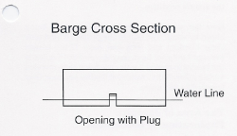
Ether 2:20 Thou shalt make a hole in the top, and also in the bottom (Illustration): Barge Cross Section, Opening with Plug [Paul Hedengren, The Land of Lehi: Further Evidence for the Book of Mormon, p. 79]

Ether 2:20 Thou Shalt Make a Hole in the Top, and Also in the Bottom [EASTERN MIGRATION THEORY]:

According to Randall Spackman, in certain types of Asian vessels, the foremost (and less frequently the aftermost) compartment is made free-flooding. Holes are placed in the planking; however, the vessel does not sink because the watertight compartment bulkhead keeps the remainder of the vessel dry. According to Chinese tradition, a free-flooding compartment reduces the vessel's resistance to water to a minimum and cushions the shocks of pounding when the vessel pitches in rough water. The vessel acquires and discharges water ballast just at the time when it is most desirable to counteract the buffeting at the bow or stern.

Assuming that the Jaredites used extremely tight construction methods, placing holes in the tops of the free-flooding compartments would have been required for the free movement of the water ballast. The illustrations below show the "normal" and "submerged" conditions of such theoretical free-flooding compartments. While there is no way of determining that the Jaredite devices were like those proposed, this interpretation is much more simple than one requiring submarines and compressed air devices and it is based upon East Asian technology. Except for an occasional stoppage due to "mountain waves," the air supply could have been continuous. [Randall P. Spackman, The Jaredite Journey To America, p. 96-97, unpublished]

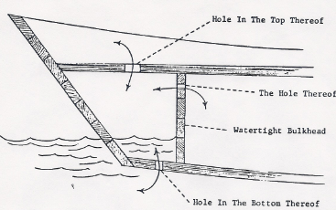
Ether 2:20 Thou shalt make a hole in the top, and also in the bottom (Illustration) [EASTERN MIGRATION THEORY]: Free-flooding compartment under normal conditions [Randall P. Spackman, The Jaredite Journey to America, p. 98, unpublished]

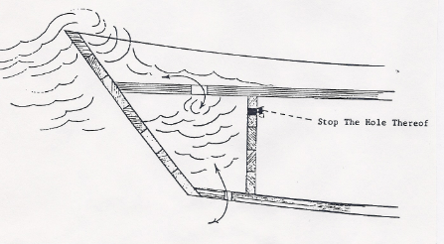
Ether 2:20 Thou shalt make a hole in the top, and also in the bottom (Illustration): Free-flooding compartment under submerged conditions [Randall P. Spackman, The Jaredite Journey to America, p. 98, unpublished]

Ether 2:20 Thou Shalt Make a Hole in the Top, and Also in the Bottom:

Glenn Scott asks the question, Now what kind of oceangoing vessel would be built intentionally, with "a hole . . . in the bottom" (Ether 2:20)? Scott then says that Edward Butterworth (Pilgrims of the Pacific, 1974, pp. 64-65) has suggested what is probably the most logical solution to this intriguing problem. Scott feels that Butterworth "may have reasoned that the barges the Jaredites had built in the wilderness were most likely a kind of raft, consisting of a simple platform supported on two large logs. They would have built them as simple and easy to construct as possible for they had to build them again and again as they crossed many waters in the wilderness. That concept certainly agrees with the description given Butterworth by two elderly Tahitians, of the great oceangoing catamarans in which the ancient Polynesians sailed the Pacific (Pilgrims, pp. 56-59).

Those long-distance vessels were basically two long, hollow logs, connected by a platform which might explain the Lord's instruction to build them "after the manner of barges which ye have hitherto built" (Ether 2:16). Those Polynesian catamarans were up to one hundred feet long, and the platform sometimes had a double-deck superstructure. The largest Polynesian oceangoing catamarans carried more than 200 warriors or migrating colonists, for thousands of miles across the Pacific. However, since Ether wrote that the Jaredites took "flocks and herds, and whatsoever beast, or animal, or fowl that they should carry with them" (Ether 6:4) it is not likely that there were half that many persons in each barge.

The most convincing reason for accepting this design, is that it provides a reasonable solution for a ship; having a hole in the bottom. His concept would, in all but the roughest weather, have kept the hole above the water and at the same time provided means for air circulation, fishing, and disposal of refuse. When the weather became rough, the holes could be sealed by doors making them as watertight.

Some have suggested that the Jaredite barges may have looked like a submarine (essentially a tube pointed at both ends), but that would not fit the description of being "light . . . like unto the lightness of a fowl upon the water" (Ether 2:16). Neither would it explain how they could have had a hole in the bottom without sinking. [Glenn A. Scott, Voices from the Dust, pp. 38, 40]

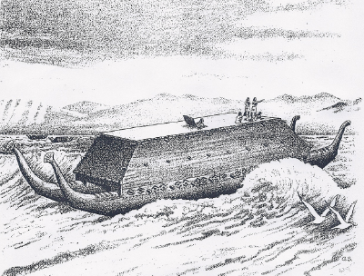
Ether 2:20 Thou shalt make a hole in the top, and also in the bottom (Illustration): These illustrations show how the Jaredite barges may have looked based on F.E. Butterworth's concept of seagoing Polynesian catamarans in his book Pilgrims of the Pacific. [Glenn A. Scott, Voices from the Dust, p. 42]

Ether 2:23 What Will Ye That I Should Prepare For You That Ye May Have Light:

Jeffrey R. Holland writes:

“Clearly the brother of Jared was being tested. God had done his part. Unique, resolutely seaworthy ships for crossing the ocean had been provided. The brilliant engineering had been done. The hard part of the construction project was over. Now the Lord wanted to know what the brother of Jared would do about incidentals.” (Christ And The New Covenant, p. 16)

Harold B. Lee adds:

“Then the Lord went away [from the brother of Jared] and left him alone. It was as though the Lord were saying to him, ‘Look, I gave you a mind to think with, and I gave you agency to use it. Now you do all you can to help yourself with this problem; and then, after you've done all you can, I'll step in to help you.’” (Stand Ye in Holy Places, p. 243)

[Note that we are talking about a Prophet here, chosen to lead. Members of the Church (to say nothing of non-members) tend to hold Joseph Smith (or other Church leaders) up to an unreasonable standard, as if everything they did or said came directly from the mouth of God. In my view, Joseph was left on his own for much of the time by the true Head of the Church (Christ) and allowed to do things that, while not necessarily inconsequential or unimportant in their imperfection, still did not deter the Lord in his grand plans for the Church in these Latter-days. Alan Miner, Personal Notes]

Harold B. Lee continues:

“This is the principle in action. If you want the blessing, don't just kneel down and pray about it. Prepare yourselves in every conceivable way you can in order to make yourselves worthy to receive the blessing you seek.

“…When we are situated that we cannot get anything to help ourselves, then we may call upon the Lord and His servants who can do all. But it is our duty to do what we can within our own power.

“That is a tremendous principle. In order to teach young people how to approach the Lord and how to prepare to receive what the Lord has promised for those who are faithful, we must teach them these fundamental steps. After Moroni had read this great experience of the brother of Jared, he added: ‘. . . wherefore, dispute not because ye see not, for ye receive no witness until after the trial of your faith.’ (Ether 12:6.)” (Stand Ye in Holy Places, p. 244-5)
[josephsmith.com . . . Ether ]

Ether 2:23 Ye Cannot Have Windows for They Will Be Dashed in Pieces:

According to Hugh Nibley, for some it might be perplexing that the reference in Ether 2:23 to "windows . . . [that] will be dashed in pieces seems to refer to glass windows, since no other kind would be waterproof and still be windows, and the windows would have to be brittle enough in order to be dashed "in pieces." Moreover, Moroni, in actually referring to "transparent glass" in Ether 3:1, is probably following the words of Ether.

This would make the invention of glass far older than anyone dreamed it was until the recent finding of such objects as Egyptian glass beads from "the end of the third millennium B.C." Nevertheless, "very little . . . is known," writes Newberry, "about the early history of glass," though that history "can indeed be traced back to prehistoric times, for glass beads have been found in prehistoric graves." We need not be surprised if the occurrences of glass objects before the sixteenth century B.C. "are few and far between," for glass rots, like wood, and it is a wonder that any of it at all survives from remote antiquity. . . . The finding of the oldest glass and ironwork in Egypt is not a tribute to the superior civilization of the Egyptians at all, but rather to the superior preservative qualities of their dry sands. [Hugh Nibley, The World of the Jaredites, pp. 216-217]

[Note* Windows were also a part of Noah's ark: "A window shalt thou make to the ark" (Genesis 6:16). [Alan Miner, Personal Notes]

Ether 2:23 Ye Cannot Have Windows for They Will Be Dashed in Pieces:

Brant Gardner writes that Nibley points out the existence of some glass technology at this time—primarily in the form of small beads(n.21)—but beads are a long way from the technological challenges of glass panes mounted in frames. A more likely possibility is wooden-shuttered holes, something much more likely in the ancient world than glass windows. Still, they could be broken by wave action, suggesting that the barge door also had to have reinforcement or sealing of some kind to prevent a similar problem. A different possibility is explained by an unnamed author at the Neal A Maxwell Institute for Religious Scholarship:
The term window originally referred to an opening through which the wind could enter. It is found 42 times in the Bible, where it does not refer to glass windows as we know them. In one passage (2 Kings 13:17), we read that a window in the palace was opened. So windows sometimes had doors or shutters. The same is true of the window that Noah built into the ark (Gen. 6:16; 8:6).
It seems likely that Ether 2:23 means that the barges themselves would break if they had windows or openings built into them. In the next verse, the Lord explains that this is because they would go through extremely turbulent conditions at sea, sometimes being buried beneath the waves. Windows would mean weakening the wooden structure, by creating openings, making it more fragile and thus liable to be “dashed in pieces.” If we read only the sentence containing the word “windows” and read it out of context, then the antecedent of “they” would, indeed, be “windows.” But it is probable that the antecedent is “vessels,” the last word in the preceding sentence.(n.22)
[Brant A. Gardner, Second Witness, Vol. 6: Fourth Nephi through Moroni, p. 190]

Ether 2:23 Neither Shall Ye Take Fire with You:
Brant Gardner notes that the reason for this instruction doesn’t seem to have been the inherent problem of an open fire in a flammable boat. Yahweh tells the brother of Jared that they cannot have fire because “ye shall go as a whale in the midst of the sea,” an image that means they would be underwater at least part of the time [and sealed “tight” in the boat]. Fire would be dangerous at such a time because it consumes precious oxygen at the very time when it was most needed. [Carbon monoxide poisoning]. [Brant A. Gardner, Second Witness, Vol. 6: Fourth Nephi through Moroni, p. 190]

Ether 2:24-25 I Prepare You Against These Things (Covenant Language and Structure):

According to Donald Parry, parallelism is universally recognized as the characteristic feature of biblical Hebrew poetry. (p. i)

Apparently, the prophets and writers of the scriptures employed the repetition of alternating parallel lines for the purpose of reinforcing their teachings and doctrines. (p. x)

An "extended alternate" type of parallelism takes the form A-B-C-D/A-B-C-D. (p. xiii)
A fine example of this Extended Alternate Parallelism is found in Ether 2:24-25.

24 . . . For behold, ye shall be . . . in the midst of the sea; for the mountain waves shall dash upon you.
a. Nevertheless, I will bring you up again out of the depths of the sea;
b. for the winds have gone forth out of my mouth.
c. and also the rains and the floods have I sent forth.
d. And behold, I prepare you against these things;
25 a. for ye cannot cross this great deep save I prepare you against the waves of the sea;
b. and the winds which have gone forth,
c. and the floods which shall come,
d. Therefore what will ye that I should prepare for you.
[Donald W. Parry, The Book of Mormon text Reformatted according to Parallelistic Patterns, F.A.R.M.S., p. 456-457]
[Note* Ether 2:24-25 uses alternate extended parallelism to emphasize that for the covenant faithful of the Lord, they will be required to go through profound hardships that threaten to sink them to the depths (symbolized by sea, winds, floods, etc.) but that the Lord will prepare his covenant faithful to endure and overcome those hardships. Alan Miner, Personal Notes]

NOTES

. Whiston, trans. n.d., 39.
. On this subject see Karl Preisendanz, "Nimrod," in RE 17:624. On the crimes of Nimrod, see Nibley, "The Arrow, the Hunter, and the State," 339-41.
. G. Sale, The Koran (Philadelphia: Lippincott, 1870), 269. The same custom and the same arrogance is reported of the ancient Thracians, Herodotus, Histories IV, 94.
. I.A. Richards, quoted by A.C. Bouquet, Comparative Religion, 6th ed. (Baltimore: Penguin, 1962), 24.
. Dieterici, Thier und Mensch, 112; A. Wunsche, Salomons Thron und Hippodrom Abbilder des Babylonischen Himmelsbildes, Ex Oriente Lux 2,3 (Leipzig: Pfeiffer, 1906), 26.
. Ad-Diyarbakri, Tarikh al=Khamis (Cairo, A.H., 1283), 1:67; Clement Huart and Louis Delaporte, L'Iran antique (Paris: Michel, 1952), 454-55. Egyptian priests, royalty, and the dead were all clothed in the classic skin garment of the Egyptian priesthood; cf. T.J. C. Baly, "Notes on the Ritual of Opening the Mouth," JEA 16 (1930): 173-86. The Kaunakes of the Sumerians was a heavy skin garment wholly unsuited to the climate of Babylonia and has for that reason been taken as proof that the Sumerians came from the North, Moret, Histoire de l'Orient 1:21, n. 81; vs. George A. Barton, "Whence Came the Sumerians?" JAOS 49 (1929):263-64. Montague R. James, The Apocryphal New Testament (Oxford: Clarendon, 1924), 414; cf. p. 412, on the garment of the King of Kings. In 1939 an amber statuette was found showing the King of Assyria wearing the insignia of the Jewish High Priest, "A Unique Example of Assyrian Sculpture: A Portrait in Amber," ILN (7 January 1939): 25.
. In later times the Egyptian priest wore "no real leopard-skin but a close-fitting coat of fine linen in the form of a leopard-skin," H.R. Hall, "The Bronze Statuette of Khonserdaisu in the British Museum," JEA 16 (1930): 1, cf. T.J.C. Baly, "Notes on the Ritual of Opening the Mouth," 178. The Syrian Christians said that the garment given to Adam was of cotton, the "skin" of the tree, Eisler, Iesous Basileus, 2;34; this doctrine, they say, was known only to Moses, "who called cotton 'skin' because among trees it takes the place of skin"' hence the idea that John the Baptist took his clothes from trees. The Jews retained traces of the older garment in their phylacteries and in the Sisith, the four strings that every Jew once had on the edge of his garment, Ferris J. Stephens, "The Ancient Significance of Sisith," JBL 50 (1931):59-70. Compare the Irham of the Moslems in John L. Burckhardt, Travels in Arabia, 2 vols. (London: Colburn & Bently, 1831), 1:104-05; 163-64.
. Eisler, Iesous Basileus, 2:34, n. 11 for references.
. History Begins At Sumer, Philadelphia: University of Pennsylvania Press, 1956.
. Leon Jaroff 1992, "Iceman," Time October, 62; Sandy Fritz 1993, "Who was the Iceman?" Popular Science 2:46-50,88; 1994, "Death of a Hunter," Popular Science 3:80-81,88.
. Nibley 1988, 235.
. Milton Daniels, ed. 1989, Chronicle of America.
. Funk & Wagnells Encyclopedia 1951, S.V. Herodotus, 18:6527.
. Times Atlas of World History 1985, S.V. Empire of Alexander, 77.
. Times Atlas of World History 1985, s.v. The Silk Route (map), 71.
. Anon. 1988, "Traveling the Silk Road," Aramco World, 7-8.
. Neil Steede, ed. 1990, Cornerstone, 1;4;34.
. Staff 1974, "Discoverers of the Pacific," National Geographic, December.

