Book of Ether

Chapter 6

Ether 6:2 [The Stones] Did Give Light unto the Vessels:

In Ether 6:2 we find that,

after the Lord had prepared the stones which the brother of Jared had carried up into the mount, the brother of Jared came down out of the mount, and he did put forth the stones into the vessels which were prepared, one in each end thereof; and behold they did give light unto the vessels.

According to a F.A.R.M.S. Update, some critics have completely dismissed the Book of Mormon because they could not believe that a light source such as the brother of Jared's stones was physically feasible. For example, some have said, "the story of Ether's stone candles overtaxes the marvelous," while others have said "the words 'patently ridiculous' seem too kind."

However, Sandia National Laboratories in New Mexico has recently developed radioluminescent lights that invite some interesting comparisons with the Jaredite stones. The radioluminescent lights are made from a highly porous silica matrix --"aerogel" -- in which a phosphor such as zinc sulfide is dispersed.


Aerogel reacting with light Aerogel

The radioactive source of the lights is tritium gas, which when incorporated in the aerogel, actually becomes chemically bonded to the aerogel matrix. The radioactivity of tritium results in beta particles (electrons) striking the phosphor particles and causing them to emit light while not escaping the matrix. Their life expectancy is about 20 years and their light is described as being "bright" and very "intense." Even the possibility that the Jaredite stones were created according to similar physical laws should be enough to quiet the critics. [Based on research by Nicholas Read, Jae R. Ballif, John W. Welch, Bill Evenson, Kathleen Reynolds, and Matt Roper, "New Light on the Shining Stones of the Jaredites," in F.A.R.M.S. Update Number 83, July 1992]
Ether 6:2 [The Stones] Did Give Light unto the Vessels:

According to John Heinerman, the problem with the F.A.R.M.S. article is that it looks at a spiritually generated procedure from an entirely secular point of view. No one has ever considered the priesthood virtue emanating from our Lord constantly as being the TRUE SOURCE for the stones' continuous illumination. Now this virtue is an interesting thing to explore, for it sheds a great deal of understanding on how light came to be in otherwise dull rocks. The Prophet Joseph Smith, who felt this light or power often in his own life, referred to this peculiar virtue of the priesthood as "the spirit of life." It would leave while blessing little children sometimes; and a small portion of it certainly left our Lord when the woman with the blood issue touched the hem of Jesus' garment and was promptly made whole again (Matthew 9:20).

The virtue of the holy priesthood has been described in different ways by those who've felt it surging through their own bodily systems on various occasions. In his autobiography, Apostle Orson F. Whitney mentioned it "ran like liquid flame to the very tips of my fingers," while in the act of administering to a sick sister, who was instantly healed the moment it surged into her own body from his.

Consider what happened in ancient times with the Old Testament prophet Elisha. He was a man obviously filled with a great deal of this eternal priesthood element in life, as evidenced by the many great miracles he performed for others. Upon his death, as written in 2 Kings 13:20-21, his body was entombed in the usual sepulcher reserved for such purposes. In time, the elements of nature claimed the flesh of his corpse, leaving only the skeletal remains behind. Now a band of marauding Moabites had invaded the land "at the coming in of [a certain] year." One of their number was slain and in making a hasty retreat "they cast the [dead] man into the sepulcher of Elisha; and when the man was let down, and touched the bones of Elisha, he revived and stood on his feet" on account of the priesthood virtue which still remained in the prophet's weathered bones. [John Heinerman, Hidden Treasures of Ancient American Cultures, pp. 136-137142]

Ether 6:2 [The Stones] Did Give Light unto the Vessels:

According to Randall Spackman, the Babylonian deluge story has been preserved in three similar stories . . . all of which appear to have been known in Mesopotamia by the middle of the 2nd millennium B.C. The Babylonian "Noah" was called Utnapishtim. In his boat were carried "stone things" which protected it. These miraculous stones also may have had special light-giving functions. The Babylonian story of Utnapishtim related his boat to the moon, a crescent-shaped vessel which sailed safely through the dark heavens illuminated by a miraculous source of light.

The deluge of the Bible came when "there were giants in the earth" and "God saw the wickedness of man was great in the earth" (Genesis 6:4-5). Warned by God of the impending flood, Noah, his sons, and their wives built an ark, loaded various creatures into it, and survived the great flood in safety. The biblical story refers to a special light source, tsohar, which is translated "window" in the King James Version of Genesis 6:16. Von Rad acknowledged that the meaning of tsohar was not certain, but he accepted the word "roof" as the "best translation." Speiser's translation attempted to reach a middle ground; he read the word as "sky light." Despite this confusion, Nibley has noted that hundreds of years ago, a number of rabbis concluded that tsohar was a light-giving stone. [Randall P. Spackman, The Jaredite Journey to America, pp. 101-104, unpublished]

Ether 6:3 The Lord Caused Stones to Shine in Darkness, to Give Light unto Men, Women, and Children:

According to John S. Thompson, by applying some techniques of literary analysis to the Jaredite exodus narrative in Ether 1–3 and 6, the text reveals that it is more than just a historical account. The author or editor of the narrative uses imagery and dialogue to help the reader look beyond the historical facts and see elements of the creation, Christ, and temples, among other things.

The rapid movement of the narration of Jaredite historical beginnings from the Tower of Babel to the shore of the ocean (prior to the Jaredites' crossing) slows down significantly as the author/editor focuses the reader upon a theme through the literary device of dialogue. The writer reports a conversation which takes place between the Lord and the brother of Jared (see Ether 2:18–3:16, 21–27), and the primary focus of this dialogue is a discussion of the need for air and light in the barges which would be used for crossing the ocean. After the brother of Jared questions the Lord on what to do for air, the Lord tells him exactly how to obtain it: "Behold, thou shalt make a hole in the top, and also in the bottom; and when thou shalt suffer for air thou shalt unstop the hole and receive air" (Ether 2:20). However, when Jared's brother brings up the issue of light, the Lord merely says, "What will ye that I should do that ye may have light in your vessels?" (Ether 2:23). In contrast to the air, a necessary component to sustain life which is freely given by God,8 the brother of Jared must work out for himself the problem of light. Eventually, when presenting his plan to the Lord, the brother of Jared pleads: "Suffer not that they [the Jaredites] shall go forth across this raging deep in darkness; . . . therefore touch these stones, O Lord, with thy finger, and prepare them that they may shine forth in darkness" (Ether 3:3–4). This prayer for light produces more than what the offerer had expected. In sum, as the Lord touches the stones, the brother of Jared sees the divine finger and is eventually privileged to see Christ (Ether 3:6, 13). When the reader analyzes the narrative as a whole, he or she finds that the answer to the brother of Jared's plea for light is not necessarily limited to the illumination of the stones, though their presence in the narrative is significant, but it also encompasses Christ himself, the source of light. It is his finger that touches the stones, illumi nating them. In other words, the brother of Jared's diligent search and humble request for light brought him face to face with the Light. This imagery brings to mind the Savior's words: "I am the light of the world: he that followeth me shall not walk [or, in this case, cross the "raging deep"] in darkness, but shall have the light of life" (John 8:12).

The stones of light play a significant role in the Jaredite story because the writer uses them to carry the imagery of Christ throughout the rest of the narrative. In chapter six, we read that the brother of Jared "did put forth the stones into the vessels which were prepared, one in each end thereof; and behold, they did give light unto the vessels" (Ether 6:2). However, in contrast to "the" stones in this verse, verse three omits any definite article in reference to stones and also "men, women, and children." The author/editor seems specifically to ignore direct reference to the stones which the brother of Jared "moltened" and the men, women, and children of the Jaredites: "And thus the Lord caused stones to shine in darkness, to give light unto men, women, and children, that they might not cross the great waters in darkness." The absence of the definite articles prompts the reader to broaden his view, rather than focusing in on the actual stones and Jaredites of the story, allowing the imagery of Christ—who is the "light that shineth in darkness" (D&C 11:11), giving light or truth unto all men, women, and children-to surface.9 [John S. Thompson, “The Jaredite Exodus: A Literary Perspective of a Historical Narrative,” Journal of Book of Mormon Studies 3/1 (1994)]

Ether 6:3 The Lord Caused Stones to Shine in Darkness . . . That They Might Not Cross the Great Waters in Darkness:

According to Robert Clark, the story of the Brother of Jared, as a type, lies at the extremity of human experience, at that place where the veil is rent and we are taken back into the presence of the Lord. Or at least the brother of Jared is taken back, as he acts as intercessor for his people upon Mount Shelem (Ether 3). Shelem is the Hebrew singular term for the "peace offering" of the Mosaic sacrificial rite. In going to this mountain, the brother of Jared is making a sacrifice for the sake of his people, in order that they might cross the great waters in safety. The waters stand between two worlds. Which two worlds? The nature of types doesn't allow us to say for sure. They may be any two worlds, and the waters could be any kind of catastrophic transition, including birth and death. The peculiarity of the Jaredite voyage, however, is that they do not forget. Language and light remain their inheritance thanks to the intercession of their high priest. At least until the wicked one comes to them in the new world and takes away their light as they choose themselves a king. [Robert E. Clark, "The Type at the Border: An Inquiry into Book of Mormon Typology," Journal of Book of Mormon Studies, Vol. 2, Num. 2 (Fall 1993), pp. 74-75] [See the commentary on Ether 3:1]

Ether 6:4 When They Had Prepared All Manner of Good, That Thereby They Might Subsist upon the Water:

In Ether 6:4 we find that when the Jaredites had prepared "all manner of food, that thereby they might subsist upon the water, and also food for their flocks and herds, and whatsoever beast or animal or fowl that they should carry with them . . . they got aboard of their vessels or barges, and set forth into the sea."

According to Richard Gudmundsen, the biggest problem in a year's journey is fresh water for the humans and animals. For example, one cow would consume many gallons of water each day. Rain water is the solution to this problem. The top is designed to catch rain water. If it was not contaminated with too much ocean spray, the port on the side of the pump column would be opened so that a water vessel held inside the pump through the port, could be filled with rain water plunging from the roof catch basin through the top valve, (which would open due to the weight of the water). Fish and grain would be the staple diet of the humans. Uncooked, the fish would provide the necessary vitamins to prevent scurvy.

There were eight barges built each with the "length of a tree," (perhaps 40 to 50 feet). It is doubtful that more than one family could be housed in such a vessel along with their livestock. This would suggest that there were no more than 80 to 100 people in the entire group, i.e. perhaps 10 to 12 in each barge. The types of cattle/animals taken on the trip are unknown. Certainly they would be far different from the highly bred domesticated animals we know today. However, the following table is a coarse estimate of the required stores for a year's voyage. (see illustration below)

The milk output of each cow is hard to estimate. While modern cows produce about 80 pounds of milk per day, ancient cattle would probably not produce more than 30 or 40 pounds per day. However, for 12 people, there would still be perhaps 2.5 pints of milk per person available for both drinking and butter/cheese production. Twelve laying hens should easily produce enough eggs for 12 people. Hatching chickens would be able to keep the population at least constant, as would the natural increase of the cattle and sheep.
The period 90 days is an estimate of the maximum time between rain showers which would allow replenishment of the water stores. The total weight of cargo is thus about 36 tons, or a ship sea displacement of 1056 cubic feet. For a ship length of 50 feet, and a beam average of 25 feet, the required cargo displacement depth, (the depth the hull would sink into the water to just carry the cargo), would be 0.8 feet. The craft itself might weigh another 30 tongs or so which would yield a total (hull+cargo) ship displacement of only about 18 inches. The total food/water cargo volume of 1,331 cubic feet and a deck area of 1000 square feet would require a deck-space-height of only a few feet including crawl space.

Such a craft with no keel would be blown easily over the sea by the wind. For a voyage duration of 8256 hours, and a total distance of 15,000 miles, the average wind driven ship speed would have to be 1.82 mph. This would easily be achieved by wind speeds of the order of 20 mph blowing against the "peaked" side of the structure.

The human living quarters area would be about 625 square feet in size. This is only 50 square feet per person, but under the circumstances should be adequate. The animals would require pens and cages to keep them under control. Regular exercise could be provided the large animals by providing an animal-powered grinding mill for grinding the grain on board so that it could be mixed with milk and honey for human consumption. The small animals might be allowed to roam free part of the time. Refuse would have to be collected daily and heaved overboard from time to time through a special hatch. Drop-line fishing through the pump would be done continuously so as to catch whatever fish they might encounter while traveling through fishing grounds.

Again, it should be emphasized to the reader that the construction and design shown is pure speculation by the author, as no scriptural information is known to exist. The reason that the speculative study was performed, however, is to show that such a vessel as described, and that such a voyage with no fire cooked meals, is indeed feasible. It should be pointed out that essential vitamins are decomposed by heat. By having the people eat the food without cooking it, the Lord prevented beri-beri from afflicting them. [Richard A. Gudmundsen, Scientific Inquiry Applied to the Gospel of Jesus Christ, pp. 99-103]

Ether 6:4 They . . . Set Forth into the Sea [Western Migration – ATLANTIC CROSSING]

In 1848, Verla Birrell published her Book of Mormon Guidebook in which she gave the approximate date of the Jaredite culture to be 2700—585 B.C. Her map shown below depicts a western migration for the Jaredites (and also the Mulekites). Birrell gave no other cultural details, only scriptural citations.

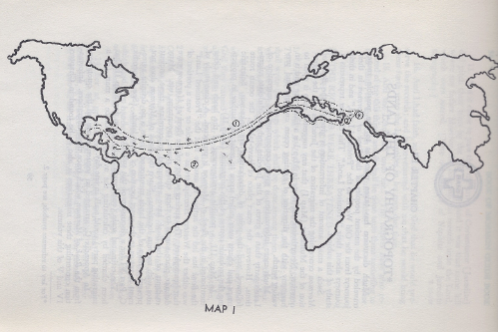
[Verla Birrell, Book of Mormon Guidebook, po. 60-61, 72-73]

Over five decades later, David Palmer would provide some details on an an Atlantic crossing.

OCEAN CROSSING

Crossing the Atlantic by unpowered and unsteered barges would require rather consistent ocean currents that could carry them to the New World. It would be like putting a floating bottle in the water at Gibraltar and pulling it out at Veracruz 344 days later. In effect, the Atlantic provides two enormous rivers that circle around. In the North Atlantic, off the coast of Portugal is the Canary Current. It goes past the Madeira, Canary, and Cape Verde Islands in its southward track. It has a relatively slow speed. Then it turns westward, becoming the broader North Equatorial Current. That current combines with the South Equatorial Current and passes into the Caribbean. As shown on Map #5-3, the southerly portion of the Caribbean Current passes the northern part of South America, curves past Honduras, and angles up the Yucatan Peninsula. It then passes between Cuba and Yucatan, and splits into two parts. The part of most interest to us is the section that follows along the coast of Yucatan and Mexico up towards Texas. This was undoubtedly the route taken, if the Jaredites crossed the Atlantic. That route would require that they travel about 7200 statute miles from Gibraltar. A detailed computation of the trip time has been made using the published surface current information (Oceanographic Atlas of the North Atlantic Ocean, Section I, Tides and Currents, U.S. Naval Oceanographic Office, Washington, D.C., 1969.) It is estimated to be 351 days, within a week of the 344 days reported in the Book of Mormon and easily within the accuracy of the ocean current speeds reported.

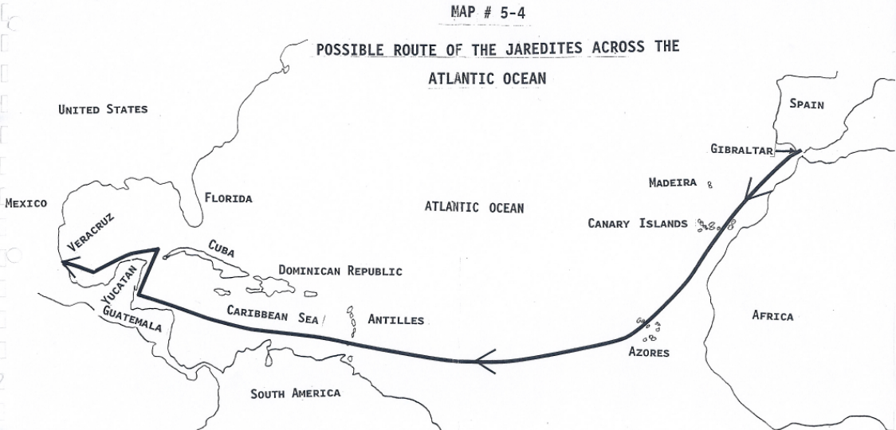
Map #5-4 Possible Route of the Jaredites Across the Atlantic Ocean [Warren and Palmer, Jaredite Saga, unpublished]

The currents spoken of turn into the Gulf Stream, which moves more rapidly past the eastern seaboard of the United States. Part turns into the North Atlantic current going northward, and the other part turns south and forms the Canary current. In the middle is a large and almost motionless area crossed by Christopher Columbus on his first voyage. That area is known today as the Sargasso Sea.

Leaving Gibraltar

It may have been possible to travel from Gibraltar into the Canary current using the natural currents. Five hours before high tide a current sweeps counterclockwise in the bay of Algeciras at a speed of 72 miles per hour. It then rushes westward through the strait for a period of three to five hours, with velocities gradually decreasing. That peri9od of flow counter to the normal eastward current of the strait would have provided the window of opportunity for escape the west.

The trip across the ocean was not to be without difficulties, in spite of the fact that they would be following the normal currents: [Ether 2:24-25 is quoted]

Later, during the actual voyage, the waves are described in this manner: [Ether 6:5, 6, 8 are quoted]

The record does not reveal how the boats managed to keep together during this voyage. Were they connected by long ropes either in parallel, or bow to stern? They were probably not connected directly. It is of course possible that they were simply watched over by God . . .

[Here he talks about Thor Heyerdahl and the Ra Expedition’s experience with storms and waves.]
[ People, water storage, food storage, space and weight computations]

If the vessels were over 100 feet long, and fifteen feet across, and twelve to fifteen feet high, there might indeed have been sufficient room to contain that cargo. . . . It seems more likely that there were several landfalls. An Atlantic crossing would have provided a number of possible opportunities.

Madeira Island

. . . Though it seems a short distance on a map, the distance to Madeira Island may have seemed to be almost a lifetime. In might have been their first landfall, a place to obtain food and water. It has been called a “garden paradise . . . a lush setting . . . abounding in all kinds of fruit” (Mertz, 1964:70). . . . The northern shores are extremely steep, but there are a number of appropriate landfalls on the southern shore. One serves as the port for the island’s fishing fleet. Great waterfalls cascade from the well-watered upper elevations down to the sea. . .

Canary Islands

Another very logical refueling stop would be the Canary Islands. They are off the shore of Africa, and 640 miles from Spain. It is actually an archipelago, comprised of seven major islands. Amazingly, the islands have no less than five climatic zones. Thus many different crops can be grown. Three crops of many products can be grown each year . . . The Jaredites, as they crossed the Atlantic, might have stopped for several days at one of the greener islands to fish, hunt, and restore their supply of food and water. It would not have been difficult . . . Overall, it would have been fairly easy to reprovision at the Canary Islands. Even the fishing is good.

Cape Verde Islands

The next logical stop would have been the Cape Verde Islands. Not as luxurious, they still would have been a source of pure water plus some food. They are in the direct path of a vessel traveling in the Canary current, and are located about four hundred miles west of the African country of Senegal. Most of the islands have rugged mountainous land, with tall cliffs on the coastlines.

Cape Verde Islands are generally dry, but storms could have ;provided sufficient water for the venturing explorers. Today, most of the land is too dry to support plant life. Some vegetables such as beans and corn and tomatoes are grown today. Other corps include fruits and sugar cane. It is possible that the uninviting nature of these islands limited the travelers’ stop to an acquisition of water. In fact, they may have simply observed them, and then passed on by. We must remember that they had no way to steer, and were simply powered by the ocean currents.

[Note* The above statement about not being able to steer seems illogical. How would they maneuver into a harbor? Alan Miner, Personal Notes]

Mid-Atlantic

The crossing of the Mid-Atlantic comprised one third of the distance covered in this voyage. The Jaredites would have been carried westward by the current, as shown on Map 5-3,l and headed straight for the West Indies . . . Eventually, they had sight of land at one of the southerly islands. Those include Trinidad, Grenada, Barbados, Saint Vincent, or Martinique. They might have taken the opportunity to refresh themselves before continuing on.

Caribbean Passage

The currents through the Caribbean pass in a relatively straight line heading westward between the northern coast of South America and the major Caribbean islands such as Jamaica, as shown on the map. The Jaredites were probably close to the coast of South America. Then their route moved northerly and would have passed by Honduras. There is a very slight possibility that they may have had a landfall on the eastern side of the Yucatan peninsula. If so, it is possible that several families decided to stay.

There is a very interesting ruin near the coast of Belize, called Cuello. Today it can be recognized by a multi-step platform. However, its origins might go back to a time consistent with this voyage. Cuello has been excavated by Norman Hammond and others. In a very interesting study, Hammond made the following observation: “The new dates indicate sedentary occupation by people with a developed ceramic technology before 2500 B.C.” He then notes that there may have been seen earlier human use of the site. (Hammond, 1977) Michael Coe disputes the antiquity of this finding . . . “Not only do the radiocarbon dates span a millennium—something unusual for an archaeological phase—but the ceramics look Middle or even Late Formative (Coe, Michael: 1986:93).

The Landing in Veracruz

The Jaredites then passed through the strait separating the Yucatan peninsula of Mexico from Cuba. Finally, the coastal currents would carry them to their landing place near Veracruz. From here, they would be able to explore the wonders of the new world that they were to inherit. In fact, this was the very area where the earliest settlements in the New World were apparently constructed. Mesoamerican archaeology and historical accounts place initial inhabitants of the Jaredites [Olmecs] primarily on the Gulf Coast, not on the Pacific Coast of Mexico. [Bruce Warren and David Palmer, The Jaredite Saga, pp. ]

Ether 6:4 They . . . Set Forth into the Sea [Southern Migration to Oman—NORTH PACIFIC CROSSING]
Note* Perhaps the most authoritative and straightforward explanation of the Jaredite journey to the promised land that I have read comes from retired Captain Richard Rothery from Australia. He experienced 40 years at sea, starting from a boy in sailing skiffs, progressing upward in the merchant marine to Master mariner F.G. and beyond. His father and two brothers also achieved the rank of foreign-going Master, as high as one can go, and were qualified to command any foreign-going vessel. His was a family sea-going tradition going back generations.
His experience covers most types of vessels: tin canoe, skiff, racing yacht, passenger/cargo, bulk carriers to 120,000 tons, oil tankers, Ro-Ro’s, coastal and overseas, to Singapore, Japan, Pacific islands, Canada, USA, South America, UK. During his service at sea several typhoons in North Pacific/Japan, one cyclone off NW Australia and southern ocean storms all provided him with excellent experience in avoiding pitfalls by planning and action in accordance with the laws of meteorology and navigation. Ship handling in difficult situations brought him much satisfaction. He obtained pilotage exemptions in multiple major ports and brought his ships in and fault free. Ship construction cargo stowage and stability was a favourite study of his, which is pertinent here in the case of the Jaredites.
He is probably one of very few if not the only person in the Church with the necessary qualifications to understand what we read in Ether about the barges and the voyage. Captain Rothery writes:
Abundant supplies of fresh water, up to about 10000 gallons, would be obtained by rain upon the [cleaned] deck, after rinsing the salt away, draining into the side tanks through stoppable valves . . . These side tanks are not only important for storing water, they also add to the overall strength of the vessel. The winging out of weights and raising the centre of gravity by filling the tanks is very important to moderate the rolling period thus dramatically improving the comfort of those on board and helping to ensure the seaworthiness of the vessel. All similar to the principles behind a metronome . . .
In Ether 2: 16 they are told to get to work and build the barges, to the Lords instructions, ’after the manner of barges which ye have hitherto built.’ [Implying that they had had previous experience with shipbuilding.] Barges have always been used around Babylon on the Euphrates and Tigris rivers transporting cargoes. These, in particular, were small barges, light like a fowl, upon the water.
Verse 17 says they were exceedingly tight like a dish, top bottom and sides, peaked at the ends to provide more buoyancy lift there in big waves, the length of a tree (about 70ft) and a door which when shut was tight like a dish. This door would best be located in the bow to provide easy access when the bow is beached while the stern is held out in deep water by the anchors streamed out astern on each quarter and by which they can heave off into deep water upon departure. Like military landing craft. When loaded up the barges are trimmed by the stern, drawing about 2 ft forward and 4 feet aft. This helps them maintain the stern to the weather by providing more windage forward. If all the barges are so trimmed they are less likely to damage each other if they [move]close up to each other at sea.
In verse 18, the brother of Jared reports back to the Lord that he has done all that; but in verse 19 says there is no light inside the barges and ‘we cannot breath’ that air when all is closed up.
In verse 20 the Lord tells him to make a hole in the top for air and also in the bottom and if water comes in, in stormy weather, stop the holes that you don’t perish in the flood. This indicates the stormy weather would not last long enough for the air to foul too much. In fact the worst of most tropical storms is usually past in about twelve to eighteen hours from my experience.
Verse 24 suggests to some people that these craft were like submarines. But does ‘light like a fowl upon the water’ sound like a submarine? No! However in typhoon conditions the seas would be breaking right over these barges causing those within to think they were under the water.
The brother of Jared prepared 16 small stones— molten and clear like glass, then expressing his faith, asked the Lord to touch the stones with his finger that they may give light within the barges . . . The stones are used, two to each barge, to give light therein.
Using my knowledge of ship building and ship stability I have drawn a sketch of the barge providing for all the specifications given in the Book of Mormon and suited to the conditions expected on such a voyage.
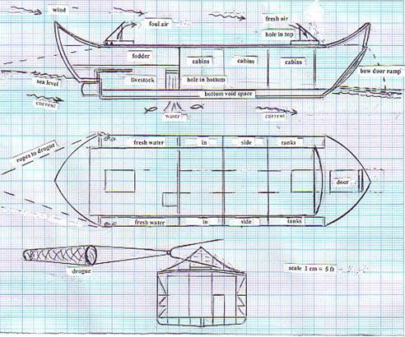
Proposed Design of the Jaredite Barges
These vessels will provide the occupants with the optimum of safety, comfort and convenience. The dimensions of each barge are important . . .length about 70 ft, breadth about 18 ft, depth about 12 ft giving an inside height of about 10ft, inside breadth about 14ft. The side tanks are about 2 ft wide by 10 ft deep by 40ft length. Total capacity about 10000 gals, quite adequate for their health and hygiene needs and providing good stability for a smooth ride. Animal capacity equivalent to about twenty sheep or goats and about ten people. Stock feed storage for about two months max with rationing.
So fresh air is circulated throughout and plenty of fresh water for all their needs. A couple of holes in the top for air intake forward and egress aft over the livestock space. The hole in the bottom is situated close by the livestock. It has sides like a well extending up to above the outside water level. The hole in the bottom is an important aspect of maintaining the freshness of the air inside, in that any animal or human waste must be immediately disposed of down the hole to dissipate into the sea.
A good supply of fish can be caught by net or spear or line through this hole so the people should never go hungry. Only in calmer conditions would the people safely go out onto the upper deck with adequate supervision and nets hung over side in case of accident. Below deck they would need to be assigned daily chores to maintain hygiene and to give them exercise and entertainment, thus avoiding boredom and maintaining good health and morale. Together with the dried food provisions etc the cuisine could be quite enticing. Provision must be made for securely closing the holes (hatches) top and bottom (Ether 2:20) in the event of heavy seas crashing aboard as in a typhoon.
Most people expect all vessels must have sails or some means of propulsion. In this peculiar case that is unnecessary. Yes, most vessels at that time would have sails, and experienced seamen to control and handle them; but only when they have geographical knowledge and therefore courses to steer towards pre-determined waypoints.
Sails without experienced seamen are a definite hazard at the onset of sudden line squalls. If not doused in time they can cause major damage to rigging and often do capsize the vessel. I can assure you that is true from personal experience and from reports of yachtsmen getting into trouble on long ocean voyages where their yachts do sometimes turn turtle.
[Note* Here he asks why the theory he just stated about no sails would not also apply to Lehi’s ship. He answers that Lehi & Nephi simply followed the Master’s inspiration. Thus, this might allow for limited sails or a simple single sail on the Jaredite vessels. He continues:]
They would have to be provided with oars and maybe a small sail on a demountable mast with which to leave or enter a harbour and anchors forward and aft to use when mooring bow in to a beach to afford the means of hauling away from the beach into deep water for departure. Oars, mast and sail etc. must be securely stowed below deck as the vessel would occasionally be ‘buried in the depths of the sea because of the mountain waves’. (Ether 6:6) . . .
To scoop fresh air down into the vessel to freshen and cool the atmosphere within, the cover on the forward hatch would be hinged on the forward side so the raised cover will form a scoop for the wind to enter. Another hole above the livestock aft where the fouled air would be ejected would have its cover hinged on the aft side to let the stale air out. This together with the trim by the stern (producing more windage forward) and together with the drogue, would maintain a stern to the wind and waves orientation, thus affording the greatest degree of safety and comfort for the people within. A wicker or canvas drogue would be towed on a bight of rope from the stern, fastened on each quarter. These are commonly referred to as sea anchors by the sailing and fishing fraternity and are part of the required equipment for ship’s lifeboats specifically to prevent broaching as they drift . . .
The ocean currents give adequate speed over the ground to make their destination in the time stated. i.e. 344 days (Ether 6:11). They would need a rudder . . . if the drogue streamed astern breaks up until a fresh one can be streamed. But like a bottle drifting on the currents, once these barges were at sea their safety was entirely in the hands of the Lord. 24-7. (Ether 6:4).
The Master would ensure they didn’t hit any rocks or snags along the way. Being His plan He will cause the wind to blow them in the right directions around the various land masses. (Proverbs 3:5,6.) Ether 6:5 states that the Lord caused a wind to blow across the seas towards the promised land. Sea currents are caused by the prevailing wind which is seasonal as around Asia and the sub continent. For this reason their departure [from what is now Oman] would have to be around the commencement of the SW monsoon across the gulf of Arabia-- August. The currents run from Oman, around India, down the Malacca strait, up the China coast, past Japan, across the North Pacific and down the west coast. Average current speed over the ground of about 1.25 knots. The distance over that route to Guatemala is roughly 14400 miles. Barge speed through the water is about ½ knot being pushed by the wind. 14400mls @ 1 ¾ kts = 344 days. Calculations are approximate only given the many variables, but close enough to bear out the truth and allow for diversions for animal fodder, destination, variable weather and currents etc.
Under the circumstances, I can see no other route possible and it complies with the ancient trading routes. At that speed, the voyage would take approximately 344 days just as Ether 6: 11 states. Not counting stopovers. If I was a relatively uneducated farm boy writing a novel about such a voyage in 1827, how could I possibly guess such a voyage to have taken 344 days except by divine revelation? Nobody, at that time, had such knowledge of the ocean currents of the world.
Transoceanic migrations and trading have been taking place for thousands of years as indicated by the many foreign artifacts being found on the various continents. . . .
The voyage across the seas ('many waters') involved being carried along on the conveying currents towards the promised land-- speed about 1.5 – 2 knots, making it in 344 days . . . I've spent many years travelling across the seas encountering storms, typhoons etc. and coming through quite safely and comfortably because of my thorough knowledge of marine science including meteorology, ship construction and stability etc., etc. They must have enjoyed a marvelous experience because they were in the hands of the Lord. [Captain Richard Rothery, Ret., Jaredite Journey by Sea]

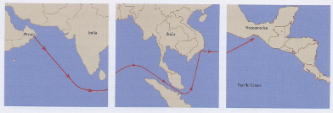
Ether 6:4 They . . . Set Forth into the Sea (Illustration) [Southern Migration to Oman—NORTH PACIFIC CROSSING] When we pursue the hypothesis that the Jaredites launched their barges in the Arabian Sea, we then realize they would have crossed the Indian Ocean to Malaysia and the continued on to the New World, following the Pacific rotue where the water currents would have taken them into the Gulf of Tehuantepec. [Joseph Lovell Allen & Blake Joseph Allen, Exploring the Lands of the Book of Mormon, Second Edition, 2008, p. 505]

Ether 6:4 They . . . Set Forth into the Sea [Eastern Migration—NORTH PACIFIC CROSSING]

Bruce Warren notes that eight vessels or barges were built (2:16-25; 3:1; 6:2-4). These eight barges that set forth into the sea were driven “by furious and fierce winds that never eased to blow towards the promised land while they were upon the waters . . . they were driven forth three hundred and forty and four days upon the water.” (6:5-2) A possible route is shown on Map #6-2.

Two or three comments are in order here. There must have been some way of tying these eight units together so they could travel as a unit and arrive as a unit in ancient America. Otherwise, the fierceness of the storms and the waves would have separated the barges and they would have had individual histories. Also, the fact that they were driven forth by the furious and fierce wins that never ceased to blow towards the Promised Land would imply that they had the capability to use some type of sails to take advantage of those winds. Finally, the 344 days upon the waters that were required before the eight barges landed upon the shores of America implies a Pacific crossing. Probably, they were on the Japanese current of the North Pacific which heads northward, then eastward, but south of the Aleutian Islands. The current then turns south to pass by parts of Alaska, Canada, and North America, and then Mesoamerica before the currents turn outward into the Pacific. (Warren and Palmer, The jaredite Saga, Unpublished]

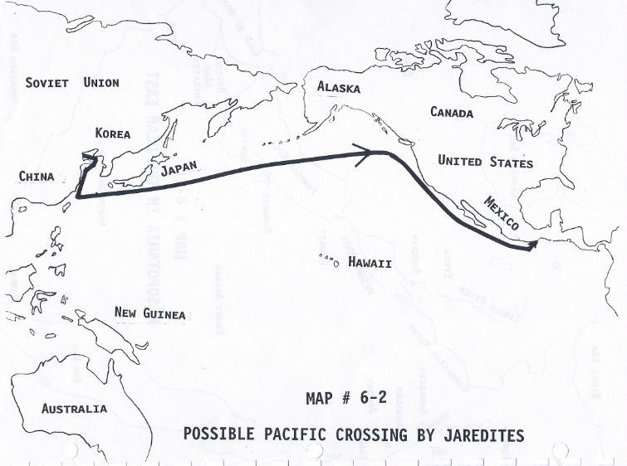
Ether 6:4 They . . . Set Forth into the Sea (Illustration) [Eastern Migration—NORTH PACIFIC CROSSING] Map #6-2 Possible Pacific Crossing By The Jaredites [Warren and Palmer, The Jaredite Saga, Unpublished]

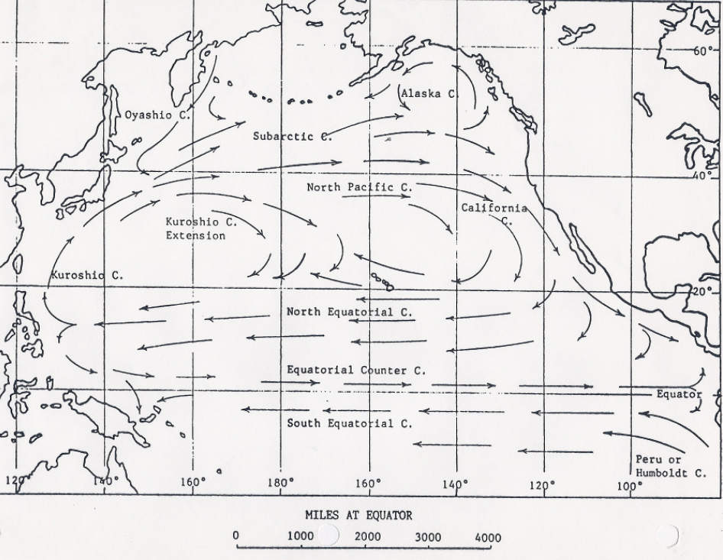
Map VIII

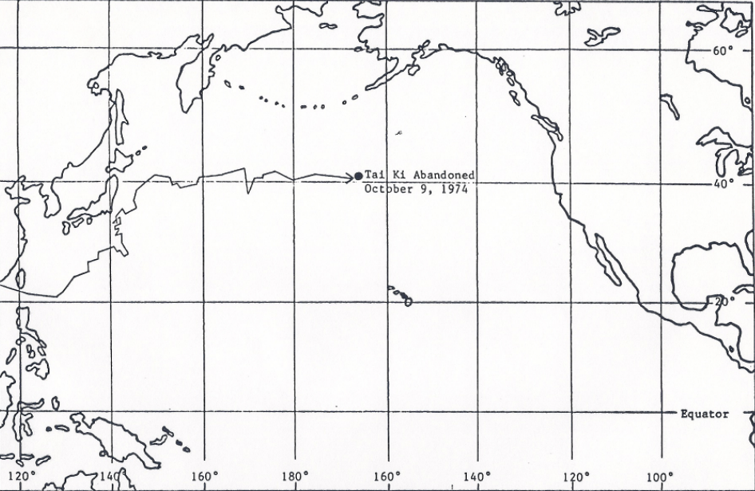
Map IX

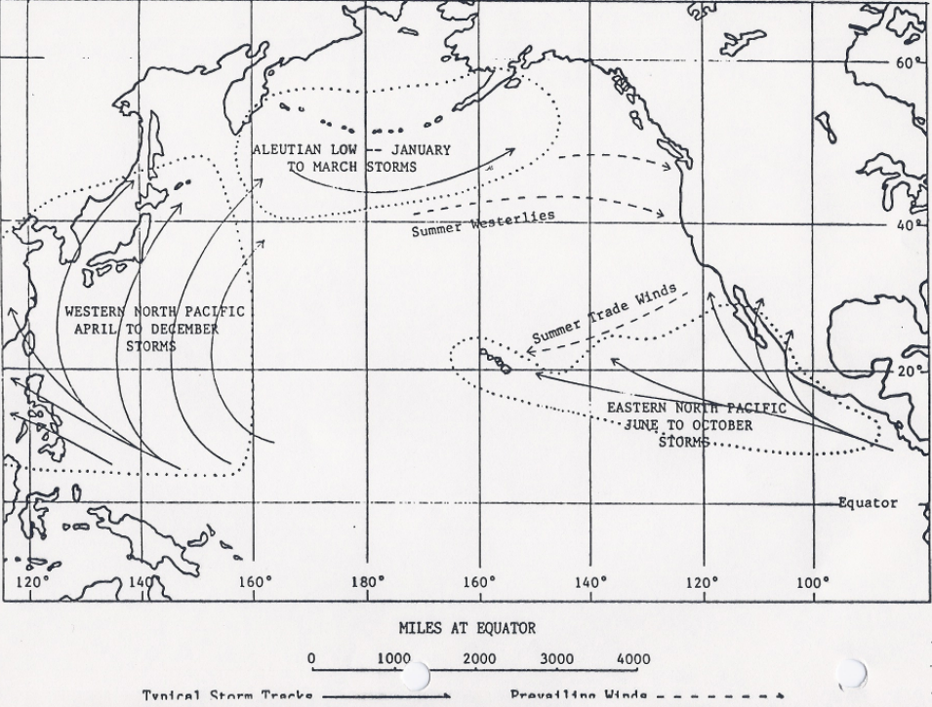
Map X

Ether 6:5 They were tossed upon the waves of the sea before the wind (Illustration) [VOYAGE: CHINA EASTWARD]: Map VIII presents a simplified view of the ocean currents of the North Pacific. Map IX shows the course of the Tai Ki and how seriously it was affected by the storms encountered in the western North Pacific. As can be seen, the ocean currents provided only the barest of outlines for the course of a small boat across the Pacific. The severe North Pacific storms drive a small craft at their whim and have a dramatic effect on the ultimate course. However, Map X shows the typical wind patterns and storm tracks for the North Pacific that would be expected during a year-long voyage beginning in the East China Sea in autumn. . . . As can be seen from comparing Maps VIII and X, these storm tracks virtually parallel the North Pacific currents that wend their way from China to America. [Randall P. Spackman, The Jaredite Journey to America, pp. 155-158, unpublished]

Ether 6:4 They . . . Set Forth into the Sea [Southern Migration – SOUTH PACIFIC CROSSING]

In 1974, Edward Butterworth would propose a southern migration from the valley of Nimrod. He first had the Jaredites travel eastward across the Zagros mountains, as far as the Indus River, after which they turned south going down to the Arabian Sea. From there they made a south Pacific crossing to Mesoamerica, with a stopover in Australia. They constructed a Polynesian-style boat.

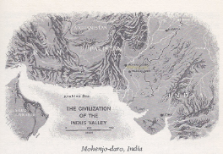

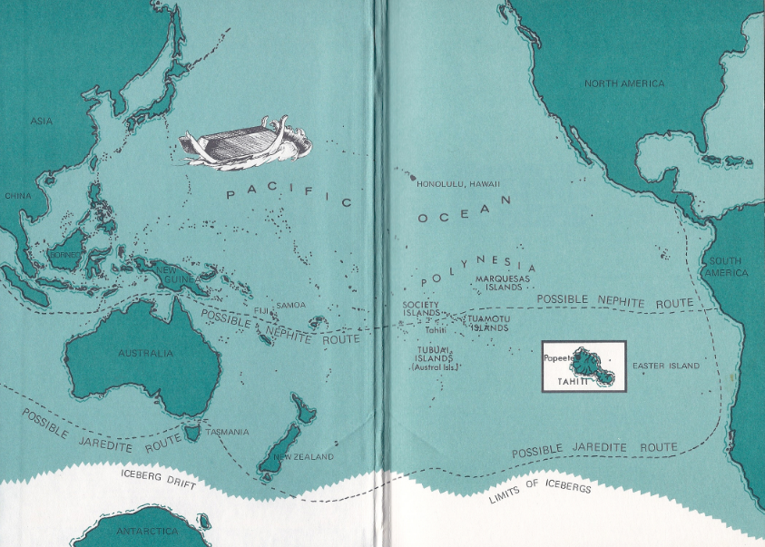
[F. Edward Butterworth, Pilgrims of the Pacific, pp. 40-41, inside cover]
Ether 6:4 They . . . Set Forth into the Sea [Southern Migration – SOUTH PACIFIC CROSSING]

In 2011, George Potter, Frank Linehan, and Conrad Dickson would again propose a southern migration, but this time to Oman. And from Oman they would propose that the Jaredites made a south Pacific crossing to Peru.

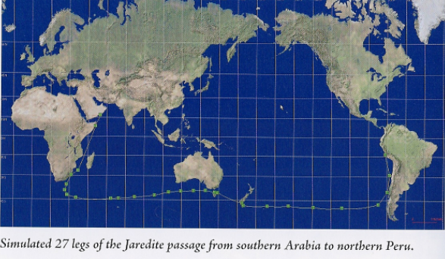
[George Potter, Frank Linehan, and Conrad Dickson, Voyages of the Book of Mormon, p. 224]

[Note* In 1975, Venice Priddis published The Book and the Map in which she proposed that the Jaredites landed “on the coast of today’s Ecuador, north of Guayaquil.” (p 33) But there are no details given of the migration from Babylon or the embarkation point of the ocean voyage, nor of the route.

In 1989 Arthur J. Kockerhans also proposed the west coast of South America to be the lands of the Book of Mormon in his book Lehi’s Isle of Promise. But he also failed to give any details of the Jaredite migration or ocean crossing. Alan Miner, Personal Notes]

Ether 6:6 They Were . . . Buried in the Depths of the Sea:

According to Thomas Valletta:

Anciently water was often symbolic of the primordial chaos, “when darkness was upon the face of the deep”(Gen. 1:2) The act of creation or organization occurred when “the Spirit of God moved upon the deep,” and order and life came upon the chaos (Gen. 1:2). To pass through the waters symbolized death and renewal. The ordinance of baptism partially draws upon this symbolism. To baptize is to bury the natural man in the dissolutive primordial waters, and then to raise up, by God’s Spirit, a new creature. As Paul puts it, “Buried with him in baptism, wherein also ye are risen with him through the faith of the operation of God, who hath raised him from the dead” (Col. 2:12; see also Rom. 6:4).

In much the same symbolic fashion, to cross the waters of seas is to leave the old decadent world behind to receive the new pristine and promised land. In ancient lore, crossing the great waters evoked images of traveling through time or life and traversing from old to new worlds. Friedrich Weinreb points out that, “The passage through this world is very much like passing through water, hence . . . a passage through time. And lest we should be drowned in water, in time God gave us the ‘teba’ the ‘word’ [Ark], which carries us like a ship through the water.” Just as the “Flood figures both the descent into the watery depths and baptism,” so too would the Jaredites journey into the seas. After all, the Jaredites were “buried in the depths of the sea” but “there was no water that could hurt them, their vessels being tight like unto a dish, and also they were tight like unto the ark of Noah” (Ether 6:6-7). Like Noah, these Jaredites left the old behind, pressing forward to a new land of promise.

[Thomas R. Valletta, ”Jared and his Brother,” in Fourth Nephi through Moroni: From Zion to Destruction, pp. 317-318.]

Ether 6:6 They Were Many Times Buried in the Depths of the Sea:

The Moroni's telling of the Jaredite crossing of the ocean, he writes that "they were many times buried in the depths of the sea" (Ether 6:6). According to Hugh Nibley, these experiences at sea sound very reminiscent of Noah's ark. In the Babylonian versions of the Great Flood, Ut-Nepishtim (Noah) built a magur boat to survive the flood. A magur boat was written ideographically MA-TU, literally "a deluge boat," not because it was a sailing boat driven by the wind or rather the hurricane (abubu, shubtu), but because it possessed certain qualities which rendered its use especially effective during the deluge, when its exclusive purpose was to carry the remains of life and to protect men and beasts against the waters from below and the pouring rains from above. . . . "It shall be a house-boat carrying what is saved of life," says the Nippur version, its purpose being to reserve life and offer full protection "against the waves washing overboard." [Hugh Nibley, There Were Jaredites, pp. 361-363]

Ether 6:6 They Were . . . Buried in the Depths of the Sea:

According to Richard Rust, essentially every event or person in the Book of Mormon may well remind us of another event or person; the book is like a beautifully composed symphony with repeated themes and motifs . . . Most significantly, all God-given events or God directed persons in the Book of Mormon are reminders of Jesus Christ or his gospel. This is Nephi's point in saying, "Behold, my soul delighteth in proving unto my people the truth of the coming of Christ; for, for this end hath the law of Moses been given; and all things which have been given of God from the beginning of the world, unto man, are the typifying of him" (2 Nephi 11:4) . . .

Directed or lighted by objects requiring faith for their operation, Nephi's ship and the Jaredite barges are connected with Noah's ark in being types of rebirth and baptism (1 Peter 3:20-21); further, the Jaredite vessels "were tight like unto the ark of Noah" (Ether 6:7). They all bring the occupants through the water into a new life, representing in the process the death, burial, and resurrection of Christ (Colossians 2:12). Or reminiscent of Jonah, the Jaredites in their vessels, like "a whale in the midst of the sea," are "buried in the depths of the sea" (Ether 2:24; Ether 6:6). [Richard D. Rust, Feasting on the Word, pp. 196, 206]

Ether 6:6 Great and Terrible Tempests:

According to Randall Spackman, when the Lord described the conditions to be faced, the word "floods" was used (Ether 2:24), but when the actual conditions were described, the words used were "great and terrible tempests" (Ether 6:6). The Jaredites, who may have viewed their voyage in a sense as a re-creation of Noah's voyage, knew of the great flood as a violent downpour of rain which resulted in the inundation. Similarly, the word tempest refers to a windstorm that is usually accompanied by rain, hail, snow, or thunder. In Hebrew, a Semitic language like Akkadian, the word zerem means a gush of water, a flood, or a tempest; indeed, in Isaiah 28:2, zerem appears in both senses as a tempest and a flood. Hence, it is not surprising that the storm conditions are referred to both as tempests and floods.

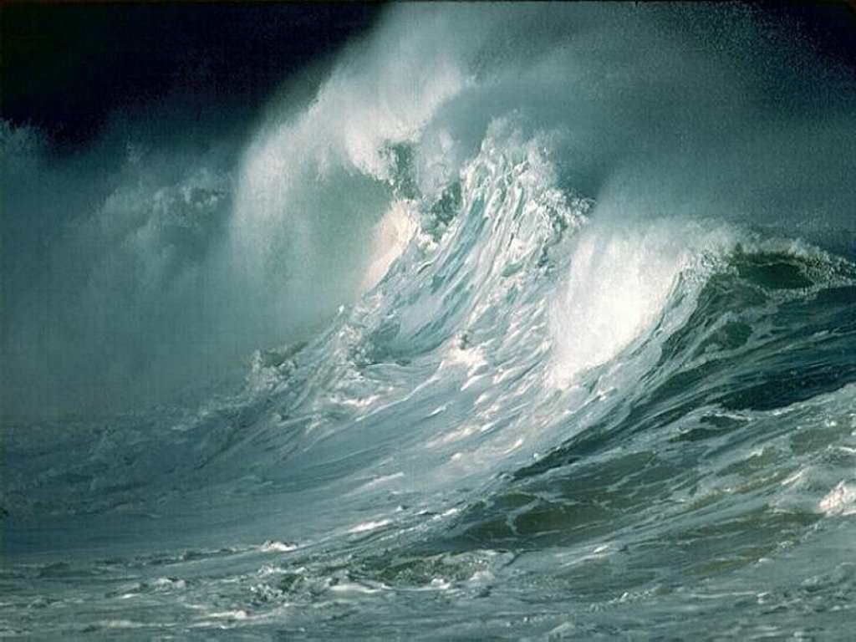

Heyerdahl described this mixture of sea, wind, and rain: "The crests blew away as they broke, and the spray stood like salt rain over the sea. When the tropical rain poured over us in horizontal squalls and whipped the surface of the sea, making invisible all around us . . . we crawled about the deck, naked and frozen, seeing that all the gear was in order to weather the storm." Knoble wrote: "the storm is mixing salt and water, water and air into a new element that makes breathing difficult." [Randall P. Spackman, The Jaredite Journey to America, pp. 136,139, unpublished]

Ether 6:6 Tempests Which Were Caused by the Fierceness of the Wind:

In describing the sea voyage of the Jaredites, mention is made of "tempests which were caused by the fierceness of the wind" (Ether 6:6). According to Randall Spackman, despite the tremendous destruction that wind and rain can cause on land, the principal danger of heavy weather at sea is normally from the seas produced by the wind . . . Captain Harding, U.S.N., emphasized that a wind increases its force upon a solid object in proportion to the square of the wind velocity. "A wind that doubles its speed increases its force four times. A 60-mph wind exerts 15 pounds per square foot pressure; a 125-mph wind exerts 78 pounds . . . [Randall P. Spackman, The Jaredite Journey to America, pp. 138-139, unpublished]

Ether 6:7 They Were Tight Like unto the Ark of Noah:

There are more similarities between Noah’s ark and the Jaredite barges than one might think. Both had to be built to withstand torrential rains and tidal waves. Therefore, they were both built “tight,” in other words, completely sealed when the hatch was closed. For the Jaredites, we know that this design meant that extraordinary means would be needed to provide light. Well then, what did Noah and family do in order to see when they were sealed up in their “tight” ark? By rabbinical and ancient Oriental tradition, they also were given lighted stones to illuminate the ark.

Hugh Nibley writes:

“The oldest accounts of the ark of Noah, the Sumerian ones, describe it as a ‘magur boat,’ peaked at the ends, completely covered but for a door, without sails, and completely covered by the waters from time to time, as men and animals rode safe within. But the remarkable thing about Jared's boats was their illumination by stones which shone in the dark because they had been touched by the finger of the Lord (Ether 3:6, 6:3).

“The Rabbis tell of a mysterious Zohar that illuminated the ark, but for further instruction we must go to much older sources: the Pyrophilus is traced back to the Jalakanta stone of India, which shines in the dark and enables its owner to pass unharmed beneath the waters; this in turn has been traced back through classical and Oriental sources to the Gilgamesh Epic, where Alexander's wonderful Pyrophilus stone turns up as the Plant of Life in the possession of the Babylonian Noah.

“A large number of ancient traditions, first brought together in the present century, justify one in assuming some sort of legendary shining stones in the ark of Noah. Whether or not there is any historical reality behind it, the fact is that we now know, from sources completely inaccessible to the world of Joseph Smith, that such a tradition actually did exist in very ancient times. It is nothing to laugh at after all.” (The Prophetic Book of Mormon, p. 244)
[josephsmith.com . . . Ether ]
Ether 6:7 They Were Tight Like unto the Ark of Noah:

In Ether 6:7 it says that the vessels of the Jaredites: "were tight like unto the ark of Noah. Therefore when they were encompassed about by many waters they did cry unto the Lord, and he did bring them forth again upon the top of the waters."

According to Hugh Nibley this aspect of the ark is not specifically mentioned in the Bible, and has led to great confusion among Bible illustrators, ancient medieval, and modern. The only peculiarities mentioned in the brief three verses of Genesis (6:14-16) are the window and the door; but they, combined with persistent traditions about the ark, were enough to perplex the learned for generation. They lead us directly to the most puzzling problem of all--that of the illumination of the ark, for while the window is called as zohar (more properly tsohar), i.e., shiner or illuminator, in the Hebrew versions, the Babylonian word for it is nappashi, meaning breather or ventilator. Of course all windows have the double function of lighting (hence the common fenester--"Light giver"), and ventilation ("Window"), but in a boat equipped to go under water other sources for both would have to be found, and it is in the lighting department that the Jewish sources are most specific. For the Rabbis do not settle for the zohar--the lighter of the Ark--as being simply a window: for some of them it was rather a miraculous light-giving stone. Its purpose, however, was not to furnish illumination as such, but to provide Noah with a means of distinguishing night from day. It is in that connection that the Rabbis come to mention the stone, for a very important point in the observation of the Law is to determine the exact moment at which night ends and day begins, and vice versa. The Rabbis, according to the Midrash Rabbah, "could not explain the meaning of zohar," but they did know that it had something to do with light in the ark. Rabbi Akiba ben Kahmana, for example, says it was a skylight, while Rabbi Levi said it was a precious stone. He quotes R Phineas as saying that "during the whole twelve months that Noah was in the ark he did not require the light of the sun by day or the moon by night, but he had a polished gem which he hung up; when it was dim he knew that it was day, and when it shone he knew it was night." . . . But all such stories seem to go back to a single source, a brief notice in the Jerushalmi or Palestinian Talmud, which reports that Noah was able to distinguish day from night by certain precious stones he possessed, which became dim by day and shone forth by night.

Plainly we have here statements which could have given Joseph Smith some hints in writing about the shining stones . . . unfortunately the Palestine Talmud remains a rare and difficult book. Only the most eminent Rabbis ever read or cite it. [Hugh Nibley, "Strange and Shining Stones," in A Book of Mormon Treasury, pp. 140-142] [See the commentary on Ether 6:2]

Ether 6:7 They Were Tight Like unto the Ark of Noah:

Randall Spackman notes that Hugh Nibley wrote at some length about the features of the Jaredite barges, comparing them to the description of Noah's ark as found in the Sumerian version of the Deluge story from Nippur in lower Mesopotamia, dated to before 3000 B.C. Nibley's analysis, however, relied in part on a questionable reading of a phrase in the Jaredite record describing the watertight nature of the barges at sea as "tight like unto the ark of Noah" (Ether 6:7). Nibley read this as referring to "the submarine nature of Jared's ships" and he concluded that "Jared's boats were built on the same pattern as Noah's ark."

According to Spackman, such a reading is much too broad. The Jaredite barges could have been watertight like Noah's ark, without ever being the same pattern or design, without ever using the same construction methods, and certainly without ever being classified as submarines! Nevertheless, Nibley's review of twelve items of correspondence between the book of Ether and the ancient Sumerian Deluge story does indicate, as Nibley concluded, that Joseph Smith hardly could have invented the story.

The Jaredites would have been familiar with the Deluge story and its similarities to their own situation; so, their earliest records of the barges and the sea voyage may have played upon such similarities. Nonetheless, in order to evaluate the description of the barges in the book of Ether, it might be better to compare the boatbuilding techniques of the ancient Mesopotamians and Chinese with what the Jaredite record actually says about the shape, displacement, size, and tightness of the hull. [Randall P. Spackman, The Jaredite Journey to America, pp. 63-64, unpublished]

Ether 6:7 They Were Tight Like unto the Ark of Noah:

According to Warren and Palmer, the Holy Bible describes God's command to Noah concerning the ark, "Make thee an ark of gopher wood; rooms shalt thou make in the ark, and shalt pitch it within and without with pitch." (Genesis 6:14) This description tends to imply that this second set of Jaredite barges might have been caulked with pitch, for "they were tight like unto the ark of Noah" (Ether 6:7). The Sumerians at the time of Jared were acquainted with the use of asphalt for caulking. [Bruce W. Warren and David A. Palmer, The Jaredite Saga, ch. 5, unpublished]

Ether 6:7 [Their Vessels] Were Tight Like unto the Ark of Noah:

According to John Heinerman, the archaeological evidence from Sumer suggests, among other marvelous inventions, the use of asphalt. In the time of the Great Tower, asphalt was in common use for things such as road making, roofing and waterproofing. According to Henry Frederick Lutz's translation of Sumerian Temple Records of The Late Ur Dynasty, asphalt was a frequent part of temple inventories at the time. And The Septuagint Version of The Old Testament and Apocrypha informs us that "the brick was to them for stone, and their mortar was bitumen," during the construction of the Tower itself. Perhaps that's why one third of it burned so well when the Lord struck it with lightning, while a great earthquake took down another third of it, leaving just a mere third standing in ruble (see Jasher 9:38).

It isn't unreasonable to assume that Jared and his brother Mahonri Moriancumer and those who went with them across the inland seas of Asia to the coasts of China, took along some of this same bitumen with them to use in their own barges that God inspired them to make with which to cross the mighty oceans. We know for sure that Noah used it extensively when he built the ark. In a rare, out-of-print archaeological magazine called Records of The Past, George Smith presented some new data about Noah that had come from several cuneiform tablets found in the ancient palace library of King Assurbanipal of Nineveh around 660 B.C.

We learn from these clay documents that the ark was at least as tall as a six-story building. Noah divided "it into seven compartments; [and] its floors [were] divided into nine chambers each." It also contained a short mast and rudder pole with which to give the huge vessel better steering capabilities. Noah gave the ship a trial launch but soon discovered it leaking like a sieve in a number of places. So he, his sons and their assorted servant laborers took buckets of bitumen and coated everything inside and out with several layers of this black gooey stuff; they followed it up with a hard shellac covering for good measure. [John Heinerman, Hidden Treasures of Ancient American Cultures, pp. 110-111]

Ether 6:8 The Wind Did Never Cease to Blow toward the Promised Land:

According to Hugh Nibley, in relationship to what direction the Jaredites traveled, one thing that is most revealing is the report that "the wind did never cease to blow towards the promised land, while they were upon the waters; and thus they were driven forth before the wind" (Ether 6:8). Although weather has changed through the ages, and freak storms do occur; the extreme steadiness of the wind strongly suggests prevailing westerlies and a North Pacific crossing. [Hugh Nibley, The World of the Jaredites, p. 182]

According to Verneil Simmons, this statement that "the wind did never cease to blow" (Ether 6:8) lends some credence to a legend recorded by the historian Josephus that the great tower was destroyed by mighty winds when the world was experiencing a period of violent weather. (Josephus, The Antiquities of the Jews, Book 1, Chapter 4) [Verneil W. Simmons, Peoples, Places and Prophecies, p. 30]

Glenn Scott notes that in speaking of these "mighty winds" which destroyed the tower, Josephus quoted the Sibyl, a prophetess who was also quoted by Heraclitus as early as 500 B.C. and whose verses were accepted by most Christian writers down to the fourth century A.D. Josephus says the following:

When all men were of one language some of them built a high tower, but the gods sent storms of wind and overthrew the tower and gave everyone his peculiar language. After this, they were dispersed abroad on account of their languages, and went out by colonies everywhere; each colony took possession of that land which they did light upon and unto which God led them. There were some who passed over the sea in ships.

This description of "storms of wind" fits very well into the Jaredite account that "the wind did never cease to blow towards the promised land and thus they were driven forth before the wind" (Ether 6:8). Furthermore Scott raises some very interesting questions about the Josephus quote: How do you suppose they knew about "some who passed over the sea in ships"? and Why would they mention migrations by sea? [Glenn A. Scott, Voices from the Dust: New Light on an Ancient American Record, pp. 21-22] [See the commentary on Ether 1:33]

Ether 6:8 They Were Driven Forth before the Wind:

Randall Spackman notes that on the question of wind propulsion, Hugh Nibley stated his opinion that the Jaredites "apparently did not use sails: the almost perpetual hurricane conditions would have made sails impossible even if they had them." (The World of the Jaredites, p. 176) John Sorenson seems to have assumed from the length of time the crossing took that the barges merely drifted and were "sailless." (An Ancient American Setting for the Book of Mormon, p. 111) Nonetheless, according to Spackman, the Book of Mormon does not support the idea of a completely sailless barge. The Lord commanded that the barges be built in the manner "hitherto built" (Ether 2:16); so, it may be assumed that the Jaredites, at a minimum, attempted to make use of common propulsion technology in the new barges. Such technology included sails. Furthermore, the Book of Mormon records the travels of Lehi and his family, who came to America in the 6th century B.C. They are said to have "put forth into the sea and were driven forth before the wind toward the promised land" (1 Nephi 18:8). These are identical phrases to those used to describe the voyage of the Jaredites. Ether 6:8 similarly states that "they were driven before the wind." The Book of Mormon also notes that after some difficulties, Lehi's family "sailed again towards the promised land" (1 Nephi 18:22). Hence, the phrase "driven forth before the wind" (Ether 6:8) has a textual connection with Lehi's sailing vessel and cannot be cited without question to refer merely to drifting with the wind. [Randall P. Spackman, The Jaredite Journey to America, pp. 89-91, unpublished]

Ether 6:8 Driven Forth before the Wind:

According to Randall Spackman, so long as there is sufficient sea room to avoid being driven onto a shore, drifting with the storm may be the safest tactic for surviving extreme weather conditions, particularly for a vessel built in the manner of the Jaredite barges. Drifting or "hulling" or "lying a-hull," as the tactic may be referred to in different nautical works, is a desirable storm tactic when "the boat has a high range of stability, . . . is light but strongly built," and "the keel is of such shape and depth that it permits ample leeway when the boat has no headway." In other words, a wide, low, barge-like hull, which is light and watertight, with no keel to resist the drift of the barge with the wind, is the best form of vessel for drifting safely through a storm at sea. [Randall P. Spackman, The Jaredite Journey to America, p. 144, unpublished]

Geographical Theory Map: Ether 6:8-12 Driven before the Wind 344 Days to Promised Land (Year)


Choose: Embarkation Point Choose: Travel Route (Ocean)
Choose: Landing Point Choose: Time

Ether 6:9 They Did Sing Praises unto the Lord:

Music has the power to lift people in the most trying of circumstances. Michael F. Moody said, “Music has the power to transport us from the hard realities of day-to-day living, to a peaceful, beautiful realm in which we can find a renewed perspective of life.” (Church News, 11/16/91) It was this peaceful, beautiful realm to which the Jaredites were transported by their songs of praise. Furthermore, the Lord has declared, my soul delighteth in the song of the heart; yea, the song of the righteous is a prayer unto me (DC 25:12). The parallelism between the song of the righteous and the prayer of the righteous is seen in the language used by Moroni and Enos. The Jaredites did thank and praise the Lord all the day long; and when the night came, they did not cease to praise the Lord. Enos records, all the day long did I cry unto him; yea, and when the night came I did still raise my voice high that it reached the heavens. (Enos 1:4)
[josephsmith.com . . . Ether ]

Ether 6:10 No Monster of the Sea Could Break Them, Neither Whale That Could Mar Them:

In Ether 6:10 it states that in the Jaredite travels across the great sea, "no monster of the sea could break them, neither whale that could mar them" (Ether 6:10). According to Randall Spackman, this brief statement when combined with what is known about storms at sea, suggests that there were times when the Jaredites could remain on deck and view the sea life that surrounded them. The Jaredite record points to the most frightening meetings between men and these huge creatures, when vessels and leviathans encounter each other close up and occasionally collide. Heyerdahl reported that one day on the Kon Tiki, while the crew ate by the side of the raft, "we started when suddenly something behind us blew hard like a swimming horse and a big whale came up and stared at us." Knoble described an incident when the whale disappeared momentarily, then "the deck began to tremble, and a scraping sound rose up from below the ship. The whale was scratching its back . . ."

Heyerdahl also found monsters in the sea at night when the stars twinkled in the dark sky and the sea was phosphorescent with glowing plankton. The visitors were big squids which came to the surface and floated near the raft, their "two round shining eyes" a "devilish green" color like phosphorus. On several occasions, "the black water round the raft was suddenly full of round heads two or three feet in diameter, lying motionless and staring at us with great glowing eyes. On other nights balls of light three feet and more in diameter would be visible down in the water, flashing at irregular intervals like electric lights turned on for a moment." [Randall P. Spackman, The Jaredite Journey to America, pp. 146-150, unpublished]

Ether 6:10 No Monster of the Sea Could Break Them, Neither Whale That Could Mar Them:

According to Joseph Allen, from a monument discovered at the Olmec site of La Venta in the state of Tabasco, Mexico, we have a hint of the first settlers crossing the ocean. The monument is labeled Monument No. 12, and is located today at the outdoor La Venta Museum in the city of Villahermosa, Tabasco. According to a resident archaeologist there at the park, the lines flowing from the back of the individual's head represented sun rays – suggesting that the first settlers came from the west where the sun sets. He noted that the footprints suggest that the people traveled great distances to arrive at their destination. And he pointed out that the sculpture's giant sea monster with jaws opened together with the main character's warding off of the sea monster suggests that the people crossed the ocean in their journeys. [Joseph L. Allen, Exploring the Lands of the Book of Mormon, p. 55]

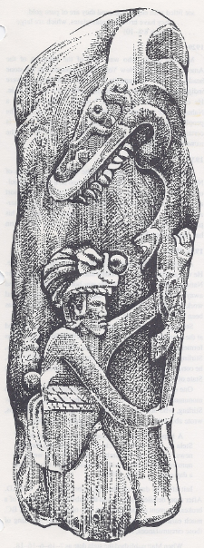
Ether 6:10 And no monster of the sea could break them (Illustration): Monument No. 12 at La Venta Museum, Villahermosa, Tabasco.] [Joseph L. Allen, Exploring the Lands of the Book of Mormon, p. 57]

Ether 6:11 They Were Driven Forth, Three Hundred and Forty and Four Days:

Even though the Jaredites traveled for a very long time, Noah and his family had to suffer even longer. Noah and his family remained on the ark for a record 366 days (see Gen 7:11-13; 8:14-16). [josephsmith.com . . . Ether ]

Ether 6:11 They Were Driven Forth Three Hundred and Forty and Four Days upon the Water [VOYAGE: JAPAN EASTWARD]

Ether 6:11 records the fact that the Jaredites "were driven forth three hundred and forty and four days upon the water." According to Hugh Nibley, the fact that the party spent almost a year on the water even with the winds behind them certainly suggests the Pacific, and recalls many tales of Chinese junks that through the centuries have been driven helplessly before the wind to end up after a year or so at sea stranded on the beaches of our West Coast. [Hugh Nibley, The World of the Jaredites, p. 182]

According to Warren and Palmer, there is an account of Japanese fishermen being caught in a storm taking them across the North Pacific and arriving as far south as Ecuador (Evans, et.al. 1966:63-67). In this case they were upon the waters 377 days, some 33 days longer than the time stated in the Book of Ether. [Bruce W. Warren and David A. Palmer, The Jaredite Saga, ch. 7, unpublished]

In an unpublished manuscript, Bruce Warren cites Edwin Doran, Jr., who while investigating early trans-Pacific voyages cited the following:

Of sixty cases of inadvertent drifts of Japanese junks into the Pacific, at least a half dozen reached the coast of America between Sitka and the Columbia River and another half dozen were wrecked on the Mexican coast or encountered just offshore. . . . Drift voyages between Asia and America not only are clearly possible but actually have occurred repeatedly in historic time. . . . There appears to be no question that rafts could have crossed the Pacific, repeatedly and in appreciable numbers (Doran 1974, 133-35) [Bruce W. Warren, Blaine M. Yorgason, Harold Brown, New Evidences of Christ in Mesoamerica, Unpublished Manuscript]

Ether 6:11 Three Hundred and Forty and Four Days upon the Water [WESTWARD MIGRATION THEORY]
Brant Gardner writes:
Joseph Allen (who interprets the statement “344 days” more literally and who favors an eastern migration through China and a voyage across the Pacific) writes that the Jaredites traveled 344 days on the ocean, which more closely approximates a Pacific crossing as opposed to an Atlantic crossing.(n.9) Allen doesn’t give the average time of a typical Pacific crossing, but it would also likely be less than 344 days. . . . “The distance from the Pacific by China to the Gulf of Tehuantepec in Mesoamerica is more than twice the Atlantic’s crossing distance, thus placing us closer to the required time for the Jaredites to travel from the Old to the New World.”(n.2)
Allen’s suggestion that the Pacific crossing was twice as long as Heyerdahl’s Atlantic crossing of “two months” produces only four months’ travel – 120 days is obviously more than 60, but it still falls significantly short of 344 . . . Regardless of route, the necessary stops (for resupply) would have lengthened the journey’s total time. [Brant A. Gardner, Second Witness, Vol. 6: Fourth Nephi through Moroni, pp. 183, 229]

THE JAREDITE LAND OF PROMISE: A MESOAMERICAN MODEL

Note* I will pause here to say that the cultural commentary put forth from this time forward supports a Mesoamerican location for the Jaredite lands---northward in Mesoamerica in the states of Veracruz and Tabasco Mexico. I have done this because the types of historical and geographical support and archaeological evidence in this area provide a plausible pattern—even a Cultural Standard for the Book of Mormon story. This support and evidence provide a challenge for those with differing geographical Book of Mormon geography models to produce something equal to that standard.
[Alan Miner, Personal Notes]

Ether 6:11-12 They were Driven Forth . . . upon the Water . . . and They Did Land upon the Shore of the Promised Land:

According to Joy Osborn, while some scholars have sought to prove that America was settled by peoples who came from Asia, across the Bering Strait, into Alaska and southward--evidence is to the contrary. While a few groups probably came that way, and intermarried into some of the northwestern Indian tribes--the major civilizations on the American continents were established in south and Central America--then moved northward. According to the Book of Mormon, all three of the great civilizations that developed in the Americas were established by people who crossed the seas. Modern-day scholars verify this fact.

Bradford, in American Antiquities, states:

There is one circumstance, which, as respects the civilized nations of Mexico and Central America, seems to be decisive of the question. In the maps of the migrations of these nations, the first journey is generally represented as having been made over some body of water; and indeed there does not appear to be a single well-authenticated tradition among any aboriginal tribes, civilized or barbarous, of a passage by land, while many have preserved a clear account of a prior event, the great deluge, which, in Mexico and Peru at least, is manifestly the same as recorded by Moses. (pp. 227-228)

[Joy M. Osborn, The Book of Mormon -- The Stick of Joseph, pp. 164-165]

Ether 6:11-12 They Were Driven Forth . . . upon the Water . . . and They Did Land upon the Shore of the Promised Land:

According to Richardson, Richardson and Bentley, Book of Mormon critics often refer to a few scientists who have held to the theory that all migrations to America originated from Asia via the Bering Strait. However, these critics are facing increasing difficulty in finding support for their weakening position. Such a position is rapidly losing credibility in light of the mountain of evidence to the contrary. [Allen H. Richardson, David E. Richardson and Anthony E. Bentley, 1000 Evidences for the Church of Jesus Christ of Latter-day Saints: Part Two-A Voice from the Dust: 500 Evidences in Support of the Book of Mormon, p. 174]

Ether 6:12 They Did Land upon the Shore of the Promised Land:

John Sorenson has accumulated a collection of scientific articles which advocate, with increasing substantiation, that there were trans-Pacific journeys from East Asia to Mesoamerica during the times of the Book of Mormon. [See John L. Sorenson and Martin H. Raish, editors, Pre-Columbian Contacts with the Americas across the Oceans: An Annotated Bibliography, F.A.R.M.S., second edition, revised]

Ether 6:12 And They Did Land upon the Shore of the Promised Land:

Vine Deloria Jr. is an outspoken Native American activist. He is a member of the Standing Rock Sioux tribe of North Dakota, a former executive director of the National Congress of American Indians, and a professor of history at the University of Colorado at Boulder. In a 1992 paper in the academic journal American Antiquity, Deloria chastised the archaeological and anthropological establishment for embracing the monocultural implications of the Bering Strait hypothesis. "This migration from Siberia," he wrote, "is regarded as doctrine, but basically it is a fictional doctrine that places American Indians outside the realm of planetary human experiences." . . . "There's no effort to ask the tribes what they remember of things that happened." . . . "Numerous tribes do say that strange people doing this or that came through our land, visited us, and so on. Or they remember that we came across the Atlantic as refugees from some struggle . . . and so forth. There's a great reluctance among archaeologists and anthropologists to break centuries-old doctrine and to take a look at something new." . . . "There's the Stephen Jay Gould attitude out there . . . that believes science can do whatever it wants unless it comforts religion--because religion is considered a mere superstition. But if you look at it, most things that they're calling religious are not really religious. They're oral traditions; they're ancient memory." If mainstream archaeologists and anthropologists are unwilling or unable to consider evidence of this type, Deloria suggests, perhaps they're not the right ones for the job. . . ."As for the history of this hemisphere from, say, five thousand B.C. forward to our time, the mainstream scholars just don't want to deal with that at all." [Marc K. Stengel, "The Diffusionists Have Landed" in Atlantic Monthly, January 2000, 35-48. Reprinted with permission by FARMS]

Ether 6:12 And They Did Land upon the Shore of the Promised Land:

According to Andrew Skinner, even those modern-day skeptics who most disbelieve maritime theories concerning the ancient peopling of the Americas admit that some early transoceanic voyages are probable due to oceanic currents and prevailing winds. From the work of one writer we read:

The winds and current of the North Pacific trend eastward. Any craft caught helpless in their embrace can easily be carried across the ocean; in fact, there are records to show that, for example, between 1775 and 1875 about twenty Japanese ”junks” [common Japanese vessels] were blown, against their will, to the west coast of America and deposited at various points between Alaska and Mexico. If Japanese vessels in the last century, why not Chinese or Indian or Malaysian during all the long centuries that preceded the arrival of Columbus? There must have been a certain number that ended a storm-tossed journey on this side of the Pacific. Perhaps a few of the hardier spirits among their crews risked the long sail back home, but most must have chosen to live on where they landed. Eventually they either died out or became wholly absorbed, leaving behind only tantalizing indirect reminiscences of their presence such as art motifs, pottery shapes, and the like. (Jamake Highwater, Native Land, Sagas of the Indian Americas. Boston: Little, Brown and Company, 1986, p. 16.)

[Andrew C. Skinner, "Promises Fulfilled," in Studies in Scripture: Book of Mormon, Part 2, p. 264]

Geographical Theory Map: Ether 6:12 Jared Lands upon the Shore of the Promised Land (Year )

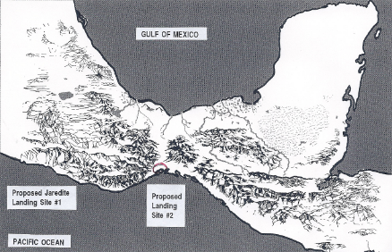
Choose: Landing Site Choose: Year

Ether 6:12 They Did Land upon the Shore of the Promised Land [EASTWARD MIGRATION THEORY – NORTHERN PACIFIC CROSSING]:

According to Randall Spackman, when Jared, his brother, and their families and friends "did land upon the shore of the promised land" (Ether 6:12), they had come to the end of a journey of immense hardship and length. They had trekked and barged more than 5,000 miles across Asia. And then from their temporary home on the East Asian seashore, they had voyaged over 8,000 miles at sea, across an ocean infamous for its typhoons, freezing winter storms, and hurricanes. Finally, they arrived in America, their promised land, full of faith in the goodness of the Lord. [Randall P. Spackman, The Jaredite Journey to America, p. 163, unpublished]

According to Glenn Scott, we do not know what part of the long Pacific coast of the American continent that the Jaredites first sighted, but after 344 days at sea, they must have been desperate to stand on dry ground again.

Charles and Ellen Brush found the earliest evidence (so far) of Mesoamerican civilization in middens (refuse heaps) at Puerto Marques, near Acapulco in the state of Guerrero, on the Pacific coast of Mexico.

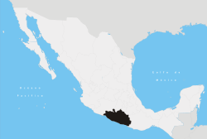
State of Guerrero, Mexico

The evidence is an early type of fiber-tempered ceramic, called Pox pottery. Richard Adams says, "A date on material from the shell midden has been read as about 2900 B.C." . . . Thus, evidence indicates that perhaps the Jaredites "did land upon the shore of the promised land" (Ether 6:12) in the vicinity of Puerto Marques at the southeastern corner of the Bay of Acapulco, a natural bay, one of the few on the west coast of Mexico. In fact this very bay was used as a harbor for Spanish galleons sailing to and from the Far East from A.D. 1531 and for more than 200 years. [Glenn A. Scott, Voices from the Dust, p. 43]

Ether 6:12 They Did Land upon the Shore of the Promised Land:

According to Warren and Palmer, the ancient Mexican historian Ixtlilxochitl states that his distant ancestors traveled a great distance, living in caves, suffering many hardships, and going through the "Great Tartary" (the steppes of central Asia). Then they crossed the Great Ocean and arrived in America in the area of present day Mexico (Ixtlilxochitl I:16). Most of the early Jaredite history involves either the highlands, now thought to be the valley of Oaxaca, or the lowland Gulf Coast. Ixtlilxochitl appears to state that 104 years after landing, his ancient ancestors were led by their great king, Chichimecatl, to settle by the Gulf of Mexico. That was an area they called "Huehuetlapallan" (Ibid. 41). We know from various documents from ancient Mesoamerica that Huehuetlapallan is located in the area of Central and Southern Veracruz. In time the area was expanded to include the Gulf Coast states of Tabasco and Campeche. [Bruce W. Warren and David A. Palmer, The Jaredite Saga, ch. 6, 7, unpublished]

Ether 6:12 They Did Land Upon the Shore of the Promised Land [WESTERN MIGRATION]:
In 1950, Milton R. Hunter and Thomas Stuart Ferguson would write:

Ixtlilxochitl dates the great flood, it being the first great calamity, at 3513 B.C. (1,716 years after his creation date, 5229 B.C.) The date of the arrival of the first artisans, whom he refers to elsewhere as “the Ancient Ones,” in Hue-hue Tlapallan (ancient bountiful land) in the New World is placed by him at 2993 B.C. [Milton R. Hunter and Thomas Stuart Ferguson, Ancient America and the Book of Mormon, p. 35]

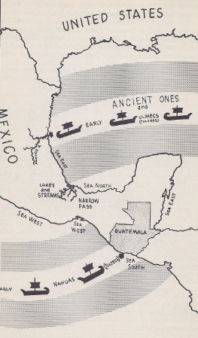
Ether 6:11 They did land upon the shore of the promised land.(Illustration) (WESTERN MIGRATION] Map—Landing Places of Ancient Ones, Ulmecs and Nahuas. [Milton R. Hunter and Thomas Stuart Ferguson, Ancient America and the Book of Mormon, p. 36]

Ether 6:12 And They Did Land upon the Shore of the Promised Land (Western Migration – Atlantic Crossing):
John Sorenson writes:
Recent study on the location of Jaredite lands has led me to modify my earlier views on the probable correlation for those areas. (See An Ancient American Setting for the Book of Mormon, p. 1-48). To a major degree, these changes stem from my reassessment of the size of the Jaredite immigrant population in relation to their occupied lands. [p. 709] . . . Taking all these points into consideration, the area inhabited by the Jaredites is plausibly set in central and southern Veracruz.
The three key lands mentioned in the book of Ether are plausibly equated with valley areas below or near Jalapa, Cordoba, and Tuxtepec in central Veracruz (other possibilities exist); as such they would have been above the drier portions of Veracruz, in desirable arable areas. . . .
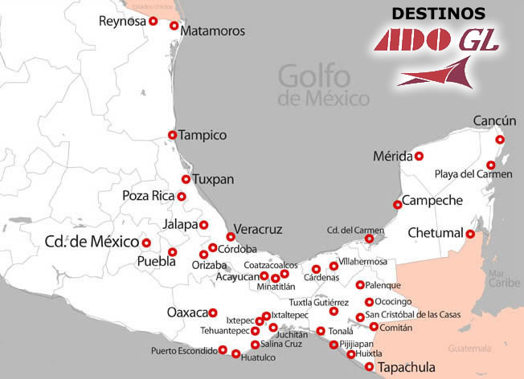
Locations of Jalapa and Cordoba in the state of Veracruz, Mexico

The Gulf of Mexico fits what is said of the east sea (Ether 9:3) (no west sea is mentioned in Ether, and none apparently was in the Jaredites’ geographical cognizance); this suggests that the Jaredite voyagers crossed the Atlantic rather than the Pacific. [Western Migration – Atlantic Crossing]
As already noted, locating Jaredite lands in Veracruz implies an Atlantic Ocean crossing for their ancestors. That is contrary to my former view that they probably traveled across Asia and the North Pacific. But I have always considered any suggested route within the Old World only tentative because the limited information in the book of Ether regarding the path and direction of their journey does not allow certainty. So this proposal for a landing in Veracruz also remains tentative.
[John Sorenson, Mormon’s Codex, pp. 709, 712, 713-714 ]

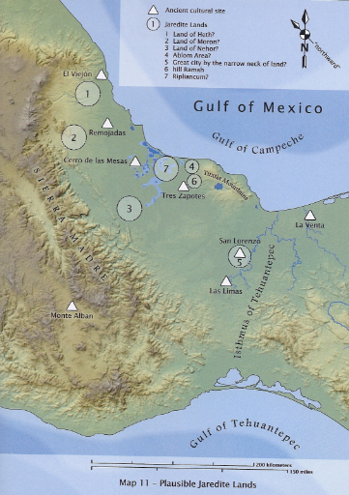
[John L. Sorenson, Plausible Jaredite Lands, Mormon’s Codex, p. Maps ]
#1 = Land of Heth? #2 = Land of Moron? #3 = Land of Nehor? #4 = Ablom Area?
#5 = Great City by the narrow neck of land? #6 = Hill Ramah #7 = Ripliancum

Ether 6:12 They Did Land upon the Shore of the Promised Land (Chronology):

Moroni writes that the Jaredites "did land upon the shore of the promised land" (Ether 6:12), but what was the date of that momentous event? According to Glenn Scott, there is substantial evidence that the date was August 13, 3114 B.C. Why August 13, 3114 B.C.? This was the zero date of the Olmec/Maya Long-count calendar. Pottery has been found in the very area in which the Jaredites must have landed (near Acapulco in the state of Guerrero, Mexico). This pottery is the earliest evidence of Mesoamerican civilization found so far, dated within 200+ years of that zero date. It closely fits the chronology table (SEE APPENDIX –Proposed Jaredite Chronologies). What could have been more appropriate than for them to commemorate the first day of a new life, in a new land, than by making it the first day of a new calendar?

Michael Coe has written:

The Long-count calendar was a refinement, by the Maya, of a much older Calendar Round of 52 years, used by all Mesoamerican peoples and undeniably of very great age. It is generally agreed that the Long-count calendar was developed after the inception of the Calendar Round, but by how many centuries of millennia archaeologists are not sure. Since the oldest Long-count dates appear on monuments outside the Maya area it can be concluded that it had reached its final form by the first century B.C., among people who were under powerful Olmec influence . . . probably not the Maya.

[Glenn A. Scott, Voices from the Dust: New Light on an Ancient American Record, pp. 43-44] SEE APPENDIX

Ether 6:12 When They Had Set Their Feet upon the . . . Promised Land They Bowed Themselves Down . . . Before the Lord (Covenant Imagery):

According to John S. Thompson, by applying some techniques of literary analysis to the Jaredite exodus narrative in Ether 1–3 and 6, the text reveals that it is more than just a historical account. The author or editor of the narrative uses imagery and dialogue to help the reader look beyond the historical facts and see elements of the creation, Christ, and temples, among other things.

Imagery often associated with temples from the ancient Near East also appear in the Jaredite narrative. . . . The plans for Solomon's temple are revealed by God to David (see 2 Samuel 7; 1 Kings 8). This same idea is found in the Jaredite narrative when the reader is informed that the Jaredites constructed their barges "according to the instructions of the Lord" (Ether 2:16).

Another common feature of ancient temples is that they are associated with the realm of the dead, the underworld, the afterlife, the grave.13 As the Jaredites cross the ocean, the author/editor describes them as being "buried in the deep" and "[brought] forth again upon the top of the waters" (Ether 6:6–7). Being "buried" and "brought forth again" conveys the image of death and resurrection, which Lundquist states is "the unifying principle between temple and tomb."14

Covenants and other means of establishing relationships between God and man are another common temple characteristic . . . Before the Jaredites enter their barges and obtain the promised land, they establish a covenant with the Lord. The Lord says, "whatsoever nation shall possess [the promised land] shall serve God, or they shall be swept off" (Ether 2:9). In other words, the covenant is that God would give them a new land if they would serve him, otherwise the penalty is that they would have no claim upon the land and would be "swept off." A similar account is given in Genesis where Noah does not enter the ark until a covenant is established: "But with thee will I establish my covenant and thou shalt come into the ark" (Genesis 6:18).

The Jaredites' action upon arriving in the promised land reflects yet another temple characteristic. The text reads, "when they had set their feet upon the shores of the promised land they bowed themselves down . . . before the Lord" (Ether 6:12). Menahem Haran describes the term "before the Lord" as "an indication of the existence of a temple at the site, since this expression stems from the basic conception of the temple as a divine dwelling-place."15 Although no temple structure is mentioned in the Jaredite account, being "before the Lord" certainly has temple imagery, as Haran suggests. The promised land as the divine dwelling-place is further suggested in the imagery the author/editor creates through the use of the phrases "they bowed themselves down" and "did shed tears of joy before the Lord." These phrases bring to mind the blessings of the faithful who, after overcoming the world, humbly and joyfully enter into the presence of the Lord.

Nevertheless, in spite of all the parallels and imagery which appear in the Jaredite story, one main question remains. Why? For what purpose are these images present? One answer may be that through the use of imagery, the author/editor prompts us to read for metaphorical meaning in addition to the literal historical meaning, thus giving us the opportunity to "liken the scriptures unto ourselves." Perhaps if we look beyond the literal meaning of the text and see the Jaredite narrative as symbolizing a journey through life, a common theme of temple-related dramas, a journey which includes the re-creation of the human soul through a covenant relationship with the Lord, then the reason for the imagery becomes clear. Through imagery and by slowing the narrative pace using dialogue, the author/editor stresses the need for the light of Christ as a guide while making this journey through life. Jared's brother illustrates this in a question: "O Lord, in them [the vessels] there is no light; whither shall we steer?" (Ether 2:19) The question, strange as it may be (it seems to focus on the need of light for knowing where to steer rather than for seeing), fits beautifully the imagery of Christ as the Light, who provides the humble traveler with the proper directions and the means to steer his life on a correct course that leads to the presence of God in the "promised land." . . . The Book of Ether (and the Book of Mormon) contains lessons of breadth and depth, and the imagery in the historical narratives is not to be passed over lightly. [John S. Thompson, “The Jaredite Exodus: A Literary Perspective of a Historical Narrative,” Journal of Book of Mormon Studies 3/1 (1994)]

[Note* Such imagery is a subtle addition of evidence to the truthfulness and title of “The Book of Mormon: Another Testament of Jesus Christ.” Alan Miner, Personal Notes]

Ether 6:12 They Did Shed Tears of Joy Because of the Multitude of His Tender Mercies Over Them:
In Ether 2:12 Moroni records:
And they did land upon the shore of the promised land. And when they had set their feet upon the shores of the promised land they bowed themselves down upon the face of the land, and did humble themselves before the Lord, and did shed tears of joy before the Lord, because of the multitude of his tender mercies over them.
In light of the covenant blessings and covenant destruction that would come upon the covenant Jaredite nation, and in light of our present-day circumstances in the United States and the other parts of this new world “promised land,”--- where God is not part of our schools or our governments, or rightfully worshipped by a large share of the population of this continent, it is indeed sobering to reflect on the Prayer of the First Continental Congress of the United States in 1774:
O Lord our Heavenly Father, high and mighty King of kings, and Lord of lords, who dost from thy throne behold all the dwellers on earth and reignest with power supreme and uncontrolled over all the Kingdoms, Empires and Governments; look down in mercy, we beseech Thee, on these our American States, who have fled to Thee from the rod of the oppressors and thrown themselves on Thy gracious protection, desiring to be henceforth dependent only on Thee. To Thee have they appealed for the righteousness of their cause; to Thee do they now look up for that countenance and support, which Thou alone canst give. Take them, therefore, Heavenly Father, under Thy nurturing care; give them wisdom in Council and valor in the field; defeat the malicious designs of our cruel adversaries; convince them of the unrighteousness of their Cause and if they persist in their sanguinary purposes, of own unerring justice, sounding in their hearts, constrain them to drop the weapons of war from their unnerved hands in the day of battle!
Be Thou present, O God of wisdom, and direct the councils of this honorable assembly; enable them to settle things on the best and surest foundation. That the scene of blood may be speedily closed; that order, harmony and peace may be effectually restored, and truth and justice, religion and piety, prevail and flourish amongst the people. Preserve the health of their bodies and vigor of their minds; shower down on them and the millions they here represent, such temporal blessings as Thou seest expedient for them in this world and crown them with everlasting glory in the world to come. All this we ask in the name and through the merits of Jesus Christ, Thy Son and Our Savior.
Amen.
Reverend Jacob Duché
Rector of Christ Church of Philadelphia, Pennsylvania
September 7, 1774, 9 o’clock a.m.

[Alan Miner, Personal Notes]

Geographical Theory Map: Ether 6:13 Jared Goes Forth Upon the Face of the Land (Year )

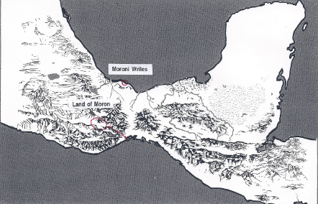
Choose: Location Choose: Year

Ether 6:13 They Went Forth upon the Face of the Land, and Began to Till the Earth:

Moroni writes that the Jaredites "went forth upon the face of the land, and began to till the earth" (Ether 6:13). According to John Thompson, tilling the ground seems like such an ordinary thing to do. Why, then, would one waste time and space writing about such things? Such an apparently superfluous piece of information becomes more meaningful when we realize that tilling the earth had symbolic significance among various ancient societies. Mircea Eliade has noticed in his studies of ancient cultures and religions that "when possession is taken of a territory, . . . rites are performed that symbolically repeat the act of Creation: the uncultivated zone is first 'cosmicized,' then inhabited." . . . Thus, tilling the ground may symbolize the act of creation to the author/editor of the Jaredite record and therefore warrants inclusion. [John S. Thompson, "The Jaredite Exodus: A Literary Perspective of a Historical Narrative," in Journal of Book of Mormon Studies, Spring 1994, pp. 106-107]

The reader might wonder how far the Jaredites "went forth" into the territory of the New World. All the text mentions is that by the time of Ether 7:5 the king dwelt in the land of Moron, which was "up," apparently from the landing site.

Ether 6:13 They Went Forth upon the Face of the Land, and Began to Till the Earth:

According to John S. Thompson, by applying some techniques of literary analysis to the Jaredite exodus narrative in Ether 1–3 and 6, the text reveals that it is more than just a historical account. The author or editor of the narrative uses imagery and dialogue to help the reader look beyond the historical facts and see elements of the creation, Christ, and temples, among other things.

We see an example of this principle in the writer's selection of data which he uses to report the Jaredites' arrival in the promised land. In Ether 6:13, the author/editor writes that "they went forth upon the face of the land, and began to till the earth." Tilling the ground seems like such an ordinary thing to do. Why, then, would one waste time and space writing about such things? Such an apparently superfluous piece of information becomes more meaningful when we realize that tilling the earth had symbolic significance among various ancient societies. Mircea Eliade has noticed in his studies of ancient cultures and religions that "when possession is taken of a territory, . . . rites are performed that symbolically repeat the act of Creation: the uncultivated zone is first 'cosmicized,' then inhabited."6 Although different cultures have different ways of "creating" newly acquired territory (i.e., building an altar, temple, or other structure; establishing a "center" with a pole or edifice around which all other things are organized), tilling the ground is not an uncommon method of accomplishing this purpose.7 Thus, tilling the ground may symbolize the act of creation to the author/editor of the Jaredite record and therefore warrants inclusion. [John S. Thompson, “The Jaredite Exodus: A Literary Perspective of a Historical Narrative,” Journal of Book of Mormon Studies 3/1 (1994)]

Ether 6:13 They Went Forth upon the Face of the Land, and Began to Till the Earth:

According to John Sorenson, Ether's account does not make logical or anthropological sense unless we suppose that his Jaredite line lived among other groups, both other lineages from the original barges and different groups, too. There is no doubt whatever that many--perhaps most--aspects of culture in both the First [Olmec-age] and Second [Nephite-age] Traditions clearly did not come from the Old World. A unique configuration of distinctive, ancient patterns or life and thought characterizes this area of Mesoamerica at a fundamental level; no later introductions by diffusion (as those brought by Jaredites, Mulekites, or Lehites) would have changed those much. Rather than exactly equating the Jaredites with the Olmecs, the Jaredites can be seen as one social element in a complex situation that included cultural, ethnic and linguistic variety--some immigrant and some "native."

The Olmecs were bearers of an especially interesting early culture centered in tropical lowlands near the Gulf of Mexico. But the Jaredite lineage inhabited an area in the highlands (Moron, their continuing ruling seat, was "up" from the coasts). As far as the brevity of the record allows us to judge, Ether's lineage dwelt in Moron all along. My judgment was that this place was located in the state of Oaxaca (alternatively, I would now say that portions of Guerrero, Puebla or Veracruz might qualify).

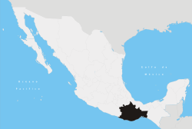
State of Oaxaca, Mexico

In those areas there were cultures related to but earlier than the coastal Olmec development, although scholars do not have a convenient cover term comparable to "Olmec" for the highland group(s). I have used the term "Olmec Tradition" to encompass the whole Early and Middle Pre-classic development, lowland and highland, which culminated in the classic gulf Coast Olmec manifestation. Eventually Jaredite rulers and their rivals were also active in the east sea lowlands, where their extinction finally occurred. I suppose that Ether's lineage, originating with Jared, held a significant measure of rulership while "involved in" groups bearing Olmec-period cultures. [John L. Sorenson, "Viva Zapato! Hurray for the Shoe! in Review of Books on the Book of Mormon, Vol. 6, Num. 1, p. 356]

Ether 6:13 They Went Forth upon the Face of the Land and Began to Till the Earth:

John Sorenson notes that new physical and statistical procedures have expanded the possibilities of C-14 dating, but they also necessitate correcting the "radiocarbon years" in order to fit our normal calendar. Calibrated dates can be expressed only as statistical ranges, not as single years; this means that there is a 95% chance that the real age falls within the indicated range. A few of the dates that apply to early Mesoamerican pottery-users, and presumably to agriculture-based villages, are listed below. These are sufficient to show that village life and ceramics were widespread in Mesoamerica during the period that John Sorenson assigns to the early Jaredites:

Puerto Marquez, Guerrero (Brush): 3765-3000 B.C.,+ 140 years.
Zohapilco, D.F. (Niederberger): 4085-3645 B.C. + 110.
Cuicuilco, D.F. (Heizer and Benyhoff): 3160-2635 B.C. + 120
Teopantecuantitlan, Guerrero (an "Olmec city") (Martinez Donjuan): 2115-1640 B.C. + 110
San Lorenzo Tenochtitlan, Veracruz (Coe and Diehl): 1910-1435 B.C. + 120

[John L. Sorenson, "Viva Zapato! Hurray for the Shoe! in Review of Books on the Book of Mormon, Vol. 6, Num. 1, pp. 317-318]

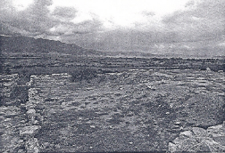
Ether 6:13 They went forth upon the face of the land (Illustration): San Jose Mogote and the northern valley of Oaxaca, the best candidate to have been the Jaredite Moron. (Courtesy Richard Jones)] [John L. Sorenson, An Ancient American Setting for the Book of Mormon, p. 185]

Ether 6:13 They went forth upon the face of the land (Illustration-not shown): The valley of Oaxaca seen from Monte Alban [F.A.R.M.S. Staff, "Lands of the Book of Mormon," Slide #86]

Ether 6:13 They Went Forth upon the Face of the Land:

Readers need to understand that there were already people living in the Americas when the Jaredites arrived. The BMAF Staff write:

There is evidence of people inhabiting that [Olmec] area thousands of years prior to the Early Preclassic. Soil cores were taken just 5 kilometers from the Olmec city of La Venta and they “yielded domesticated maize pollen around 5000 cal. B.C., domesticated manioc pollen dated to 4600 ca. B.C., and maize macrofossils around 2500 cal. B.C.; pottery dates to 2300 B.C.” 2 Not only were people inhabiting that area during Jaredite times, they were inhabiting the area for millennia before the Jaredites entered the scene.

[BMAF Staff, “Response to George Potter’s ‘Ten Reasons why Mesoamerica is Not Book of Mormon Lands’,” Book of Mormon Archaeological Forum]

Ether 6:13 They Went Forth upon the Face of the Land (First Jaredite Settlement):

Jerry Ainsworth notes that Sahagun reported that the wooden boats the Quinamis used landed at the Panuco River by the city of Tampico, which is in the state of Tamaulipas on the east coast of Mexico. In the ancient Nahuatl language, tam means "roots," while pico means "point." Tampico therefore means "Point of our Roots."

Upon landing at the Panuco River, these early settlers moved quickly to a land in the mountains of Mexico. Sahagun relates:

The old men used to tell, in a certain time which nobody can count anymore, "By water in their boats, they did come, in many groups. And they arrived at the water's edge, on the north coast, and where they left their boast is called Panutla. It means, "over where one crosses over the water." Right away they followed along the coast of the sea and they went looking for mountains, some for white mountains and the smoking mountains."

This account appears to describe a contingent of Jaredites moving to the valleys of Puebla and Tlaxcala, in south central Mexico. These valleys are surrounded by four volcanoes that are perpetually capped with snow and intermittently emit smoke. It is the only place in Mexico--or in Central America--where there exist "smoking mountains" capped with snow (see illustrations).

Ruins in the state of Puebla themselves go back to the time of the Quinamis, who were contemporary with the Olmec. The pyramid of Cholula in that area, which is the largest structure in the world, consists of many built-over pyramids. When archaeologists dug tunnels into this structure to document the number of superimpositions, they concluded that the original pyramid in the very center was built by people who lived at the time of the Olmec (Jaredites), around 2500 B.C. Archaeologists now make distinction between the Olmec, the ancient people of the Caribbean side of Mexico, and the people of the central highlands of Mexico (valleys of Puebla and Tlaxcala, and those of the west coast of Mexico. It appears that although these people shared similar cultural traits and habits, they were considered distinct and separate "countries."

Graham Hancock reports in Fingerprints of the Gods, "Though it was not known who had been the first builders here, as far as it had been possible to establish the earliest major edifice on the site consisted of a tall conical pyramid, shaped like an upturned bucket, flattened at the summit where a temple had stood." Although this pyramid is inaccessible to the public--being covered by the many others built over it--another round spiral pyramid nearby is not. One of three pyramids at the site of Xochitecatl, just seven miles from Cholula, stands clearly visible as a round, spiral type (see illustration).

[Jerry L. Ainsworth, The Lives and Travels of Mormon and Moroni, pp. 48-53] [See the commentary on Alma 22:30]

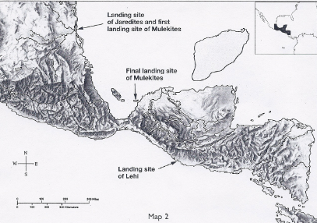
Ether 6:13 They went forth upon the face of the land (Illustration) [WESTWARD MIGRATION THEORY]: Map 2. The landing site of the Jaredites [Jerry L. Ainsworth, The Lives and Travels of Mormon and Moroni, p. 49]

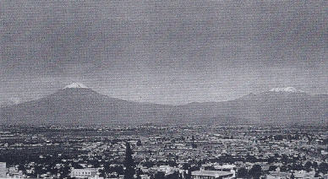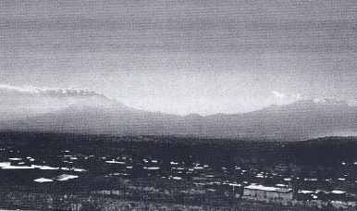
Ether 6:13 They went forth upon the face of the land (Illustration): L/R (22) the "land of the white caps"--snow covered volcanoes in Puebla, Mexico (Popocatepetl and Iztaccihuatl). (23) The "land of the smoking mountains"--smoking volcano in Puebla, Mexico (Popocatepetl). [Jerry L. Ainsworth, The Lives and Travels of Mormon and Moroni, p. 50]

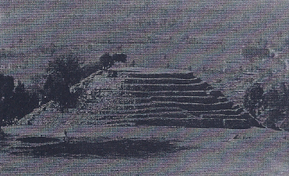
Ether 6:13 They went forth upon the face of the land (Illustration): (26) A round, spiral pyramid at Xochitecatl, seven miles from Cholula. [Jerry L. Ainsworth, The Lives and Travels of Mormon and Moroni, p. 52]

[Note: In view of this Mesoamerican design for their pyramids, in my view it is worth noting the similarity to the design of how the Israelites were to arrange themselves around the tabernacle in the wilderness. Matthew Brown writes that the “camp of the Israelites in the wilderness was arranged in the form of an enormous square with the tabernacle in the center.

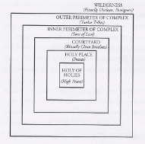

It becomes obvious when one compares the configuration of the camp of Israel around the tabernacle with John the revelator’s description of the heavenly city of Zion that the Lord’s intent was to imitate heaven on earth (see Revelation 21:9-16). [Matthew B.Brown, The Gate of Heaven, p. 62]

[Alan Miner, Personal Notes]

Ether 6:14 Mahah, and Orihah:

The four sons of Jared were called "Jacom, and Gilgah, and Mahah, and Orihah" (Ether 6:14). Jerry Ainsworth notes that the last two names end in hah, which in Maya means "by, or connected to water." These two sons, in other words, may have been born while traveling on or living by the ocean. A search of Book of Mormon names from Lehi to Mosiah yields no names ending in hah. Once King Mosiah's group united with Zarahemla's people, however, the term hah came into use. The fact that the Nephites and Mulekites incorporated the term hah into their vocabulary signifies the influence of Jaredite culture. Even today, any Mayan city whose name ends in ha or hah is situated by or connected to water. Altun-Ha, for example, is the site of an ancient Mayan city by a river on the coast of Belize. Xel-Ha is an ancient site on the coast of the Yucatan Peninsula that is used as a water resort today. Misol-Ha is the site of a waterfall and ancient ruins by a river south of Palenque, in the state of Chiapas, southern Mexico. It's therefore a safe assumption that the names of the Nephites cities of Moronihah and Nephihah refer to their proximity to water. [Jerry L. Ainsworth, The Lives and Travels of Mormon and Moroni, pp. 63-64]

Geographical Theory Map: Ether 6:14-7:3 Kingship Begins in the Land of Moron (Chronology)
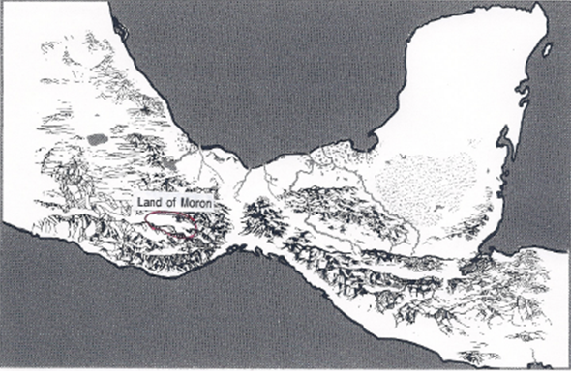

LAND of MORON (Where the king dwells) (7:6)

ORIHAH becomes first king (6:27)
Orihah begets Kib (7:3)
KIB reigns (7:3)
Kib begets Corihor (7:3)

Ether 6:16 The Friends of Jared and His Brother Were in Number about Twenty and Two Souls:

We are not told how many "friends" (see Ether 1:41) left the great tower with Jared and his brother, but after arriving in the New World, Moroni writes that, "the friends of Jared and his brother were in number about twenty and two souls" (Ether 6:16). These twenty two "friends" of Jared and his brother had already "begat sons and daughters before they came to the promised land; and therefore they began to be many."

According to Verneil Simmons, since only males beget, we know that the 22 friends represent heads of households, in the patriarchal sense. Women had no civil status in the social structure of the times and would not have been included in the census, nor included in the genealogy lists. They were considered as property of their husbands. [Verneil W. Simmons, Peoples, Places and Prophecies, p. 27]

According to Glenn Scott, the number "twenty and two" must mean the number of families that had made the sea voyage together. If the average number of children per family was somewhere between those of Jared and his brother (see Ether 6:20), the total would have been about 456 persons (17 children + 2 parents x 24 families averaging nineteen persons each, totaling about 57 per vessel plus animals and fowls, which was probably about the practical maximum for such an extended voyage. [Glenn A. Scott, Voices from the Dust: New Light on an Ancient American Record, pp. 41, 44]

Ether 6:19 The Brother of Jared Began to Be Old (Chronology):
How old was Jared and the brother of Jared when he died? How old were his sons when they died, and so on? Regarding the generations that followed Jared and the brother of Jared the text of the book of Ether provides insufficient clues as to exactly how many years they lived. Concerning Orihah, the son of Jared, we find only that his “days were exceeding many.” Of Orihah’s son Kib, who he begat in his old age, the text says nothing about how many years he lived except that he lived to be “exceeding old.”
Dan Neville begins his discussion of ancient life-spans with a common question: “How does one reconcile the differences between science and theology when it comes to the long life spans of Adam and Eve and the rest of their posterity up and until (and even beyond) the time of the flood?”
Beginning in the book of Genesis chapter 5, Moses tells us that Adam lived 930 years, Seth lived 912 years, and so forth continuing all the way down to Noah who lived 950 years. (Genesis 9:29) Noah begat Shem, Ham, and Japheth. In Genesis chapter 11 we are told that Shem lived 600 years, Shem’s son Arphaxad lived 403 years after he begat Salah. Salah lived 403 years after he begat Eber, and Eber lived 430 years, and begat Peleg, after which Eber lived another 430 years. And Peleg lived at least 239 years. And in the days of Peleg the earth was divided.
Dan Neville writes that today many would write off these claims to such a long life-span as make-believe. However, science might give us a plausible solution to this aging question.
While fossil records have been found, all those records tell us about the life span of those creatures is that they existed.
Some have surmised that prior to the flood, a layer of water hung in the atmosphere, blocking the sun’s killing” radiation, and that is why man lived longer in those days. However, that doesn’t account for Noah and others living hundreds of years after the flood.
Yet another theory holds that until the flood, man didn’t eat the flesh of other creatures, possibly accounting for a physically and spiritually healthier lifestyle. That may be true, but still seems like quite a stretch.
There is an additional plausible theory proposed in 1997 by Dr. Gerald L. Schroeder, author of The Science of God. Schroeder’s contention is that aging is a product of genetics and that each species is programmed to die at a given age range. Elephants live to be about a hundred years old; dogs live to be around fifteen years old; fleas live for about five years; man lives for about seventy-five years, and so on. Each species’ genetic package limits the age that the species can live. We accept that some trees can live 1000 years or more. Why can’t man?
We read about terrible mutations that play havoc with the aging process. A genetic disorder called Progeria speeds up aging, so that children only eight or ten years old have already become shriveled old peopled. Most die as they enter their teenage years. If genetic mutations shorten life, can we not assume that changes in gene structure could lengthen life?
Dr. Schroeder comments: “It would be surprising but not inconceivable that the manipulation of a flea’s genome might allow it to live ten times longer than normal.” (The Science of God, p. 202) This would translate into humans living 750 years. Genesis describes a time when perhaps human metabolism was slower and life spans were lengthened. In times prior to the flood, the first child often wasn’t born until a person was about 120 years old. Enoch refers to himself as just “a lad” when he was 65 years old. (see Moses 6:27, 31).
[Dan Neville, Scientific Discoveries That Build Testimonies and Strengthen Faith, pp. 130-132 ]

Note* What follows are two recent reports about finding the aging gene: "Genetic Control of Aging and Life Span" by Jill U. Adams, Ph.D. (Freelance Science Writer, Albany, NY). Nature Education, 2008, 1(1):130
What determines how long a person will live? Many things affect longevity, but could a single gene play a large role in the length of the human life span?
The action of a single gene can have huge effects on how long a creature lives. This may seem hard to believe because so many things go into determining life span, including a host of lifestyle factors and a long list of diseases. Nonetheless, remarkable effects on life span are seen when particular genes are deleted from an animal's genetic sequence. Furthermore, research—particularly that involving microscopic roundworms—continues to provide scientists with tantalizing clues about the molecular pathways involved in aging.
Determination of the Aging Gene
When studying life span, scientists tend to work with organisms that do not live very long; that way, they can observe the entire course of an organism's existence and obtain relatively rapid experimental results. One organism that researchers frequently employ in their studies of life span is Caenorhabditis elegans, a microscopic roundworm that typically lives to a ripe old age of two to three weeks. Another advantage of using C. elegans is that these worms have a simple physiology and easily manipulated genes.
Over the last several decades, C. elegans has been the subject of many published studies, but perhaps the most famous of these appeared in 1993. In that paper, researcher Cynthia Kenyon and her associates showed that C. elegans with a specific single-gene mutation lived twice as long as members of the species that lacked this mutation (Kenyon et al., 1993).
This finding was groundbreaking for a number of reasons. First, it challenged the prevailing concept that aging occurs as the body deteriorates over time. Second, it led to a shift in thinking, even among researchers who already believed that aging was subject to some sort of genetic control. Prior to this point, most such scientists figured that aging, age-related illnesses, and death were consequences of multiple cellular and physiological processes, and therefore under the regulation of a wide and diverse set of genes. Kenyon's paper, however, suggested that a single gene could dramatically regulate how long an organism lived, thus opening the door to new hypotheses about modifying life span through genetic manipulation.
The responsible gene is called daf-2, and, in 1997, a research group led by Gary Ruvkun finally solved its DNA sequence (Kimura et al., 1997). Scientists were surprised to find that the protein coded for by this gene (designated DAF-2) looked much like the receptor protein within humans that responds to the hormone insulin. In other words, the worm protein is simply a primitive form of our own insulin receptors.
Later research has revealed even more about daf-2. The gene is now known to regulate a number of factors in addition to aging, including stress resistance, metabolism, and development (Table 1) (Gami & Wolkow, 2006). Furthermore, scientists have determined that the gene and its hormone-signaling protein have been conserved evolutionarily, and they are found in many other animals, from fruit flies to mice. In worms and flies, the gene codes for a receptor protein that is activated by an "insulin-like" growth factor. This signaling pathway is analogous to the mammalian insulin pathway.
----------------------------

Science News from research organizations: First gene therapy successful against aging-associated decline: Mouse lifespan extended up to 24% with a single treatment
Date: May 14, 2012
Source: Centro Nacional de Investigaciones Oncologicas (CNIO)
Summary: A new study consisting of inducing cells to express telomerase, the enzyme which -- metaphorically -- slows down the biological clock -- was successful. The research provides a "proof-of-principle" that this "feasible and safe" approach can effectively "improve health span."

A number of studies have shown that it is possible to lengthen the average life of individuals of many species, including mammals, by acting on specific genes. To date, however, this has meant altering the animals' genes permanently from the embryonic stage -- an approach impracticable in humans. Researchers at the Spanish National Cancer Research Centre (CNIO), led by its director María Blasco, have demonstrated that the mouse lifespan can be extended by the application in adult life of a single treatment acting directly on the animal's genes. And they have done so using gene therapy, a strategy never before employed to combat aging. The therapy has been found to be safe and effective in mice.
The results were recently published in the journal EMBO Molecular Medicine. The CNIO team, in collaboration with Eduard Ayuso and Fátima Bosch of the Centre of Animal Biotechnology and Gene Therapy at the Universitat Autònoma de Barcelona (UAB), treated adult (one‐year‐old) and aged (two‐year‐old) mice, with the gene therapy delivering a "rejuvenating" effect in both cases, according to the authors.
Mice treated at the age of one lived longer by 24% on average, and those treated at the age of two, by 13%. The therapy, furthermore, produced an appreciable improvement in the animals' health, delaying the onset of age-‐related diseases like osteoporosis and insulin resistance, and achieving improved readings on aging indicators like neuromuscular coordination.

Ether 6:19 The Brother of Jared Began to Be Old (Chronology):

Soon after the Jaredites arrived in the promised land, "the brother of Jared began to be old, and saw that he must soon go down to the grave" (Ether 6:19). According to Glenn Scott, the brother of Jared was contemporary with the biblical patriarchs Peleg and Reu, who lived 239 years (see KJV Genesis 11:18-19) or 339 years (see Septuagint Genesis 11:18-21). The years that the Jaredites had spent in the wilderness, must have been "many" indeed (see Ether 3:3). [Glenn A. Scott, Voices from the Dust: New Light on an Ancient American Record, p. 45]

Ether 6:20 The Number of Sons and Daughters of Jared were Twelve, He Having Four sons:

In Ether 6:19-20 we find that when Jared and the brother of Jared began to be old and about to die, they decided to gather all their people together and “number them, that we may know of them what they will desire of us before we go down to our graves. Ether 6:20 notes: “And accordingly the people were gathered together. Now the number of the sons and the daughters of the brother of Jared were twenty and two souls; and the number of sons and daughters of Jared were twelve, he having four sons.”

According to Brant Gardner, the numbers given in Ether 6:20 are too neat to plausibly be actual counts. There are twenty-four [from the family of the brother of Jared -- 22 sons and daughters plus the brother of Jared and his wife] (twice twelve). Jared had four sons and twelve total children. All of these numbers are symbolically important in either the Bible (twelve) or Mesoamerica (four). In other words, the only numbers given have symbolic meaning. [Brant A. Gardner, Second Witness: Vol. 6: Fourth Nephi through Moroni, p. 233]

[Note* In ancient times, the number 24 symbolized heavenly government—and, as a multiple of 12, symbolized priestly judgment in particular. (E. Bullinger, Number in Scripture, 1969) I would also like to observe that the word “know” is used here. That word in the Book of Mormon very often seems to be associated with covenants. In other words, this gathering seems to be more than just a census, it appears to be an assessment of the covenants that Jared and the brother of Jared have made with the Lord in regard to the governing of their lives, their family, and those people who have followed them into the wilderness. This covenant perspective gives added meaning to the verses that follow. Their people essentially want an earthly king in addition to the heavenly King that Jared and the brother of Jared have followed. But as Jared and his brother know, that can lead to problems. Alan Miner, Personal Notes]

Ether 6:23 Surely This Thing [Kingship] Leadeth into Captivity:

When the Jaredites wanted a king, the brother of Jared warned them: "surely this thing leadeth into captivity" (Ether 6:23). This warning is not alone in the Book of Mormon. King Mosiah also commented on the potential dangers of kings (see Mosiah 29:16-24). A similar situation is also found in the Bible. The people of Israel, like the people of Jared, suddenly wanted to change to a monarchial form of government. The prophet Samuel, who was the judge or ruler over Israel, was saddened by his people's request. But the Lord revealed the real problem when he told Samuel, "they have not rejected thee, but they have rejected me, that I should not reign over them" (1 Samuel 8:7). Then the Lord told Samuel to give in to their request after warning them of the consequences of their wishes (see 1 Samuel 8:11-18). Sadly, the Israelites, just like the Jaredites, refused to obey the voice of their prophet and seer.

In the case of the Jaredites, the prediction of kingship leading to captivity proved true. Kib, and later his son Shule, were taken captive by rivals. From the illustration below, the reader should notice how short the time was between the brother of Jared's prophecy and its fulfillment. [CES, Book of Mormon Student Manual: Religion 121 and 122, 1989, p. 139] [See the commentary on Mosiah 29:5]

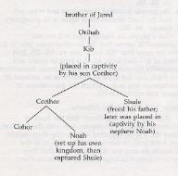
Ether 6:23 Surely this thing [Kingship] leadeth into captivity (Illustration): The following genealogical chart illustrates the early part of Jaredite history. Notice how short the time was between the brother of Jared's prophecy and its fulfillment. [CES, Book of Mormon Student Manual: Religion 121 and 122, 1989, p. 139]

Ether 6:23 Surely This Thing Leadeth into Captivity:

In the Old Testament, we read that when the Israelites asked the prophet Samuel for a king so that they could be like all the other nations in the land, the Lord replied, Hearken unto the voice of the people…for they have not rejected thee, but they have rejected me, that I should not reign over them (1 Sam 8:7). The Israelites and the Jaredites would have benefited most if they had the KING OF KINGS, AND LORD OF LORDS (Rev 19:16) as their king, for I, the Lord, the king of heaven, will be their king, and I will be a light unto them forever, that hear my words (2 Ne 10:14).
[josephsmith.com . . . Ether ]

Ether 6:24 Choose Ye out from among Our Sons a King:

Jared and his brother, knowing that they were soon to die, did number their people; and after that they had numbered them, they did desire of them the things which they would that they should do before they went down to their graves. And the people desired of them that they should anoint one of their sons to be a king over them. And now, behold, this was grievous unto them. And the brother of Jared said unto them: Surely this thing leadeth into captivity. But Jared said unto his brother: Suffer them that they may have a king. And therefore he said unto them: Choose ye out from among our sons a king, even whom ye will. (Ether 6:21-24)

The fact that the people of Jared and the brother of Jared were "numbered" is reminiscent of the kingship covenant discourse of King Benjamin wherein he thought it was expedient that "he should take the names of all those who had entered into a covenant with God to keep his commandments" (Mosiah 6:1). This Benjamin did even though at the onset of the gathering "there were a great number, even so many that they did not number them" (Mosiah 2:2).

It is somewhat puzzling how the people of Jared and his brother, who had come out from under the wicked power of Nimrod, would now desire a king. It is also interesting that when given the choice to "choose ye out from among our sons a king" (Ether 6:24), the people first "chose all the brothers of Pagag" (who were sons of the brother of Jared) "and they would not" (Ether 6:25-26). One might ask, why were the sons of the brother of Jared asked to be king first? Was he higher in authority than Jared? Unfortunately, we are not told. However, it is interesting that it was the brother of Jared (and not Jared) who went to speak with the Lord about lighting the ships (Ether 3). It is also noteworthy that while the brother of Jared had warned the people about kingship ("surely this thing [kingship] leadeth into captivity"), it was Jared who acquiesced to the people's wishes. Not one of the sons of the brother of Jared would accept the kingship, but Orihah, one of the sons of Jared accepted the offer (Ether 6:27). One might wonder, would this be a point of contention between the two families in the future? Had the people disobeyed their prophet? Did the descendants of the brother of Jared record their own history from a different perspective?

Glenn Scott notes that the choosing of Orihah, the youngest son of Jared (see Ether 6:14) might have started a trend--that of the youngest son being chosen as king. [Glenn A. Scott, Voices from the Dust: New Light on an Ancient American Record, p. 45]

Ether 6:27 Orihah Was Anointed to be King (Chronology-- Length of Reign):
John Gee writes:
We have one other piece of information about Orihah before he became king: “And Jared had four sons; and they were called Jacom, and Gilgah, and Mahah, and Orihah.” (Ether 6:14) Orihah comes last in the list and seems to have been the youngest of Jared's sons. With the founding ruler the youngest son, the precedent seems to have been for the youngest son to succeed the father as ruler. This would at least explain an otherwise peculiar system of Jaredite succession.
Jaredite kingship passes from father to son, but perhaps not from father to oldest son. Consider the following passages:
And it came to pass that he [Orihah] also begat Kib in his old age. And it came to pass that Kib reigned in his stead (Ether 7:3).
Nevertheless Kib begat Shule in his old age, while he was yet in captivity . . . And now because of the thing which Shule had done, his father bestowed upon him the kingdom; therefore he began to reign in the stead of his father. (Ether 7:7, 10)
And it came to pass that Shule begat sons and daughters in his old age . . . And it came to pass that he begat Omer, and Omer reigned in his stead. (Ether 7:26, 8:1)
And it came to pass that Omer began to be old; nevertheless, in his old age he begat Emer; and he anointed Emer to be king to reign in his stead. (Ether 9:14)
And Emer did execute judgment in righteousness all his days, and he begat many sons and daughters; and he begat Coriantum, and he anointed Coriantum to reign in his stead. (Ether 9:21)
And it came to pass that Coriantum took to wife, in his old age, a young maid, and begat sons and daughters; wherefore he lived until he was an hundred and forty and two years old. And it came to pass that he begat Com, and Com reigned in his stead (Ether 9:24–25).
There is a possible break in the pattern at this point, but the text is not clear. “And Shez did live to an exceedingly old age; and he begat Riplakish. And he died, and Riplakish reigned in his stead.” (Ether 10:4)
There is another break at this point, but the pattern continues with two successive kings:
And it came to pass that Kim did not reign in righteousness, wherefore he was not favored of the Lord. And his brother did rise up in rebellion against him, by which he did bring him into captivity; and he did remain in captivity all his days; and he begat sons and daughters in captivity, and in his old age he begat Levi; and he died. And it came to pass that Levi did serve in captivity after the death of his father, for the space of forty and two years. And he did make war against the king of the land, by which he did obtain unto himself the kingdom. And after he had obtained unto himself the kingdom he did that which was right in the sight of the Lord; and the people did prosper in the land; and he did live to a good old age, and begat sons and daughters; and he also begat Corom, whom he anointed king in his stead. (Ether 10:13–16)
Later, the pattern continues: “And he [Com] lived to a good old age, and begat Shiblom; and Shiblom reigned in his stead.” (Ether 11:4)
So among the Jaredites, at least ten kings were replaced by children born when they were old. While we do not know that these children were the youngest or the youngest son, it certainly looks like a case of ultimogeniture as opposed to the more common primogeniture. This follows the precedent in the case of the first Jaredite king:
And it came to pass that the people desired of them that they should anoint one of their sons to be a king over them. And now behold, this was grievous unto them. And the brother of Jared said unto them: Surely this thing leadeth into captivity. But Jared said unto his brother: Suffer them that they may have a king. And therefore he said unto them: Choose ye out from among our sons a king, even whom ye will. And it came to pass that they chose even the firstborn of the brother of Jared; and his name was Pagag. And it came to pass that he refused and would not be their king. And the people would that his father should constrain him, but his father would not; and he commanded them that they should constrain no man to be their king. And it came to pass that they chose all the brothers of Pagag, and they would not. And it came to pass that neither would the sons of Jared, even all save it were one; and Orihah was anointed to be king over the people. (Ether 6:22–27)
[John Gee , “Jaredite Inheritance Patterns,” etherscave.blogspot.ca, Sunday, January 5, 2014]
[Note* If ultimogeniture was the kingship practice among the Jaredties, this would indicate that the length of kinship reign could have been consistently long in years. If we also take into consideration the possible practice of polygamy among the Jaredites, this could have lengthened the overall chronological timetable considerably. Alan Miner, Personal Notes]

Ether 6:28 The People . . . Became Exceedingly Rich:

Moroni writes that during the reign of Orihah, "the people began to prosper; and they became exceedingly rich" (Ether 6:28). Glenn Scott notes that although Moroni did not define "rich" in that early time period, it probably meant that their crops prospered, they reaped bountiful harvests, and their homesteads expanded. A food surplus would have allowed time for such pursuits as weaving, leather work, carving wood and stone, music, trade and such. [Glenn A. Scott, Voices from the Dust: New Light on an Ancient American Record, p. 45]

Ether 6:30 And [Orihah] Did Walk Humbly Before the Lord, and He Did Remember How Great Things . . . the Lord Had Done for Their Fathers (Covenant Language and Structure):
According to Donald Parry, parallelism is universally recognized as the characteristic feature of biblical Hebrew poetry. (p. i) Apparently, the prophets and writers of the scriptures employed the repetition of alternating parallel lines for the purpose of reinforcing their teachings and doctrines. (p. x) The message of Ether 6:30—7:1 is covenant related and is tied to the prosperity mentioned just previously in verse 28. Either Moroni or Ether stressed the message here with a parallelistic simple alternate construction and covenant terms encapsulated by profound covenant actions:
A And it came to pass that Orihah did walk humbly before the Lord,
B and did remember how great things
C the Lord had done for his father,
B and also taught his people how great things
C the Lord had done for their fathers.
A And it came to pass that Orihah did execute judgment upon the land in righteousness
all his days.

The covenant action of “walking humbly before the Lord “ is paired and defined by the parallel action of “executing judgement upon the land in righteousness.” The covenant action of “remembering” is paired and defined by the covenant action of “teaching his people” covenant obedience. This implies that this covenant teaching was accompanied by example. Most importantly, either Moroni or Ether pointed out in parallelistic fashion that it is the “Lord” who has done this for righteous covenant-faithful “fathers.” We find the following in Psalm 105:8 (KJV): "He [the Lord]hath remembered his covenant for ever, the word which he commanded to a thousand generations."
[Alan Miner, Personal Notes and Donald W. Parry, The Book of Mormon Text Reformatted to Parallelistic Patterns , pp. 462-463]
Allen & David Richardson and Anthony Bentley note that the Book of Mormon prophet writers frequently emphasize the importance of remembering. For example 1 Nephi 10:20: "Therefore remember, O man, for all thy doings thou shalt be brought into judgment." Other classic examples are found in Mosiah 2:41: "O remember, remember that these things are true; for the Lord God hath spoken it," and Mosiah 4:30: "An now, O man, remember, and perish not."
The charge to "remember" is repeated seven times in Helaman 5:5-6. Note that seven is a number that was used in ancient Hebrew culture to signify perfection or completion. (See also, 1 Nephi 15:25; 19:15-16; Jacob 3:9-11; Alma 37:35; 3 Nephi 18:7, 11; and Moroni 4-5.)
All in all, the Book of Mormon prophets stress the importance of remembering the Lord's dealings with their fathers some seventy-nine times! The frequent emphasis on remembering throughout the Book of Mormon is consistent with the Hebrew literature. (See Wallace E Hunt Jr., "Moses' Brazen Serpent as It Relates to Serpent Worship in Mesoamerica," Journal of Book of Mormon Studies, 1993, p. 126.)
The following is quoted from John W. Welch, Reexploring the Book of Mormon, 1992, pp. 127-129:
Brevard S. Childs has shown that various forms of the Hebrew verb zakhor (to remember) occur in the Old Testament well over two hundred times. He shows that what the Old Testament understands by "memory" goes well beyond the mere mental recall of information, though of course that is part of its meaning. To remember often means to be active, to consider, to keep divine commandments, or to act. The word in Hebrew thus carries a wider range of meaning than is common with the verb remember in English. Indeed, to remember involves turning to God, or repenting, or acting in accordance with divine injunctions.
Not only man, but also God "remembers." He remembers covenants he has made with Noah (see Genesis 9:15-16), with Abraham, Isaac and Jacob (see Exodus 2:24; Leviticus 26:42), and with all of Israel (see Ezekiel 16:60; Luke 1:72).
Conversely, the antonym of the verb to remember in Hebrew--to forget does not merely describe the passing of a thought from the mind, but involves a failure to act, or a failure to do or keep something. Hence, failing to remember God and His commandments is the equivalent of apostasy.
Interestingly, words for memory and remembrance also occur well over two hundred times in the Book of Mormon. This high density is not noticed by casual readers, but it vividly reflects a religious sensitivity on the part of Book of Mormon prophets that is similar to that of other Israelite prophets. Though the range of uses of remembering in the Book of Mormon is perhaps not quite as extensive as that identifiable in the Old Testament, the idiom of remembrance in both books includes warning, promises, threats, pleas, and complaints, and the same deep connection between memory and action can be found in both. To remember is to hearken, to awaken, to see, to hear, to believe, to trust. (See Jacob 3:9-11; Mosiah 2:41; 4:30; 13:29-30; Alma 7:16; 9:13-14; 18:10; 36:1-2; 37:35; 46:23; 58:40 and compare with Numbers 15:39-40; Psalms 103:18.)
. . . In such ways the Book of Mormon shows a clear link between the ways of remembrance or forgetfulness and the blessings or cursings associated with the covenant people of God. Since one of the main purposes of the Book of Mormon, as stated on its title page, is to show that God remembers the covenants he has made with his people (see also 1 Nephi 19:15-16; 2 Nephi 29:1-2; 3 Nephi 16:11), it is especially appropriate that eh renewal of covenants includes a commitment to "always remember him, and keep his commandments." as the faithful affirm their willingness to take upon them the name of Jesus Christ (Moroni 4:3).
[Allen H. Richardson, David E. Richardson, and Anthony E. Bentley, Voice from the Dust-500 Evidences Supporting the Book of Mormon, pp. 270-271] [See the commentary on Mosiah 4:30; Helaman 5:6]

[Note* In reference to the word “memory” as it is related to the covenant term “remember” and to covenant faithfulness, the reader should remember that Moroni writes in Ether 5:1 that he had “written the words which were commanded me, according to my memory.” For other uses of the covenant related term “remember” see Ether 10:2]

NOTES

. See Edwin F. Parry's Joseph Smith's Teachings (SLC: Deseret News, 1919;155).
. Through Memory's Halls (p. 87).
. Hugh Nibley, The World of the Jaredites. (Note 235 of Randall P. Spackman, The Jaredite Journey to America, unpublished.
. They can't make up their minds whether the ark was a boat or a box or a bizarre combination of the two: See our illustration in The Improvement Era, Vol. 59 (July, 1956), p. 511. The very word "ark" means, according to Webster, "a close receptacle," being a literal translation of Hebrew tevah, "box," a word borrowed from the Egyptians.
. Midrash Rabbah, Trsl. H. Freedman (London: Soncino Press, 1939), I, 244.
. Berkeley, CA: University of California Press, 1928; University of California Publications in Semitic Philology 9(2):167.
. London: Samuel Bagster & Sons, 1851; p. 12, Chapt. 11, verse 4.
. 1(12):363-380; December 1902.
. Whiston, trans. n.d., Josephus: Antiquities of the Jews, 4.
. R. Henderson, Sea Sense (Camden, Maine: International Marine, 1972) note 320 supra, p. 233
. See Paul Rivet, Maya Cities, [London: Elek Books, 1960] p. 227; L. Sprague, and Catherine de Camp, Ancient Ruins and Archaeology, Thesis [Garden City, New York: Doubleday, 1964] p. 167; Robert Wauchope, Lost Tribes and Sunken Continents [Chicago: University of Chicago Press, 1956] p. 7. All three above sources were cited in Cheesman, The World of the Book of Mormon, [1978], p. 1.
. Charles Brush 1965, "Pox Pottery," Science, 149:194,195.
. Richard Adams 1977, Prehistoric America, 67.
. M. Coe 1992, The Maya, 50.
. Cfr. Sorenson, An Ancient American Setting, 117, 119.
. John L. Sorenson, "When Lehi's Party Arrived, Did They Find Others in the Land?" Journal of Book of Mormon Studies 1/1 (1992): 112
. Ibid., 112.
. Following J. Klein et al., "Calibration of Radiocarbon Dates," Radiocarbon 24 (1982): 103-50.
. Quoted in Hunter and Ferguson, Ancient America and the Book of Mormon, pp. 30-31.
. Quoted in David Palmer's response to papers by V.G. Norman and J.L. Sorenson, Book of Mormon Geography Symposium, Brigham Young University, April 1975, p. 11.
. David Groves at a Conference on Discovering the Occident of Mexico, 1998.
. Fingerprints of the Gods, p. 116.

