Book of Ether

Chapter 7

Ether 7:1 [Orihah's] Days Were Exceeding Many:

Moroni notes that Orihah reigned "in righteousness all his days, whose days were exceeding many" (Ether 7:1). According to Glenn Scott, since Orihah was of the first generation following the flight from the great tower, a contemporary of biblical patriarchs who lived hundreds of years (see Genesis 11:18-21), it is no surprise that Orihah's days were termed "exceeding many." [Glenn A. Scott, Voices from the Dust: New Light on an Ancient American Record, p. 45] [SEE APPENDIX –The Jaredite Story Chronological Setting]

Ether 7:2 He Begat Thirty and One:
According to Brant Gardner, thirty one children strongly suggests that Orihah had more than one wife. Polygamy was common early in the biblical record (even Jacob references David and Solomon, Jacob 1:15), so it should not surprise us that it would be practiced by men coming from that time and place. In the New World, polygamy was an adaptive strategy that helped transform smaller social units into larger and more successful ones. [Brant A. Gardner, Second Witness, Vol. 6: Fourth Nephi through Moroni, p. 236]

Ether 7:2 He Begat Sons and Daughters; Yea, He Begat Thirty and One:

It is hard to imagine how Orihah had 31 children unless he had more than one wife. The practice of polygamy (or more accurately, polygyny) was probably regularly practiced among the Jaredites. The brother of Jared had 22 children (Ether 6:20), Shule also begat many sons and daughters (v. 12), Corihor had many sons and daughters (v. 14), and the people had become exceedingly numerous (v. 11) in the space of only a couple of generations. The practice was abused by Riplakish, who did not that which was right in the sight of the Lord, for he did have many wives and concubines (Ether 10:5). The record implies not that he started the practice, but that he abused it.

However, among the Lamanites and Nephites, the practice of polygamy was expressly forbidden, For there shall not any man among you have save it be one wife; and concubines he shall have none (Jacob 2:27). The only known instance in which it was practiced among them was the wicked king Noah, who had many wives and concubines…and they did commit whoredoms and all manner of wickedness (Mosiah 11:2).

Thus, the Lord allows the practice under certain special conditions—specifically, he has said, if I will . . . raise up seed unto me, I will command my people; otherwise they shall hearken unto these things (Jacob 2:30). [josephsmith.com . . . Ether]

Ether 7:3 Kib:

According to Bruce Warren, "Kib" (Ether 7:3) is a familiar Mesoamerican name. It is the name of the sixth month in the Yucatec Maya calendar. [Bruce W. Warren, Blaine M. Yorgason, Harold Brown, New Evidences of Christ in Mesoamerica, Unpublished Manuscript]

Ether 7:4 Corihor . . . Went over and Dwelt in the Land of Nehor:

The record states that Kib "begat Corihor." For some unmentioned reason, when Corihor was 32 years old, he "rebelled against his father, and went over and dwelt in the land of Nehor (Ether 7:4). Thus, geographically speaking, we might assume that the land of Nehor was "over" from the land of Moron. Furthermore, the land of Nehor was probably at a lower elevation because it says that after Corihor had begat many sons and daughters, and "drew away many people after him," that he "came up unto the land of Moron where the king dwelt" (Ether 7:5). Thus the land of Moron seems not only close to the land of Nehor, but it seems to be located in hills or mountains.

The reader might note that whoever the original writer of this information was (Ether or Moroni), they are using directional terms ("went" and "came") which might imply a reference point. But what is the reference point? Is it from where Moroni was writing? Is it from where Ether was writing? If Ether "hid himself in the cavity of a rock by day, and by night he went forth viewing the things which should come upon the people" (Ether 13:13), and if the final battle location of the Jaredites was near the hill Ramah (Ether 15:11), and if the hill Ramah "was the same hill where [Moroni's] father Mormon did hide up the records unto the Lord" (Ether 15:11), and if Moroni returned to the hill Cumorah (hill Ramah) in order to record the contents of the book of Ether on his plates (see Mormon 8:3-5; Ether 1:1-2), then the geographical reference terms ("came" and "went") for both Ether and Moroni not only might be the same, but they might offer some degree of geographical orientation. On the other hand, words such as "came" and "went" might not have been intended to imply any directional information at all other than conveying a general sense of going from one place to another. [Alan C. Miner, Personal Notes]

Geographical Theory Map: Ether 7:4 - 7:13 Corihor Reigns in the Land of Nehor (Chronology)
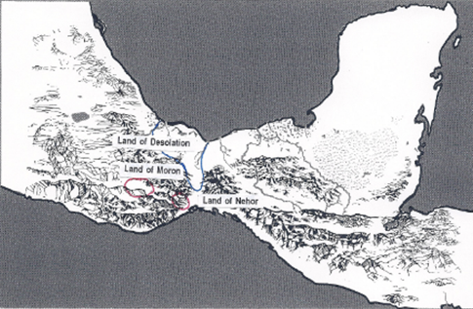

LAND of MORON (Where the king dwells) (7:6)

KIB reigns (7:3)
Kib begets Corihor (7:3)
Corihor “went over" to Nehor (7:4) --------->
LAND of NEHOR

<----------------- Corihor “came” "up" to land of Moron (7:5)

Corihor takes Kib captive to Nehor (7:5) ---------->

“Now the land of Moron where the king dwelt was near the land which is called Desolation by the Nephites.” (7:6)

CORIHOR reigns from Nehor (7:7,9)
Kib begets Shule (7:7)
Shule “came” to Hill Ephraim (7:9)
He made swords out of STEEL (7:9)
He returned to the City Nehor (7:9)
Shule defeats Corihor (7:9)

[LAND OF MORON] <----------------- Kib restored to Kingship (7:9)
KIB reigns (7:9)
Kib bestows kingdom to Shule (7:10)
SHULE reigns over Moron + Nehor (7:10)
He spreads the kingdom “upon all the face of the land” (7:11)
_____
Ether 7:4 The Land of Nehor --- Corihor:

Interestingly in Ether 7:4-5 we find that Corihor “rebelled against his father, and went over and dwelt in the land of Nehor” and Corihor “drew away many people after him.” One might wonder what the philosophy of Corihor was that caused many people to follow after him. Details are lacking here in the Book of Ether but if I might speculate, perhaps we can glean some insight from two dissenters and an order of “religion” that are part of Nephite history among the people in Zarahemla, which people of Zarahemla (Mulekites) would have contact with the Jaredite culture, perhaps for hundreds of years.
One dissenter would be called “Nehor” (Alma 1: 2-15).
Later we find an “Order of Nehors” (Alma 14:16-18; 15: 15).
In Alma 30:6-59 we encounter another dissenter named Korihor, who is an antichrist.

Perhaps their names would be purposefully symbolic of the Jaredites who rebelled. For a commentary on their various beliefs, SEE Alma chapt. 1, chapt. 14, chapt. 15, chapt. 30).

In a paper titled “Religious Beliefs of the Nehors” by Tom Cherrington, he summarized the teachings of the Nehors. In essence they eliminated the need for a Savior:
1. They believed that all men were saved and excelled according to their talents.
2. Priests and teachers ought to be paid and become popular (priestcraft).
3. They were unfamiliar with the resurrection of the dead.
4. They seem not to understand the need for a final judgment.
5. They did not believe in repentance from sin. They likely did not believe in sin.
6. They did not believe in the scriptures that testified of Jesus Christ.
7. They did not believe in revelation.

Alma would declare that “were priestcraft to be enforced among this people it would prove their entire destruction.” (Alma 1:12)

While Nehor would be executed, the practice of priestcraft would continue to spread, and with it the idea of kingship rule. (Alma 2) Also judges and lawyers of the order of Nehor would persecute the true believers in Christ. (Alma 14)

Korihor’s teachings would reflect the teachings of the Nehors in nearly every detail. The one belief that Korihor would verbalize perhaps more than the others that have been mentioned is that he believed that the doctrine of Christ was the result of a conspiracy or false tradition of the Fathers used by the Nephite Priesthood to keep people in subjection to them and to glut themselves on their labors (Alma 30).

Korihor would be called an “antichrist” because he didn’t believe it was possible for the Nephites to know of some future Christ, a so-called “Son of God,” who would redeem the world.
[Tom Cherrington, “Religious Beliefs of the Nehors”]

Ether 7:6 The Land of Moron . . . Was near the Land Which Is Called Desolation by the Nephites:

Moroni writes that "the land of Moron, where the king dwelt, was near the land which is called Desolation by the Nephites" (Ether 7:6). In Alma 22, Mormon gives a description of Lamanite and Nephite lands. (The reader is referred to the commentary on those verses.) Suffice it to say that,

the land which they [the Nephites] called Bountiful . . . bordered upon the land which they called Desolation, it being so far northward that it came into the land which had been peopled and been destroyed [the land of the Jaredites], of whose bones we have spoken, which was discovered by the people of Zarahemla, it being the place of their first landing. And they came from there up into the south wilderness. Thus the land on the northward was called Desolation, and the land on the southward was called Bountiful. (Alma 22:29-31)

In Alma 2:31-32 we find that the land of Desolation (so named because the Jaredites were destroyed there, see Hel 3:6) was near the narrow neck of land (Alma 22:31-32). Therefore, the Jaredites landed north of the narrow neck of land, but not by very far. The question then becomes, how "near" was the land of Moron to the land of Desolation? [Alan Miner Personal Notes]

Note* In trying to support his geographic model, Richard Hauck writes that readers should use caution in using these verses to prove, beyond any doubt, that only one "land of Desolation," existed. Near Eastern scholars have stated that the ancient Semites denoted any scene of defeat with the name Hormah, which translates as "Destruction" or "Desolation" (Nibley 1976:195) [F. Richard Hauck, Deciphering the Geography of the Book of Mormon, p. 104]

Ether 7:6, 16-17 [The City of Moron]:

It is interesting to note that no "city of Moron" is ever mentioned as part of the land of Moron or within the Jaredite "land of their first inheritance." (Ether 7:5, 16-17) This lack of a "city of Moron" certainly can't be due to inadequate population or cultural abilities because the land of Moron is mentioned from the beginning of the Jaredite civilization unto the end (Ether 14:11).

One might ask, why then is no city of Moron mentioned? Could it be that Ether (or Moroni) did not want the reader to feel that the land of Moron was always ruled from the city of Moron? In other words, was it possible that as the land of Moron grew through the years, that various kings ruled it from various locations? If so, then when Ether (or Moroni) mentioned anything concerning the "throne," he might have felt he was confusing the issue of location if he originally had the throne established in the city of Moron.

Ether 7:7 Kib Dwelt in Captivity:

Kib, who was king over the land of Moron, was taken captive by his son Corihor, who at the time was the leader over the people in land of Nehor, and thus Kib "dwelt in captivity, and his people under Corihor" (Ether 7:7). According to Verneil Simmons, holding kings in captivity rather than killing them appears to have been a trait brought from ancient Sumer, the apparent homeland of Jared. There are many records and legends of this practice in regard to deposed kings throughout the Fertile Crescent and Asia, even down to the days of Genghis Khan, who also was taken, locked in stocks, and carried in the retinue of a rival ruler, as a royal captive. While this practice might seem strange to people of other times and cultures, it fits the Jaredite culture very well. One example from the Bible is that of Jehoiachin, King of Judah, taken captive by Nebuchadnezzar and kept a prisoner for 36 years (Jeremiah 52:31-34). [Verneil W. Simmons, Peoples, Places and Prophecies, p. 37]

Ether 7:7 Kib Dwelt in Captivity, and His People:

In Ether 7:7 we find that "Kib dwelt in captivity, and his people under Corihor his son." According to Warren and Palmer, in the probable time of the Jaredite departure to the New World, a population of at least ten thousand may have been found in at least four or five Sumerian cities. These people were divided into groups of nobles, commoners, clients, and slaves. The practice of trying to develop a slave class became common in the New World (Ether 7:7,17; 8:3; 10:14; 10:30). The practice of slavery is also evident in the archaeological remains of the Olmec culture of Mesoamerica. [Bruce W. Warren and David A. Palmer, The Jaredite Saga, ch. 4, unpublished]

Ether 7:7 Shule:

According to Matthew Brown, inasmuch as the Jaredites supposedly came from the tower of Babel, and one of their kings was named "Shule" (Ether 7:7), it is interesting to note that Shulgi is attested as the name of a king who reigned in Sumeria from 2094-2045 B.C. (see E. Jan Wilson, "Inside a Sumerian Temple: The Ekishnugal at Ur," in Donald W. Parry and Stephen D. Ricks, eds., The Temple in Time and Eternity [Provo, Utah: Foundation for Ancient Research and Mormon Studies, 1999], 319. [Matthew B. Brown, All Things Restored: Confirming the Authenticity of LDS Beliefs, p. 213]

Ether 7:7 Shule:

According to Bruce Warren, we see some evidence for the name "Shule" (Ether 7:7) in Mesoamerica. The name Xul (pronounced "Shule") was an important name in the Mesoamerican calendar. It is the name of the sixteenth day of the 260-day calendar of the Yucatec Maya. [Bruce W. Warren, Blaine M. Yorgason, Harold Brown, New Evidences of Christ in Mesoamerica, Unpublished Manuscript]

Ether 7:9 [Shule] Returned to the City Nehor:

We are told that "Kib begat Shule in his old age, while he was yet in captivity" (Ether 7:7). For some reason that is not recorded, Shule was allowed to "become mighty." Ether 7:9 states that Shule,
“came to the hill Ephraim, and . . . made swords out of steel for those whom he had drawn away with him;
and . . . returned to the city Nehor and gave battle unto his brother Corihor, by which means he obtained
the kingdom and restored it unto his father Kib.”

If Shule "returned to the city of Nehor" from "the hill Ephraim," then the hill Ephraim was probably near the city of Nehor. And if Shule "did molten out of the hill, and made swords out of "steel," then the city (and the land of Nehor) were apparently located near an area of iron ore deposits. Whether the hill Ephraim was located in the land of Moron (Kib's original throne location), or whether the hill was located in the land of Nehor is not mentioned. However, one should remember that the land of Moron was "up" from the land of Nehor. [Alan C. Miner, Personal Notes]

Ether 7:9 [Shule] Made Swords out of Steel:

In Ether 7:9 we find the statement that Shule "made swords out of steel." According to Hugh Nibley, a few years ago much objection was made to the careless references in Jaredite history to iron and steel in an age when iron and steel were supposedly undreamed of. Today the protest must be rather feeble. . . A Mesopotamian knife blade "not of meteoric origin" and set in a handle has been dated with certainty to the twenty-eighth century B.C.; iron from the Great Pyramid goes back to 2900 B.C. and "might have been smelted from an ore." . . .

If we move farther east, into the region in which the Jaredites took their rise, we find the manufacture of iron so far advanced by the Amarna period that the local monarch can send to the king of Egypt two splendid daggers "whose blade is of khabalkinu," the word being usually translated as "steel." [Hugh Nibley, The World of the Jaredites, p. 215]

According to William Hamblin and Brent Merrill, in light of contemporary conditions in Mesoamerica, one can understand [the mention of "swords . . . of steel"] in a number of ways. Although the blades of most macuahuitls in Mesoamerica were made from obsidian, the Aztecs are known to have had war clubs studded with iron instead of the usual obsidian. . . . Various types of material, including iron, replaced the usual obsidian of the macuahuitl, and such a weapon could thus be described as a sword with a metal "blade." Another possibility is to equate this Jaredite steel with the "steel" of the King James translation of the Old Testament, which actually refers to the Hebrew word for "bronze." [William J. Hamblin and A. Brent Merrill, "Swords in the Book of Mormon," in Warfare in the Book of Mormon, pp. 346-347]

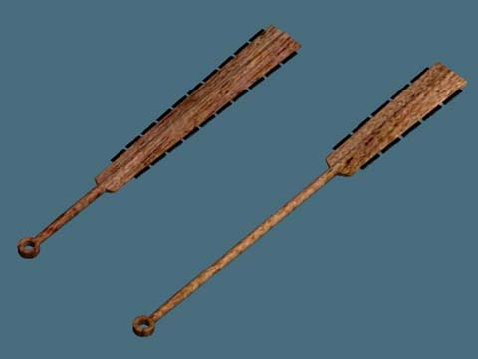
Macuahuitl

According to John Sorenson, steel in the Book of Mormon is a complex problem. Hugh Nibley has discussed how uncertain we remain about what might be meant by "steel" in ancient Old World texts. In Mexico we face similar obscurity. The native chronicler Tezozomoc reported that the Tarascans (Mesoamerica's most noted metallurgists at the time of the Spanish conquest) wore "steel" helmets. Was he telling the "truth"? Should we favor historical accounts over archaeological finds? Caley and Easby address this argument, but in regards to pre-Columbian tin in Mexico. After demonstrating that specimens of metal were there all the time despite the doubts of archaeologists, who had failed to examine the evidence, they end by observing, "The results also show that it is not prudent always to discount or ignore historical accounts as possible sources of technical information; some of the 16th century chroniclers apparently were wiser and more observant in such matters than many of their critics." Perhaps the Jaredite historian who talked of steel (Ether 7:9) and Tezozomoc with his steel helmets on the Tarascans both knew something that archaeologists will yet document. [John L. Sorenson, An Ancient American Setting for the Book of Mormon, p. 287]

Ether 7:9 Did Molten out of a Hill, and Made Swords out of Steel:
According to Brant Gardner, neither steel nor smelting re known for this period of time in Mesoamerica, but “steel” may be a misnomer. It is not possible to know [what translator] used the word “steel” to translate whatever was in Ether’s record—Mosiah, Moroni, or Joseph Smith.
Historian William J. Hamblin and A. Brent Merrill, a former major in the U.S. Air Force, suggest:
“Mosiah translated Ether’s plates into social and linguistic concepts with which he was familiar. Mosiah, as king, possessed Laban’s sword, a steel weapon that was passed down as one of the insignia of royalty. In translating Ether’s record, Mosiah might thus have given the Jaredite kings steel swords, like the one he himself possessed, because in Mosiah’s society a king was expected to have a steel sword as his royal weapon.”(n. 6)
A metal that might have been “molten” and which was present during the Jaredite/Olmec period is iron. John L. Sorenson observes:
Iron use was documented in the statements of early Spaniards, who told of the Aztecs using iron-studded clubs. A number of artifacts have been preserved that are unquestionably of iron; their considerable sophistication, in some cases, a t least suggests interest in this metal. (That is not surprising, since even a culture as simple as the Eskimo found iron—iron meteors—valuable.) Few of these specimens have been chemically analyzed to determine whether the iron used was from meteors or from smelted ore. . . .
Without even considering smelted iron, we find that peoples in Mesoamerica exploited iron minerals form early times. Lumps of hematite, magnetite, and ilmenite were brought into the Valley of Oaxaca sites from some of the thirty-six ore exposures located near or in the valley.

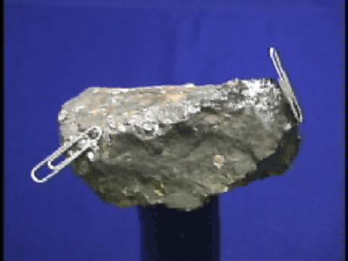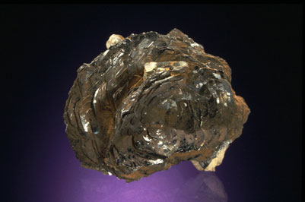
Hematite Magnetite Ilmenite
These were carried to a workshop section within the site of San Jose Mogote as early as 1200 B.C. There they were crafted into mirrors by sticking the fragments onto prepared mirror backs and polishing the surface highly. These objects, clearly of high value, were traded at considerable distances.(n.7)
Direct archaeological evidence for metal use (other than for mirrors) is not yet attested. The linguistic evidence reconstructs a word for metal in the Mixe-Zoquean vocabulary (*ting-kuy).(n.8) It is certain that there was metal, else there would be no reason to have the word. However, it could have referred to the iron ore and not to smelted metal. Confirmation of early metal working is still absent. [Brant A. Gardner, Second Witness, Vol. 6: Fourth Nephi through Moroni, p. 240]

Ether 7:9 [Shule] Obtained the Kingdom and Restored It unto His Father Kib:

Once Shule "obtained the kingdom" from his brother Corihor, he "restored it unto his father Kib" (Ether 7:9). Kib probably returned to his throne in the land of Moron to reign. We can come to that conclusion because it says in Ether 7:5-7 that Corihor "took" Kib captive and that Kib "dwelt in captivity," which probably means that Kib was taken away from the land of Moron to the land of Nehor? A precedent for the removal of a king from his own land to that of his conqueror is found in the Bible, where both Jehoiachin and Zedekiah were taken captive into Babylon (2 Kings 25:27). [Alan C. Miner, Personal Notes]

Ether 7:13 Shule Gave [Corihor] Power in His Kingdom:

In Ether 7:9 it states that Shule "gave battle unto his brother Corihor, by which means he obtained the kingdom and restored it unto his father Kib." Kib then turned around and "bestowed upon [Shule] the kingdom" (Ether 7:10). Nothing is said of whether Corihor was taken captive, just that apparently after a number of years (see v. 12), "Corihor repented" and Shule "gave him power in his kingdom" (Ether 7:13). Thus, we might surmise that Corihor once again "reigned" (under Shule) over the people in the land of Nehor. We might also conclude that the land of Nehor, at this time, was considered a province of an "expanded" land of Moron. [Alan C. Miner, Personal Notes] [See Geographical Theory Maps]

Geographical Theory Map: Ether 7:13 - 7:19 Shule Restored to Power (Chronology)
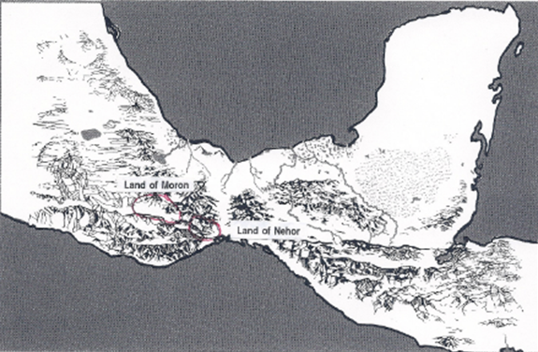

LAND OF MORON [LAND OF NEHOR]

SHULE reigns over Moron + Nehor (7:10)
He spreads the kingdom “upon all the face of the land” (7:11)
Shule gives Corihor some power (7:13) -----------------------------> Corihor "reigns" in Nehor (7:13)
Corihor begets Noah (7:14)
Noah rebels (7:15)
<------------------ Noah gives battle to Shule (7:16)
Noah obtains land of “their first Inheritance (Nehor?)(7:16)
NOAH reigns over ”that part of the land” (Nehor (7:16)

<------------------------------ Noah gives battle again to Shule (7:17)
<-------------------------------- Shule taken captive into Moron (7:17)
Noah about to reign over Moron + Nehor (7:18)
Sons of Shule kill Noah (7:18)
SHULE restored to kingship over Moron (7:18)
COHOR rules in Nehor (7:20)

____________

Ether 7:14 Noah:

We are told that Corihor had a son named "Noah" (Ether 7:14). According to Hugh Nibley, the name "Noah" may be authentic Jaredite, for aside from the original Biblical character "Noah," the name "does not recur elsewhere in Hebrew either alone or as a component part of a name," according to C.L. Woolley, but is "Harrian," coming from the country north of Babylonia, i.e., the original Jaredite home. [Hugh Nibley, The World of the Jaredites, p. 245]

The Book of Mormon student would be wise to keep the apparent Jaredite heritage of the name "Noah" in mind when trying to understand the cultural background relative to other mentions in the Book of Mormon story of the same name. For example: Noah, the son of Zeniff (see Mosiah 10-19); and the land of Noah, which was associated with the wicked people of Ammonihah (see Alma 8-16). [Alan C. Miner, Personal Notes]

Ether 7:16 The Land of Their First Inheritance:

We are told that Noah rebelled against Shule, and drew away all his brethren and many of the people (Ether 7:15). "He gave battle unto Shule in the which he did obtain the land of their first inheritance, and he became a king over that part of the land" (Ether 7:16). If the term "their" in the phrase "the land of their first inheritance" refers to Noah and Cohor his brother, and if they were born in the land of Nehor where their father Corihor reigned, then "the land of their first inheritance" might be interpreted to mean the land of Nehor. Thus we can understand that if Noah became "king over that part of the land" he probably took over total control of the land of Nehor. The phrase "land of their first inheritance" here in Ether 7:16 probably has no reference to the first Jaredite landing site. However, "the land of their first inheritance" might have some connection with the land of Moron. The reader should notice that the land of Nehor had apparently been assimilated into the land of Moron before it was battled for and retaken by Noah. One might wonder if this apparent practice of assimilation of lands might be part of the Jaredite history? [Alan C. Miner, Personal Notes]

Ether 7:17 [Noah] Gave Battle Again unto Shule:

It is interesting that in Ether 7:17, we find that Noah "gave battle again unto Shule." We might assume that when Noah "gave" battle "again" unto Shule, he was trying to establish power over the entire land of Moron. Apparently, from the site of the battle, Noah "carried [Shule] away captive into Moron" (Ether 7:17) with an apparent desire to not only put him to death in front of his own people (see Ether 7:18), but to put all the people in submission to his power. The sons of Shule, however, killed Noah "by night," and then placed Shule "upon his throne in his own kingdom." Given the textual clues, Shule apparently had been reigning from the land of Moron and Noah had been reigning from the land of Nehor. [Alan C. Miner, Personal Notes]

Geographical Theory Map: Ether 7:19 - 8:1 Two Kingdoms (Moron & Nehor) Are United (Chronology)

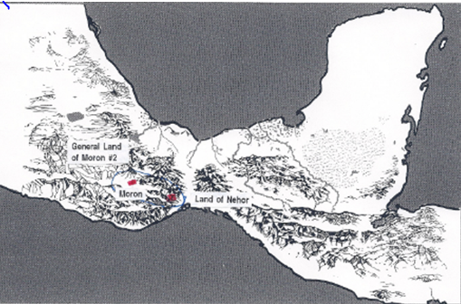

LAND OF MORON [LAND OF NEHOR]
SHULE restored to kingship over Moron (7:18)
COHOR rules in Nehor (7:20)

[“The country is divided into two kingdoms” --- Shule and Cohor (7:20]

<----------Cohor gives battle to Shule (7:21)
Shule beats & slays Cohor (7:21)----.
Nimrod (Cohor's son) gives up power in Nehor (7:22)
SHULE reigns over Moron + Nehor (7:22)
Shule gives Nimrod some power (7:22)

MORON #1 + NEHOR ARE UNITED = LAND of MORON #2?
(Reasoning: Nehor as a separate land is never mentioned after this)

LAND of MORON #2

SHULE reigns (7:22)
Shule begets Omer (8:1)
OMER reigns (8:1)
Omer begets Jared (8:1)
_______________
Ether 7:19 The Son of Noah Did Build Up His Kingdom in His Stead:

Because "the son of Noah did build up his [Noah's] kingdom in his stead" (Ether 7:19), we can probably say that Cohor (the son of Noah) continued living in, and reigning from the land of Nehor. We are told that "the country was divided; and there were two kingdoms, the kingdom of Shule, and the kingdom of Cohor, the son of Noah" (Ether 7:20). The reader can deduce by this statement that the land of Moron and the land of Nehor had previously been united into one "country" (an expanded land of Moron). [Alan C. Miner, Personal Notes]

Ether 7:22 Nimrod Gave Up the Kingdom of Cohor unto Shule:

With the death of Cohor, his son Nimrod "gave up the kingdom of Cohor unto Shule" (Ether 7:22). This might have been just a transfer of political power. Nimrod probably continued to reside in the land of Nehor. We are told that Shule "did bestow great favors on him [Nimrod]" (Ether 7:22), and that Nimrod did "according to his [Shule's] desires." Thus Nimrod probably became somewhat like a vassal king and still "ruled" somewhat over the land of Nehor.

Note* The land of Nehor is never mentioned after this. It was probably forever absorbed into a general land of Moron. [Alan C. Miner, Personal Notes]

Ether 7:23 There Came Prophets among the People:

It seems that moral and spiritual conditions in the kingdom had so declined (perhaps as a result of war), that,
"there came prophets among the people, who were sent from the Lord, prophesying that the wickedness and idolatry of the people was bringing a curse upon the land, and they should be destroyed if they did not repent. And . . . the people did revile against the prophets, and did mock them. (Ether 7:23-24)

It is not specified here just exactly what the term "idolatry" implies, but Moroni writes that "the Lord did spare them, and they began to prosper again in the land" (Ether 7:26) which is covenant language related to the promised land covenant given to the brother of Jared:

Behold, this is a choice land, and whatsoever nation shall possess it shall be free from bondage, and from captivity, and from all other nations under heaven, if they will but serve the God of the land, who is Jesus Christ . . . (Ether 2:12)
And [the Lord] had sworn in his wrath unto the brother of Jared, that whoso should possess this land of promise, from that time henceforth and forever, should serve him, the true and only God, or they should be swept off when the fulness of his wrath should come upon them. (Ether 2:8)

Thus, apparently the Jaredites were worshiping other gods than the Lord Jehovah. However, unlike some other times in history, King Shule passed judgment on those who abused the prophets and issued a decree allowing the prophets to go wherever they wished, unharmed and unhindered. Once the prophets were protected by law, people listened and were brought to repentance. The apparent result of these actions was that,

there were no more wars in the days of Shule; and he remembered [a covenant term] the great things that the Lord had done for his fathers in bringing them across the great deep into the promised land; wherefore he did execute judgment in righteousness all his days. (Ether 7:27)

Note* This was the first of three times when prophets would be sent among the Jaredite people to warn them of impending destruction. While the people rejected the prophets on this first occasion, King Shule saved them. The next two rejections of the prophets are recorded in Ether 9:29 and Ether 11:5.
[Alan C. Miner, Personal Notes]

Chapter 8

Geographical Theory Map: Ether 8:2 - 8:6 Jared Comes to the Land of Heth (Chronology)
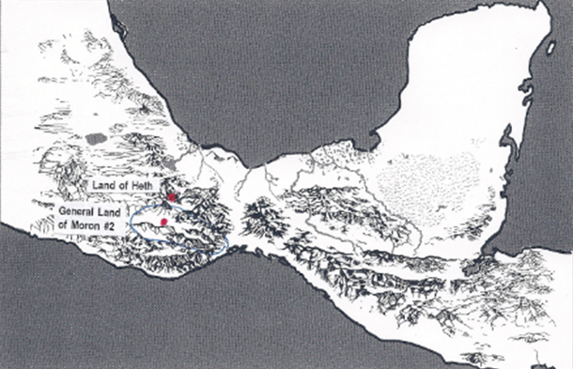

LAND of MORON #2

OMER reigns (8:1)
Omer begets Jared (8:1)
Jared rebels & "came" to land of Heth (8:2) ---------> HETH

Jared flatters & gains half of kingdom (8:2)
<------------------------------- Jared gives battle to Omer (8:3)
Jared carries Omer into captivity (8:3) -------------------------------------->
JARED reigns over Heth + Moron #2
Omer begets Esrom & Coriantum (8:4)
They battle Jared (8:5)
Jared gives up power (8:6)

OMER reigns <----------------

_____________

Ether 8:2 Jared . . . Came and Dwelt in the Land of Heth:

In his old age, Shule begat Omer, and Omer reigned in his stead," implying once again that the youngest son reigned in the king's stead. We are told that "Omer begat Jared₂ and Jared₂ begat sons and daughters," but that Jared₂ rebelled against his father and "came and dwelt in the land of Heth, and . . . he did flatter many people, because of his cunning words, until he had gained the half of the kingdom" (Ether 8:2). From this information we can probably assume that the land of Heth was culturally connected, if not also politically connected to at least the general land of Moron over which King Omer reigned. The fact that Jared₂ "came" to the land of Heth might imply that from Moroni (or Ether's) perspective (near the hill Ramah/Cumorah) the land of Heth was located somewhere between the local land of Moron and the hill Ramah. [Alan C. Miner, Personal Notes]

Ether 8:2 Land of Heth:

According to Bruce Warren, the "land of Heth" (Ether 8:2) is mentioned early in the Jaredite account. An indirect hint for the location for this land might center on the meaning of the letter Heth in Hebrew. The letter Heth relates to the Big Dipper constellation and the number seven (Moran and Kelley 1969, 49, 81). The Popol Vuh account of Wakub Kaqix (pronounced "kaw-kish") might be linguistically tied to the name of "Akish" in the Jaredite account. In the Popul Vuh account Wakub Kaqix is associated with the Big Dipper, and his name means seven macaw. The Tuxtla Mountains of southern Veracruz were referred to by the Aztecs as the place of the Macaw parrots. The Aztec placed name glyph also depicts a macaw parrot for these mountains (Covarrubias 1947, 26, n. 4). Could this tie the land of Heth to the Tuxtla Mountain region of southern Veracruz? It is interesting that one of the major proposed geographical sites for the location of the Jaredites is the Tuxtla mountains of southern Veracruz.

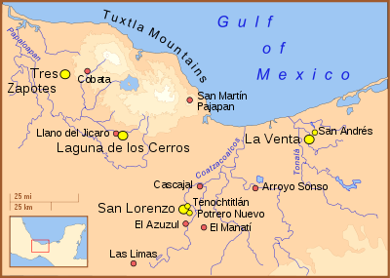
The Tuxtla Mountains in the state of Veracruz, Mexico

It is also the heartland of the Olmecs, a Mesoamerican civilization which corresponds in many ways with the Jaredites of the Book of Mormon. [Bruce W. Warren, Blaine M. Yorgason, Harold Brown, New Evidences of Christ in Mesoamerica, Unpublished Manuscript] [See the commentary on Ether 14:3]

Ether 8:2 [Jared] Gained the Half of the Kingdom:

If Jared₂ gained the "half of the kingdom" (Ether 8:2), we can probably suppose that he gained half of the general land of Moron. If so, this probably implies that the land of Heth became connected politically to at least half of the general land of Moron. [Alan C. Miner, Personal Notes]

Ether 8:3 [Jared] Gave Battle unto His Father:

Like his ancestor Corihor, when Jared₂ felt like he was strong enough to seize the other half of the kingdom, “he gave battle unto his father, and he did carry away his father into captivity, and did make him serve in captivity. And now, in the days of the reigns of Omer he was in captivity the half of his days.” (Ether 8:3-4)

What might be implied in these verses is that Jared₂ had to travel some distance toward the local land of Moron in order to "give battle." When Jared₂ "carried away" his father (Omer) to serve him in captivity" we can assume that Jared₂ probably returned to his throne in the land of Heth to reign. However, from that location he controlled all the "expanded" general land of Moron (which now included the land of Heth). [Alan C. Miner, Personal Notes] [See the commentary on Ether 7:7]

Ether 8:5 [The Sons and Daughters of Omer] Gave Battle unto Him [Jared] by Night:

One might wonder why it would be necessary for the sons and daughters of Omer to attack Jared₂ "by night" (Ether 8:5). Was the battle was so fierce and so long that it continued into the night? Or was this a battle fully waged during the night? If Omer "was in captivity the half of his days" and "begat sons and daughters, among whom were Esrom and Coriantumr" (Ether 8:4), then these sons and daughters had apparently been raised in captivity in the land of Heth. But from where did Esrom and Coriantumr recruit their troops? Did they return to the local land of Moron to rally their troops and then come "by night" from the land of Moron to the land of Heth? Or were the troops rallied right under the nose of Jared₂ and utilized in a dark-of-night "coup" in the land of Heth? The text does not specifically say. The text does say that they were about to slay Jared, "and he plead with them that they would not slay him, and he would give up the kingdom unto his father. And it came to pass that they did grant unto him his life" (Ether 8:6). [Alan C. Miner, Personal Notes]

Geographical Theory Map: Ether 8:8 - 9:3 Akish Overthrows Kingdom (Chronology)
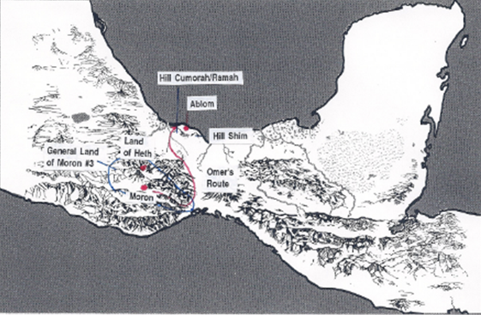

LAND OF MORON #3 LAND OF HETH

OMER reigns
Jared plots with Akish by means of sorcery and secret combinations.
Whoso upholds these things shall be destroyed. (8:7-25)
Akish overthrows Omer (9:1) <----------------------------------------------------------------------------

Omer “departed out of the land,”
“traveled many days,
“came over and passed by the hill of Shim”
and "came over by the place where the Nephites were destroyed,” (Hill Cumorah?)
“and from thence eastward"
“and came to a place called Ablom, by the seashore.” (9:3)--- ABLOM

____________

Ether 8:8 Now the Daughter of Jared . . . Devised a Plan:

The text mentions that Jared₂ "became exceeding sorrowful because of the loss of the kingdom for he had set his heart upon the kingdom, and upon the glory of the world" (Ether 8:7)

According to Hugh Nibley, there is one tale of intrigue in the book of Ether that presents very ancient and widespread (though but recently discovered) parallels. That is the story of Jared's daughter and her "plan" (Ether 8:8) in restoring her father to the power which he had gained through rebellion in the first place. Jared's daughter asked her father if he had read,

the record which our fathers brought across the great deep, [a very instructive account of those secret devices by which the men of old got "kingdoms and great glory"]
And now, therefore, let my father send for Akish, the son of Kimnor; and behold, I am fair, and I will dance before him, and I will please him, that he will desire me to wife; wherefore if he shall desire of thee that ye shall give unto him me to wife, then shall ye say, I will give her if ye will bring unto me the head of my father, the king. (Ether 8:9-10)

The most important point of this whole story is that it was not the first time that it happened in history . . . This is indeed a strange and terrible tradition of throne succession, yet there is no better attested tradition in the early world than the ritual of the dancing princess (represented by the salme priestess of the Babylonians, hence the name Salome) who wins the heart of a stranger and induces him to marry her, behead the old king, and mount the throne . . . You can find out all about the sordid triangle of the old king, the challenger, and the dancing beauty from Frazer, Jane Harrison, Altheim, B. Schweitzer, Farnell, and any number of folklorists. The thing to note especially is that there actually seems to have been a succession rite of great antiquity that followed this pattern . . . The episode of the dancing princess is at all times essentially a ritual, and the name of Salome is perhaps no accident, for her story is anything but unique. Certainly the book of Ether is on the soundest possible ground in attributing the behavior of the daughter of Jared to the inspiration of ritual texts – secret directories on the art of deposing an aging king. The Jaredite version, incidentally, is quite different from the Salome story of the Bible, but is identical with many earlier accounts that have come down to us in the oldest records of civilization. [Hugh Nibley, The World of the Jaredites, pp. 210-213]

Ether 8:9 An Account Concerning Them of Old, That They By Their Secret Plans Did Obtain Kingdoms and Great Glory:

As the Nephites carried with them the brass plates of Laban, so the Jaredites carried an ancient record, but Moroni’s abridgment does not tell us much about this record. We know that it must have contained the story of Creation, the Garden, and the Fall (Ether 1:3-4). Apparently, it also contained an account of secret plans and combinations. Likely, this record was a lot more extensive than the few chapters we have in Genesis. It probably included a more comprehensive account of the story of Cain as it appears in Moses 2:25-32:

‘(the word of the Lord to Cain) And it shall be said in time to come—That these abominations were had from Cain; for he rejected the greater counsel which was had from God; and this is a cursing which I will put upon thee, except thou repent.
And Cain was wroth, and listened not any more to the voice of the Lord . . .
And Satan said unto Cain: Swear unto me by thy throat, and if thou tell it thou shalt die; and swear thy brethren by their heads, and by the living God, that they tell it not; for if they tell it, they shall surely die; and this that thy father may not know it; and this day I will deliver thy brother Abel into thine hands.
And Satan sware unto Cain that he would do according to his commands. And all these things were done in secret.
And Cain said: Truly I am Mahan, the master of this great secret, that I may murder and get gain. Wherefore Cain was called Master Mahan, and he gloried in his wickedness.
And Cain went into the field, and Cain talked with Abel, his brother. And it came to pass that while they were in the field, Cain rose up against Abel, his brother, and slew him.

Here is a record of how the secret combinations, certified by an oath, were established on the earth. But it does not explain how these were used to obtain kingdoms and great glory as the daughter of Jared suggests. Obviously, their record was a lot more comprehensive than what we have today.
[josephsmith.com . . . Ether ]

Ether 8:9 The Record Which Our Fathers Brought across the Great Deep:

[See the commentary on 3 Nephi 3:9]

Ether 8:9 Is There Not an Account Concerning Them of Old, That They by Their Secret Plans Did Obtain Kingdoms and Great Glory:

In the 8th chapter of Ether, we find an interesting statement. In attempting to overthrow king Omer and establish her father on the throne by subversive means, the daughter of Jared says to her father:
Whereby hath my father so much sorrow? Hath he not read the record which our fathers brought across the great deep? Behold, is there not an account concerning them of old, that they by their secret plans did obtain kingdoms and great glory?

According to Bruce Warren, although this account is more particularly addressing records of secret societies or secret combinations, all of which were ruled by shamanistic priests or "medicine men," there can be little doubt that such records also contained shamanistic calendars. A few years ago, David H. Kelley (1969, 143-94) analyzed the workings of some Old World lunar zodiac calendars that were widespread across Europe, the Near East, and northern and southern Asia. He concluded that the earliest evidence for a 364-day sidereal (measured by means of the stars) lunar zodiac calendar was from Semitic-speaking peoples of Mesopotamia early in the third millennium B.C. (Kelley 1969, 148-49). What is very interesting is that Kelley also found such calendars in Mesoamerica. Thus there might be a calendar and cultural link between the ancient people of Mesopotamia and the ancient people of Mesoamerica. [Bruce W. Warren, Blaine M. Yorgason, Harold Brown, New Evidences of Christ in Mesoamerica, Unpublished Manuscript]

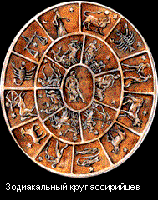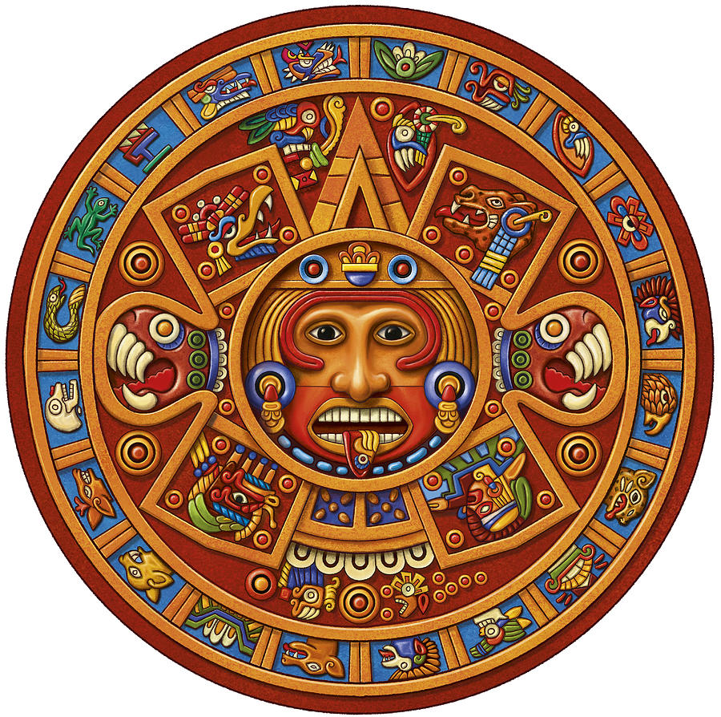
Illustrationof Mesopotamia Zodiac Calendar Illustration of Mesoamerican Zodiac Calendar
(Notice the symbols on the perimeter) (Notice the symbols on the perimeter)

Ether 8:9 They, by Their Secret Plans Did Obtain Kingdoms and Great Glory:

In the book of Ether, the daughter of Jared₂ apparently revived the practice of secret societies by saying,
Hath [my father] not read the record which our fathers brought across the great deep? Behold, is there not an account concerning them of old, that they by their secret plans did obtain kingdoms and great glory? (Ether 8:9)

According to John Sorenson, in the Book of Mormon there definitely was historical continuity from the Old World to the New World in the origin of Jaredite secret societies. The secret societies began only a few generations after the immigrants arrived in the new land from the Mesopotamian area. Historian Nesta Webster points out that, "the [Near] east is the cradle of secret societies," however Mesoamerican secret groups were up to the same tricks and operated according to similar rules. But were these practices really ancient in America, or were they late developments? Professor Coe maintains that a similar institution was vital in Olmec civilization before 1000 B.C. J.A. Bennyhoff has interpreted masks recovered by archaeologists as indications of the presence of secret societies anciently. These ritual artifacts are present from about 1200 B.C. to 600 B.C. in the valley of Oaxaca (a proposed Jaredite land of Moron).

Interestingly, the masks again are found in large numbers during developed Teotihuacan times, for a few centuries after A.D. 300. This happens to be just the period when Mormon reports the rise of the secret society that was instrumental in the downfall of the Nephites (Mormon 2:8, 10, 27-28; Ether 8:19-21).
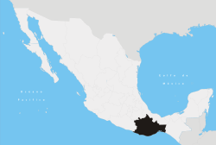
State of Oaxaca, Mexico

[John L. Sorenson, An Ancient American Setting for the Book of Mormon, pp. 305, 308-309]

Ether 8:9 They, by Their Secret Plans Did Obtain Kingdoms and Great Glory:
In Ether 8:9 we find that Jared’s daughter refers to a text that crossed the oceans with them: “Hath he not read the record which our fathers brought across the great deep? Behold, is there not an account concerning them of old, that they by their secret plans did obtain kingdoms and great glory?” What that document might have been is not as clear.
Brant Gardner writes:
Although I have suggested that Mosiah read his own brass-plates text into his translation of Ether’s record, there still had to have been some similarity upon which Mosiah’s translation was based. Some version of the Adam and Eve story must have been in Ether’s record. However, the indication that it also contained these secret combinations does not fit with any text that we know for the Old Testament. Therefore, while the original Jaredite text had similarities to the Old Testament, it was not the Old Testament as we know it. [Brant A. Gardner, Second Witness, Vol. 6: Fourth Nephi through Moroni, p. 248]

Ether 8:10-11 Let My Father Send For Akish . . . and I Will Dance Before Him:

One cannot help but see some similarities between the story of Akish and the story of Salome. Salome, whose name is not mentioned in the Bible but is recorded by Josephus (see Bible Dictionary), was the daughter of Herodias who had illegally married Herod. She and her mother devised a plan to get John the Baptist killed. Like the plan of the daughter of Jared, it involved a dance designed to please Herod and company (see Matt 14:3-12). Hereby, we learn how wicked women wield power over weak men. “The daughter of Jared used her beauty and charm to evil purpose…Jared’s daughter is described as ‘exceedingly expert’ (Ether 8:8); her plan involved no armies, but was quite effective in bringing destruction to many…Her success in enticing Akish led to the downfall not only of her grandfather and father, but to the destruction of her people. In preparing Jared’s daughter’s dowry—the severed head of her grandfather the king—Akish restored the practice of secret combinations and blood oaths. “(Camille S. Williams & Donna Lee Brown, Ensign, Jan. 1992, “Ordinary People in the Book of Mormon”)

If we are to correctly identify secret combinations, we must know what constitutes a secret combination. Ether 8 instructs us that:

They are based on ancient and secret plans (v. 9).
Their members must join with an oath (v. 14)
Their loyalty and secrecy are maintained with threats of violence (v. 14)
Their author is the devil (v. 16)
Their goal is to obtain kingdoms and great glory (v. 9), to gain power, and to murder, and to plunder, and to lie, and to commit all manner of wickedness and whoredoms (v. 16).
For a more comprehensive list, see commentary for Helaman 6:18.
[josephsmith.com . . . Ether ]

Ether 8:11 He Desired Her to Wife:

According to John Tvedtnes, Hebraisms are evidence of the authenticity of the Book of Mormon. In Ether 8:11 we read "he desired her to wife." English would prefer for a wife. There is a Hebrew preposition that means both to and for. [John A. Tvedtnes, "The Hebrew Background of the Book of Mormon," in Rediscovering the Book of Mormon, p. 91]

Ether 8:11 Omer Was a Friend to Akish:

[See the commentary on Ether 8:15]

Ether 8:14 They All Sware unto Him, by the God of Heaven:

Moroni writes that in making these secret oaths, Akish had all his kinsfolk "sware unto him, by the God of heaven" that they would keep those oaths secret (Ether 8:14). Kishkumen also "went unto those that sent him, and they all entered into a covenant, yea, swearing by their everlasting Maker, that they would tell no man that Kishkumen had murdered Pahoran" (Helaman 1:11). This is exactly what Cain did, that is Satan said unto him: "Sware thy brethren . . . by the living God" (Moses 5:29)

According to Cleon Skousen, the reader should note the strange anomaly wherein Satan, the enemy of God, wanted Cain to swear "by the living God," that he would not disclose the great secret Lucifer was about to reveal to him. This reflects the secret respect which Satan continues to feel toward the God of the universe even though he is working day and night to destroy His kingdom. [W. Cleon Skousen, The First 2000 Years, p. 112]

Note* Swearing "by the God of heaven" might also reflect the ultimate "in your face" attitude of Satan towards God--the ultimate blasphemy of a son of Perdition, the ultimate sealing of one's eternal fate. [Alan C. Miner, Personal Notes from a class by David Ridges]

Ether 8:14 They All Sware unto Him . . . by Their Heads:
John Lund writes:
There are those who are satanic and who enter into a secret oath and combination to swear “by their heads” to murder and get gain (Moses 5:29). The early Mesoamerican civilization of the Jaredites swore by their heads “that whoso should vary from the assistance which Akish desired should lose his head” (Ether 8:14). A very beautiful but wicked granddaughter danced and was betrothed on a promised her new husband would bring the head of her grandfather to her father (Ether 8:9-12) . . . Ultimately, Jared, her father, lost his own head being decapitated while sitting upon his thrown (Ether 9:5) . . .
There is a long history and considerable ritual in the taking of heads in Mesoamerica. On Stela 21 from Izapa, Mexico, near the Guatemala –Mexico border on the coastal plain of the the Pacific Ocean, is a Late Pre-classic stone carving from the time of the Book of Mormon. It is quite simply, “a decapitation scene.”(n.226)

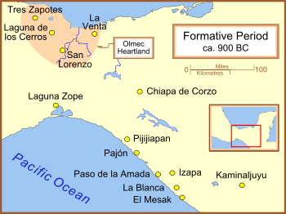
Location of Izapa

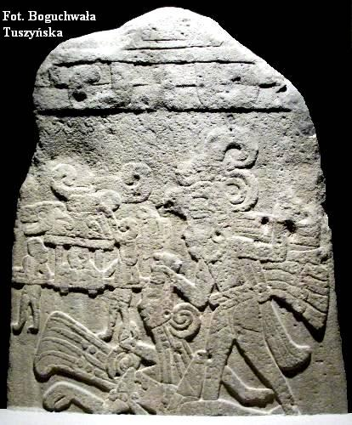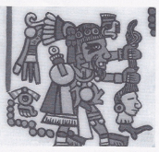
Stela 21 Codex Nuttall

It is similar to the decapitation scene from the Codex Nuttall. [John L. Lund, Mesoamerica and the Book of Mormon: Is This the Place?, pp. 167-168]

Ether 8:15 Oaths . . . Which Had Been Handed down Even from Cain, Who Was a Murderer from the Beginning:

Cain's actions typify the road to spiritual destruction in that eventually "Cain was shut out from the presence of the Lord" (Moses 5:41). Cain was called a son of Perdition ("from this time forth . . . thou shalt be called Perdition"--Moses 5:24) which implies he had once held high priesthood power and also knew the gospel plan yet rejected them. Because of the scriptural parallels, can we put the leaders of these secret societies in the Book of Mormon story in the same class as Cain--that is, were they also sons of Perdition?

For secret combinations to be linked with Cain (see Ether 8:15 and Helaman 6:27), does this imply that secret combinations worked so well because the leaders held (or had held) high political and priesthood power despite covenanting to destroy that power? The apparent leader of the secret band among the Nephites was called "Kishkumen" (see Helaman 1:9-12; 2-11) Kish was a Jaredite king (see Ether 10:17-18). Kishkumen plotted with Gadianton to put him upon the judgment-seat (see Helaman 2:3-5). Did these secret society leaders come from the high ranks of church and state? King Omer "was a friend to Akish" (Ether 8:11). Does this imply that Akish held power, either priesthood or political or both? [Alan C. Miner, Personal Notes]

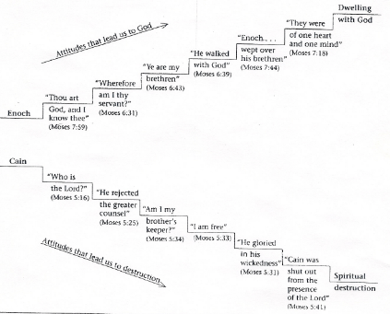
Ether 8:15 Oaths . . . which had been handed down even from Cain, who was a murderer from the beginning (Illustration): Cain's Path to Spiritual Destruction. [Handout, David Ridges]

Ether 8:15 Akish Did Administer unto Them the Oaths Which Were Given by Them of Old:

Moroni writes that, “Akish did administer unto them the oaths which were given by them of old who also sought power, which had been handed down even from Cain . . . And it came to pass that they all sware unto him, by the God of heaven, and also by the heavens, and also by the earth" (Ether 8:15,14).

According to Hugh Nibley, the oath was the cornerstone of the Asiatic state of the Jaredite. The reader should note that these terrible oaths are traced back explicitly to the Old World. The very oldest texts in "the oldest language in the world," according to Hommel, are incantations" having the stereotyped conclusion: 'let it be sworn (or conjured) by the name of heaven, let it be sworn by the name of earth!" [Hugh Nibley, The World of the Jaredites, pp. 200-201]

According to J.N. Washburn, we do not find mention of the oath of Cain in the Bible. We do, however, find in the New Testament what the Savior had to say about oaths and swearing in Matthew 5:34-36:
Swear not at all; neither by heaven; for it is God's throne: neither by the earth; for it is his footstool: neither by Jerusalem; for it is the city of the great King. Neither shalt thou swear by the head, because thou canst not make one hair white or black.

Anyone who, at this point, questions the authenticity of the Book of Mormon, should stop for a moment to think about the foregoing circumstance. Did Joseph Smith invent the oath of Cain? And how did he manage it so that it goes directly contrary to Jesus' admonitions with regard to swearing? [J.N. Washburn, The Miracle of the Book of Mormon, p. 169]

Ether 8:15 The Oaths Which Were Given by Them of Old:

According to John Heinerman, to understand the oaths and covenants which bound the fraternal order of Gadianton brethren together, one must go back to an even earlier period in earth's long history. For, as Giddianhi observed in his infamous epistle to Lachoneus, "[Our] society and [its] works are of ancient date and have been handed down unto us." The Book of Mormon is very clear on this point:

"[These] oaths were given by them of old, who also sought power, which had been handed down even from Cain" (Ether 8:15). Helaman refers to "that same being who did plot with Cain and his followers from that time forth. Behold, it is [Satan] who is the author of [these] works of darkness and doth hand down plots, and oaths, and covenants, and plans of awful wickedness, from generation to generation" (Helaman 6:27, 30).

The book of Moses in The Pearl of Great Price explains something about the secret pacts which Cain and Lamech (a great-great-great grandson) made with the Evil One on separate occasions.

And Satan said unto Cain: Swear unto me by thy throat, and if thou tell it thou shalt die. And swear thy brethren by their heads, and by the living God, that they tell it not. For if they tell it, they shall surely die. And this that their father [Adam] may not know it. And Satan swear unto Cain that he would do according to his commands. And all these things were done in secret. And Cain said: Truly I am Mahan, the master of this great secret, that I may murder and get gain. Wherefore Cain was called Master Mahan, and he gloried in his wickedness. (Moses 5:29-31)

For Lamech having entered into a covenant with Satan, after the manner of Cain, wherein he [also] became [a] Master Mahan [or] master of that great secret which was administered unto Cain by Satan. And Irad, the son of Enoch, having known their secret, began to reveal it unto the sons of Adam. Wherefore Lamech, being angry, slew him, not like unto Cain, his brother Abel, for the sake of getting gain, but he slew him for the oath's sake. For, from the days of Cain, there was a secret combination, and their works were in the dark, and they knew every man his brother. Wherefore the Lord cursed Lamech, and his house, and all them that had covenanted with Satan, for they kept not the commandments of God, and it displeased God, and he ministered not unto them, and their works were abominations, and began to spread among all the sons of men. (Moses 5:49-52)

[John Heinerman, Hidden Treasures of Ancient American Cultures, pp. 62-63]

Ether 8:17 To Search Up These Things of Old:

According to Roy Weldon, there are 118 superfluous prepositions in the Nephite record--a very evident Hebraic usage. One good example is found in Ether 8:17: "to search up these things of old . . ." [Roy E. Weldon, Book of Mormon Deeps, Vol. III, p. 271] [See the commentary on Helaman 16:22]

Ether 8:18 They Formed a Secret Combination:

From the account of Ether, Moroni writes:

it was the daughter of Jared who put it into his heart to search up these things of old; and Jared put it into the heart of Akish; wherefore, Akish administered it unto his kindred and friends, leading them away by fair promises to do whatsoever thing he desired. . . . And it came to pass that they formed a secret combination, even as they of old . . . And now I, Moroni, do not write the manner of their oaths and combinations, for it hath been made known unto me that they are had among all people, and they are had among the Lamanites. (Ether 8:17,18, 20)

According to Bruce Warren, "secret combinations" or secret societies were a part pre-Columbian Mesoamerica. Mexican artist and writer Miguel Covarrubias describes the nature of secret societies in Mesoamerica as follows:

"In those days the ancient jaguar cult prevailed throughout southern Mexico and in Central America, superimposed upon the formal, official Indian religion. . . . To quote Sahagun . . ., "People like assassins, daring and accustomed to kill, they carried on their persons pieces of jaguar skin. . . . In ancient times the jaguar was an earth god, symbol of the interior of the earth and of the night, of darkness, because jaguars were believed to swallow the sun and cause eclipses. He was the god of caves, the dark interior of mountains . . . As such he was worshipped throughout southern Mexico and particularly around Tehuantepec."

Because of their secret nature, often very little is known about secret societies. However, that secret societies did exist in pre-Columbian Mesoamerica and that they parallel to a certain degree those found in the book of Ether in some respects is nonetheless certain. [Bruce W. Warren, "Secret Combinations, Warfare, and Sacrifice," in Warfare in the Book of Mormon, pp. 229-230]

[Note* Bernardino de Sahagún (1499 – October 23, 1590) was a Franciscan friar, missionary priest and pioneering ethnographer who participated in the Catholic evangelization of colonial New Spain (now Mexico.

Born in Sahagún, Spain, in 1499, he journeyed to New Spain in 1529, and spent more than 50 years in the study of Native American beliefs, culture and history. Though he dedicated himself primarily to the missionary task, his extraordinary work documenting indigenous worldview and culture has earned him the title “the first anthropologist."[1][2] He also contributed to the description of the Aztec language Nahuatl, into which he translated the Psalms, the Gospels and a basic manual of religious education. Sahagún is perhaps best known as the compiler of the Historia general de las cosas de la Nueva España (in English: General History of the Things of New Spain.

Bernardino de Sahagun

Wikipedia]

Ether 8:18-22 (The Laws of God Regarding Secret Combinations):

In Ether 8:18-22 we learn four important things concerning secret combinations:

1. Secret combinations are wicked and forbidden of the Lord (see vv. 18-19)
2. Secret combinations are "had among all people" (v. 20)
3. Secret combinations "caused the destruction" of both the Jaredite and Nephite nations (v. 21)
4. Whatever nation upholds secret combinations "shall be destroyed" (v. 22)
[CES, Book of Mormon Student Manual, Religion 121 and 122, 1989, p. 140]

Ether 8:19 The Lord [Doth Not] Will That Man Should Shed Blood:

Boyd K. Packer comments:

“Every time physical conditions are met, conception will take place, whether in wedlock or out. Once a life is conceived, to destroy that life, even before birth, is a major transgression, save conception results from rape, the mother’s life hangs in the balance, or the life of the unborn is certified to be hopeless. We do not know all about when a spirit enters the body, but we do know that life, in any form, is very precious. While we are given the power to generate life and commanded to do so, we have no license to destroy it. ‘For the Lord . . . in all things hath forbidden it, from the beginning of man’ (Ether 8:19). And the commandment given at Sinai was renewed in this dispensation: ‘Thou shalt not kill’ (Exodus 20:13; see also 2 Nephi 9:35) ‘nor do anything like unto it’ (D&C 59:6).” (The Things of the Soul, p. 108)
[josephsmith.com . . . Ether ]

Ether 8:19-21 Secret Combinations . . . Have Caused the Destruction of This People:

Ezra Taft Benson comments:

“But the greatest handbook for freedom in this fight against evil is the Book of Mormon…This most correct book on earth states that the downfall of two great American civilizations came as a result of secret conspiracies whose desire was to overthrow the freedom of the people. ‘And they have caused the destruction of this people of whom I am now speaking,’ says Moroni, ‘and also the destruction of the people of Nephi.’ (Ether 8:21.)

“Now undoubtedly Moroni could have pointed out many factors that led to the destruction of the people, but notice how he singled out the secret combinations, just as the Church today could point out many threats to peace, prosperity, and the spread of God’s work, but it has singled out the greatest threat as the godless conspiracy. There is no conspiracy theory in the Book of Mormon —it is a conspiracy fact.

“Then Moroni speaks to us in this day and says, ‘Wherefore, the Lord commandeth you, when ye shall see these things come among you that ye shall awake to a sense of your awful situation, because of this secret combination which shall be among you’ (Ether 8:14.)

“The Book of Mormon further warns that ‘whatsoever nation shall uphold such secret combinations, to get power and gain, until they shall spread over the nation, behold they shall be destroyed. ’ (Ether 8:22.)

“This scripture should alert us to what is ahead unless we repent, because there is no question but that as people of the free world, we are increasingly upholding many of the evils of the adversary today. By court edict godless conspirators can run for government office, teach in our schools, hold office in labor unions, work in our defense plants, serve in our merchant marines, etc. As a nation, we are helping to underwrite many evil revolutionaries in our country.” (Ensign, July 1972, “Civic Standards for the Faithful Saints”)
[josephsmith.com . . . Ether ]

Ether 8:22 The Blood of His Saints . . . Shall Always Cry unto Him from the Ground for Vengeance:

Remember in the story of Cain, Satan lied to him and told him that the murder of Abel would be forever secret, that if he would murder his brother Abel it should not be known unto the world (Hel 6:27, see Moses 5:29). Nothing could be further from the truth, for the Lord made this evil act famous among all people declaring, it shall be said in time to come—That these abominations were had from Cain (Moses 5:25). But who was the whistle blower? How could anyone testify of what was done in secret? The answer is that the earth itself revealed the great secret. The Lord declared, The voice of thy brother’s blood cries unto me from the ground (Moses 5:35).

Hugh Nibley comments:

“What is the rationale of this saying we have again and again in the Pearl of Great Price especially-‘his blood shall cry from the ground’ or ‘from the earth.’ There's a rationale for this very ancient formula. The earth is the mother of life and is the womb of the resurrection also. From the earth we are resurrected and out from the earth we are born. She is Mother Earth. She is the mother of life and the womb of the resurrection. The destruction of life in any form is the reversal and perversion of existence itself, as we learn in Ether 8:19 in the Book of Mormon. ‘For the Lord worketh not in secret combinations, neither doth he will that man should shed blood, but in all things hath forbidden it, from the beginning of man.’ It's an unspeakably horrendous calamity deliberately to reverse the process for which the earth was created. If the earth accepts their blood, it will cry from the ground and demand vengeance, as it does in the book of Moses.” (Teachings From the Book of Mormon, Lecture 52, p. 393)
[josephsmith.com . . . Ether ]

Ether 8:23-26 (Special Warnings Regarding Secret Combinations):

Moroni said he was "commanded to write" the things that he did (Ether 8:26). As Moroni did so, three special warnings to the Gentiles concerning secret combinations emerged:

1. Suffer not that these murderous combinations shall get above you" (v. 23)
2. If you allow secret combinations, l"the sword of the justice of the Eternal God shall fall upon you, to your overthrow and destruction" (v. 23).
3. "When ye shall see these things come among you . . . awake to a sense of your awful situation" (v. 24).

Elder Ezra Taft Benson spoke concerning Moroni's warning:

Now undoubtedly Moroni could have pointed out many factors that led to the destruction of the people, but notice how he singled out the secret combinations, just as the Church today could point out many threats to peace, prosperity, and the spread of God's work, but it has singled out the greatest threat as the godless conspiracy. There is no conspiracy theory in the Book of Mormon--it is a conspiracy fact. Now we are assured that the Church will remain on the earth until the Lord comes again--but at what price? . . . President [J. Reuben] Clark [Jr.] warned us that "we stand in danger of losing our liberties, and that once lost, only blood will bring them back; and once lost, we of this church will, in order to keep the Church going forward, have more sacrifices to make and more persecutions to endure than we have yet known." [in Conference Report, April 1944, p. 116]

He also stated that if the conspiracy "comes here it will probably come in its full vigor and there will be a lot of vacant places among those who guide and direct, not only this government, but also this Church of ours." [in Conference Report, April 1952, p. 80] (Ezra Taft Benson, Conference Report, April 1972, p. 51; and Ensign, July 1972, pp. 60-61) [CES, Book of Mormon Student Manual, Religion 121 and 122, 1989, p. 140]
Ether 8:23 The Sword of the Justice of the Eternal God Shall Fall upon You . . . If Ye Shall Suffer These Things to Be:

Hugh Nibley writes:

“(speaking of secret combinations) What makes the thing so frightening is not the parasite itself but the fact that a society is willing to offer it entry and encouragement (to ‘uphold’ it), without which it is not dangerous at all. Its presence therefore should be viewed more as a symptom than a cause: ‘Wherefore, the Lord commandeth you, when ye shall see these things come among you that ye shall awake to a sense of your awful situation’ (Ether 8:24). Immediate repentance, not police action, is urgently prescribed: ‘O ye Gentiles . . . repent of your sins, and suffer not that these murderous combinations shall get above you, which are built up to get power and gain’ (Ether 8:23).” (Since Cumorah, p. 396)

Hugh Nibley adds:

“The key word is ‘suffer’; we may not stand idly by under such conditions. Nor can we live sheltered lives and still do the work for which we were sent into the world: ‘As sheep among wolves’(Matt 10:16)—is that sheltered?” (Brother Brigham Challenges the Saints, p. 130)

Ezra Taft Benson comments:

“’Don't worry,’ says the devil; ‘the Lord will protect you, and besides, the world is so corrupt and heading toward destruction at such a pace that you can't stop it, so why try?’ Well, to begin with, the Lord will not protect us unless we do our part. This devilish tactic of persuading people not to get concerned because the Lord will protect them no matter what they do is exposed by the Book of Mormon. Referring to the devil, it says: ‘And others will he pacify, and lull them away into carnal security, that they will say: All is well in Zion; yea, Zion prospereth, all is well-and thus the devil cheateth their souls, and leadeth them away carefully down to hell’ (2 Nephi 28:21).

“I like that word carefully. In other words, don't shake them-you might wake them. The Book of Mormon warns us that when we see these murderous conspiracies in our midst, we should awaken to our awful situation (see Ether 8:24). Now, why should we awaken if the Lord is going to take care of us anyway? Let us suppose that it is too late to save freedom. It is still accounted unto us for righteousness' sake to stand up and fight. Some Book of Mormon prophets knew of the final desolate end of their nations, but they still fought on, and they saved some souls, including their own, by so doing. For, after all, the purpose of life is to prove ourselves, and the final victory will be for freedom (Abraham 3:24-25).” (The Teachings of Ezra Taft Benson, p. 660)
[josephsmith.com . . . Ether ]

[Note* These murderous conspiracies are demonstrated at the U.S. southern border.]
Ether 8:26 I . . . Am Commanded to Write These Things That Evil May Be Done Away . . . That They May Be Persuaded to Do Good Continually:

[See the commentary on 2 Nephi 10:23]

Ether 8:26 Come unto the Fountain of All Righteousness and Be Saved:

Bruce R. McConkie writes:

“Isaiah 12 tells of a millennial day when men shall ‘draw water out of the wells of salvation’; and Zechariah, speaking of that same day of peace and righteousness, tells how ‘living waters shall go out from Jerusalem’ (Zech. 14:8.)

“From all this it is perfectly clear that men must drink living water to be saved. As Moroni expressed it: ‘Come unto the fountain of all righteousness and be saved.’ (Ether 8:26.) And the same truths flow from the same fountain yesterday, today, and forever.” (The Promised Messiah, p. 206)
[josephsmith.com . . . Ether ]

Chapter 9

Ether 9:3 Omer . . . Came over and Passed by the Hill Shim, and Came over by the Place Where the Nephites Were Destroyed:

Moroni writes that,
Omer . . . departed out of the land with his family, and traveled many days, and came over and passed by the hill of Shim, and cam over by the place where the Nephites were destroyed, and from thence eastward, and came to a place which was called Ablom, by the seashore, and there he pitched his tent. (Ether 9:3)

Because of the terms and places that are mentioned here, it might be a good time to review some geographical relationships not only between the hill Shim and the hill Cumorah, but between those locations and other geographical landmarks.
1. The terms "came" and "over": What does it mean when it says that Omer "came over" by the hill Shim, and from there "came over" by to the place where the Nephites were destroyed (the hill Cumorah), and from there "came to a place called Ablom by the seashore"? If we assume that the term "came" implies the location of the writer, then Moroni might have been writing from a location near "the seashore" and not too far from "the place where the Nephites were destroyed." This leads to the next question: Does "over" imply elevation? Omer was apparently coming from the land of Moron. If the land of Moron was "up" (Ether 7:5), and if the "place where the Nephites were destroyed" was near "the seashore," then perhaps the term "over" is appropriate (although one might wonder why the term "down" is not used).
2. The last Jaredite Battles: In fleeing "southward" from the waters of Ripliancum, the armies of Shiz came to "a place which was called Ogath" (Ether 15:10) while the armies of Coriantumr pitched their tents by the hill Ramah, "and it was that same hill where my father Mormon did hide up the records unto the Lord, which were sacred." (Ether 15:11). Mormon hid the records up in the hill Cumorah (see Mormon 6:6). No mention is made of the Jaredite armies passing by the hill Shim, which Omer did in his flight. In regard to Omer’s flight, the text says that after passing by the hill of Shim, Omer "came over by the place where the Nephites were destroyed (Cumorah), and from thence eastward, and came to a place which was called Ablom, by the seashore" (Ether 9:3). If the armies of Shiz and Coriantumr came from somewhere northward (they were fleeing "southward"), and if they were apparently near an "eastern" seashore, then Omer's path would probably have come from somewhere southward and to the west of the seashore. Thus one might conclude that from the hill Ramah/Cumorah, one would travel southward to reach the hill Shim, and that they were both relatively close to a seashore.
However, assuming this is true, one would still have to correlate this geography with the land of Heth because there is also no mention of the hill Shim or the hill Cumorah when Nimrah flees the land of Heth and comes over and dwells with Omer at Ablom. (Ether 9:9)
3. Other Jaredite References: In the context of the Jaredite account to this point, all flights to other lands have been of a distance such that the rebel could "draw away" people in the original land of Moron through "cunning words" (see Ether 7:4; Ether 8:2). Thus, the hill Shim and the hill Ramah/Cumorah might not be an extended distance apart.
4. Ammaron and Mormon: Ammaron directed a ten year old Mormon to a hill Shim in the land Antum where the Nephite records were deposited (Mormon 1:2-3). At age eleven, Mormon went "into the land southward, even to the land of Zarahemla," which implies that Mormon and Ammaron were earlier in the land northward. If, during the final Nephite battles, the Nephites were driven northward, and if it was necessary to transfer the records from the hill Shim to the hill Cumorah, then we might assume that the hill Shim was closer to the land southward than the hill Cumorah, otherwise, there would have been no need to transfer the records.
5. The Final Nephite Battles (Chronology): A total of five to six years passed from the time Mormon went to the hill Shim to retrieve the records (375 A.S.), and when Mormon wrote to the Lamanite king about the possibility of the Nephites gathering at the hill Cumorah (Mormon 6:2). At the time Mormon retrieved the records from the hill Shim, the Nephite-Lamanite wars of extinction had started in Zarahemla and had been going on for 54 years. The final 26 of those years can definitely be located by the narrow pass. Once again, if the Nephites didn't move much beyond the narrow pass in 26 years, how far were they going to move in the 6 years from the hill Shim to the hill Cumorah (Ramah)? Thus, the hill Shim and the hill Cumorah were probably not that far from the narrow pass.
The last land that Mormon makes mention of in the Nephite retreat before the hill Shim is the land of Desolation (Mormon 4:2) If the hill Shim is in or near the land of Desolation; and the land of Desolation is near the land Bountiful (Alma 22:31) and also near the small neck of land (Alma 22:32) and also near the narrow pass (Mormon 3:5) and also near where the Jaredites were destroyed (Ramah-Cumorah)(Alma 22:30), then the hill Shim and the hill Cumorah were probably not far from the narrow pass or small neck of land which was between the land northward and the land southward, and which was between the land of Desolation and the land Bountiful. [Alan C. Miner, Personal Notes]

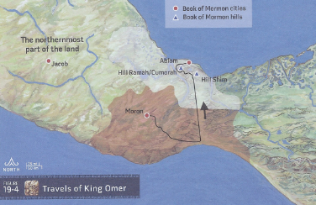
Ether 9:3 Omer came over and passed by the hill of Shim, and came over by the place where the Nephites were destroyed (Illustration): Travels of King Omer. [Joseph Lovell Allen & Blake Joseph Allen, Exploring the Lands of the Book of Mormon, Second Edition, 2008, p. 436]

Ether 9:3 The Hill Shim:

According to Warren and Palmer, the "hill Shim" (Ether 9:3) may have been "Corn Hill" in the Tuxtla mountains of Veracruz, Mexico. This hill Shim identification is based on linguistic evidence from Mayan languages, using their word for corn or maize. It is "sim" (transliterated "Shim"). There is no hill called Shim today in Southern Veracruz. However, there is a mountain with the same meaning. In Aztec language, "Cintepec" means "corn hill" (Warren, 1983). This hill Cintepec is located near Lake Catemaco in the Tuxtla mountains (see illustration). It is also close to the coastal plain, so that a trip from this hill to the Cerro Vigia (the proposed place where the Nephites were destroyed) would probably have been carried on the plains, skirting the mountains themselves. Thus, a journey from Laguna de los Cerros (the proposed land of Nehor) to Cintepec (the proposed hill Shim), to the Cerro Vigia (the proposed hill Cumorah), and finally to the coast of the Gulf of Mexico (the proposed location of Ablom) would make sense. [Bruce W. Warren and David A. Palmer, The Jaredite Saga, p. 7-3, unpublished]


Lake Catemaco

The Tuxtla Mountains in the state of Veracruz, Mexico
(The large blue spot east of Tres Zapotes and Cobara is Lake Catemaco)

Ether 9: 3 The Hill Shim:

According to Joseph Allen, there is a hill named "Cintepec" which is located east of Lake Catemaco in the Tuxtla Mountain Range in the State of Veracruz, Mexico. The location of this Hill Cintepec is close to the Hill Vigia, which is the leading candidate for the location where the last great battles as discussed in the Book of Mormon were fought. The last part of the word Cintepec, "tepec," means hill or mountain in the Nahuatl (Aztec) language. The front part of the word, "Cin," means corn. Hence, the word "Cintepec" means Corn Hill. The word "Shim" in the Maya language also means corn. Therefore, Hill Cintepec, the Tuxtla Mountains hill that is close to the Hill Vigia (proposed hill Cumorah), may be the hill Shim mentioned in the Book of Mormon. It is very interesting that Hill Cintepec is the hill where the stone was quarried to construct the large Olmec stone heads discovered along the Gulf of Mexico. The Olmec culture dates to the Jaredite time period. [Joseph L. Allen, Exploring the Lands of the Book of Mormon, pp. 38-39]

According to John Sorenson, the book of Ether tells us that the hill Shim was between the Jaredite land of Moron and the hill Ramah (the Nephites' hill Cumorah--Ether 9:3). Hills prominent enough to deserve being named as landmarks such as the hill Shim was are in the southern part of the Tuxtlas mountain mass or, less likely, in the foothills of the Sierra Madre 80 miles to the southwest. [John L. Sorenson, An Ancient American Setting for the Book of Mormon, pp. 343-344]

Ether 9:3 [Omer] Came [from the hill Cumorah] to a Place Which Was Called Ablom, by the Seashore:

With the phrase (Omer) "came" (from the hill Cumorah) to a place which was called Ablom, by the seashore" (Ether 9:3), we get a possible implication that there was a sea "eastward" from the hill Cumorah and from the hill Shim. How far eastward we are not told. What the name of the sea was we are not told.

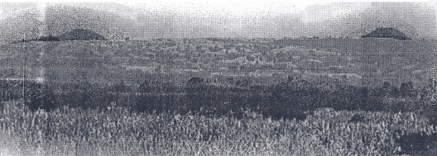
Ether 9:3 Omer came over and passed by the hill of Shim, and came over by the place where the Nephites were destroyed (Illustration): The two peaks of the Hill shim (right) and the Hill Ramah/Cumorah (left) on site in Veracruz, Mexico. Photographer: Ian Miller in The Book of Mormon Archaeological Digest, Vol. I, Issue IV, 1998, p. 13]

Ether 9:3 Ablom:

According to Warren and Palmer, archaeological ruins in the area of Roca Partida, situated at the northwestern edge of the Tuxtla mountains in Veracruz, Mexico, present the most logical spot to propose for the location of "Ablom" (Ether 9:3). Although various sites were observed and photographed along the coast of the Gulf of Mexico, the sites have not been seriously explored because they are in an extremely remote area. [Bruce W. Warren and David A. Palmer, The Jaredite Saga, p. 7-4, unpublished]

Ether 9:3 Ablom:

On the suggestion of John L. Sorenson, a ten-day expedition was conducted between December 27, 1989 and January 6, 1990 to the Gulf of Mexico side of the Isthmus of Tehuantepec in southern Mexico. The principal objective of this trip was to find a plausible site for the Book of Mormon city first called "Bountiful" (Alma 52:17). Additionally, plausible sites were investigated for the Jaredite place called Ablom (Ether 9:3). At the time, John Sorenson felt that an informed amateur could possibly accomplish more than a professional archaeologist because of the laws regarding the ancient mounds, so he arranged funding and asked Dr. David A. Palmer to head the expedition. He was assisted by Dr. Robert E. Fisher who did videotaping, and Elder Octaviano Tenorio, a regional representative of the LDS Church, as he was born and raised in a community called Tilapan, Veracruz, about ten miles from the Cerro Vigia (a proposed location for the hill Cumorah / hill Ramah).

A number of flights were made over the Isthmus area near the Gulf Coast. During the flight around the hill Vigia and toward the coast (see illustrated map below) the group saw not one, but three ancient sites on the Gulf Coast near Roca Partida. Those sites have potential for great antiquity as a place for the people of Omer (Ether 9:3) and Nimrah (Ether 9:9). They date to roughly 2400-2500 B.C. Therefore, the group wanted to drive over to the coast to investigate. The Veracruz mission president, Leonardo Ramirez Rivas offered a ride in his Suburban. The road was pathetic, however, and by the time they arrived at the coastal village called "Salinas," they were too exhausted to proceed to Roca Partida. [David A. Palmer, Robert E. Fisher, and Octaviano Tenorio, "Trip Report--Bountiful Expedition," submitted March 17, 1990, used by permission from the files of Robert E. Fisher and John L. Sorenson]

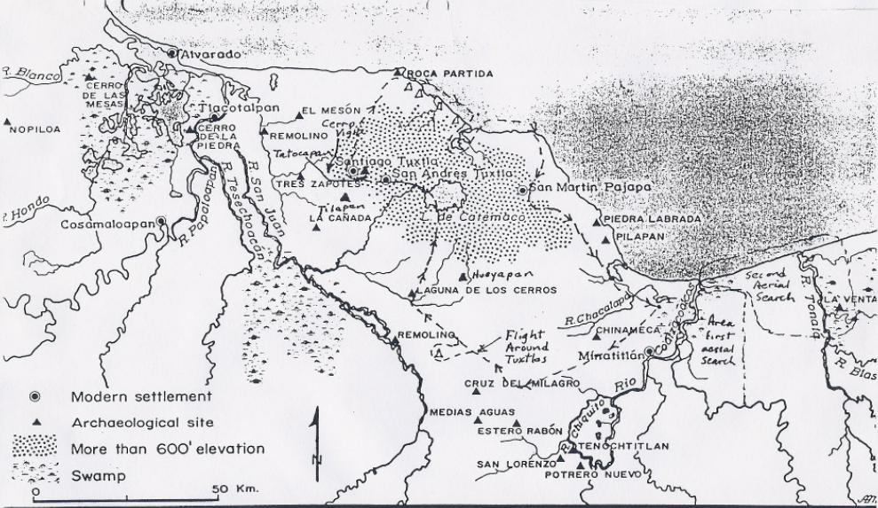
Ether 9:3 Ablom (Illustration): Map of the route of the flight around the hill Vigia and over Roca Partida. [David A. Palmer, Robert E. Fisher, and Octaviano Tenorio, "Trip Report--Bountiful Expedition," submitted March 17, 1990, used by permission from the files of Robert E. Fisher and John L. Sorenson]

Ether 9:3 Ablom (Illustration-not shown): Video: Second Flyover of Cerro Vigia and Roca Partida. [David A. Palmer, Robert E. Fisher, and Octaviano Tenorio, "Trip Report--Bountiful Expedition," submitted March 17, 1990, used by permission from the files of Robert E. Fisher]

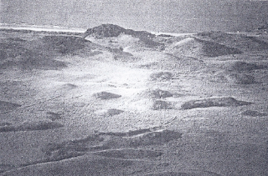
Ether 9:3 Ablom (Illustration): Photo: Ruins at the Gulf Coast. [David A. Palmer, Robert E. Fisher, and Octaviano Tenorio, "Trip Report--Bountiful Expedition," submitted March 17, 1990, used by permission from the files of Robert E. Fisher]
Ether 9:4 Jared_{[2]} Was Anointed King over the People:

Ether 9:4 tells us that "Jared_{[2]} was anointed king over the people," but it does not tell us from what location Jared₂ ruled. Did Jared₂ set his throne in the land of Heth or in the land of Moron?

Geographical Theory Map: Ether 9:5 - 9:26 Omer Restored to Power (Chronology)
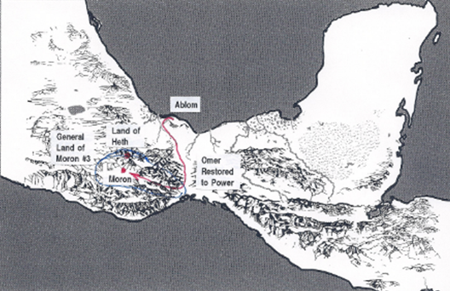

LAND OF MORON #3 LAND OF HETH

JARED annointed king over Moron #2 & Heth = Moron #3 <-------------------------------------------------------------------
Akish kills Jared (9:5)
AKISH reigns (9:6)
Akish imprisons & kills one son (9:7)
Akish's son (Nimrah) “fled out of the land and came over and dwelt with Omer” (in Ablom) (9:9) --------> ABLOM

Civil War (9:12) “lasted fort the space of many years,
unto the destruction of nearly all the people of the kingdom”
30 remain plus “they who fled with the house of Omer” (of royal house?) (9:12) Omer restored to power (9:13)
---------------------------------------------------OMER reigns (9:12)------------------------------------------------

Ether 9:6 A-kish
Matt Roper writes that while we cannot say precisely when the Jaredites came out from the great tower (presumably somewhere in ancient Mesopotamia), and while we do not know precisely where in that region they came from, it is noteworthy that there are four “Kish” names in the Book of Mormon. We have three Jaredite kings, Akish (Ether 9:6), after whom was named the wilderness of Akish (Ether 14:14), Riplakish (Ether 10:4), and Kish the father of the good king Lib in whose reign, “they built a great city by the narrow neck of land” (Ether 10:18-20). Then we have the later Nephite conspirator Kishkumen (Helaman 1:9), who was associated with those seeking for political power and after whom a later city was named (3 Nephi 9:10) The name Kish was an important Sumerian city from an early time in ancient Mesopotamia. As one historian notes:
"After the great flood, kingship was re-established by the gods and given to the rulers of the city of Kish, at which time we move from legend into the very beginning of the proto-historical period. . . . According to Summerian legend, the period scholars now call Early Dynastic I was dominated by then hegemony of the kings of Kish. Throughout the Sumerian period the title `king of Kish' (lugal Kish) meant hegemon of Summer, and every warlord claiming universal domination of Mesopotamia adopted `king of Kish' as one of his titles" (William J. Hamblin, Warfare in the Ancient Near East to 1600 BC: Holy Warriors at the Dawn of History (London and New York: Routledge, 2006), 42. See also Tohru Maeda, “`King of Kish’ in Pre-Sargonic Sumer,” Orient 17 [1981]: 1-17).
Yigal Levin notes:
“The mid-third millennium BCE was a time of great change in Mesopotamia. After several centuries of rivalry between various Sumerian city-states such as Ur, Uruk, Lagash and Umma, the rulers of the city of Kish managed to establish a sort of priority over much of Mesopotamia. The primacy of one Sumerian city over the others was an innovation. In successive generations the title `King of Kish’ would come to mean a divinely authorized ruler over all of Sumer and would be claimed at different times by the rulers of various cities. Use of the title `King of Kish’ implied such qualities as being victorious at war, a righteous judge and a builder of cities” (Yigal Levin, “Nimrod the Mighty, King of Kish, King of Sumer and Akkad,” Vetus Testamentum 52/3 [2002]: 359).
“According to the Sumerian King List, which is the very document that supplies us with most of the `hard’ information about the Sargonic period (such as names and reigns of kings), it was to the city of Kish that kinship itself was lowered from heaven after the flood. Like the biblical Nimrod, the ancient kings of Kish were the very embodiment of human kingship in the postdiluvian era. Over a thousand years later, the Neo-Assyrian kings would use Sargon’s royal title sar-kissati, taking it to mean quote literally, `King of the Universe’” (Levin, 361-62).
In addition to the name of the Sumerian city, and the honorary royal title “King of Kish” there are also attested personal names such as Kishibgal (Jerrold S. Cooper, Sumerian and Akkadian Royal Inscriptions. New Haven: American Oriental Society, 1986, 1:25), and Iphur-Kish (Douglas Frayne, The Royal Inscriptions of Mesopotamia. Early Periods Volume 2. Sargonic and Gutian Periods (2334-2113) Toronto, Buffalo, Longdon: University of Toronto Press, 1993, 103-109).
In addition to the early Mesopotamian connection it is interesting, given the background discussed by historians, that the only people with Kish names in the Book of Mormon would be kings and or individuals who were seeking political power.
[Matt Roper, “Kish in Ancient Mesopotamia and the Book of Mormon,” (etherscave.blogspot.ca)]

Ether 9:5 Akish . . . Sought the Life of His Father-in-Law:

When Jared₂ was anointed king over the people, he gave unto Akish his daughter to wife. But Akish was apparently not content, for he,

sought the life of his father-in-law; and he applied unto those whom he had sworn by the oath of the ancients, and they obtained the head of his father-in-law, as he sat upon his throne . . . and Akish reigned in his stead. And it came to pass that Akish began to be jealous of his son, therefore he shut him up in prison, and kept him upon little or no food until he had suffered death.
And now the brother of him that suffered death, (and his name was Nimrah) was angry with his father because of that which his father had done unto his brother . . . and he fled out of the land, and came over and dwelt with Omer.
And it came to pass that Akish begat other sons, and they won the hearts of the people . . .wherefore, the sons of Akish did offer them money, by which means they drew away the more part of the people after them.
And there began to be a war between the sons of Akish and Akish, which lasted for the space of many years, yea, unto the destruction of nearly all the people of the kingdom, yea, even all, save it were thirty souls, and they who fled with the house of Omer. (Ether 9:5-12)

According to Warren and Palmer, there is an external source which may be relevant to the name Akish and the development of secret combinations in the Jaredite culture. It is found in a Guatemalan (Quiche-Maya) account known as the Popol Vuh. It mentions a person, Cakix (pronounced Caw Kish), and his two sons. Their names were Cipacna and Cabracan. They exalted themselves among the sun, planets, and stars, and became desirous of great riches, power and conquest. They were so abusive that the gods decided they must be destroyed. he account describes the birth of the hero twins who would carry out the task of the gods, destruction of the father and his two malevolent sons.

Akish of the Book of Ether, could conceivably be Cakix (Caw Kish) of the Popol Vuh account. He beheaded his father to get the throne, and then starved to death one of his sons. Other sons eventually warred with him and they were killed. It is not clear who the hero twins may have been. Many illustrations can be given from codices and Late Classic Maya polychrome vessels which have scenes dealing with the hero twins and the downfall of Cakix and his two sons. [Bruce W. Warren and David A. Palmer, The Jaredite Saga, 7-11, unpublished]

Ether 9:6 Jared Was Murdered upon His Throne and Akish Reigned in His Stead:

According to Ether 9:6, Akish "reigned in [Jared's] stead, but this does tell us where Akish set his throne. Did Akish set his throne in the land of Heth or in the land of Moron? [Alan Miner, Personal Notes]
Ether 9:7 Akish Began to Be Jealous Of His Son:

It is hard to imagine anyone so wicked that they would torture their son to death because of an uncontrollable desire for power. Moroni doesn’t discuss much of the demented psychology of these paranoid Jaredite power mongers. However, Josephus goes to great lengths to describe the same thought process as it occurred in the life of Herod the Great. We know him as the king who killed all the children that were in Bethlehem, and in all the coasts thereof, from two years old and under (Matt 2:16). But this mass infanticide was but one of many atrocious acts which marked Herod’s reign.

Like Akish, Herod’s paranoia seemed to have no end, nor did his cruelty to those who were a threat to him. He “never left off avenging and punishing every day those that had chosen to be of the party of his enemies” (Josephus, Antiquities of the Jews, Book XV, 1:1) Accordingly, Herod had his brother-in-law, his uncle, his mother-in-law, and her father killed. Once, he even considered murdering Cleopatra. In his paranoia, he became suspicious of those who had been his most intimate friends and therefore had them killed. Based on false rumors, he had his once beloved wife killed. He killed everyone who might be a threat to his power, until “there were…none at all left of the kindred of Hyrcanus [his mother-in-law’s father]; and the kingdom was entirely in Herod’s power, and there was nobody remaining of such dignity as could put a stop to [him].” (Josephus, Antiquities of the Jews, Book XV, 7:10)

Of his sons, Herod was perpetually suspicious. Concerned that one of his sons was guilty of sedition, he had his son’s friends tortured in order to extract information from them. This torture resulted not in a confession but in the death of many of the young men. (Ibid, Book XVI, 8:4). Josephus writes, “he was…overrun with suspicion and hatred against all about him…in order to his preservation, he continued to suspect those that were guiltless: nor did he set any bounds to himself; but supposing that those who stayed with him had the most power to hurt him, they were to him very frightful.” This mentality lead to mental illness with paranoid delusions, “because he could trust nobody, he was sorely punished by the expectation of further misery; for he often fancied in his imagination, that his son had fallen upon him, or stood by him with a sword in his hand; and thus was his mind night and day intent upon this thing, and revolved it over and over…And this was the sad condition Herod was now in.” (Ibid, Book XVI, 8:5) Predictably, Herod had three of his own sons killed: Alexander, Aristobulus, and Antipater.

The Lord wants us to have homes which are a “heaven on earth.” Satan wants us to have homes which are a “hell on earth.” The sons of Herod and Akish undoubtedly had homes more aptly described by the latter. Thus we learn what price was paid by the wicked who lusted for power above all. They lived in perpetual paranoia until they had their very family members killed.
[josephsmith.com . . . Ether ]

Ether 9:9 Nimrah . . . Came over and Dwelt with Omer [at Ablom]:

From either the land of Moron or the land of Heth, Nimrah "came over" to Ablom. This phrase is consistent with the commentary on Ether 9:3. From where Nimrah was (either Moron or Heth) the total distance to Ablom must not have been too great, because Nimrah apparently had no trouble locating Omer. Additionally, when the opportunity arose, Omer was restored to the "land of his inheritance," which was probably the land of Moron (Ether 7:20,21,22, 8:1). Because of this we might assume that there was no great distance between the land of Moron and Ablom. [Alan C. Miner, Personal Notes]

Ether 9:11 The Sons of Akish Did Offer Them Money, by Which Means They Drew Away the More Part of the People:

According to Hugh Nibley, not only was the Jaredite practice of seeking to "draw away" to one's own side the followers of a rival in the best Asiatic tradition, but the method of doing it was likewise in the best accepted tradition. Thus Akish bound his followers around the nucleus of his of his family by lavish gifts, for "the people of Akish were desirous for gain, even as Akish was desirous for power; where, the sons of Akish did offer them money, by which means they drew away the more part of the people after them" (Ether 9:11)

In the sixth century, Menander--a Roman ambassador to the court of the Grand Khan--beheld five hundred wagons full of gold, silver, and silken garments, that accompanied the monarch on his wanderings, for "the ancient law of the Khans" was that none enters the presence of the ruler empty-handed nor departs hence unrewarded. [Hugh Nibley, The World of the Jaredites, pp. 199-200]

Ether 9:11 Akish Was Desirous For Power; Wherefore, the Sons of Akish Did Offer Them Money:

Hugh Nibley writes: “Akish got elected because he offered the people money . . . People got their money and Akish got his power.” (Approaching Zion, p. 94)
[josephsmith.com . . . Ether ]

Ether 9:12 A War . . . unto the Destruction of Nearly All . . . Save It Were Thirty Souls:

Just before Omer was restored to the land of his inheritance, we are told that "all, save it were thirty souls" (Ether 9:12) were destroyed in the battle between Akish and his sons. In his "old age" Omer had a son named Emer and "he anointed Emer to be king to reign in his stead. The people began to prosper under Emer such that after "sixty and two years they had become exceeding strong, insomuch that they became exceeding rich. Later, we are told that by the reign of Emer's son, Coriantum, the Jaredites were able to "build many mighty cities" (Ether 9:23). Omer had initially fled with "his sons and his daughters, and all his household save it were Jared and his family" (Ether 9:3). Would that have been enough people to "build many mighty cities" within two generations? Or were the 30 survivors mentioned here just representatives of royalty? Hugh Nibley cautions us that we should not equate destruction among the Jaredites with annihilation. We also might be careful to not underestimate the number of years the Jaredite kings reigned. We are told that Coriantum "lived until he was an hundred and forty and two years old" (Ether 9:24). We are not told how long Emer or Omer lived. From the destruction to the "many mighty cities" could have taken as many as 300 years. [Alan C. Miner, Personal Notes] [See the Commentary on Ether 13:21 and 15:29]

Ether 9:15-35 (Cycle of Great Prosperity and Tragic Wickedness):

Ether 9:15-35 shows a pattern repeated many times in the Book of Mormon:
1. During the righteous reigns of Emer and Coriantum the people prospered exceedingly (see vv. 15-25)
2. Under the reign of Heth, the people began to join together in secret combinations, and they turned to wickedness (see vv. 26-27)
3. The Lord sent prophets to warn the people of their terrible circumstances (see v. 28).
4. The people of Heth rejected the prophets (see v. 29)
5. The judgments of God fell upon the people (see vv. 30-33).
6. The people humbled themselves and repented and the Lord blessed them again with prosperity (see vv. 34-35).

While the fall from prosperity to wickedness is lamentable, what is also worthy of note here is that the Jaredites were able to be wealthy and remain righteous for more than 225 years (see vv. 15-25). [CES, Book of Mormon Student Manual, Religion 121 and 122, 1989, p. 140]

Ether 9: 17-20 . . . Ether 10: 19-28 (Parallel expressions of being blessed by faithfully possessing the covenant promised land unto the Lord):.
It is rather intriguing to me that in an abridgment such as the Book of Ether, Moroni would take the space he did in Ether 9 and then Ether 10 to give the details of how the Lord blessed his Jaredite people when they honored and obeyed the covenants they had made with him. I will list the two sets of verses below and also notify the reader that what commentary might be missing on the highlighted items of one set of verses will probably appear on the parallel highlighted items of the other set of verses. Whereas chapter 9 emphasizes food and animals usefully managed by man, chapter 10 emphasizes hunting animals of the forest, digging for ore, and making metals and tools. Both sets of verses emphasize the blessings of prosperity that the Jaredites had been given by the Lord.
Ether chapter 9
16 And the Lord began again to take the curse from off the land, and the house of Emer did prosper exceedingly under the reign of Emer; and in the space of sixty and two years they had become exceedingly strong, insomuch that they became exceedingly rich—
17 Having all manner of fruit, and of grain, and of silks, and of fine linen, and of gold, and of silver, and of precious things;
18 And also all manner of cattle, of oxen, and cows, and of sheep, and of swine, and of goats, and also many other kinds of animals which were useful for the food of man.
19 And they also had horses, and asses, and there were elephants and cureloms and cumoms; all of which were useful unto man, and more especially the elephants and cureloms and cumoms.
20 And thus the Lord did pour out his blessings upon this land, which was choice above all other lands; and he commanded that whoso should possess the land should possess it unto the Lord, or they should be destroyed when they were ripened in iniquity; for upon such, saith the Lord: I will pour out the fulness of my wrath.

Ether chapter 10
19 And it came to pass that Lib also did that which was good in the sight of the Lord. And in the days of Lib the poisonous serpents were destroyed. Wherefore they did go into the land southward, to hunt food for the people of the land, for the land was covered with animals of the forest. And Lib also himself became a great hunter.
20 And they built a great city by the narrow neck of land, by the place where the sea divides the land.
21 And they did preserve the land southward for a wilderness, to get game. And the whole face of the land northward was covered with inhabitants.
22 And they were exceedingly industrious, and they did buy and sell and traffic one with another, that they might get gain.
23 And they did work in all manner of ore, and they did make gold, and silver, and iron, and brass, and all manner of metals; and they did dig it out of the earth; wherefore, they did cast up mighty heaps of earth to get ore, of gold, and of silver, and of iron, and of copper. And they did work all manner of fine work.
24 And they did have silks, and fine-twined linen; and they did work all manner of cloth, that they might clothe themselves from their nakedness.
25 And they did make all manner of tools to till the earth, both to plow and to sow, to reap and to hoe, and also to thrash.
26 And they did make all manner of tools with which they did work their beasts.
27 And they did make all manner of weapons of war. And they did work all manner of work of exceedingly curious workmanship.
28 And never could be a people more blessed than were they, and more prospered by the hand of the Lord. And they were in a land that was choice above all lands, for the Lord had spoken it.

Ether 9:17 Having All Manner of . . . Grain:

According to Warren and Palmer, if we assume a Mesoamerican setting, then with the phrase "all manner of . . . grain" (Ether 9:17), we might postulate that Maize cultivation may have made its great leap forward during the reign of king Emer, son of king Omer. This accomplishment may have been due to advances in plant breeding as well as the development of irrigation techniques (Flannery, Kirby, Kirby, and Williams; 1967:445) [Bruce W. Warren and David A. Palmer, The Jaredite Saga, p. 7-9, unpublished]

Ether 9:17 Having All Manner . . . of Silks, and of Fine Linen:

According to Verneil Simmons, linen was not always made from flax. Herodotus, in the fifth century B.C., reports the Thracians making hempen garments which could not be told from true linen except by the most expert (Book 4:74). The native agave plant, commonly called the maguey, is a source of hemp-like fibers from which many textiles are manufactured today in Mexico. A few scraps of agave-fiber cloth have been found in Mexican tomb excavation. Jaredite women were not without the means of making "fine twined linen" (Ether 9:17).

"Silk" (Ether 9:17) has been produced in the New World. The quality is not up to Chinese standards and it cannot compete on the cost level, but the "raw material" is available. The Indians of Guatemala are still familiar with the various sources of fibers that produce silklike materials. (See Indian Crafts of Guatemala and El Salvador by Lilly de Jongh Osborne, pp. 31-32). Wallrath reported that wild silk used to be gathered by Zapotec women and woven into fabrics which sold with high profits. (See Excavations in the Tehuantepec Region of Mexico, Vol 57, Part 2, May 1967. p. 12) Both in the United States and in Mexico there are native silkworm moths -- butterflies to most people. The tropical variety are of the Saturnidae family.

(Note* Neither linen nor silk was used in ancient Peru, but rather cotton, and wool from the alpacas and llamas)
[Verneil W. Simmons, Peoples, Places and Prophecies, pp. 46, 273]

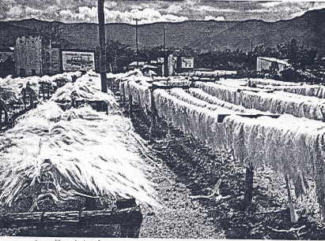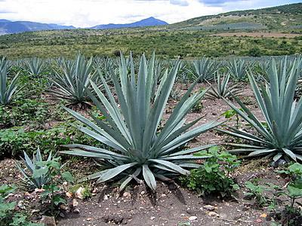
Ether 9:17 Having all manner . . . of silks, and of fine linen (Illustration): Agave fibers drying, for use in textiles -- Northern Mexico; photo by Wayne E. Simmons. [Verneil W. Simmons, Peoples, Places and Prophecies, p. 122]

Ether 9:17 Silks:

According to Glenn Scott, it is not surprising that no trace of silk has been found in Mesoamerica for silk oxidizes completely in damp climates. However, it is said that silk was produced in China as early as 3000 B.C., and this knowledge may have been brought to the New World by the Jaredites.

Possibilities from the land of promise include a silk-like fabric known at the time of the Conquest, which was spun from filaments of the cocoon of native Saturniidae moths. Another possibility is a native fabric which Fr. Diego de Landa described as "silk," spun from fibers of the Ceiba tree. [Glenn A. Scott, Voices from the Dust, p. 51]

[Note* Ceiba pentandra is a tropical tree of the order Malvales and the family Malvaceae (previously separated in the family Bombacaceae), native to Mexico, Central America and the Caribbean, northern South America. The tree is cultivated for the seed fibre.
The tree grows to 70 m (230 ft.) with a trunk up to 3 m (10 ft.) in diameter with buttresses
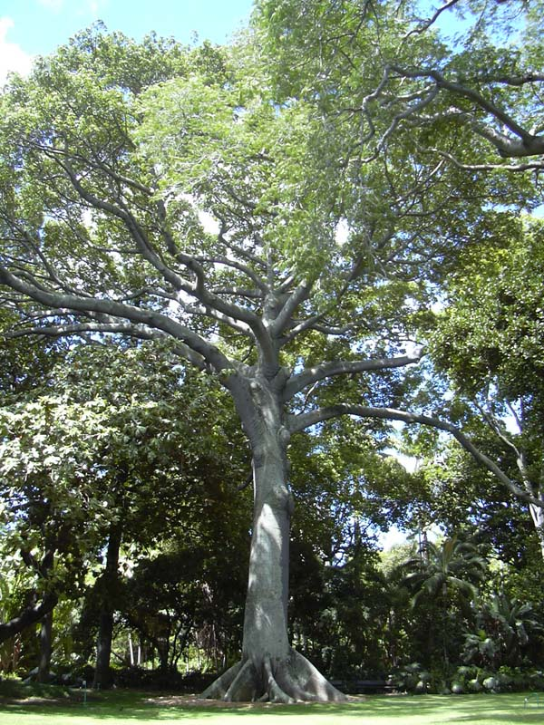
The trees produce several hundred 15 cm (6 in) pods containing seeds surrounded by a fluffy, yellowish fibre that is a mix of lignin and cellulose.
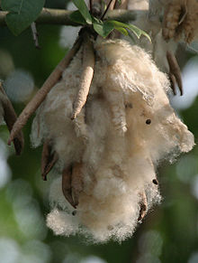
The fiber is light, very buoyant, resilient, resistant to water, but it is very flammable. The process of harvesting and separating the fibre is labour-intensive and manual. It is difficult to spin, but is used as an alternative to down as filling in mattresses, pillows, upholstery, zafus, and stuffed toys such as teddy bears, and for insulation.
["Ceiba pentandra," Wikipedia]
Ether 9:17 Having All Manner of . . . Silks:
John L. Sorenson writes:
Linen and silk are textiles mentioned in the Book of Mormon (Alma 4:6). Neither fabric as we now know them was found in Mesoamerica at the coming of the Spaniards. The problem might be no more than linguistic. The redoubtable Bernal Diaz, who served with Cortez in the initial wave of conquest, described native Mexican garments made of "henequen which is like linen." [2] The fiber of the maguey plant, from which henequen was manufactured, closely resembles the flax fiber used to make European linen. Several kinds of "silk," too, were reported by the conquerors. One kind was of thread spun from the fine hair on the bellies of rabbits. Padre Motolinia also reported the presence of a wild silkworm, although he thought the Indians did not make use of the cocoons. But other reports indicate that wild silk was spun and woven in certain areas of Mesoamerica. Another type came from the pod of the ceiba tree. [3]
We may never discover actual remains of these fabrics, but at least the use of the words in the Book of Mormon now seems to offer no problem
[John L. Sorenson, An Ancient American Setting for the Book of Mormon , p. 232. See also Sorenson, "Silk and Linen in the Book of Mormon," Ensign (April 1992), p. 62.]

Careyn Patricia Armitage reports:
The theory that "wild silk" was used anciently in Oaxaca, near the Isthmus of Tehuantepec in Mesoamerica, "has been greatly debated."
Wild silk was produced by the Gloveria paidii, a moth, and the Eucheira socialis, a butterfly, found in the Oaxaca area (de Ávila Blomberg, 1997). It is suggested by de Ávila Blomberg that wild silk was used in Oaxaca in pre-Columbian times, a theory that has been greatly debated. However, in a 1777 document, an excavation of a pre-Columbian burial site is described as containing wild silk.[4]
[ Careyn Patricia Armitage, "Silk production and its impact on families and communities in Oaxaca, Mexico," Graduate Theses and Dissertations, Iowa State University (2008) ]
[As reported on http://en.fairmormon.org/Book_of_Mormon/Anachronisms/Animals/Silkworms
Book of Mormon/Anachronisms/Animals/Silkworms]

[Note* Gloveria is a genus of Moth in the family Lasiocampidae
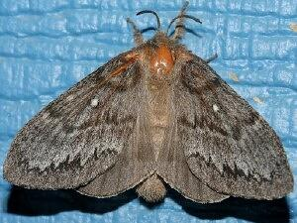
Gloveria arizonensis a relative of Gloeria paidii

The Madrone Caterpillar (Eucheira socialis)butterfly is found in the high mountainous regions of Mexico where its host tree, the madrone (Arbutus) occurs
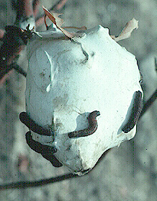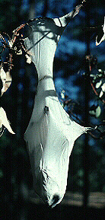
Eucheira socialis Butterfly Madrone nest of caterpillars Madrone caterpillar nest

The caterpillars are present from early summer unit late the following spring. The caterpillars that comprise a colony, which may number 200 or more, are siblings and they remain together throughout their lifetime, pupating and eclosing to the adult en masse. The larvae construct a silken, bag-like nest, within which they rest between bouts of feeding. Adults emerge from an opening at the bottom of the nest in June.
The caterpillars construct their shelter entirely from silk. The walls of the nest are so densely woven that the nests will hold water and can only be penetrated with a sharp knife. There is usually only one exit hole which is found at the bottom of the structure. overnight temperatures and cannot return to the bolsa until the sun comes up and warms their bodies.
[http://facultyweb.cortland.edu/fitzgerald/MadroneCaterpillar.html]
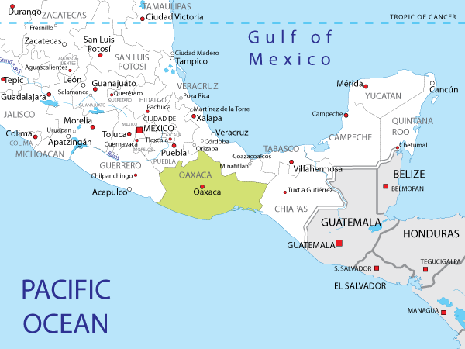
Location of the state of Oaxaca, Mexico

Ether 9:17 Having All Manner . . . of Gold:

Under the reign of Emer, the Jaredites became rich, "having all manner of . . . gold" (Ether 9:17). According to Verneil Simmons, at 2700 B.C., the Sumerian craftsmen could do nearly all that can be done by a modern goldsmith, and could do it nearly as well. Whether it was sheet metal for vase or bowl, repousse, chasing, inlay, riveting, or soldering, he was master of them all. He could cast gold or bronze in sectional or closed molds or use the cire perdue (lost wax) process, a most sophisticated technique. The technique of "granulation" in which minute beads or grains of gold are arranged to form a pattern and then soldered to a solid back, was used on objects found in the royal cemetery. The secret of this process was eventually lost and only rediscovered in the 1930s! (See Leonard Woolley, the Beginnings of Civilization, p. 287) [Verneil W. Simmons, Peoples, Places and Prophecies, p. 44] SEE the commentary on Ether 10:23

Ether 9:17 Having All Manner . . . of Precious Things:

According to Glenn Scott, the "precious things" referred to in Ether 9:17 could refer to jade, for it was as precious in Mesoamerica as it was in China. [Glenn A. Scott, Voices from the Dust, p. 51]

According to Verneil Simmons, as for the expert craft skills that were known to the artisans of Sumer, the apparent homeland of the Jaredites in the Old World, there are two special crafts related to the artifacts that are today found in Mexico. The Sumerian artists made obsidian pots that were ground down to the thinness of blown glass, which must have involved immense time and labor. One of Mexico's ancient art treasures is a black obsidian monkey pot, ground down to unbelievable thinness. In addition, conch shells from the Persian Gulf were worked into ornaments in ancient Sumer. Shells from the Caribbean Gulf made into ornaments are found in all the early cultures of Mexico. [Verneil W. Simmons, Peoples, Places and Prophecies, p. 46] SEE the commentary on Ether 10:23

Ether 9:18 All Manner of Cattle:

According to Glenn Scott, as to the "cattle" referred to in Ether 9:18, not only were bison a known food of earlier natives, but in 1959, Richard Shutler found at Falcon Hill, Nevada, bones of a Euceratherium (shrub ox) together with basketry, indicating slaughter by man. The bones were below items of the Lovelock culture dating to 2000-500 B.C. Similar bones were found in New Mexico dating to 5470 B.C. +/- 370 years. [Glenn A. Scott, Voices from the Dust, p. 51]

Ether 9:18 Cattle:

In an article by the Book of Mormon Archaeological Forum Staff countering claims against a Mesoamerican setting for the Book of Ether, and specifically the challenge that “there were no animals in Mesoamerica that could have been identified as cattle,” they write:

Again, Potter allows the term “cattle” to mean something other than cows in order to support his theory, but denies the Mesoamerican setting for The Book of Mormon the same luxury. Potter correctly states in his article Cattle and The Book of Mormon: “Noah Webster's 1828 American Usage Dictionary defines "cattle" as: "In its primary sense, the word includes camels, horses, asses, all the varieties of domesticated horned beasts of the bovine genus, sheep of all kinds, and goats."…the term "cattle" meant something different to the translator of the Book of Mormon than what the term generally means today.”
Potter believes that Llamas are what are described as cattle in The Book of Mormon. I cannot disagree that the Llama could be considered a possibility, but what Potter doesn’t know is that the Llama actually existed in Mesoamerica until recently. “Llamas used to cover all of North and South America in the Pleistocene era until they became extinct everywhere except in South America. But new evidence suggests that llamas actually survived in Mesoamerica, well into Book of Mormon times.”43

John Sorenson notes:

“A Costa Rican archaeologist has discovered an effigy pot in the form of a cameloid. And on the Isthmus of Tehuantepec in the middle of the last century, alpaca were reported living wild.”44 So even if Potter is correct about the llama being cattle, it is equally as possible that they were the llama of Mesoamerica. However, the llama isn’t the only possibility of being cattle. “The Hebrew word b'hemah, sometimes translated as "cattle" in the Old Testament, can refer to "any large quadruped or animal" [Strong, A Concise Dictionary of the Words in the Hebrew Bible, 19]. The Hebrew word s'eh, also translated as "cattle," usually refers to smaller domesticates such as sheep or goats. The Book of Mormon term could easily refer to any small or large quadruped. There are, of course, many New World species that could fall within this description.”45 This means that most any animal could fall under the description of cattle. The only requirements are that it be a quadruped, or an animal that has four feet. The possibilities are endless on what they actually may have been, and we won’t go into them but would like to point out that deer were a semi-domesticated animal in Mesoamerica and were treated as pets. “Deer bones are very common at many Maya sites and, if not fully domesticated, there is some archaeological evidence that deer may have been kept within fenced enclosures or encouraged to browse amongst the secondary growth of cleared fields.”46 There is also documentation of females breast-feeding deer, and treating them as they did other domesticated animals.47 “ . . . the most secure evidence for domestication comes from a cache of subadult deer limbs excavated from Str. N5-21 at Dos Pilas. One femur shows a healed midshaft complete fracture, an injury that would predispose a juvenile animal to rapid death in the wild. The animal survived after the injury for several months, which is an unlikely outcome unless it had been protected from predation.”48

[BMAF Staff, “Response to George Potter’s ‘Ten Reasons why Mesoamerica is Not Book of Mormon Lands’,” Book of Mormon Archaeological Forum]

Ether 9:18-19 All Manner of Cattle, . . .Horses . . . Elephants . . . Cureloms and Cumoms (Animals):
Wade Miller and Matt Roper note that animals (mammals) in common between the Bible and Book of Mormon are the horse, ass, cattle (steer, cow), ox (oxen), swine, goat and wild goat. It’s interesting that the elephant can be found in the Book of Mormon, but not in the Bible. However, an inference to this animal can be found in I Kings (10:18). Here it is stated that Solomon had a great throne of ivory. Caution must be taken when identifying animals in either of these two scriptural Books, though. Some of the names given in both represent animals for which we cannot be sure of their true nature. A few of these given in the Bible are the behemoth, cherogrillus, unicorn and pygarg. In the Book of Mormon there are the curelom and cumom. Part of the problem in taxonomy is in translating from one language to another as is true for both Books. Commonly people will name an unidentified animal in a newly settled region after a similar looking animal with which they are familiar. This happened on many occasions when Europeans colonized on foreign lands. For example, the true buffalo is an Old World bovid whose name was applied to the American bison. And the American pronghorns are commonly called antelopes as they resemble these Old World animals. The North American moose is known as an elk in Europe. Even in the same language, a given animal can have various names (e.g., mountain lion, cougar, puma, mountain cat, catamount, etc.). All this serves to point out the need for caution in identifying animals in scriptures.

For the Bible translator perhaps no aspect of his work is more complex, confusing, and time consuming than the problems encountered in attempting to render satisfactorily the terms for differing plants and animals of the Scriptures.”²⁸ Edward Hope observes, “In the Old Testament it is extremely difficult to decide with any certainty the animals (or birds) referred to by their Hebrew names. In some cases the range of suggestions is staggering.”²⁹

One challenge has to do with identifying the animals named in the Hebrew text. One approach is to simply follow previous translations. This, however, “sometimes introduces into the text animals which were not found in Biblical times in the ancient Middle East, as far as we know.”³⁰ Still, this may at times be the best approach, hence, “a translator should, carefully consider the existing tradition in translating, that is, the practice of other translations of the Scriptures into this receptor language.”³¹ Similarly, Joseph Smith may have simply followed the King James rendering of animal terms for some Book of Mormon animals, even if the association with some animals in the American land of promise may not have been precise.

Another approach taken by translators is to derive a meaning from the Hebrew root of the animal name and then associate it with an animal that has characteristics or behavior that fits with that meaning. But this approach has had limited success.

In a third approach to this challenge, “One would start from animals known to have lived in the area and period as evidenced from the archaeological findings. Then a Hebrew name would be associated with an appropriate animal, bearing in the mind the known habitat, characteristics and behavior of the animal chosen. Another important factor would be the relative `prominence’ the animal was likely to have had.”³² Our archaeological knowledge, however, is limited by what scholars have found, which may or may not be an accurate reflection of the animal history of the region.

A second challenge for Bible translators has to do with translating animal names in the Biblical languages into target languages. In some languages this poses fewer difficulties, but in others this can pose interesting challenges. As an example from the New Testament, Jesus is said to have been moved with compassion on the multitude because “they fainted, and were scattered abroad, as sheep having no shepherd” (Matthew 9:36). A Greenlandic translation made in 1744 renders sheep as “small animals which are nearly like caribous.” Inge Kleivan explains that, The comparison may at first sight appear astonishing, but in fact Poul Egede [the 1744 translator] has chosen the animal which is nearest to the sheep in size, appearance, and behavior if he wanted to compare the sheep with an animal which the Greenlanders knew. There were only the following land animals in West Greenland: hares, foxes, caribous, and polar bears. The comparison is, however, unsatisfactory at a very important point, because the caribous are not tame animals and the pastoral culture which pervades the Bible was quite unknown to the Greenlanders.³³

Translators find that in certain cases, “one may have to employ a term for something belonging to quite a different species, but having some of the same essential features.”³⁴ No one solution is always completely satisfactory. . . .

Certainly problems exist in correctly identifying the animals listed in both the Jaredite and Nephite records. As discussed above, we can’t be positive that some of the animals stated equate with our present-day understanding of that animal. This relates to translated names. In our opinion, though, the animals in both records are at least close approximations. Sorenson (1985) felt that some of the animals given in the Book of Mormon might not be what we think. But he did say, “Present knowledge of the species in Mesoamerica indicates there were enough of the right sorts of animals in that setting that all twelve of the Book of Mormon beasts can be plausibly accounted for.”⁷⁴

[Wade E. Miller and Matthew Roper, “Animals in the Book of Mormon: Challenges and Perspectives,” Interpreter: A Journal of Mormon Scripture]

Ether 9:18 All Manner of Cattle, of Oxen, and Cows:
Wade Miller and Matt Roper write that cattle, oxen and cows are some of the animals listed in the Book of Ether (Ether 9:18. They could be ones we envision with these names today. However, these names could possibly apply to other closely related forms.
As Sorenson noted, some early Spanish explorers in America, called the bison or American buffalo “vaca,” which means cow in Spanish.76 Hernando De Soto, Francisco Coronado and their contemporary Spanish explorers related the American Bison as “cattle” “cows” and “bulls.”77
In Finland and Sweden even reindeer have been called “cow” and “ox” in the past. The word translated as “wild ox” in Deuteronomy 14:5 can also be applied to the gazelle, antelope, or some other species of deer.78
It is unclear in Book of Mormon scriptures whether more than one species is being referred to by “cattle,” “oxen” and “cow,” or just one. It seems likely, though, that there is more than one kind of animal indicated. Why list three separate names for just one kind of animal? In any event good explanations exist for separate types of bovids being present. Different kinds of these animals could have been brought over by the Jaredites. However, in the Book of Ether (9:18) it’s simply stated long after they were in the New World that they had . . . ”all manner of cattle, of oxen, and cows . . .” The text does not say if these were introduced by the Jaredites or if these were native to the Land of Promise. Much later, in the land southward as they journeyed in the wilderness, Lehi and his group encountered, “ . . . both the cow and the ox . . .” among the beasts of the forests (1 Nephi 18:25). The American Bison apparently survived throughout various regions of Mexico and as far south as Nicaragua until fairly recent times.79

Different species of bovids are and have been native to the New World. The bison (misnamed, buffalo) is one, for which there are different species .
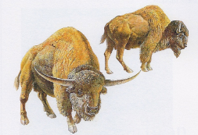
Represented here are two species of extinct bison known until the latest Pleistocene, and quite possibly later. Both species are larger than our present bison. The giant bison, Bison latifrons, is on the left, and the small bison, Bison antiquus, is on the right. Bison, especially the small liver species, B.bison, could well be included among some of the cattle mentioned in the Book of Mormon . Illustration courtesy of the George C. Page Museum in Los Angeles, California. [Wade Miller, Science and the Book of Mormon: Cureloms, Cumoms, Horses and More, p. 35]

Although now extinct, the shrub-ox and southern woodland muskox could have survived well past the end of the Pleistocene. When first described by paleontologists, these animals were placed in the same genus as modern cattle (Bos).
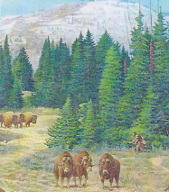
Restoration of extinct woodland muskoxen, Bootherium bombifrons, with a native hunter looking for bison. Muskoxen, recent and extinct forms, are also a type of cattle, and the extinct form here could have been encountered by the Jaredites. Living muskoxen, however, are now confined to Arctic regions, and commonly used for food and clothing by Alaskan Inuit people. (From Miller, 2002, “Quaternary Vertebrates of the Northeastern Bonneville Basin and Vicinity, Utah.” Original painting in the Prehistoric Museum, Price, Utah. Joe Venus, artist. [Wade Miller, Science and the Book of Mormon: Cureloms, Cumoms, Horses and More, p. 36]

This is similar to the mammoth (Mammuthus) being placed in the same genus as the elephant (Elephas) by early paleontologists. Current practices show that the American bison can be semi-domesticated. Certainly it is conceivable that both the woodland muskox and shrub-ox were capable of this as well. This is substantiated by some living northern muskoxen being semi-domesticated.
Bones of domesticated cattle (Bos taurus) have been reported from different caves in the Yucatan Peninsula of Mexico.80
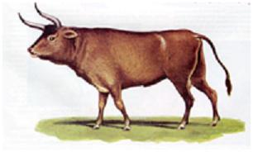
Bos taurus is a basic type which represents cattle in general, and apparently the species from which most of our modern cattle descended. Its remains have been identified from a number of archaeological sites including some from the Yucatan Peninsula.

In one instance these bones were found with those of an extinct horse, Equus conversidens. It is especially interesting that along with these cow and horse remains, human artifacts were found in association with them! The indication is that domesticated cattle and the horse coexisted with humans in pre-Columbian time.81

[Wade E. Miller and Matthew Roper, “Animals in the Book of Mormon: Challenges and Perspectives,” Interpreter: A Journal of Mormon Scripture]

Ether 9:18 All Manner of Cattle, of Oxen, and Cows, , and of Sheep, and of Swine, and of Goats:
According to Brant Gardner, in Ether 9:18 with the mention of cattle, oxen, cows, sheep, swine, etc, perhaps once again we find evidence of a translator shaping the original account. He writes:
This list is an obvious collection of the OId World domesticated animals. While there is an outside chance that the Jaredite barges carried breeding populations of these large mammals, realistically, by this point in time, any imported animals would have either become a major food source for the entire region or they would have died out. However there is currently no accepted evidence that these animals lived in Mesoamerica from 1100 B.C. forward. This passage is beset seen as Joseph Smith’s replacement of whatever was on the record [he was translating] with animals from his own environment. [Brant A. Gardner, Second Witness, Vol. 6: Fourth Nephi through Moroni, p. 259]

Ether 9:18 Swine:

According to John Sorenson, it is interesting that "swine" and "sow" are mentioned in the Nephite portion of the Book of Mormon with a tone of disgust (3 Nephi 7:8; 14:6). That's what we would expect among people who even nominally followed the constraints of the law of Moses on eating pork. But the non-Israelite Jaredites reveal no sensitivity about using "swine" as food (Ether 9:18). The peccary or wild pig was abundantly present throughout most of Mesoamerica, being valued both for its flesh and because it kills snakes in the wild. [John L. Sorenson, An Ancient American Setting for the Book of Mormon, p. 297]

Ether 9: 18 Swine:
Wade Miller and Matt Roper write that swine are mentioned as being among those animals known to the Jaredites which these non-Israelites found “useful for the food of man” (Ether 9:18). . . .

No evidence for Old World pigs (true swine) has been found showing that they were present in the Americas before the time of Columbus. If we assume swine were brought over by the Jaredites, we still do not know how long they might have survived before becoming extirpated. Being in limited numbers in a restricted region, any evidence of their former existence might not have been detected to date. The widespread and intensive battles between different Jaredite factions could have been instrumental in their demise in Mesoamerica.

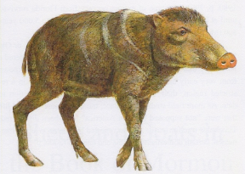
Platygonus shown here is an example of an extinct peccary that might have been present when man was in Mesoamerica. It was somewhat larger than the peccaries that live in the region today. It can be seen that both types are very pig-like and they both could easily be called a pig. Illustration courtesy of the George C. Page Museum in Los Angeles, California. [Wade Miller, Science and the Book of Mormon: Cureloms, Cumoms, Horses and More, p. 39]

Another reasonable possibility is that references to “swine” do not refer to the Old World species at all, but to American peccaries.

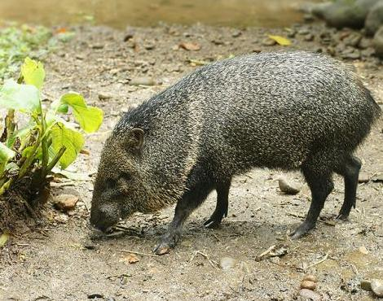
Collared Peccary near Las Horquetas, Costa Rica

While not a true pig, the peccary, known throughout much of Mesoamerica and South America, is most definitely a pig-like beast and is closely related to it. The early Spanish who encountered them called them “pigs.” In regions of Mesoamerica where peccaries are found today, they are almost always called “wild pigs” “wild hogs” or their equivalents in Spanish.”82 “The peccary,” argues Lyle Sowls, “if properly treated, could perhaps become a domesticated animal.”83 Brian Dillon has recently summarized evidence that the Maya may have captured and tamed peccary and concludes that it is “probable” that “the modern Maya pattern of peccary taming owes much to Precolumbian tradition.”84
Presently two distinct species of peccary live in Mesoamerica. These include the Collared Peccary (Pecari tajacu) and the White-lipped Peccary (Tayassu pecari), both of which can be found in the tropical regions near the Tuxtlas Mountains of the Yucatan.85 The Jaredites as they presumably established settlements in Mesoamerica no doubt would have encountered them. They were hunted and eaten as early as Olmec times. Remains of these animals have been found associated with man for several thousands of years.

There is a paleo-Indian carving of an extinct camel sacrum in the shape of a peccary. A Picture of this bone is shown by Evans.86 The bone of this extinct camel came from deposits in central Mexico, and shows ancient interaction between this extinct animal and Pre-columbian natives. Remains of Pre-Columbian peccary have been found finds in Loltún Cave in the Yucatan87and in several other caves in the region associated with human artifacts.88 There is no question that peccaries (“wild pigs”) and man shared this area since prehistoric times.

[Wade E. Miller and Matthew Roper, “Animals in the Book of Mormon: Challenges and Perspectives,” Interpreter: A Journal of Mormon Scripture]

Ether 9:18 Sheep:

In an article by the Book of Mormon Archaeological Forum Staff, they write:

When most people read the word “sheep” in The Book of Mormon, they usually think of the domesticated Ovis aries that is common in North America. This is not necessarily what The Book of Mormon is speaking of. One Hebrew word for sheep is zemer and is translated as “a type of mountain-sheep”17 which actually existed in Mesoamerica and could have been what the Book of Mormon was implying. There is also the definition from Strong’s Exhaustive Concordance, which actually means something similar to a gazelle “from its lightly touching the ground”. With this definition, it is possible that the word “sheep” could mean deer, antelope, gazelle, pronghorn, chamois, or other like animals. While there are several alternatives to the meaning of the word “sheep”, there is evidence of actual sheep living in pre-Columbian Mesoamerica. “Real sheep's wool was found in a burial site at Cholula, Puebla, Mexico, in an archaeological setting that gave no other indication of dating after the Spaniards arrived.”18 And the “Bones of pre-Columbian domestic goat were reported from caves in the Yucatan Peninsula of Mexico.”19 To say that they didn’t exist in Mesoamerica is not only inaccurate, their existence there is actually an evidence for the Book of Mormon and the Mesoamerican theory.

[BMAF Staff, “Response to George Potter’s ‘Ten Reasons why Mesoamerica is Not Book of Mormon Lands’,” Book of Mormon Archaeological Forum]

Ether 9:18 Sheep:

Wade Miller and Matt Roper write that sheep were probably among the animals brought to America by the Jaredites, although they were not stated explicitly by name (Ether 6:4). They most likely are to be included in the term “flocks,” and are mentioned by name in Ether ( 9:18) several generations later.

Sheep have been useful to man for many centuries and were probably man’s first domesticated animal90 (along with the dog). They are useful for both food and clothing. In addition to Old World sheep, apparently brought to the New World by the Jaredites, there are sheep native to America. The most common type is the Mountain Sheep, Ovis canadensis.

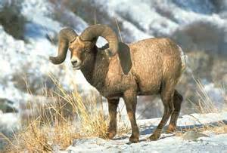

Bighorn sheep

Their current geographic range extends south only to northern Mexico. However, their past range was more extensive, as was their habitat before human settlements expanded.91 They are an animal that can be tamed or at least semi-domesticated. According to Geist , “It is hard to imagine a wild animal more readily tamed than mountain sheep.”92 Sorenson noted the apparent recovery of sheep wool from a pre-Columbian burial site near Puebla (southeast of Mexico City).93Petroglyphs from Mexico and the southwestern United States show many prehistoric depictions of sheep. It appears certain that the association of sheep and man occurred in America before this animal was brought over beginning in 1493 with Columbus’ second voyage.

[Wade E. Miller and Matthew Roper, “Animals in the Book of Mormon: Challenges and Perspectives,” Interpreter: A Journal of Mormon Scripture]

Ether 9:18 Goats:
Wade Miller and Matt Roper write that goats are mentioned among the animals once had by the Jaredites (Ether 9:18). Later, after their arrival in the land of promise Lehi’s family encountered “the goat and the wild goat” as they traveled in the wilderness in the land southward (1 Nephi 18:25). . . . It is possible that some of those encountered later by Lehi’s people were descendants of those had by the Jaredites. They would have been a useful animal to both the Jaredites and Nephites, just as they have been for man through the ages in the Old World.
Evidence of goats associated with pre-Columbian man also comes from caves in Yucatan.94 It was not made clear whether this was a wild or a domesticated type of goat . . .
The only native wild goat in North America is the Mountain Goat, Oreamnos americanus.
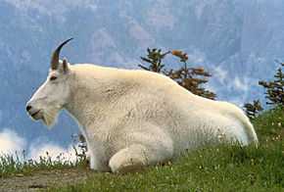
Mountain goat – This photo of the living mountain goat provides a general ideda of what the extinct species, Oreamnos harringtoni, looked like . . . (Photo by courtesy of the U.S. Fish and Wildlife Service) [Wade Miller, Science and the Book of Mormon: Cureloms, Cumoms, Horses and More, p. 43]

Its geographic range, though, currently only extends south from southwest Alaska down to the northwest United States. Even with a possible extended range for this animal during Book of Mormon time, it is extremely unlikely it got as far south as Mesoamerica. A closely related, but extinct, species is Oreamnos harringtoni.
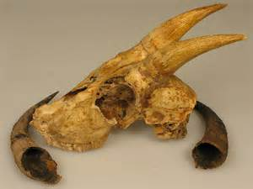
Skull of Oreamnos harringtoni

This goat did have a much more southerly distribution, extending into Mexico. While this goat might have survived much past the terminal Pleistocene along with other animals, there is not sufficient evidence yet for this.
It has already been indicated that a referenced animal in the Book of Mormon could actually be something somewhat different, but had a similar appearance. There is an animal now living in Mesoamerica that fits this description, the Red Brocket deer, Mazama americana.

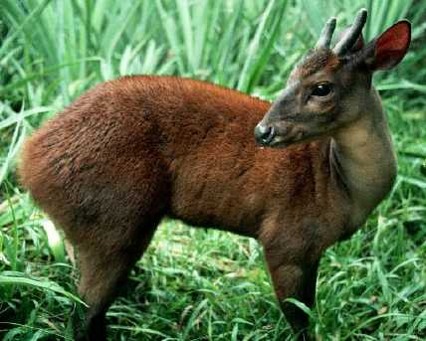
Brocket deer -- Mazama americana

Unlike other deer it has but a single goat-like horn – which is really an antler that is shed and regrown annually like other cervids. ⁹⁶

Although surprising to us today, evidence suggests that some species of Amerindian deer may have been raised and shepherded as “flocks” in pre-Columbian times. When the early Spanish explorers first visited what is now the southeastern United States, they encountered Native Americans who raised semi-domesticated deer. Men from De Soto’s expedition reported that in Ocale, an Indian town in northern Florida, “there is to be found . . . fowls, a multitude of turkeys, kept in pens, and herds of tame deer that are tended.”⁹⁷ According to the 16th-century Spanish historian Gómara, in Apalachicola (that is now the state of Florida), “there are very many deer that they raise in the house and they go with shepherds into the pasture, and they return to the corral at night.”⁹⁸ Another early historian of Spain, Peter Martyr d’Anghiera, recorded:

In all these regions they visited, the Spaniards noticed herds of deer similar to our herds of cattle. These deer bring forth and nourish their young in the houses of the natives. During the daytime they wander freely through the woods in search of their food, and in the evening they come back to their little ones, who have been cared for, allowing themselves to be shut up in the courtyards and even to be milked, when they have suckled their fawns. The only milk the natives know is that of the does, from which they make cheese.⁹⁹

Additional evidence suggests that deer may have been tamed or semi-domesticated in pre-Columbian Mesoamerica as well. According to Diego de Landa, Maya women “let the deer suck their breasts, by which means they raise them and make them so tame that they never will go into the woods, although they take them and carry them through the woods and raise them there.”¹⁰⁰ When the Spanish passed through the region of Guatemala and Honduras, they likewise encountered and easily killed fallow deer that were not afraid of them.¹⁰¹ Their tameness seems to have been due to the Maya practice of taming or husbanding them. Some Mesoamerican scholars, “… are convinced that small herds of tamed or semi-domesticated deer ranged through Maya sites, with a result not dissimilar in some respects to the ‘deer parks’ of European royalty.”¹⁰² When they entered the region of what is modern El Salvador, the Spaniards encountered a native people known as Mazahuas, who took their name from the practice of possessing and shepherding herds of “white deer,” which disappeared shortly after the Conquest.¹⁰³

Ethnohistorical sources also mention the Mesoamerican custom of caring for deer. Anthropologist Mary Pohl notes that the term “ah” in the Motul dictionary refers to “venadillo pequeño criado en casa,” that is, “a little deer raised in a house.”¹⁰⁴ Also related is the Maya term Mazatenango (from Mazatl-tenen-co), which means “en la cerca o muralla del ciervo,” that is, “inside the fence or wall of the deer.” One researcher suggests, “Perhaps the name originated in the custom of fencing or corralling deer to care for them.”¹⁰⁵ Deer were an important animal in many pre-Columbian rituals and were often sacrificed.¹⁰⁶ In the Guatemala highlands today, some Indians believe that deer are intermediaries between men and the gods and that they speak with the gods in order to cleanse the sins of men.¹⁰⁷

In light of the evidence for deer shepherding in pre-Columbian times, it is interesting that early Spanish colonists in Mesoamerica associated native Mesoamerican brocket deer with the goat. Friar Diego de Landa noted, “There are wild goats which the Indians call yuc. They have only two horns like goats and are not as large as deer.” He likewise described the small brocket deer as “a certain kind of little wild goats [sic], small and very active and of darkish color.” ¹⁰⁸ In the late 16th century, another Spanish friar reported that in Yucatán “there are in that province . . . great numbers of deer, and small goats”—the latter again apparently referring to the red brocket deer native to southern Mesoamerica.¹⁰⁹
In post-Columbian times the Maya, recognizing a similarity between the European goat and the New World brocket deer, gave the European animal the name temazate from the Nahuatl word for brocket deer (tamazatl). Since some Mesoamerican deer could fulfill many of the same purposes as goats, it is quite possible that Mesoamerican deer acquired a similar designation among peoples in the Book of Mormon.

[Wade E. Miller and Matthew Roper, “Animals in the Book of Mormon: Challenges and Perspectives,” Interpreter: A Journal of Mormon Scripture]

Ether 9:19 They Also Had Horses:

“If Joseph Smith had been writing the Book of Mormon instead of translating it from ancient records, he would have been very foolish to have included references to horses on the American continent in Book of Mormon times. (1 Nephi 18:25; Enos 21.) In 1830, nearly all the historians and scholars were convinced there had been no horses on the American continent before the coming of Columbus.
(The Book of Mormon Message and Evidences [Salt Lake City: Deseret News Press, 1953], pp. 88-89.)” (Daniel Ludlow, A Companion to Your Study of the Book of Mormon, p.117)
[josephsmith.com . . . Ether ]

Ether 9:19 And They Also Had Horses and Asses:

A FARMS report notes that the Book of Mormon mentions horses, yet these animals seem not to have been known to native Americans who greeted the Spaniards upon their arrival in the New World in the sixteenth century. Moreover, archaeological evidence for the presence of the horse in the pre-Columbian Americas is presently scant and inconclusive. How can this be explained? Careful consideration of this question begins with an examination of what the Book of Mormon says and does not say about horses.

Horses are mentioned only once in the land northward during the Jaredite period--that is, during the prosperous reign of King Emer around 2500 B.C. and before the great drought sometime in the third millennium B.C. (see Ether 9:19, 30-35). Since horses are not mentioned again in the Jaredite record, it is possible that they became extinct in the region north of the narrow neck of land following that time.

However, small herds of animals in a limited region sometimes leave no archaeological remains. Even if horses had been abundantly used and had been a vital element in the culture of Book of Mormon people (a claim never made by Book of Mormon writers), one cannot assume that evidence for this would be plentiful or obvious from the current archaeological record.

"It is probable," writes Jacques Soustelle, an authority on the Olmec, "that the Olmecs kept dogs and turkeys, animals domesticated in very early times on the American continent, but the destruction of any sort of bone remains, both human and animal, by the dampness and the acidity of the soil keeps us from being certain of this." We also know that the Norsemen probably introduced horses, cows, sheep, goats, and pigs into Eastern North America during the eleventh century A.D., yet these animals did not spread throughout the continent, or at least they have left no archaeological remains. The horse was the basis of the wealth and military power of the Huns of central Asia (fourth and fifth centuries A.D.). Nonetheless, according to S. Bokonyi, a leading authority on the zoological record for central Asia, "We know very little of the Huns' horses. It is interesting that not a single usable horse bone has been found in the territory of the whole empire of the Huns. This is all the more deplorable as contemporary sources mention these horses with high appreciation." [FARMS Research Report, "Horses in the Book of Mormon," http://farms.byu.edu/web/reports/horses.asp] [See the commentary on Alma 18:9]

Ether 9:19 They Also Had Horses, and Asses, and There Were Elephants (Extinction?):
Wade Miller and Matt Roper write:
It seems prudent to discuss extinctions in this article as this relates to some of the Book of Mormon animals. Extinction is a topic that has been extensively dealt with in the scientific literature. Of specific interest here are the widespread extinctions that occurred at the close of the Pleistocene (or Ice Age) Epoch, especially throughout North America.⁵³ The mammoth (elephant), horse and ass are animals listed in the Book of Mormon that presumably became extinct in North America at the close of the Pleistocene, about 10,000 years ago. Cureloms and cumoms mentioned in the Book of Ether (9:19) probably represent extinct animals, too. This seems likely as Joseph Smith apparently wasn’t able to relate them with any living animals. He seems to simply have transliterated the words on the gold plates from which he was translating.
While figures will vary among researchers, probably the total number of plant and animal species living today is no more than 1% of all those that ever lived on earth.⁵⁴ This means that about 99% of all life that ever lived on earth is now extinct. Sometimes extinctions will affect a single species, but more often they affect many because of interconnections of life forms. In the history of the earth there have been times of mass extinctions in a short period of time.⁵⁵

It should be realized that extinctions are a natural process in the history of the earth. As conditions are ever changing on earth, life forms are forced to adapt, or else die out (i.e., become extinct). The dying out of the mammoth, horse and ass in North America presents only a small part of the mass extinctions that occurred at the end of the Pleistocene. This particular extinction event affected mostly large mammals.⁵⁶ . . .

The fact that the mammoth (elephant), horse and ass were supposed to have been extinct in North America during Book of Mormon time has caused many to doubt, if not disbelieve, this Book’s authenticity and Divine origin. It is therefore vital to have a clear understanding of when these animals actually became extinct on this Continent. It should be realized that obtaining an exact date for the last surviving member of any extinct species would be next to impossible. Winning the lottery would be thousands of times more likely. As one team of scientists has observed, “The youngest reliably dated macrofossil (usually a bone or tooth) of an extinct species is commonly taken to represent the approximate time of its disappearance.

In practice, however, there is a very low probability of discovering fossil remains of the last members of any species, so ages for extinction based on dated macrofossil finds will likely be [show as]older than the true ages.”⁵⁷ Only a miniscule number of the animals that have lived on earth have become fossilized or preserved. And even though an animal might have been abundant in an area in the past, its remains (including fossils) could well go undetected, or not even exist.

The Central Asian and Eastern European Huns reportedly had hundreds of thousands of horses. Yet remains of these horses are now nearly nonexistent.⁵⁸ Archaeologists were earlier convinced that camels were not present in Egypt during the time of Abraham. However, it was later found that they were indeed continually present from prehistoric times to the present.

The tapir (a relative of the horse and rhinoceros) is known from the famous Pleistocene deposits of Rancho La Brea in Los Angeles, California. However, only three small foot bones attest to its presence there.⁵⁹ It was just fortuitous that these bones were found among the more than one million fossils collected. Otherwise the existence of this animal there would have been unknown.

The fossil record clearly shows that extinction is fact; but extinctions are not limited to the distant past. Numerous extinctions have occurred in recent times as well, and are continuing. More than 339 animal species (not including insects and fish) are known to have become extinct in just the last four hundred years (most of these during the 19th and 20th Centuries).⁶⁰ . . .

From the above information it should be seen that populations of animals (or plants) could be living for prolonged periods, and then later show little or no evidence of their existence. A classic example of this is the coelacanth. This is a rare fish which can reach lengths over six feet, and weigh nearly 200 pounds. It was once considered to have become extinct over 65 million years ago. Then in 1938 it was found to still be living in the ocean off the coast of eastern Africa!⁶² This fish has now also been found in the seas of Indonesia.
Additional examples of animals thought to be extinct for thousands to millions of years, but then were found to be still living, could also be cited. Therefore, it is certainly possible for an organism to live on a few thousands of years after their last recorded appearance. This undoubtedly has happened in the case of Pleistocene vertebrates, as more recent last occurrence dates have been coming out in the scientific literature.⁶³ This includes the horse and mammoth in North America.

As indicated above, extinctions of species are rarely instantaneous; it only appears so in the geologic sense. Usually it takes thousands to more than a million years for this to happen. In the case of Pleistocene vertebrate extinctions, it’s likely that it took thousands of years to eliminate a species. This can be explained by unfavorable environmental conditions developing for certain species. This undoubtedly occurred at the close of the Pleistocene Epoch (Ice Age) when much of the world’s climate was changing in a short period of time.

Applying this situation to Pleistocene mammals, as the climate and environment changed it would cause them to move into more restricted areas where they could still survive. As favorable areas further diminished in extent, the populations of a given species would also decrease as food supplies lessened. Finally a point would be reached where the breeding population would become too small to sustain itself for long. Extinction of the species would then occur. It should be readily seen that as dwindling of numbers within a species was taking place over a prolonged period, that the numbers of potential fossils would also be reduced. One reason why more recent dates of extinct animals are now being discovered is that more and more scientists are searching for them.

Mammals other than the mammoth and horse in North America now have more recent last occurrence dates. For example the mastodon was considered to be extinct at the end of the Pleistocene, 10,000 years ago. But this presumed last occurrence date had to be revised with more recent finds. One was that of two individuals discovered in Utah that were dated at 7,070 years before the present (Miller, 1987). A date of less than 6,000 years before the present was given by Mead and Meltzer (1984).The mastodon should have survived even later than this. . . .

One of the goals of the archaeologist is in trying to obtain accurate dates for the artifacts or fossils uncovered. One of the most precise methods of obtaining dates for the past 70,000 or so years is by Carbon-14 dating. However, many if not most of the bones and teeth tested lack sufficient collagen (an animal protein useful in C-14 dating) for this. So it is indeed fortunate when a date for a given sample yields usable results. . . .

There are records of extinct animals in North America being associated with man.⁶⁶ However, the dates of these associations either predate Book of Mormon peoples, or else they are not known. So, why are there no dates that do correspond to the time Jaredites and Nephites inhabited North America? As discussed above it was shown that species on their way to extinction would continue to live on, but in greatly reduced numbers, beyond their last recorded date of existence. The problem is finding specimens immediately prior to their extinction. It is a serious problem, as with fewer and fewer animals finding their remains is ever more difficult. Concomitantly, the area(s) where they still survive would almost always be more restricted. And if these areas are in highlands the problem is exacerbated. Highland areas are ones undergoing erosion with a lesser chance of preserving animals living in them. It should be kept in mind that Mesoamerica consists of many highland (mountainous) areas. Additionally, this area is mostly humid, especially in its southern extent with sub-tropical to even tropical conditions. In areas such as this animal and plant remains quickly decompose and are destroyed without leaving a trace. Even if an organism is buried before it decomposes, the commonly acidic soils continue the process. With the generally abundant vegetation in a region, there would be very limited areas of exposed ground where bones or teeth might be observed.

This combination of factors shows that a significant record of past life in Mesoamerica would be very difficult to uncover. As archaeologists as well as paleontologists have discovered, most animal remains are not preserved and are lost for all time.⁶⁷ In large part this is due to the conditions listed above. The best opportunity appears to be finds in caves. Some caves in the Yucatan have yielded human artifacts associated with an extinct horse.⁶⁸ Verification of more associations of Book of Mormon peoples and animals listed in this book can be expected at some future date.

[Wade E. Miller and Matthew Roper, “Animals in the Book of Mormon: Challenges and Perspectives,” Interpreter: A Journal of Mormon Scripture]

Ether 9:19 And They Also Had Horses and Asses:

Glen W. Chapman notes that the Book of Mormon has received severe criticism because of statements regarding the horse. The Smithsonian in its "statement Regarding the Book of Mormon" prepared by the Department of Anthropology, National Museum of Natural History, Smithsonian Institution, Washington, DC SIL-76, Summer 1982 reports: "American Indians had no . . . horses, donkeys, camels before 1492 (Camels and horses were in the Americas along with the bison, mammoth, and mastodon, but all these animals became extinct around 10,000 B.C). Since that statement a number of findings have been made which are strange to say the least and require careful investigation. Some of these findings are shown below.

In the following reference from a book by T. L. Tanton, Geological Survey of Canada Memoir 167-Fort Williams and Forth Arthur and Thunder Cape Map-Areas, pp. I-222, Ottawa, 1931:

Relics were discovered July, 1918 in an excavation made by the Canada Car and Foundry Company about 80 feet north from the turning basin Westforl. About twelve bones of a mammal and a finely made copper spearhead were found together about 40 feet below the surface of the ground. The materials found were submitted to the Geological Survey and Harlan I. Smith, archaeologist, reported the results of examination as follows:

According to Mr. Lawrence I. Lambe, vertebrate paleontologist of the Geological Survey and Mr. Sternberg, preparator of paleontological specimens, the bone marked B11 . . . is of a cloven-footed animal, possibly a buffalo, or a specimen of domestic cattle . . . Bones marked B10 and B12 to B13 inclusive, Mr. Lambe and Mr. Sternberg both pronounced to be those of a horse and not petrified. Mr. Sternberg is convinced that most of them belong to the same individual. The point with the flanged tang made of copper marked C1 is characteristic and typical of prehistoric Indian handiwork."

Griffin and Quimby, who investigated the site in 1957, noted that if the bones and copper artifacts were found in situ, they predate the Nipissing stage of the Lake Superior basin (pre-2000 B.C.) since they were on a bed of blue clay under layers of sand deposited by flooding during that period. (Quimby, The Old Copper Assemblage and Extinct Animals, American Antiquity, Vol. 20, No. 2, pp. 169-70, Salt Lake City, University of Utah.) [Glen W. Chapman, "Horses and the Book of Mormon," http://www.2s2.com/ chapmanresearch/user/documents/horses.
html] [See Enos 1:21; Alma 18:9; 3 Nephi 3:22]

Ether 9:19 And They Also Had Horses and Asses:

Daniel Johnson writes that the existence of ancient, indigenous horses on the American continent was only first accepted in 1848, when Richard Owen described a fossil horse from South America. The first scientific paper on ancient horses in the Americas was published that same year by Joseph Leidy. But now, horse fossils, bones, and teeth have been found in North, Central, and South America. Many varieties of ancient American horse are known, including the Western Horse (Equus occidentalis), the Mexican Horse (Equus conversidens), the Yukon Horse (Equus lambei), Scott’s Horse (Equus scotti), and the Complex-tooth Horse (Equus complicatus). Some of these varieties were quite large, growing to the size of modern species. The remains found in the Yucatán have been classified as E. occidentalis and E. conversidens.

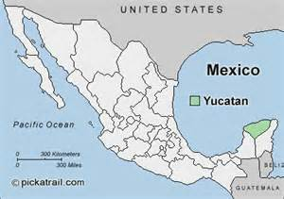
Location of the State of Yucatan, Mexico

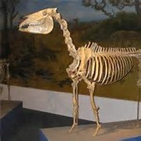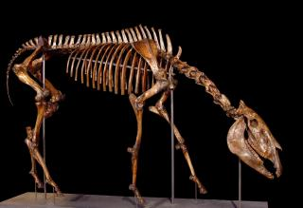
Equus Conversidens Equus Occidentalis

Johnson notes that all of these horses are now extinct, but the question of when and why they became extinct remains. It is now believed that horses, elephants, and other large animals evolved in the Americas first before migrating over the Bering Land Bridge to Asia long ago. Why they flourished there and died out here is still a mystery, especially for horses, which have thrived in the wilds of North and South America since being re-introduced by Europeans.

[Note* According to Wikipedia, Loltun cave is located about 70 miles south of Merida. It is one of the most extensive caves in all Mexico according to prolonged examinations of over two kilometers. Inside Loltún there is evidence that confirms human occupation such as recovered bones of mammoth, bison, cats, and deer remains from the pleistocene. On the walls you can observe natural formations and paintings, hand painted with representations of the technique of negative human faces painted on the walls, sculptural representations, representations of animals and some geometric shapes. Tools were also recovered.]

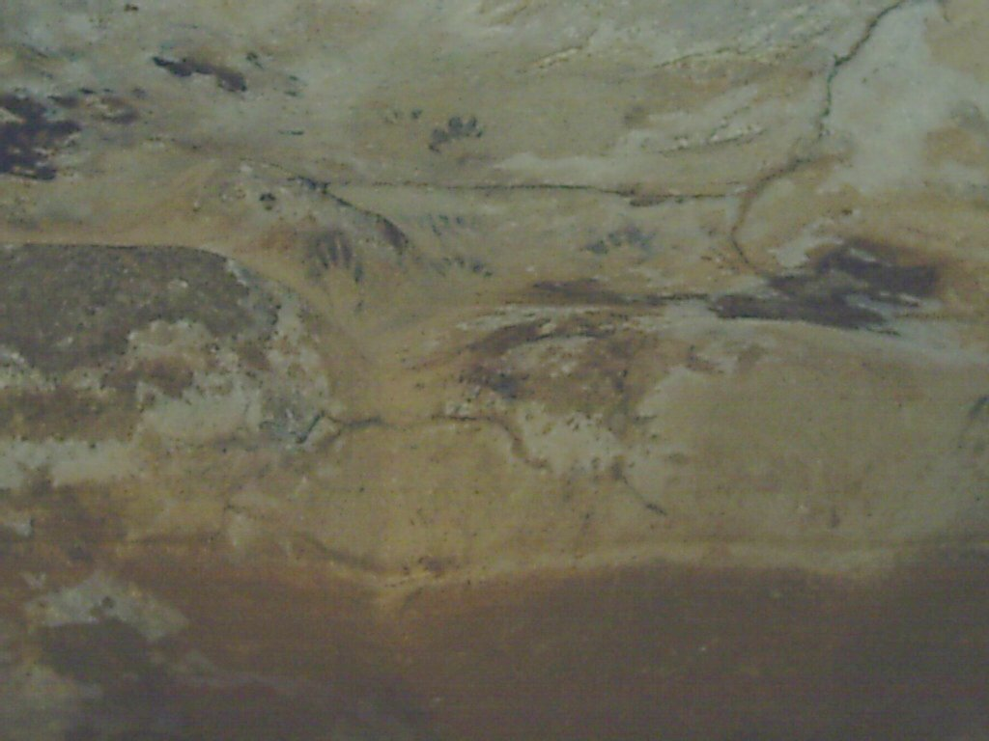
Painting from Loltun Cave
Daniel Johnson continues:

The bones and artifacts found in 1977 in two lateral extensions of the Huechil Grotto in the Loltún Cave, known as El Túnel and El Toro, have been described by Dr. Peter Schmidt of INAH as ‘problematic’ and ‘complicated.’ Unfortunately, very few details about the findings have been published. Most of the data come from stratigraphic excavations in El Toro. Labeled I to XVI, the levels represent the caves’ chronology, with I being the most recent and XVI the most ancient. Bones and bony fragments of Pleistocene megafauna have been found in most of El Toro’s levels, but the only published radiocarbon dating comes from levels VII and VIII. Taken from various pieces of charcoal, the date is 1805 B.C., with an error of +/- 150 years, well after the Ice Age. But this is not all. ‘Sadly,’ as Dr. Schmidt laments, 44 horse bone fragments have been recovered from levels VII to II, all supposedly from earlier time periods and also containing Maya Classic and Preclassic ceramics! Schmidt’s article exclaims that something has happened in Loltún that is still hard to explain: The survival of extinct animals like the Mexican Horse may need to be extended to the beginnings of the ceramic era, which would not please paleontologists.

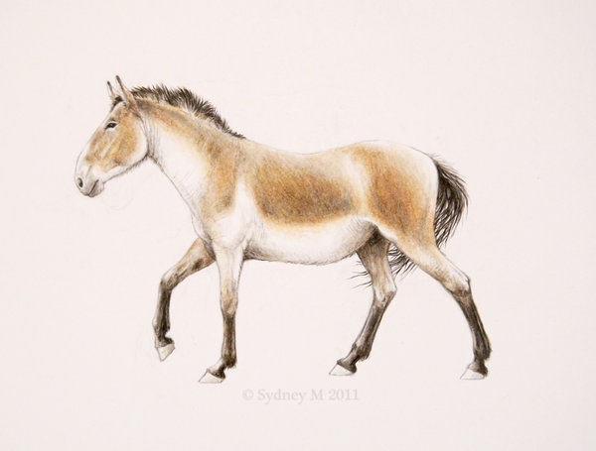
Equus Conversidens (The Mexican Horse)

This and other hard evidence of pre-Columbian horses means that we should not be too apologetic about their appearance in the Book of Mormon, nor do we have to go to extraordinary lengths to explain them. There are still some controversial elements in the scriptural record that we may never be able to explain, but the existence of horses in Ancient America is not one of them.
[Daniel M. Johnson, “Ancient Horses and the Book of Mormon,” Book of Mormon Archaeological Forum]

Note* BMAF member David Swingler adds following comments:

This is a wonderful article. My father was a science teacher who worked at the La Brea Tar pits in Los Angeles, thus by the time I was introduced to the Church and to The Book of Mormon at age 18, the existence of elephants and horses in the Americas was no surprise to me. All LDS must remember: very few animal bones fall in places where they can ever become fossilized. Virtually all bones fall in places where conditions never preserve the bones - which decay into dust within short decades. The fossilization process is very rarely created on land and it is numerically miraculous that any bones are ever preserved.

Regarding the actual date of the final extinction of the horse, elephant and other large species in the Americas, we must remember: only animals whose bones landed in a "fossilization-friendly" environment such as asphalt pits or other perfect water-soil conditions capable of preserving the bones, ever are preserved. Bones decay on the surface within years; even burial in most soils they decay within a few centuries . . .

We as Latter-day Saints must further remember: fossil-preserving sites are reliable for dating only the presence of animals up to the last specimens captured in the fossilizing tar or soil of each site; the day that site venue clogs up, or is filled in, or conditions change so that no more bones are "collected" and preserved by the site, that site's history ends. Meanwhile animals in the area continue to survive, only they are no longer "collected" by the closed fossilizing site.

Paleontologists persistently ignore the fact that just because animals seemingly disappear from the layers of sediment does not mean there were no more animals alive surviving for even thousands of years. It only means that the fossil-gathering site was filled in and stopped processing fossils.

Paleontologists persistently refute the reality that natural closure of a fossil-preserving site (or change of habitat range of animals taking them away from such rare fossil-preserving sites) does not in any way signal the extinction of a species, which may survive for extensive periods with all dying animals bones' falling in non-preserving conditions - i.e. almost everywhere.

Thus evidences such as the cave floors mentioned in this article may be, even into the future, the only sites where evidences of the horse and elephant's continued survival and existence into almost-modern time may be preserved to us.

These reported findings are wonderful. Hopefully future cave-floor digs will more carefully catalog and keep such remains for full study and analysis. As for the final extinction of these species, the most probable cause of these large animal's extinction is man, needing them for food. Our history of exterminations is catastrophic in historic time, continuing today. To site as example the extinction of the once profusely abundant Passenger Pigeon is a very recent page in United States history of our great-great-great grandparents. [David Swingler, “Comments appended to Daniel Johnson’s article, “Ancient Horses and the Book of Mormon,” Book of Mormon Archaelogical Forum]

Ether 9:19 They Also Had Horses and Asses:
In Ether 9:19 “horses” and “asses” are mentioned. Wade Miller and Matt Roper write that the horse and ass, like sheep and goats, are very closely related mammals. This can be seen in the biological classification of the former two, both belonging to the genus, Equus.

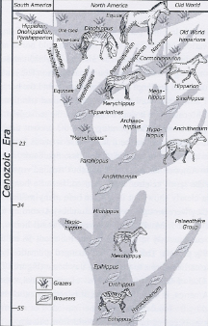

Equid fossils are one of the most common and diverse of large vertebrates throughout the Pleistocene of North America, including Mesoamerica. Many species have been named. Horses first came into being in North America (one of the earliest records coming from Baja, California), and from there spread to the rest of the world through natural dispersals. The fossil history of the horse (including the ass) shows that this animal was most numerous and varied in North America. It has not been satisfactorily explained why after so much success here, they became extinct. After being re-introduced they have done well in a feral state. Although it is commonly held that both the horse and ass became extinct in the Americas at the close of the Pleistocene (c.10,000 years ago), a growing body of evidence indicates that at least some survived on this continent much longer.
Some researchers in the past have suggested that references to horses in the Book of Mormon could refer to other animals in the land of promise which had characteristics which in certain ways resembled those of the horse or the ass.¹³⁹ While this is possible, we believe that it is most likely that the horse mentioned was the horse as we know it. However, this does not mean that they survived everywhere in the Americas or that they were numerous. Growing evidence, though, supports a post-Pleistocene survival of very small populations. Therefore, references to horses in the Book of Mormon text seem very plausible. We feel that there is a strong case for the survival of the horse well past the close of the Pleistocene Epoch into the limited regions occupied by Book of Mormon peoples in the Formative Mayan Period. Horses are not mentioned in the Book of Mormon after the time of Christ (3 Nephi 6:1) . . . If there were limited numbers of horses and asses in Nephite or Lamanite cultures, it would not be surprising that evidence for them could be very difficult to find.

The horse and the ass along with other animals dispersed more than once between Asia and North America via Beringia (This was a very large late Pleistocene land bridge that existed between Asia and Alaska). The Beringia land bridge formed and reformed throughout much of the Pleistocene Epoch. This produced common species between the two continents. As many began adapting to new environments, new species came into being. The horse was one of these animals so affected. Similarity has and still does cause confusion as to which species are valid.¹⁴⁰ Therefore, ones reintroduced by the Spaniards would be difficult if not impossible to distinguish from native forms based on their bones and teeth. If the Jaredites did bring horses to America from Asia, it would be very unlikely if they could be told apart from those that came through by natural dispersals. According to Azzaroli, a noted expert on Pleistocene horses, Equus ferus (a modern caballine horse) was widespread in the Pleistocene of Eurasia and well represented in North America during the latest Pleistocene.¹⁴¹

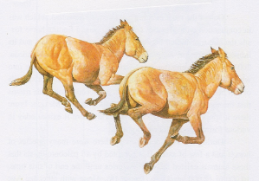
Depiction of the Pleistocene horse, Equus, that was typical of those in North and Central America. Their fossils are among the most numerous of large mammals from this time. As indicated in both the Jaredite and Nephite records, the horse (and the ass) were useful to these peoples. Whether the horse and ass were found in the New World by the Jaredites, or brought over by them, is uncertain. Either scenario is possible. (From Harris and Jefferson, 1985, “Treasures of the Tar Pits.” Courtesy of the George C. Page Museum. John Dawson, artist.) [Wade Miller, Science and the Book of Mormon: Cureloms, Cumoms, Horses and More, p. 76]

It seems reasonable to assume that the Jaredites had domesticated horses. Certainly they were present among the Nephites and Lamanites (Enos 1:21; Alma 18:9). Their domestication by these peoples should not be surprising. The horse has been domesticated by various peoples for millennia. Evidences for this keep pushing the date back. Outram and others placed this date to about 3500 B.C. This is based on discoveries in Eastern Europe and central Asia.¹⁴² The 3500 B.C. date well predates the Jaredite record. An even earlier date was suggested by Achilli et al. based on DNA.¹⁴³ If, as Nibley argued, the Jaredites journeyed through central Asia, this could be relevant. ¹⁴⁴ They surely would have seen the value of horses as they must have come across some of the peoples of that land using them. Whether they obtained horses along the way and brought these with them is not that important. As noted above, there were horses native to America which were most likely in existence then.

It cannot be overstated that extinctions take time. Too often the impression left when extinctions are discussed is that they were all very sudden. Almost always with groups of organisms the extinctions took place over thousands to many thousands of years. And as already noted, some plants and animals thought to be extinct turned out to still be living even millions of years later. Until the past few decades almost all researchers on the subject thought that the majority of North America’s large mammals became extinct at the end of the Pleistocene. This of course excludes modern species of the bison, elk, moose and bears. The proboscideans and horses, thought to have become extinct at that time, have now been shown to have lived on much past the 10,000-year limit that was placed on them. In the past few decades an ever-increasing body of evidence shows that some of these taxa survived much longer. It should be kept in mind, though, that these animals were being restricted to various refugia. In time the refugia would disappear and the animal would finally become extinct. As an example the Woolly Mammoth thought to be extinct by the close of the Pleistocene, survived much past this event on Wrangle Island northwest of Alaska. Radiocarbon dates demonstrate that this animal was still living until approximately 2000 B.C.¹⁴⁵ Proboscideans and horses also survived past the terminal Pleistocene (c. 10,000 years ago) much further south in North America, extending into Mesoamerica. Of course their populations were ever dwindling.

A reason more is not known about the horse and other extinct animals in Mesoamerica is that their remains are much less likely to be preserved and also less likely to be found when they are. In general organisms do not preserve well after death in subtropical and tropical environments. This is because of a high rate of decay in them. Even bone decomposes very quickly. Therefore all evidence of previous life is soon destroyed. Another problem is that in these environments vegetation usually thickly covers sediments that might contain fossils. This makes them very difficult to find when they do exist. One exception is caves. Here organisms stand a much better chance of preservation in humid regions. This is true in Mesoamerica. The caves found in the Yucatan Peninsula have produced some rare and important finds. Both extinct and extant faunas have been discovered with human artifacts.¹⁴⁶

There are a few post-Pleistocene, pre-Columbian dates for horses that have come to light in the past several years. A recent discovery in southern California serves as an example. Philip Ireland reported, “Archaeologists working against the clock in Carlsbad have unearthed another nearly intact skeleton of a horse that may have lived and died 50 years before the Spanish began their conquest of California.” In this article it was said remains of another horse and a burro (ass) were buried at the same level.¹⁴⁷ Archaeologist John Sorenson relayed two radiocarbon dates for horses from Beringia of 2600 and 200 B.C.¹⁴⁸ In an unpublished article three other pre-Columbian dates were given for horses. One was from a cave near El Paso, Texas. The date here was determined to be between 6020 and 5890 B.C. Another radiocarbon date was from a cave in Colorado, providing an age of 1260 to 1400 A.D. A third date on horse bone from a cave in the Yucatan has been dated between 1230 and 1300 A.D.¹⁴⁹ If these last ages, and the one from Carlsbad, California prove valid, it presents evidence that some horses still survived in western North America even at the time Spaniards first reintroduced them in 1493! Horse teeth from another cave in the Yucatan which remain undated were said to be pre-Columbian in age.¹⁵⁰ These teeth were reported to be part of a large collection made near Mayan ruins at Mayapan. Here the extinct horse identified as Equus conversidens was found associated with pot shards and other artifacts of man. According to Velázquez-Valadez, “… a good number of bone instruments was found directly associated with remains of Pleistocene megafauna, principally the horse (Equus conversidens) and animals now extinct.” An age of 1805 B.C. (± 150 years) was given in this article.¹⁵¹ Some of the radiocarbon ages given above demonstrate that the horse existed in North America during the time of both the Jaredites and the Nephites.
Positive post-Pleistocene to pre-Columbian ages for horses in America are admittedly few. Nevertheless, more continue to be added to them. How many it will take to convince the major body of scientists, especially paleontologists and archaeologists, to accept this new paradigm is unknown. However, there are more horse specimens from Mesoamerica that are presently being run by the current authors for additional radiocarbon ages.

[Wade E. Miller and Matthew Roper, “Animals in the Book of Mormon: Challenges and Perspectives,” Interpreter: A Journal of Mormon Scripture]

Ether 9:19 They Also Had Horses and Asses, and There Were Elephants and Cureloms and Cumoms:

According to Verneil Simmons, Moroni lists the animals that the Jaredites used for food, such as the cattle, sheep, swine, goats, and "many others." Sumerian temple records, unknown in Joseph Smith's lifetime, list the domestic stock of that nation. They are the same animals – cattle, sheep, swine, goats, and the ass!" (See Leonard Wooley, The Beginnings of Civilization, p. 232)

Moroni then lists the animals that were "useful unto man," including horses, asses, and the elephants, cureloms, and cumoms. But it is very interesting that there is a difference in the way they are listed. They "had horses and asses," implying possession of domesticated animals, but "there were elephants, cureloms, and cumoms" (Ether 9:19). This hints that these last-mentioned animals existed in the land and were useful to them, but were not domesticated. It also hints at extinction. Since no Nephite word for "cureloms" and "cumoms" is given, perhaps they had become extinct and were unknown to the later nation. As for elephants, they had been part of the cultural history of the Fertile Crescent and were certainly included in the historical knowledge of the Nephites . . . Interestingly enough, geologists have recognized a period of excessively high temperatures which created the deserts of the Southwest. This is known as the Hypisthermal and peaked somewhere between 2000 and 1500 B.C. It is thought that the drouths which were caused by this hot period resulted in the extinction of the large grazing animals such as the mammoth, mastodon, camel, and giant bison. (See Michael Coe, Mexico, pp. 26-27) [Verneil W. Simmons, Peoples, Places and Prophecies, pp. 40-41]

Ether 9:19 There Were Elephants:

According to Hugh Nibley, it is quite significant that the Book of Mormon associates elephants only with the Jaredites (see Ether 9:19), since there is no apparent reason why they should not have been as common in the fifth as in the fifteenth century B.C. All we know is that they became extinct in large parts of Asia somewhere between those dates, as they did likewise in the New World, to follow the Book of Mormon, leaving only the written records of men to testify of their existence. [Hugh Nibley, The World of the Jaredites, p. 220]

According to Glenn Scott, until recently paleontologists said elephants were extinct by 10,000 B.C., but a National Geographic report says small mammoths survived as late as 1700 B.C., well into Jaredite times. [Glenn A. Scott, Voices from the Dust, p. 51]

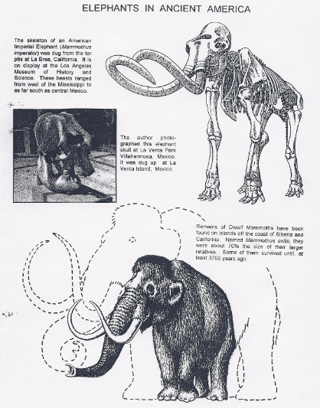
Ether 9:19 There were Elephants (Illustration): Elephants in Ancient America. A) The skeleton of an American Imperial Elephant (Mammuthus imperator) was dug from the tar pits at La Brea, California. It is on display at the Los Angeles Museum of History and Science. These beasts ranged form west of the Mississippi to as far south as central Mexico. B) The author photographed this elephant skull at La Venta Park Villahermosa, Mexico. It was dug up at La Venta Island, Mexico. C) Remains of Dwarf Mammoths have been found on islands off the coast of Siberia and California. Named Mammuthus exilis, they were about 70% the size of their larger relatives. Some of them survived until at least 3700 years ago (1700 B.C.) [Glenn A. Scott, Voices from the Dust, p. 50]

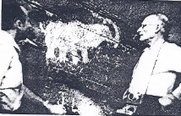
Ether 9:19 There were Elephants (Illustration): Petroglyph of an elephant done by some ancient artist on a canyon wall of the Colorado river near Moab, Utah. Clair Weldon and Roy Weldon in picture. [Roy E. Weldon, The Book of Mormon Evidences Joseph Smith a Prophet, p. 13]

Ether 9:19 Elephants:

John Hedengren notes that recently, the Smithsonian Museum of Natural History in Washington, D.C. had a display of ice age mammal skeletons, including a mammoth and a mastodon. Reflecting current evidence, a display sign states that the mastodon "may have survived until 2000 years ago." This is clearly within the time period of the Jaredites. Thus we have animals properly called elephants living around the probable time and in the proposed place of the Jaredites. [John Hedengren, The Land of Lehi: Further Evidence of the Book of Mormon, p. 106]

Ether 9:19 There Were Elephants:

According to Diane Wirth, the eminent Austrian ethnologist, Dr. Robert Heine-Geldern, reported to one Dr. Clyde Keeler that there were five elephant effigies found in Mexico, but because they were not found by bonafide archaeologists, professionals continue to disregard this controversial subject.

Dr. Verrill, a well-known archaeologist who did fieldwork for the Museum of the American Indian, Heye Foundation, describes a figure from Cocle, Panama, as follows: "The most astonishing of the idols is one bearing a figure which is so strikingly and obviously elephantine that it cannot be explained away by any of the ordinary theories of being a conventionalized or exaggerated tapir, ant-eater or macaw. Not only does this figure show a trunk, but in addition it has the big leaf-like ears and the forward-bending knees peculiar to the elephants. Moreover, it shows a load or burden strapped upon its back."

According to Diane Wirth, the rain god of the Maya, referred to as "the long-nosed rain god," is often endowed with a pronounced elephantine proboscis. It is well known that the elephant can fill its trunk with water and spew it out. Was this Maya design of the rain god, so often portrayed in their codices (books), an accident? [Diane E. Wirth, A Challenge to the Critics, pp. 51-52]

Ether 9:19 Elephants:

According to Matthew Brown, although the Jaredites immigrated to the New World around 2,500 B.C., the majority of paleontologists believe that elephants (Ether 9:19) became extinct about 25,000 years ago. However, there are three types of evidence to support the claim that elephants lived alongside man in the pre-Columbian New World.

The first type of evidence consists of the traditions of the native Americans. Widely separated native American tribes had similar traditions of seeing and hunting a huge animal that had a big head, large ears, and "teeth" long enough to pierce seven men. This creature fed upon the leaves of trees, slept by leaning against upright objects, and left behind large round tracks as it walked. The most interesting detail in the description of this beast is that it had "a fifth leg rooted between its shoulders," a "sort of arm which comes out of [its] shoulder;" a "long nose with which [it] hit people." This appendage was referred to among some of the Indian tribes as "a lip as long as seven paces." This creature, said the Indians, could use its "long nose" to uproot trees.

The second type of evidence consists of archaeological remains. Archaeological digs that pair New World elephants and human artifacts are not uncommon. By 1950 Macgowan had listed no less than 27 instances. In this category we have the complete mastodon skeleton found in 1928 in Quito, Ecuador that had lesions on its skull that could only have been inflicted by men who were attacking or butchering it. This skeleton had also been burned in several areas by fire. Man-made tools were found close to this mastodon's body and about 150 pieces of pottery surrounded it. The finer pieces of pottery were like "the fine Maya pots of the oldest Cuenca culture" and one had a design painted upon it "in Mayoid style." The pottery pieces dated to between 150 and 350 years after the time of Jesus Christ. Mammoth bones uncovered in 1887 in Attica, New York, were also found in association with a few fragments of charcoal. These artifacts were discovered twelve inches higher than many other pieces of charcoal and a fragment of pottery. "The associated human evidence found with or beneath the Attica mastodon bones," say Charles Schuchert, "is a positive hint that should open our minds to the possibility that man was associated in America with Mammut Americanum." We cannot fail to mention that a Carbon-14 date for mastodon remains in Richmond, Indiana, has been set at 3344 B.C., + 400 years. This is very close, geologically speaking, to the time frame of the Jaredite elephants. Finally, we will note that it was the considered opinion of Professor William B. Scott, "the doyen of American paleontologists," that mammoths may have still been living in the interior of the New World when the first Spanish explorers arrived.

The third type of evidence for the contemporary existence of men and elephants in the pre-Columbian New World consists of artistic representations. Some "sculptures and paintings of Mayan and Aztec origin" have long thin noses that curve either up or down and "they appear to portray elephants." In most cases," notes John Thompson, "these supposed elephants' trunks are the snouts of the long-nosed rain gods [or Chacs], and are clearly of ophidian origin, but in one or two cases the trunks are clearly very elephantine. The explanation is probably to be found . . . in a half-forgotten tradition of the mastodon. Recent discoveries have now shown that the mastodon lingered on for many centuries as a contemporary of man in the New World, and there is some evidence that in Ecuador one was slain by man not more than 3000 years ago, as the polychrome pottery associated with it attests." An art-work that may be relevant to this discussion can be found among the eighth century A.D. Mayan murals from the Temple of the Frescoes in Bonampak, Chiapas. A color reconstruction of these murals, in Mexico City's National Museum of Anthropology, shows an animal head that some observers take to be an elephant since it has a long trunk and a thin, white protrusion beneath the trunk that resembles a tusk. [Matthew B. Brown, All Things Restored: Confirming the Authenticity of LDS Beliefs, pp. 216-218]

Ether 9:19 Elephants:
Wade Miller and Matt Roper write that only in the record of the Jaredites in the Book of Mormon is there a mention of elephants (Ether 9:19). This undoubtedly referred to the mammoth which is a true elephant. Distant relatives, the mastodonts which represent other types of proboscideans, have lived in North America but were probably not the animal to which reference was being made. Joseph Smith most likely knew what an elephant was at the time he did the translating from the gold plates. However, not much was given about this animal in his translation of the Book of Ether. It was said to be an especially useful animal to man (Ether 9:19). Uses of the elephant for man have already been stated. Presumptively this elephant as previously stated was the Columbian Mammoth, Mammuthus columbi.

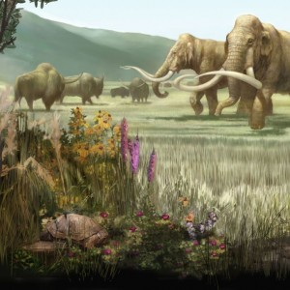
This figure of a late Pleistocene landscape in North America shows two Columbian mammoth on the right with extinct bison on the left in the background. Good evidence shows that these extinct forms were contemporaneous with man on this continent. Illustration from Karen Carr in North American Pleistocene landscape.

This animal ranged over most of North America, including Mesoamerica. Its fossils are numerous throughout northern Mesoamerica.¹¹² Many people think of the Woolly Mammoth, Mammuthus primigenius, when they think of mammoths. But this species was limited to the northern areas of North America and Eurasia.

Evidence for the survival of the elephant can be found in Native American myths and traditions. Some of these traditions may be rooted in Native American discoveries of the bones of extinct fauna, while other myths could be founded on actual encounters with living species which had notable elephant-like characteristics.

Indigenous people along the northern coast of the Gulf of Mexico have traditions of giant beasts with long noses that could trample people and uproot trees.¹¹³ Abenaki tradition tells of a great “elk” that could easily walk through more than eight feet of snow, whose skin was said to be tough and had “a kind of arm which grows out of his shoulder, which he makes use of as we do ours.” The Naskapi people tell of a large monster that once trampled them and left deep tracks in the snow had large ears and a long nose with which he hit people. The Penobscot culture hero Snow Owl is said to have gone on a long journey to a far valley in search of his missing wife. When he reached the valley he saw what appeared to be hills without vegetation moving slowly about. Upon closer inspection he found that these were the backs of huge animals with long teeth which drank water for half a day at a time and when they laid down could not get back up. Snow owl was able to trap the large beasts by making them fall on sharpened stakes where he then was able to shoot and kill them.¹¹⁴

Similar traditions have been documented for Native American groups from Canada to the Gulf of Mexico persuading some scholars that they are based upon a core memory of actual historical encounters with elephant-like species who may have survived into the region as late as 3,000 years ago.¹¹⁵
Pre-Columbian traditions from Mexico tell of monstrous ogre-like giants who once inhabited the region and were subsequently killed following the arrival of Aztec ancestors. These tales attribute some human characteristics to these legendary giants, while other ones seem less so. The giants were said to have long tapering arms and could tear up trees as if they were lettuce.¹¹⁶These legends say, notes Adrienna Mayor, “… that the giants destroyed by the ancestors pulled down trees and ate grass, elephant-like behavior.” and she suggests that these stories may reflect “a vague memory of prehensile trunks, something like the `extra arm’ of the Giant Elk in Abenaki and Iroquois myth.” While this cannot be proven, she thinks it possible that “…localized mammoth species (and other large Pleistocene animals and birds) may have survived to later dates in the Valley of Mexico and the Southwestern United States.” … and also that “some aspects of the legendary giant-ogres may have originated in ancestral memories of Columbian mammoths and may have been later confirmed by discoveries of fossils.”¹¹⁷

Along with a number of large mammals thought to have become extinct about 10,000 years ago, it’s now known that the mammoth survived for a few thousand years longer. This was long enough to bring them to the time of the Jaredites. A date for a mammoth in northern North America was cited at 3,700 years before the present.¹¹⁸ An Alaskan mammoth was dated at 5,720 years ago.¹¹⁹ In the contiguous United States Mead and Meltzer provided an age of 4,885 years for a dated mammoth specimen.¹²⁰ As more mammoth (elephant) finds are made, even younger dates will no doubt arise. Generally, when animal species’ populations decrease, they survive longer in southern refugia. Small populations could well have survived in Mesoamerica well past the close of the Pleistocene. The fact that known dates of mammoths in Mesoamerica are numerous up to the end of this epoch helps support this view. It should be pointed out that the mammoth never did range as far south as South America.

Man and mammoth have been found in association with each other at a number of Mesoamerican localities.¹²¹ Johnson stated that, “There can no longer be any reasonable doubt that man and elephant coexisted in America.”¹²² Since this statement was made even more sites showing this coexistence have been discovered. Several petroglyphs dating to ancient times in Mesoamerica depict elephant-like animals. Martin reported that spear points have been associated with fossil mammoths at a number of sites, some still embedded in bones.¹²³ Mammoth kill sites are known from Mesoamerica.¹²⁴ Martin also reported a spear shaft straightener made from a mammoth bone. The usefulness of the elephant has previously been given.

[Wade E. Miller and Matthew Roper, “Animals in the Book of Mormon: Challenges and Perspectives,” Interpreter: A Journal of Mormon Scripture]

Ether 9:19 Cureloms and Cumoms:

Hugh Nibley writes:

"They have plenty of iron, accarum, and andanicum," says Marco Polo of the people of Kobian. "Here they make mirrors of highly polished steel, of large size and very handsome." The thing to note here is not primarily the advanced state of steelworking in Central Asia, though that as we have seen is significant, but the fact that no one knows for sure what accarum and andanicum are. Marco knew, of course, but since the things didn't exist in Europe there was no western word for them and so all he could do was to call them by their only names. It is just so with the cureloms and cumoms of Ether 9:19. These animals were unknown to the Nephites, or else though known to the Nephites, they are out of our experience so that our language has no name to call them by. They were simply breeds of those "many other kinds of animals which were useful for the food of man." [Hugh Nibley, Lehi in the Desert and the Word of the Jaredites, pp. 217-18]

[Note* It is hard to know if Joseph had a knowledge of the animals of Central America (or South America) at the time of translaton. [Alan C. Miner, Personal Notes]

Ether 9:19 Cureloms and Cumoms:
Wade Miller and Matt Roper write that of all the animals named in the Book of Mormon, cureloms and cumoms have to be the most peculiar – and mysterious. While all the other animals seem familiar to us, these two definitely are not. Apparently cureloms and cumoms were not animals known to Joseph Smith as well. It seems that they were outside his realm of experience. Quite possibly these are extinct forms. Although we don’t have all the details regarding his translating procedures, the prophet Joseph most likely transliterated certain words, those with which he was unfamiliar. This seemingly applied to “cureloms” and “cumoms.” What could these two animals have been?

Well, they had to have been animals that lived in Book of Mormon lands, ostensibly in Mesoamerica, and during the time that the Jaredites lived there. LDS archaeologist, John Sorenson was of the opinion (1992) that cureloms and cumoms were probably large animals. This seems reasonable as in Ether 9:18-19 they are grouped with the elephant, and designated as being especially useful. Among other things, they likely were beasts of burdens. Using limited criteria we will try to narrow the search for identifications to the most probable animals.

One relatively large animal currently living in Mesoamerica (and also now living in South America and Southeast Asia), but doubtfully known to Joseph Smith, is the tapir.

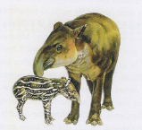
This restoration is of an extinct late Pleistocene tapir, Tapirus sp., with its young. Extinct tapirs are known in several parts of the world, with fossils in the New World coming from North, Central, and South America. Living species are found in Central and South America, as well as Southeast Asia. All living types come from humid areas, and are semi-aquatic. (From Harris and Jefferson, 1985, “Treasures of the Tar Pits.” Courtesy of the George C. Page Museum. John Dawson, artist. [Wade Miller, Science and the Book of Mormon: Cureloms, Cumoms, Horses and More, p. 56]
In the past this animal had a much greater northward geographic range in North America. It lived all through Mexico and north well into the United States. At least one species of Pleistocene tapir somewhat exceeded the living form in size. A large extant individual can grow to 600 pounds or more, and reach a height of three and one-half feet. The problem with this animal qualifying as a curelom or cumom is its usefulness. They are not noted as an especially good food item and more importantly are not easily tamed for use.

Another animal to consider is the American Pronghorn (often mistakenly called an antelope). Its current geographic range is from Canada to central Mexico.

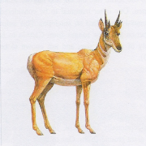
Only one type of antilocaprid (or pronghorn) now survives. Several species, though, lived in the Pleistocene of North America, down through Mexico. Shown restored here is one of these extinct species, Capromeryx minor. The living antilocaprid represents one of the largest types, while the one depicted here is much smaller. The size range of these animals is close to that of modern deer. It nowhere states how large cureloms or cumoms were in the Book of Ether, just that these animals were especially useful to man. The antilocaprid, based on the living species, has not been domesticated but is used for food. (From Harris and Jefferson, 1985, “Treasures of the Tar Pits” Courtesy of the George C. Page Museum. John Dawson, artist. [Wade Miller, Science and the Book of Mormon: Cureloms, Cumoms, Horses and More, p. 57]

They are occasionally tamed, and sometimes even semi-domesticated.¹²⁵ However, even if they were tamed, it is hard to imagine them being used for any serious type of work. There is apparently no record of this. These are only deer-sized animals, which includes extinct species. While known from northern Mexico, it appears that they did not inhabit Mesoamerica proper. They are a plains type of animal.

The edentates, or xenarthrans as they are known scientifically, are a relatively diverse group of New World mammals. With the exception of the armadillo which ranges into the southwestern United States, these animals presently live in Mesoamerica south to South America. Anteaters and tree sloths belong to this group. All these are animals with which Joseph Smith would probably have had no acquaintance. While living forms are all relatively small, many extinct species were large. The extinct ground sloths for example were very large, the largest being 18 feet in length and approaching the size of a small adult elephant.

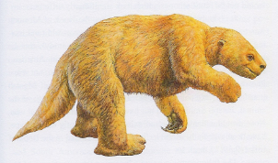
This restoration shows one type of giant ground sloth, Glossotherium harlani. There were several others known from the Pleistocene epoch, and possibly later, from North America. Whether this animal or its close relatives would have been useful to man, as were cureloms or cumoms mentioned in the Book of Ether, is very doubtful. The size of their brains indicates an animal that was probably not intelligent enough to be used as a beast of burden. Based on living tree sloths, their meat was probably inedible. (From Harris and Jefferson, 1985, “Treasures of the Tar Pits.” Courtesy of the George C. Page Museum. John Dawson, artist. [Wade Miller, Science and the Book of Mormon: Cureloms, Cumoms, Horses and More, p. 59]

Some of these ground sloths lived in Mesoamerica to the end of the Pleistocene, and probably longer. There are several localities where ground sloth hair and dung are abundant in caves, some with associated human artifacts. Additionally, even skin and nail materials are known.¹²⁶ Even if these mammals had lived long enough to have been known by Jaredites, their role as a curelom or cumom is highly unlikely. Based on brain size (determined from endocranial dimensions of the skull), ground sloths would not likely have been sufficiently intelligent to train for work. Additionally, they walked on the back of their “hands” and feet based on their foot structure. The locomotion of these large beasts must have been very slow and awkward. With these factors in mind it’s difficult to see how they could have been very useful animals to man.

So, what other Mesoamerican animals are left from which to choose for a curelom or cumom? One good candidate in our opinion is a member of the camel family. The present New World members of this family are the llamas. It is extremely doubtful whether Joseph Smith would have known about these animals in the early 1800’s. In fact the knowledge of them was not known to the general public in North America until the late 1800’s. Now, would a llama, either an existing or recently extinct species, have been an “especially useful” animal to the Jaredites (Ether 9:19)? It seems quite likely that they would have been.

Although llamas are no longer native to North America, extinct species were. And like other large mammals thought to be extinct by the close of the Pleistocene Epoch, some probably lived on much longer. To illustrate this, an undated skull of a llama from a lava tube (cave-like cavity) in Utah was recovered with dried muscle tissue intact and an oily residue in the bone.¹²⁷ This animal certainly must have survived the late Pleistocene extinction event. Several archaeological sites, including some in Mesoamerica, have yielded co-occurrences of llamas and man.¹²⁸ Dates recorded in North America showing late survival of extinct species include 3800 years ago,¹²⁹ 8240; 8527 and possibly 3000 years ago,¹³⁰ 7432 years ago,¹³¹ and 7400 to 8200 years ago.¹³² There are also petroglyphs in the American Southwest which show very llama-like animals. One of us (WEM) saw the figure of a llama carved in a stela from an archaeological site in central Mexico. Again it should be emphasized that the last recorded date for an extinct animal does not mean it vanished from earth at that time. Undoubtedly small populations survived for at least hundreds if not thousands of years later.
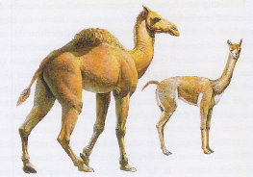
Two different extinct llamas are depicted here. Camelops (looking more like a camel in this depiction) is shown on the left, and Hemiauchenia on the right. They were very numerous as indicated by their fossils in North America throughout the Pleistocene – and probably later in time. Like living llamas and their relatives, they probably could have been domesticated. Living species have been domesticated for a few thousand years. They have been used by native peoples of South America for beasts of burden, food and clothing, as well as for a variety of other uses. They could easily fit the category of curelom or cumom as mentioned in the Book of Ether. . (From Harris and Jefferson, 1985, “Treasures of the Tar Pits.” Courtesy of the George C. Page Museum. John Dawson, artist.) [Wade Miller, Science and the Book of Mormon: Cureloms, Cumoms, Horses and More, p. 62]

Some of the extinct llamas were considerably larger than living forms. One type stood seven feet tall at the shoulder, and another species six feet. Not only is there good evidence for the co-existence of American llamas and man, but also that these animals could be domesticated. It was stated by anthropologist Ricardo Latcham that New World camelids (the llamas) were domesticated in pre-Columbian times. ¹³³ Archaeologist Jane Wheeler claimed that the domestication of the llama goes back several thousand years.¹³⁴ This would take in the time of the Jaredites in America. As far as being an especially useful animal, consider the uses for which the llama has been put by man. As stated by Walker et al., “It is easy to realize the importance of the llama to the Indian, as he utilizes it almost 100%, from its smallest hairs to its most insignificant droppings. Jerked llama meat nourishes the Indian; its woven fleece keeps him warm; its hide is made into the crude sandals with which he is shod; its tallow is used in making candles; braided, the long hairs serve him as rope; and the excrement, dried, constitutes a fuel”¹³⁵ Additionally the llama makes a very good beast of burden, and its pelt is used for blankets and outerwear. It has also been shown that they are good at guarding flocks. All these items make the llama an extremely useful animal for man. With the larger size of the extinct llamas this would have been especially so. Their fossils are known from Mesoamerica. It seems to us that this animal could well be either the curelom or cumom mentioned in the Book of Ether.

If the llama in fact represents a curelom or cumom, what could the other one be? Again, it has to be one which lived in the right place at the right time; that is, when and where the Jaredites were living. And it also must be an animal especially useful to man. Although now extinct, two viable candidates are ones related to the elephant. They belong to the same group (Order Proboscidea).

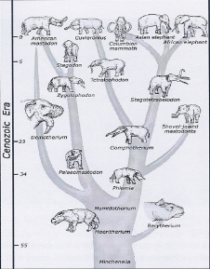
Simplified family tree (phylogeny) of the Proboscidea beginning with the earliest known ancestors. While there are many species that belong to this group (Orders), only some of the better-known types are represented here.
The Columbian mammoth is evidently the elephant to which reference is made in the Book of Ether.
The American mastodon and Cuvieronius might be either the curelom or cumom mentioned in the same book. Along with the mammoth (elephant), they both lived in the southern part of the North American continent, and presumably up until the time that the Jaredites inhabited the land. All would have been excellent beasts of burden. (Adapted from Prothero and Dott, 2002, “Evolution of the Earth”) [Numbers shown on the chart represent millions of years.] [Wade Miller, Science and the Book of Mormon: Cureloms, Cumoms, Horses and More, p. 66]

The two species involved superficially look quite similar, but have long separate histories. One is a gomphothere with the genus name of Cuvieronius, and the other a mastodon named Mammut. The latter is the American Mastodon.
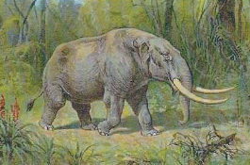
Cuvieronius American Mastodon Mammut americanum
(Restoration is by Heinrich Harder, 1858-1935)

Like the elephant, both Cuvieronius and Mammut are very large animals having tusks and a proboscis, or trunk. Both of these were intelligent animals based on the size and configuration of their braincases as determined from fossils. Consequently, it can be seen that they were capable of being tamed and trained, but probably not domesticated. One, or both, of these could qualify as a curelom or cumom. This is a distinct possibility. But if the llama is one of these animals, then a pick needs to be made between the gomphothere and the mastodon as a curelom or cumom. This pick is not an easy one to make. However, there is a possibility that with such similarity in appearance, that these animals might have been called by the same name (curelom or cumom). In the case of the living proboscideans, both the Asian and African forms go by the same general name, “elephant” despite belonging to two separate genera.

Cuvieronius and Mammut coexisted into the late Pleistocene in Mesoamerica, with the former being more common in the southern part of this land and the latter in the more northern part. In fact Cuvieronius is fairly well known in South America where there is no record of Mammut. According to Scott Drennan (personal communication) there are several associations of Cuvieronius and man in that continent. Not as much detail is known about the detailed age and distribution of Cuvieronius in North America, however.¹³⁶ The American Mastodon has several dates placing its terminal existence well past the close of the Pleistocene.¹³⁷ There is also evidence of some associations with it and man.

As far as usefulness of either the American Mastodon or Cuvieronius, both would have made a good beast of burden and one that could move large objects. They could probably rival the elephant (mammoth) in this. While the mastodon was shorter, it was also stockier. Other potential uses for either proboscidean would be similar to the elephant as well: meat for food, leather for footwear or outerwear, tallow from fat for candles, droppings for fuel, ivory for tools and objects of art, along with other possible utilizations. That the elephant and mastodon were used for food has been shown by various prehistoric kill sites. One such site demonstrated a projectile point embedded in a mastodon rib.¹³⁸

While it may never be known which animals are the ones designated as “cureloms” and “cumoms” by the Jaredites, we have listed some very likely candidates. That man in pre-Columbian time was associated with extinct llamas, elephants, mastodons and gomphotheres is a matter of record. That the non-elephants in this group could represent a “curelom” or “cumom” is a distinct possibility.

[Wade E. Miller and Matthew Roper, “Animals in the Book of Mormon: Challenges and Perspectives,” Interpreter: A Journal of Mormon Scripture]
Ether 9:19 All of Which Were Useful unto Man and More Especially the Elephants and Cureloms and Cumoms (Domestication?):
Wade Miller and Matt Roper write:
A majority of animals mentioned in the Book of Mormon are domesticated ones. This makes sense because these represent ones most useful to man. . . . The Jaredites were the earliest peoples mentioned in the Book of Mormon to have domesticated animals in what’s now America. They brought the most useful ones practical to bring in their barges from the Old World (Ether 6:4). Although no specific kinds of animals are listed, most likely the animals would have included sheep and goats under the heading of “flocks and herds.” Since the Jaredites also loaded their barges with “…whatsoever beast or animal,” the Jaredites must have carried several types of useful animals on one or more of their eight barges on their voyage to America.

In addition to sheep and goats, the later mention in the Jaredite record of cattle, oxen, cows, horses and asses (Ether 9:18-19) presents the possibility that these animals were brought along too. It might have been that the larger animals (e.g., horses, asses and cattle types) were carried across as juveniles. This would have alleviated space and food problems.³⁶ What we don’t know is what kinds of animals they found native in the New World, with the probable exceptions of the elephant, curelom and cumom. Some of these could well have been domesticated, and apparently were (Ether 9:19) . . .

All the animals except the “wild goat” in the Jaredite record could represent domesticated forms. A problematic one, though, is the elephant (Ether 9:19). The earliest descriptions of the mammoth in the scientific literature have referred to this pachyderm as an elephant – which indeed it is.³⁸ Although mammoths characteristically were considered to be extinct for 10,000 years, new discoveries show that they lived on in North America far beyond this date.³⁹ However, extinction dates for species do not represent their latest existence on earth. We consider that the “elephants” cited in the Jaredite record was accurately identified.

The most widespread and abundant North American mammoth was Mammuthus columbi.
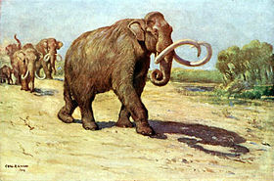
Columbian Mammoth

This in all probability was the elephant referred to in Ether 9:19. This particular mammoth shows a very close relationship to the Indian (or Asian) elephant, Elephas maximus (the circus elephant).
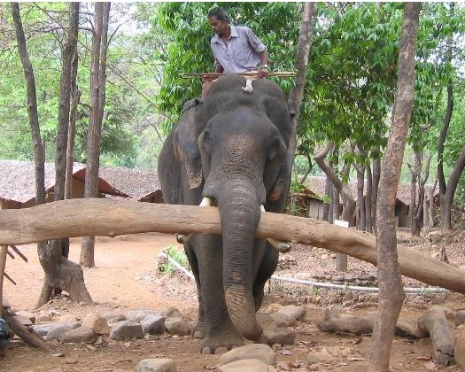
Indian elephant at work

These two proboscideans have a closer relationship to one another than either has to the African elephant, Loxodonta africana.

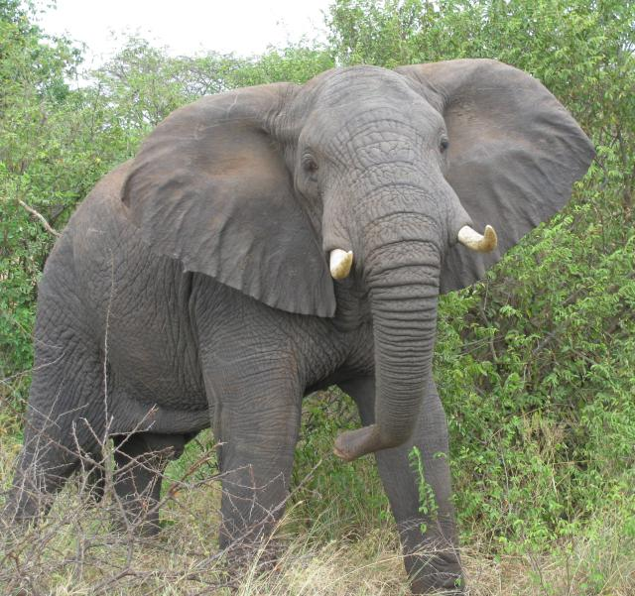
African Elephant

The potential significance of this is that the Indian elephant is fairly easily tamed and trained (but not actually domesticated), while the African elephant is not. Therefore, it seems reasonable to assume that Mammuthus columbi could also be domesticated. Archaeological evidence supports the fact that the Indian elephant was domesticated back to at least 2500 B.C. in the Indus Valley.⁴⁰ Coincidentally this is the approximate time that the Jaredites arrived in North America. If these people traveled through Asia as thought by Hugh Nibley⁴¹ Jared and his group possibly observed men working elephants. They would have seen how useful these large mammals were.

It should be realized that there is a fine line between taming and domesticating. Most mammals (as well as some other animals) can be tamed if raised from babies. However, relatively few can be truly domesticated.⁴² As far as a definition of domestication, it means to cause an animal to adapt to a life which is in intimate association with, and to the advantage of, man. Taming simply means to make an animal docile and submissive. Scientifically, domestication is the process of changing an animal genetically through selective breeding to the benefit of man. Taming is the process whereby an animal simply becomes accustomed to a human(s).
[Wade E. Miller and Matthew Roper, “Animals in the Book of Mormon: Challenges and Perspectives,” Interpreter: A Journal of Mormon Scripture]

Ether 9:22 The Son of Righteousness:
In Malachi 4:2 we find the title, “Sun of Righteousness.” Here in Ether 9:22 (as well as in 3 Nephi 25:2) the title is “Son of Righteousness.” There are over 500 different descriptive titles for Christ or God found in the Book of Mormon. [Alan Miner, Personal Notes] [SEE list]

Ether 9:22 He Even Saw the Son of Righteousness:

We know very little of Emer, but we know enough to realize that he was a great man. He had been a righteous king, much like king Benjamin would be to a later people. He had even seen God. This makes him great by association for it puts him in the same class with some great prophets including: the brother of Jared, Nephi, Jacob, Alma, Mormon, and Moroni.
[josephsmith.com . . . Ether ]

Ether 9:23 Coriantum . . . Did Build Many Mighty Cities:

Coriantum "did build many mighty cities" (Ether 9:23). According to Verneil Simmons, there might be evidence which link Old World building techniques with that of the New World. In a lecture given at the Anthropology Museum in Mexico City, Simmons heard Dr. Ignacio Bernal report on the early site of San Jose Mogote in the Oaxaca Valley.

State of Oaxaca in Mexico [Wikipedia]
He made reference to the odd bricks uncovered in the lowest level of that very early site (1500 - 1300 B.C.) -- flat on one side and arched on the other. He noted, with some surprise, that only in a few early sites in the Old World area of Mesopotamia had such convex bricks been found. Bricks formed with one flat side and a rounded or convex top are very impractical as building blocks and such bricks were quickly abandoned in both cultural areas. They seem an unlikely object for independent invention. [Verneil Simmons, Peoples, Places and Prophecies, p. 276]

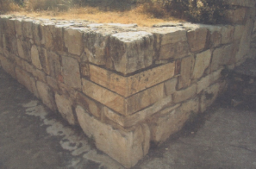
Ether 9:23 [He] did build many mighty cities (Illustration): Shown here is a portion of the restored ruins of San Josed Mogote, Oaxaca,Mexico. These ruins date to the Jaredite time period. Oaxaca is proposed to be the land of Moron. [Joseph Lovell Allen & Blake Joseph Allen, Exploring the Lands of the Book of Mormon, Second Edition, 2008, p. 511]

Ether 9:23 [He] Did Build Many Mighty Cities:

Although the text does not specify the size or population of the "many mighty cities" (Ether 9:23) built by Coriantum, the Book of Mormon reader would expect to eventually find some evidence for cities during the time period of the Jaredites. According to Daniel Peterson, within only the past few years, excavators have unearthed what is now termed the oldest city in North America, an Olmec center in Mexico called Teopantecuanitlan ("The Place of the Jaguars' Temple").

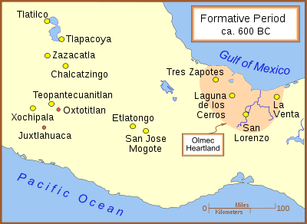
Teopantecuanitlan in relation to other Formative Period archaeological sites. [Internet, Wikipedia]

This site, which appears to have been inhabited from at least 1500 B.C. to 600 B.C., and which may indeed date back to 2000 B.C., covers an area of 241.5 acres and probably served as the residence for approximately 15,000 people. (This was a sizeable population for the period, almost anywhere.) The homes of the city's people line the local river banks. Two stone irrigation canals, each half a mile long and five feet deep, tell of a rather highly developed agricultural life at Teopantecuanitlan. [Daniel C. Peterson, Book Review in Review of Books on the Book of Mormon, Vol. 2, 1990, p. 46]

Ether 9:24 [Coriantum] Lived until He Was an Hundred and Forty and Two Years Old:

King Coriantum lived "an hundred and forty and two years" (Ether 9:24), which fact, according to Glenn Scott, reflects a decreasing life span from the time of Jared. Coriantum's wife died, "being an hundred and two years old," and we are told that "Coriantum took to wife, in his old age, a young maid, and begat sons and daughters. And it came to pass that he begat Com, and Com reigned in his stead," again implying the youngest son succeeded his father as king. [Glenn A. Scott, Voices from the Dust: New Light on an Ancient American Record, p. 51]

Ether 9:26 The People Had Spread Again over All the Face of the Land:

If the term "again" in the phrase "the people had "spread again over all the face of the land" (Ether 9:26) means that the people were spreading over the same land that they previously occupied, then apparently the people spread again over the general land of Moron, which now possibly also included the previous land of Nehor (Ether 7:4), the land of Heth (Ether 8:2), and the place Ablom (Ether 9:3). [Alan C. Miner, Personal Notes]
Geographical Theory Map: Ether 9:27 - 9:33 No Rain--Heth Flees Southward--Serpents (Chronology)
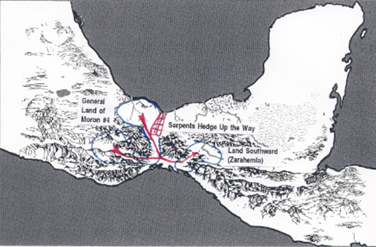

LAND of MORON #4

Heth kills Com (9:27)
HETH reigns (9:27)

No Rain & Poisonous Serpents (9:30)

Flocks Flee to Land Southward (9:31) ----------------------------->

People Follow (9:33) ----------------------------->
Serpents hedge up the way (9:33)

------RAIN -People humbled, began to revive again

North countries become fruitful as well as “all the countries round about.”l (9:35)

_______________

Ether 9:27 [Heth] Slew [Com] with His Own Sword:

Nothing significant occurred until the forty-ninth year of King Com's reign, when he begat a son named Heth, except that the people "had spread again all over the face of the land" (Ether 9:26). Unfortunately, so had their wickedness! In fact, when Heth grew to manhood he killed his father "with his own sword" (Ether 9:27) and reigned in his stead. According to Glenn Scott, the people had apparently become so callous that no one opposed that shocking act of patricide. While the full import of the phrase "with his own sword" is not conveyed by Moroni, it is significant that Moroni reports at this time that the Lord sent prophets throughout the land crying repentance and threatening a great famine if the people did not repent. With no righteous king to protect them, the people drove the prophets out or threw them into pits to die, with the tacit approval of their wicked king (see Ether 9:29). True to his word, the Lord sent a severe drought. [Glenn A. Scott, Voices from the Dust: New Light on an Ancient American Record, p. 51]

Ether 9:29 Some of Them They Cast into Pits and Left Them to Perish:

According to Ben Olsen, who has some geological experience in Mexico, Guatemala and Belize, it is interesting to note that the Book of Mormon records several instances of people being thrown into "pits" (Ether 9:29). In many humid areas, where limestones are exposed at the surface, such as the Yucatan Peninsula and Florida, sink-holes are common. These collapsed areas, where water has weakened the structural integrity of the strata and allowed the surface layers to cave in, form what is called karst topography. Could these sink-holes or cenotes (such as occur at Chichen Itza) be the type of "pits" referred to? [Ben L. Olsen, Some Earthly Treasures of the Book of Mormon, pp. 55-56, Unpublished]

Ether 9:30 A Great Dearth upon the Land:

In Ether 9:30 we are told that "there began to be a great dearth upon the land, and the inhabitants began to be destroyed exceeding fast because of the dearth, for there was no rain upon the face of the earth." According to Warren and Palmer, assuming a Mesoamerican setting, destruction by famine suggests that maize agriculture was not fully developed in this early period. According to the chronological records, this famine happened in roughly 2250 B.C. The location was probably in the rather dry highland valleys surrounding the present city of Oaxaca [Bruce W. Warren and David A. Palmer, The Jaredite Saga, 7-4; 7-12, unpublished]

Ether 9:30 There Was No Rain upon the Face of the Earth:

In Hebrew the word "eretz" can be read to mean either "earth" or "land," and only the writer knows which is meant. It seems apparent that the phrase "there was no rain upon the face of the earth" (Ether 9:30) only pertains to the Jaredite lands. [Alan C. Miner, Personal Notes]

Ether 9:30 A Great Dearth upon the Land:
Brant Gardner notes that David Webster, professor of anthropology at Pennsylvania State University, describes a similar drought cycle for the later Maya. He adds that there is no reason to suppose that the Olmec, with their similar agriculture, would have not been similarly impacted:
Sometimes plenty of rain falls, but it arrives a bit late, or there is an unusually dry interval as the crops ripen. In these circumstances, he harvest might be sparse, but people can generally tighten their belts and get by. More serious are marked deficiencies in annual rainfall extending over one or several years. Such protracted droughts can cause widespread famine, along with disease and social disruption. Many episodes of hunger, death, and conflict related to droughts of this kind are featured in the various Book of Chilam Balam, and scores of historical droughts are also recorded for northern Yucatan during Colonial and later times. Although exact census figures are unavailable, during the worst of them as many as 30-50 percent of the rural Maya population might have died.(n.20)
[Brant A. Gardner, Second Witness, Vol. 6: Fourth Nephi through Moroni, pp. 264-265]

Ether 9:31 There Came Forth Poisonous Serpents Also upon the Face of the Land:
All snakes are predators. Snakes often feed upon mice, rats, and other rodents. Their prey, in turn, tends to feed on plant material, such as grain. In the event of a famine, rodents will seek out food elsewhere. Human farms or settlements will contain large amounts of stored grain in a small area, which will naturally attract rodents. Snakes will inevitably follow . . .
Some snakes also require drinking water (rather than obtaining all hydration through predation), and modern biologists have noted that during a drought (when snakes' usual watering places have dried up) they will tend to seek new sources, which are often in human-settled areas. Dan Tredinnick, press secretary to the Pennsylvania Fish and Boat Commission, noted an increase in human-snake contacts during Pennsylvania's dry summer, and said:
The combination of heat and little rainfall is probably the cause...If people are seeing snakes and other reptiles that (lack of water) is very likely the reason...Just like us, they need water...Areas where they might traditionally slake their thirst may have dried up, he said, leaving the snakes no other choice but to go looking for new watering holes...They will go and seek other areas and the type of habitat they need . . . (See Eric Mayes, "Heat and drought bringing snakes out of their dens," The Daily Item (18 August 2005)
Furthermore, as prey animals became scarce due to drought, snakes would become more hungry and potentially more aggressive, which would also increase the number of human-snake encounters.
The disappearance of the snakes reported in Ether 10:19 may have been due solely to divine intervention, but an end of drought conditions would also result in snakes dispersing more widely as their prey was able to do so, thus decreasing the risk to the human population.
[FairMormon, "Serpents and Droughts," http://en.fairmormon.org/Book_of_Mormon/ Anachronisms/Serpents_and_drought]

Ether 9:31 Poisonous Serpents:
A Mesoamerican setting for Book of Mormon geography requires poisonous snakes in Veracruz and Oaxaca, Mexico. Brant Gardner notes the following:
Veracruz is home to the Olmecan pit viper, Petlacala montane pit viper, the small-headed rattlesnake, the Totonacan rattlesnake, the Tuxtlan coral snake, and the Mexican horned pit viper. Oaxaca is home to even more venomous species: the Mexican palm-pit viper, the Eyelash palm-pit viper, the Mexican small-headed rattlesnake, Bogett’s coral snake, the Oaxacan coral snake, the broad-ringed coral snake, the Ixtlan coral snake, the black-tailed horned pit viper, and Dunn’s hog-nosed pit viper.(n.21) [Brant A. Gardner, Second Witness, Vol. 6: Fourth Nephi through Moroni, p. 265]

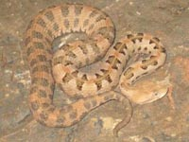
Ether 9:31 Poisonous Serpents (Illustration): L/R Mexican Jumping viper (Olmec viper), Dunn’s Hognose Pitviper [Other-Latin-American-Pit-Vipers.html]

Ether 9:30-31 There Began to be a Great Dearth . . . The Flocks Began to Flee . . . Towards the Land Southward Which Was Called by the Nephites Zarahemla:

In Ether 9:30-31 we have the following account:

And it came to pass that there began to be a great dearth upon the land, and the inhabitants began to be destroyed exceeding fast because of the dearth, for there was no rain upon the face of the earth. And there came forth poisonous serpents also upon the face of the land, and did poison many people. And it came to pass that their flocks began to flee before the poisonous serpents, towards the land southward, which was called by the Nephites Zarahemla.

Bruce Warren uses these verses as a commentary on Jaredite geography--that the Jaredite land northward appears to be a relatively small area. For example, in a time of extreme drought, "flocks," apparently in search of water and feed, wandered from the Jaredite lands "towards the land southward, which was called by the Nephites Zarahemla." One might ask the question, How far would "flocks" wander in extreme drought conditions? The answer would probably be, Not very far—certainly not in excess of a hundred or so miles. Thus, the land of the Jaredites could not have been that far away from the Nephite land of Zarahemla. [Bruce W. Warren, Blaine M. Yorgason, Harold Brown, New Evidences of Christ in Mesoamerica, Unpublished Manuscript]

Ether 9:31 Their Flocks Began to Flee . . . towards the Land Southward, Which Was Called by the Nephites Zarahemla:

In association with the great drought,

there came forth poisonous serpents also upon the face of the land, and did poison many people. And it came to pass that their flocks began to flee before the poisonous serpents, towards the land southward, which was called by the Nephites Zarahemla. And it came to pass that there were many of them which did perish by the way; nevertheless, there were some which fled into the land southward." (Ether 9:31-32)

In review, the people of Omer were living in the land of Moron (Ether 9:13). By the time of the drought, the general land of Moron had probably absorbed the land of Nehor (Ether 7:3-22), had probably absorbed the land of Heth (Ether 8:2 - 9:13), and probably also had some claim on the land of Ablom by the seashore (Ether 9:3). The people had also built "many mighty cities (Ether 9:23). From this enlarged land, their flocks began to flee southward towards the land called Zarahemla by the Nephites. (Ether 9:31) This was probably the general land of Zarahemla. Though not mentioned specifically in the text, we might presume that this "land of Zarahemla" was somewhat near the land of Moron. Ether 10:19 and 10:21 seem to imply that Moron was probably near enough to the land southward that sufficient game could be brought back without too much loss or spoilage, and that the hunters wouldn't have to travel very far.

With this information in mind, and assuming a Mesoamerican setting, David Palmer postulates that there could not have been large rivers, deserts, or impassable mountain ranges for the flocks to cross. A downhill flight through the valleys of Oaxaca (his proposed land of Moron) to the area of Tehuantepec City (the area of his proposed small neck of land separating the land northward and the land southward) seems within the realm of possibility. [David Palmer, In Search of Cumorah, p. 46]

Ether 9:31 Their Flocks Began to Flee . . . towards the Land Southward, Which Was Called by the Nephites Zarahemla:

In Ether 9:31 we find that "there came forth poisonous serpents also upon the face of the land, and did poison many people. And it came to pass that their flocks began to flee before the poisonous serpents towards the land southward, which was called by the Nephites Zarahemla."

Joseph Gorrell writes:

I am familiar with both serpents and flocks, and neither of them show behavior in the manner described above. That is, poisonous serpents do not pursue animals; they defend themselves against intruders, including animals. If in reality the flocks represent sheep or cattle, it is contrary to the way these animals react. They simply do not travel hundreds of miles just to get away from snakes.

He reasons that if the serpents and flocks are representative of specific groups of people ("flocks" tend to symbolize righteous people--Alma 5:59-60; and serpents could be symbolic of secret combinations, who spread their deadly poison among the people--note that in Ether 9, Heth became the king of the Jaredites and was directly involved with secret combinations), then this story might take on some new light. Moroni notes concerning the "flocks" that "there were many . . . which did perish by the way nevertheless; there were some which fled into the land southward" and the Lord stopped the poisonous serpents from pursuing them.

Many current Latter-day scholars see a strong relationship between the Jaredites and the Olmecs. Assuming a Mesoamerican setting for the Book of Mormon, the distance from the Olmec center of San Lorenzo, Veracruz, located at the top of the Isthmus of Tehuantepec, to Izapa, Chiapas on the Pacific coast, is about 250 miles. There are several sites on the Pacific coast of Chiapas and Guatemala that manifest a large Olmec influence beginning at about 1000 B.C. These sites include Izapa, La Blanca, Abaj Takalik, El Baul, Monte Alto, and Bilbao. These sites establish a coastal trail from Izapa to Kaminaljuyu. Kaminaljuyu is the area considered by many LDS scholars to be the city of Nephi, and also shows Olmec influence prior to 600 B.C.

Could the book of Ether imply that a remnant of the Jaredites traveled into the land southward prior to the coming of Lehi? Were there Jaredites at Izapa, a proposed landing site of the Nephites when Lehi and his people arrived?

It is interesting to note that when Nephi fled from the land of first inheritance, he noted that "all those who should go with me were those who believed in the warnings and the revelations of God, wherefore, they did hearken unto my words (2 Nephi 5:6). Is it possible that some of the people who listened to Nephi and went with them to settle in the land of Nephi (Kaminaljuyu) were none other than the descendants of the righteous flocks who had escaped the Jaredite heartland 400 years earlier? [Joseph C. Gorrell, "Serpents and Flocks" in The Book of Mormon Archaeological Digest, Vol. III, Issue II, June 2001, pp. 12-13] [See the commentary on Jacob & Sherem--review of John Clark's article, see the commentary on 2 Nephi 5:6]

Ether 9:33 The Serpents (Did) Hedge Up the Way:

If the serpents "hedged up the way" (Ether 9:33) so that the people couldn't follow the flocks into the land southward, then this seems to imply that there was a "limited" passage into the land of Zarahemla. This migration of animals "into the land southward" seems to be talked about by Mormon in Alma 22:21 when he says, "the land on the southward (of the land northward [Desolation]) was called Bountiful, it being the wilderness which is filled with all manner of wild animals of every kind, a part of which had come from the land northward for food." Mormon also goes on to say in Alma 22:32 that there was "a small neck of land between the land northward and the land southward." Perhaps this "small neck of land" was what allowed the serpents to "hedge up the way." [See the commentary on Alma 22:31-32; Ether 10:19; 10:21]

Glenn Scott notes that the river which flows across the Isthmus of Tehuantepec (a proposed area for the small neck of land and thus a proposed area where the serpents might have "hedged up the way" -- Ether 9:33) is named the Coatzacoalcos, which in the Nahuatl language means, "the place of serpents." (Robert Fishburn 1968, "Place of Serpents," FRAA Newsletter 2:4) [Glenn A. Scott, Voices from the Dust: New Light on an Ancient American Record, p. 51]

Ether 9:33 The Lord Did Cause That the Serpents . . . Should Hedge Up the Way, That the People Could Not Pass:

According to Hugh Nibley, the description of how people were driven out of a land by a plague of serpents that then "hedge up the way that the people could not pass" (Ether 9:31-35) may put a strain on some people's scientific credulity. Nevertheless it can be believed: "Pampa the Great, we are told, could not get his army into Hyrcania because the way was barred by snakes along the Araxes, a stream that still swarms with the creatures. . . Shah Sadrudin set his heart on the building of a capital which should surpass all other cities in splendor; yet the project had to be abandoned after enormous expense when during a period of drought the place so swarmed with serpents that no one could live in it." It is interesting in this connection that the plague of serpents in Ether is described as following upon a period of extreme drought (Ether 9:30). [Hugh Nibley, The World of the Jaredites, p. 221]

Ether 9:33 The Lord Did Cause That the Serpents . . . Should Hedge Up the Way:

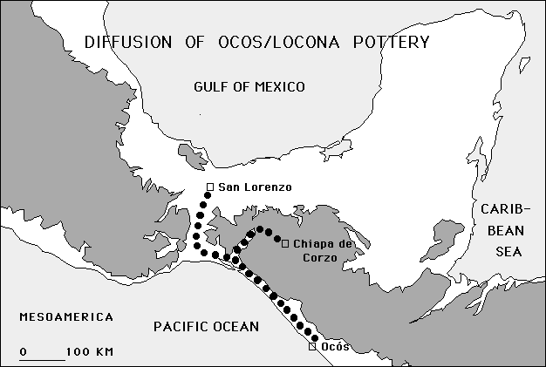

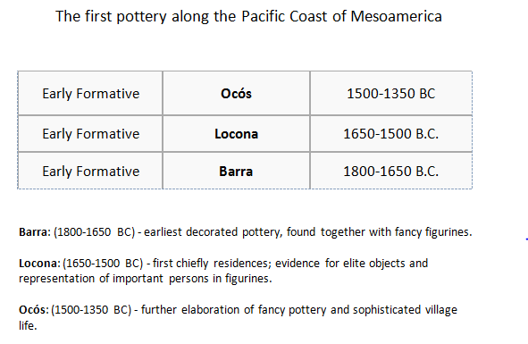
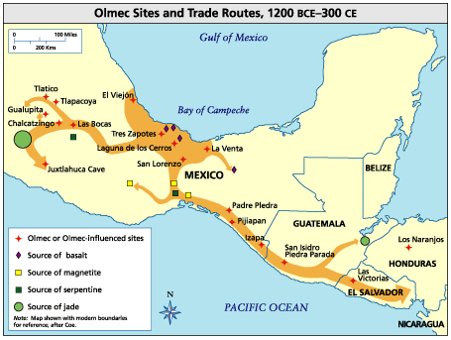
Latinamericanstudies.org

NOTES

. Harold Lamb 1954, Genghis Khan and the Mongol Horde as quoted in Glenn A. Scott, Voices from the Dust: New Light on an American Record, 1996, p. 47.
. Encyclopedia Britannica 1960, s.v. "Silk & Sericulture," 20:661]
. I.W. Johnson 1971, "Basketry & Textiles," Handbook of Middle-American Indians, 10:312.
. Tozzer, trans. 1941, Landa: Relacion de las cosas de Yucatan, 201.
. Los Angeles Times 1961, June 28, 31.
. Jacques Soustelle, The Olmecs: The Oldest Civilization in Mexico (Garden City: Doubleday, 1984), 23.
. See Gwyn Jones, The Norse Atlantic Saga: Being the Norse Voyages of Discovery and Settlement to Iceland, Greenland, America, 2nd ed. (New York: Oxford University Press, 1986), 119; see also Erik Wahlgren, The Vikings in America (New York: Thames and Hudson, 1986), 124.
. S. Bokonyi, History of Domestic Mammals in Central and Eastern Europe (Budapest: Akademiai Kiado, 1974), 267.
. Staff 1993, "Mini-mammoths Survived Longer," National Geographic, October.
. Ludwell H. Johnson, III, "Men and Elephants in America," Scientific Monthly, October 1952, 215-21; William D. Strong, "North American Indian Traditions Suggesting a Knowledge of the Mammoth," American Anthropologists, vol. 36, no. 1, January-March 1934, 81-88.
. See Kenneth Macgowan, Early Man in the New World (New York: Macmillan, 1950), 137-39, 142.
. George F. Carter, "Uhle's Mastodon," Anthropological Journal of Canada, vol. 6, no. 2, 1968, 21-24.
. Josef Augusta, The Age of Monsters, Prehistoric and Legendary (London: Paul Hamlyn, 1966), 11-12.
. Charles Schuchert, "Mammut Americanum in Connecticut," American Journal of Science, vol. 187, no. 220, April 1914, 328-29.
. See Stephen Williams, "The Island 35 Mastodon: Its Bearing on the Age of Archaic Cultures in the East," American Antiquity, vol. 22, no. 4, April 1957, 368.
. M. F. Ashley Montagu, "An Indian Tradition Relating to the Mastodon," American Anthropologist, vol. 46, no. 4, October-December 1944, 568. For further reading see John L. Sorenson, "Animals in the Book of Mormon: An Annotated Bibliography," FARMS paper, 1992, 2-3, 5-6, 10, 12, 14, 23-25, 31-35, 38-39; John L. Sorenson and Martin H. Raish, Pre-Columbian Contact with the Americas Across the Oceans: An Annotated Bibliography, 2d ed., rev. (Provo, Utah: Research Press, 1996), 1:45-46, 310, 349, 413, 426, 437, 443, 487, 520; 2:3, 104, 171, 209, 339, 385, 420, 422-23, 454.
. John E. Thompson, Mexico Before Cortez (New York: Charles Scribner's Sons, 1933), 290.
. Thompson, Mexico Before Cortez (New York: Charles Scribner's Sons, 1933), 290. See Jill L. Furst and Peter T. Furst, Pre-Columbian Art of Mexico (New York: Abbeville Press, 1980), 71.
. See Harlan Lebo, "Mayan Mysteries," UCLA Magazine 2 (Spring 1990):29-33. The dig at Nakbe is directed by Richard Hansen, a graduate of Brigham Young University, and includes scientists from both UCLA and BYU, as well as from the University of San Carlos in Guatemala.

